Supplementary Information for
Texture Similarity Network Uncover Schizophrenia Subtypes with Unique Molecular Signatures

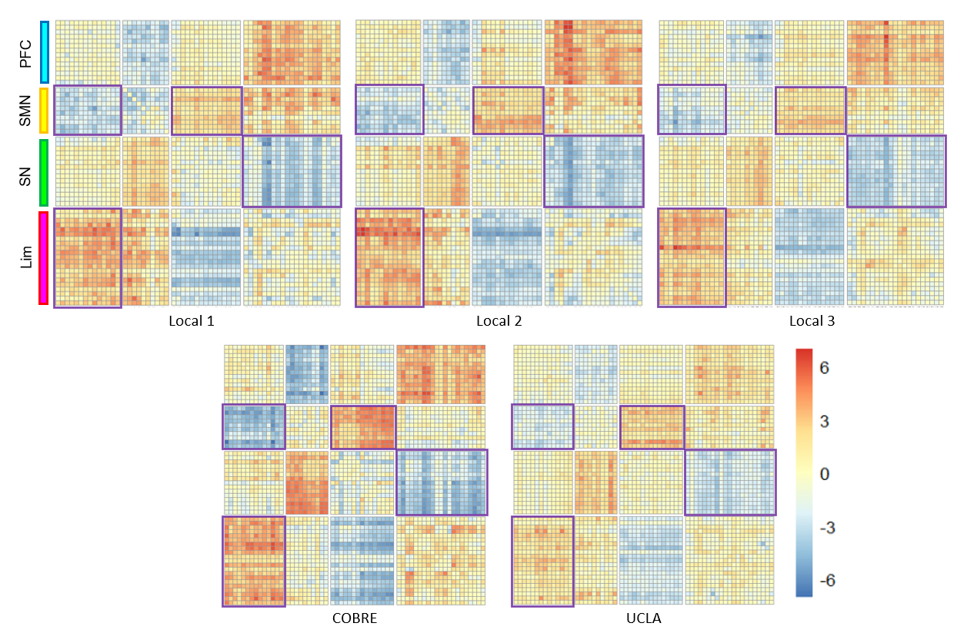
Supplementary Figure S1: T-map of the differences in the two subtypes of TSN across 5 sites. Heat maps show TSN dysconnectivities of the top 60 brain regions in five sites across subtypes. Consistent inter-regional connectivity patterns and four prominent modules are observed across centers. Abbreviations: Lim, paralimbic system; PFC, prefrontal cortex; SMN, sensorimotor network; SN, subcortical nucleus; TSN, texture similarity network.

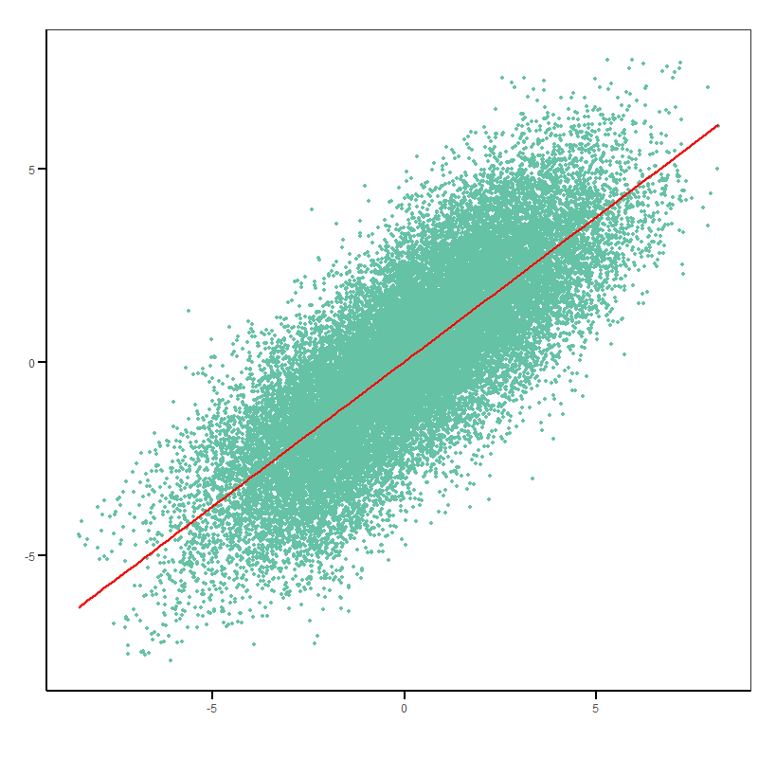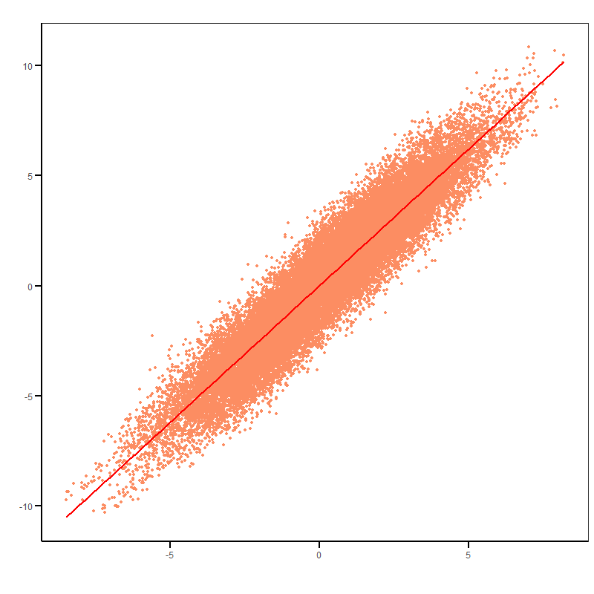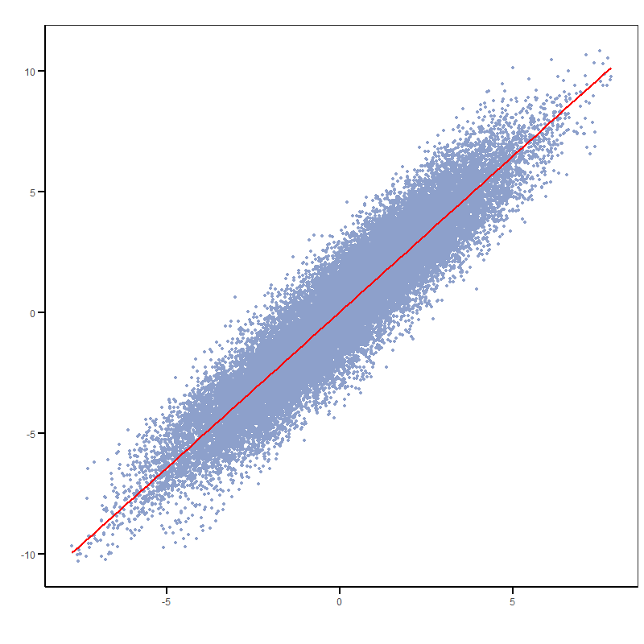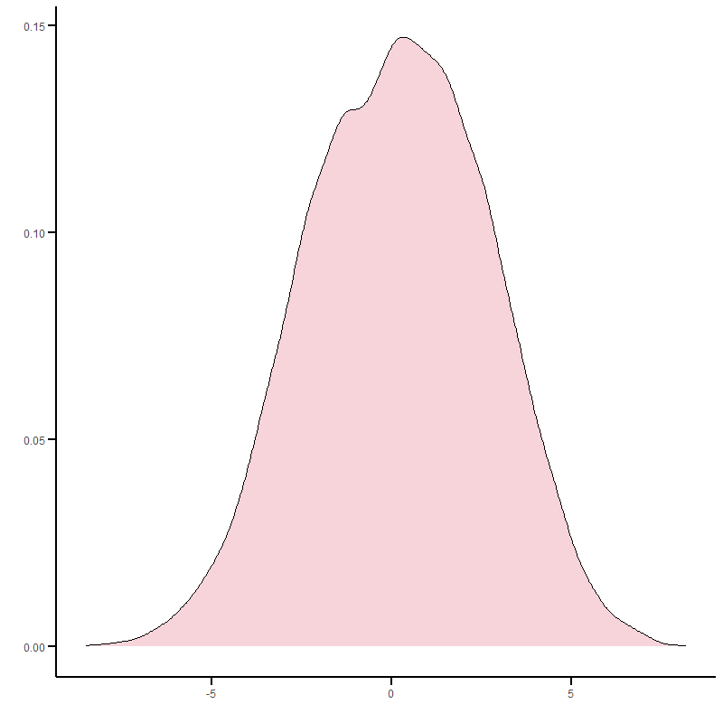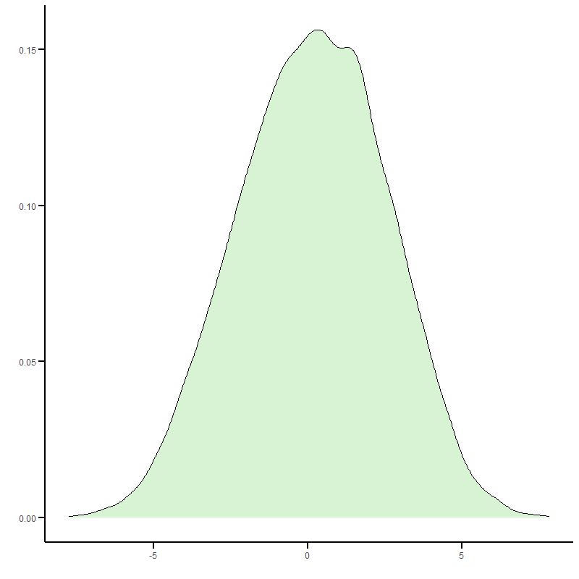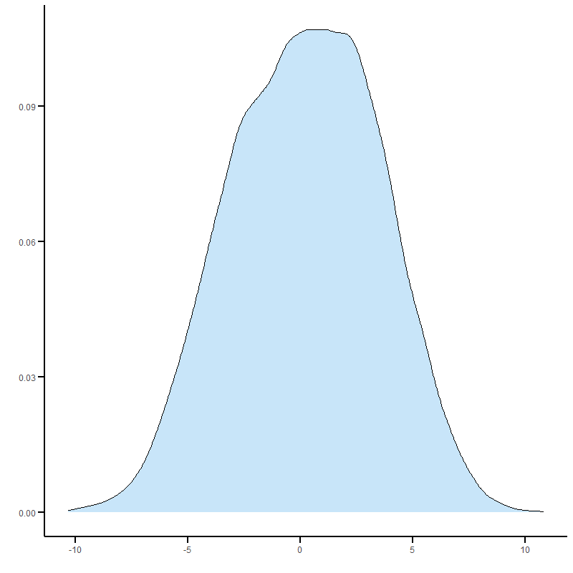
0.9434
0.7897
0.9355
Total
Split1
Split2

Supplementary Figure S2: Correlation of subtypes TSN patterns obtained from the training in the split-sample experiment. Inter-subtype differences were consistent across splits (Pearson r = 0.79–0.94).

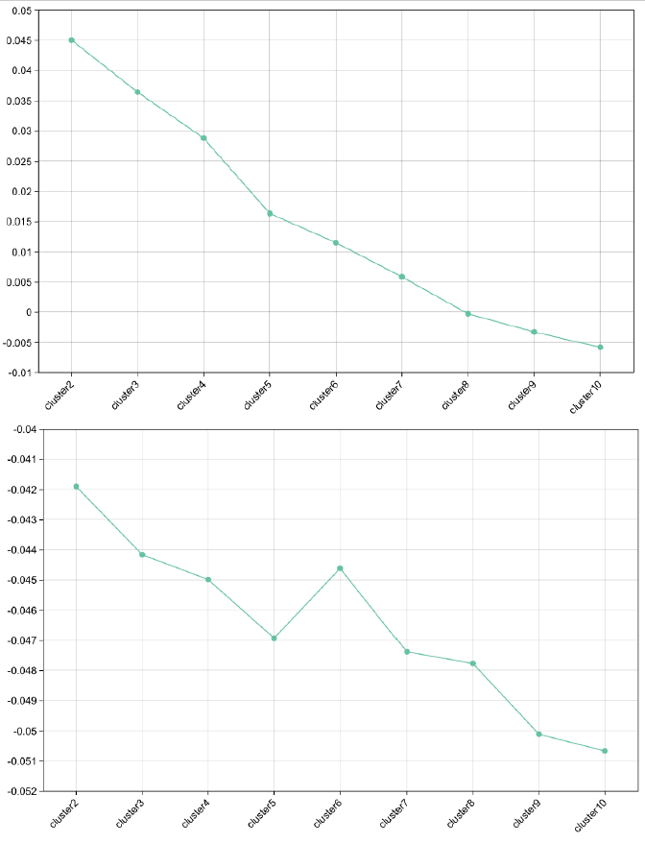
Supplementary Figure S3: The upper panel shows K-means clustering performance based on the silhouette score, indicating that the optimal clustering structure was achieved at K = 2. The lower panel shows K-means clustering performance based on the gap score, also indicating that the optimal clustering structure was achieved at K = 2.
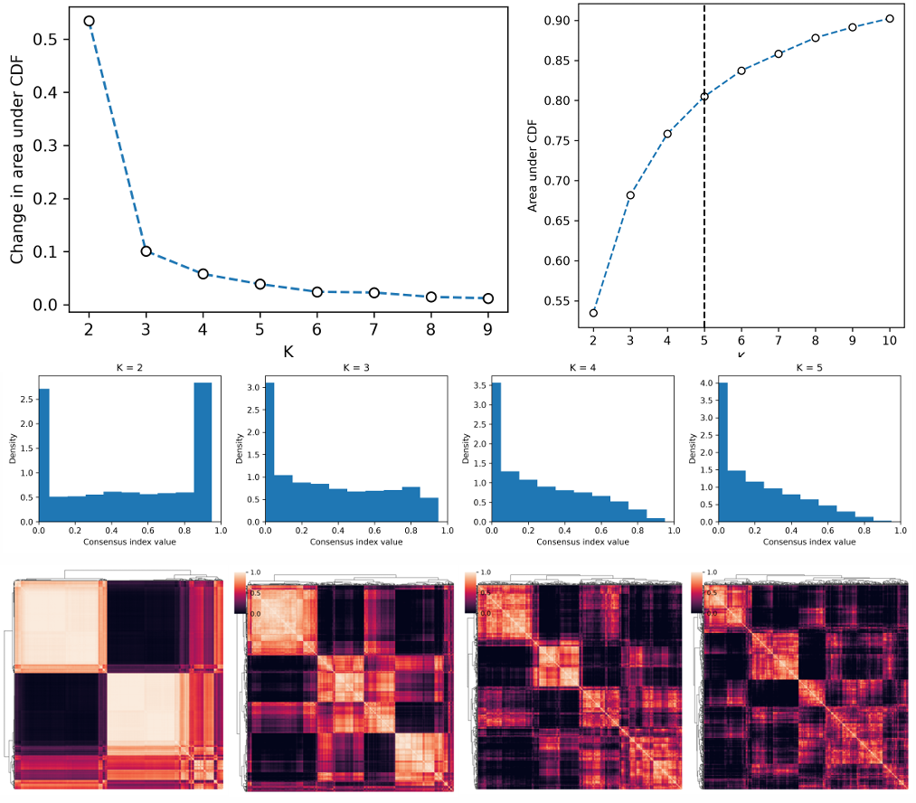
Supplementary Figure S4: The upper-left panel indicates that the optimal number of clusters is K=2, corresponding to the maximum ΔAUC. In contrast, the upper-right panel identifies K=5 as the elbow point of the AUC curve. Further analysis of the histograms shows that K=2 yields two clearly distinguishable clusters, whereas larger values of K produce less stable structure with limited separation among subgroups. Similarly, the heatmap reveals two well-defined major clusters at K=2, while higher values of K result in more heterogeneous within-cluster structures. Overall, these findings support K=2 as the most stable and biologically meaningful partition of the samples.

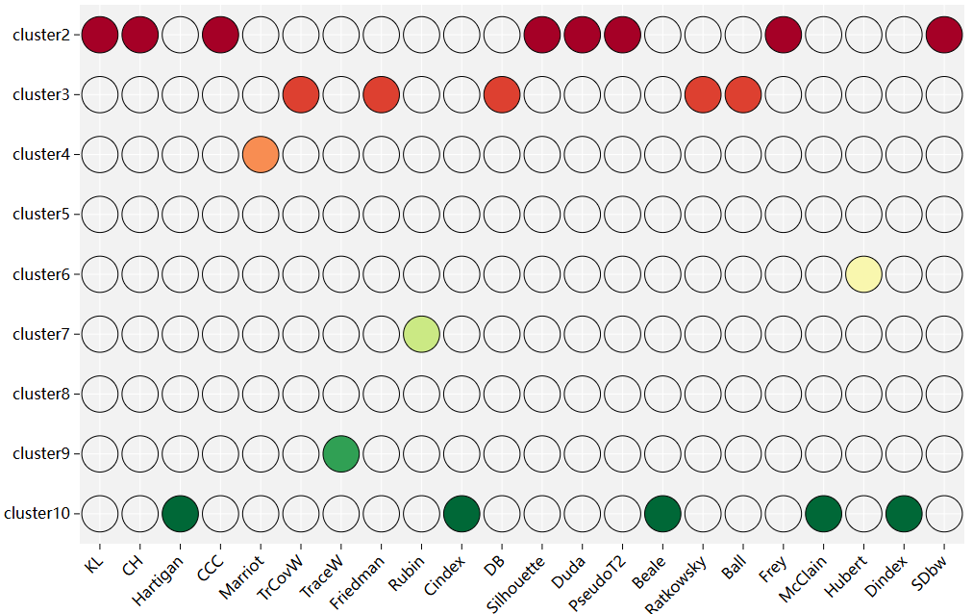
Supplementary Figure S5: NbClust (https://sites.google.com/site/malikacharrad/research/nbclust-package) determines the optimal number of clusters based on voting across 23 clustering evaluation indices. The final number of clusters, K = 2, received the majority of votes (8/23).

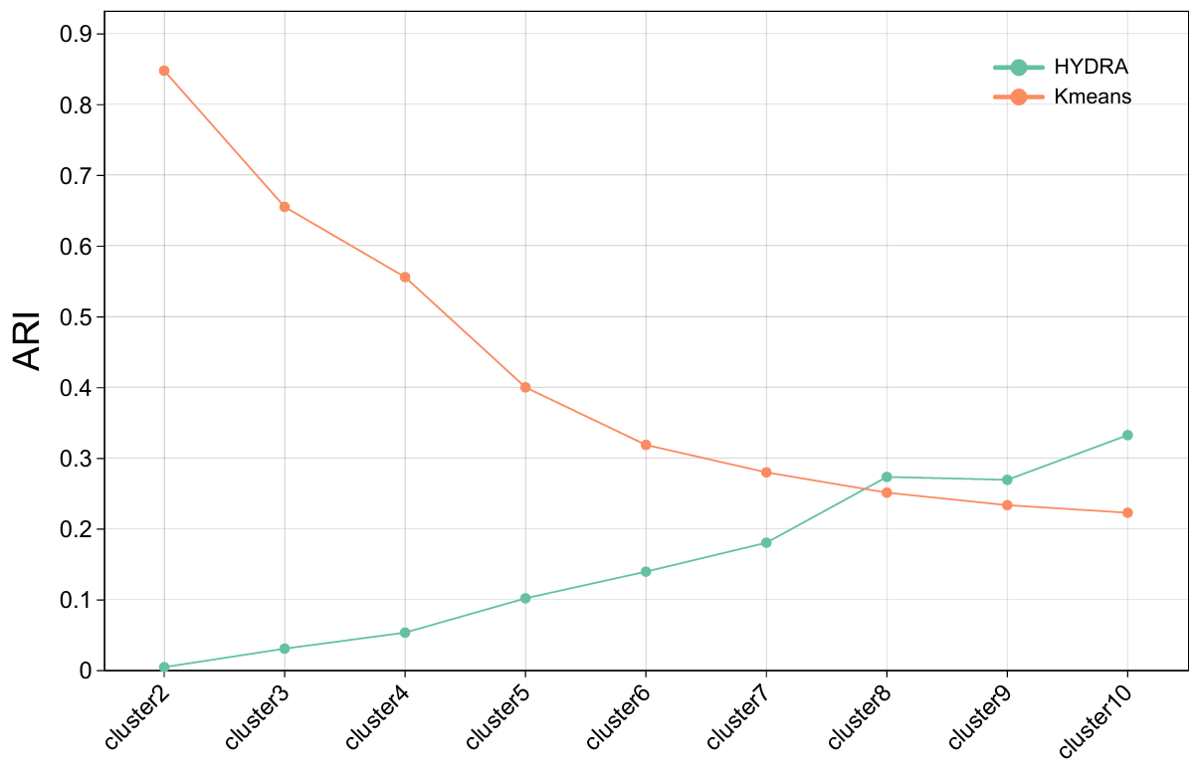
Supplementary Figure S6: Clustering performance of HYDRA for K=2–10. Compared with HYDRA, K-means showed substantially greater stability in the TSN-based classification task.

