Parahippocampal Network Dysfunction Distinguishes Suicidal Ideation from Suicide Attempts in Adolescents with Major Depressive Disorder: A Cross-Sectional Resting-State fMRI Study

1. Methods

1.1 Participants

We recruited a total of 170 adolescents aged 13 to 18 years. Among them, 145 adolescents with major depressive disorder (MDD) were recruited from the inpatient units of the Department of Child and Adolescent Psychiatry at Hefei Fourth People’s Hospital between January 2023 and December 2024. Twenty-five participants in the healthy controls (HC) were recruited from two local secondary schools in the city. The study protocol was approved by the Ethics Committee of the Anhui Mental Health Center, Hefei Fourth People’s Hospital, and the ethics approval number was HFSY-IRB-PJ-KYXM-ZH (2023-005-001). Prior to participation in any study procedures, all adolescent participants and their legal guardians were fully informed about the study and provided written informed consent.
During the data preprocessing and quality control stage, a total of 41 participants were excluded. Among them, three adolescents with MDD were excluded due to missing data on the Beck Scale for Suicide Ideation (BSSI) (1). An additional 38 participants, including 36 adolescents with MDD and 2 healthy control participants, were excluded due to excessive head motion during the resting-state fMRI scanning. Excessive head motion was defined as translation parameters greater than or equal to 3 mm, rotation parameters greater than or equal to 3 degrees, or mean Jenkinson framewise displacement greater than or equal to 0.2 mm. Ultimately, imaging data from 129 participants, including 106 adolescents with MDD and 23 HC participants, were included in subsequent statistical analyses. Based on BSSI scores and clinical assessments, the 106 adolescents with MDD were further divided into four subgroups: those with suicidal ideation only (SI, n = 32), those with suicide attempts only (SA, n = 15), those with both suicidal ideation and suicide attempts (SIA, n = 39), and those without suicidal ideation or suicide attempts (NS, n = 20).

1.2 Clinical Assessment

(1) A general information questionnaire was administered, including items on sex, age, years of education, height, and weight. (2) The 17-item Hamilton Depression Rating Scale (HAMD) (2) is a widely used clinical instrument for assessing depressive symptoms. The scale comprises 17 items, which are grouped into five factors: anxiety, cognitive impairment, weight, sleep disturbances, and retardation, with an overall composite score. A total score greater than 7 indicates clinically significant depressive symptoms. Higher scores reflect more severe depressive symptoms experienced by the participant during the past week. (3) The 14-item Hamilton Anxiety Rating Scale (HAMA) (3) was used to assess anxiety severity. A total score greater than 7 indicates the presence of anxiety symptoms, with higher scores reflecting more severe anxiety experienced by the participant during the past week. (4) The BSSI is a psychological assessment tool used to quantify the intensity of SI and the risk of suicide. All participants first completed the initial five items, which determined whether the assessment would continue. If both item 4 (active suicidal desire) and item 5 (passive suicidal desire) were answered as “none,” the participant was considered to have no SI, and the questionnaire was terminated. Conversely, if either item 4 or item 5 was answered as “mild” or “moderate to strong,” the participant was considered to have SI and was required to complete the remaining 14 items. SI intensity was calculated as the mean score of the first five items, with higher scores indicating stronger SI. For participants who completed the subsequent 14 items, the suicide risk level was calculated using the following formula: ((sum of items 6–19 − 9) / 33) × 100%. This calculation results in a range from 0 to 100, with higher scores indicating a greater likelihood of engaging in SA. (5) SA was defined according to the Columbia Classification Algorithm of Suicide Assessment (4) as a potentially self-injurious behavior with a clear suicidal intent; that is, the individual subjectively wishes to end their life through the behavior. The suicidal intent may be explicitly expressed or inferred from the behavior or the surrounding context. The act must involve a potentially lethal self-injurious behavior, such as drug overdose, wrist cutting, or jumping from a height, and must have actual lethal potential rather than being symbolic or risk-free.

1.3 MRI Data Acquisition

MRI scans were performed using a 3.0-Tesla MR system (Discovery MR 750w; General Electric, Milwaukee, WI, USA) equipped with a 16-channel head coil. Prior to scanning, all participants were provided with information about the scanning procedure and MRI contraindications by the MRI technologists. Participants were instructed to lie flat on the scanner bed, remain quiet and relaxed, keep their eyes closed, stay awake, and think of nothing in particular. Their heads were secured with comfortable foam pads to minimize head motion, and noise-canceling earplugs were used to reduce scanner noise. High-resolution three-dimensional T1-weighted structural images were obtained using the following parameters: echo time (TE) = 3.2 ms, repetition time (TR) = 8.5 ms, flip angle (FA) = 12 degrees, field of view (FOV) = 256 mm × 256 mm, matrix size = 256 × 256, slice thickness = 1 mm with no gap, voxel size = 1 mm × 1 mm × 1 mm, and 188 sagittal slices. The total scan time was approximately 6 minutes. Resting-state blood oxygen level-dependent fMRI data were acquired using a gradient-echo single-shot echo planar imaging sequence with the following parameters: TE = 30 ms, TR = 2000 ms, FA = 90 degrees, FOV = 220 mm × 220 mm, matrix size = 64 × 64, slice thickness = 3 mm, slice gap = 1 mm, 35 interleaved axial slices, and voxel size = 3 mm × 3 mm × 3 mm. A total of 185 volumes were acquired, resulting in a scan time of approximately 7 minutes.

Table S1. Bonferroni-corrected post hoc pairwise comparisons of demographic and clinical characteristics
Characteristics |  |  |  |  | p-BON (post hoc)
Characteristics | SI > SA | SI > NS |  | SI > HC |  | SA > HC | SIA > SA | SIA > NS | SIA > HC | NS > HC | HC > SIA
Age (years) | ns | ns |  | ns |  | ns | ns | ns | — | ns | .009
HAMA | ns | ns |  | < .001 |  | < .001 | ns | ns | < .001 | .001 | —
HAMD | ns | .039 |  | < .001 |  | < .001 | ns | .021 | < .001 | .003 | —
SI intensity | < .001 | < .001 |  | < .001 |  | ns | < .001 | < .001 | < .001 | ns | —
Note: Post hoc pairwise comparisons were performed only for variables showing significant overall group differences in Table 1. Only pairwise group contrasts that were significant for at least one characteristic are shown. The reported values are Bonferroni-corrected p values. The direction of each contrast indicates which group had the higher value. An em dash indicates that the significant difference was in the direction opposite to that specified by the contrast label, whereas “ns” indicates a nonsignificant pairwise comparison after Bonferroni correction.
Abbreviations: HAMA, 14-item Hamilton Anxiety Rating Scale; HAMD, 17-item Hamilton Depression Rating Scale; HC, healthy control; NS, no suicidal ideation or suicide attempts; ns, not significant; p-BON, Bonferroni-corrected p value; SA, suicide attempt; SI, suicidal ideation; SIA, suicidal ideation and suicide attempts.

Table S2. Four-group one-way ANCOVA and post hoc results for nodal metrics among adolescents with MDD
Local index | Brain region | ANCOVA |  | Post hoc
Local index | Brain region | p | F | NS > SI |  | NS > SIA
 |  |  |  | p | Cohen’s d (95% CI) | p | Cohen’s d (95% CI)
NCp | L PHG | .00028 | 7.12 | .00013 | 1.22 (0.59–1.85) | .00003 | 1.33 (0.71–1.95)
NDC | R PHG | .00049 | 6.48 | .00005 | 1.30 (0.67–1.93) | .00153 | 0.98 (0.37–1.59)
Note: The four-group one-way ANCOVA was conducted among adolescents in the SI, SA, SIA, and NS groups, with age, sex, years of education, HAMA score, HAMD score, and antidepressant use included as covariates. All reported p values are uncorrected. Main effects were tested separately for each nodal metric across the 90 AAL regions and were evaluated using a Bonferroni-corrected significance threshold of p < .00056. For the six post hoc pairwise comparisons, the uncorrected p values were compared with a Bonferroni-corrected significance threshold of p < .0083. Only contrasts that were significant for at least one nodal metric are shown. Cohen’s d values represent covariate-adjusted standardized mean differences, and 95% CI were derived from the corresponding noncentral t distributions.
Abbreviations: AAL, Automated Anatomical Labeling; ANCOVA, analysis of covariance; CI, confidence interval; HAMA, 14-item Hamilton Anxiety Rating Scale; HAMD, 17-item Hamilton Depression Rating Scale; L, left; MDD, major depressive disorder; NCp, nodal clustering coefficient; NDC, nodal degree centrality; NS, no suicidal ideation or suicide attempts; ns, not significant; PHG, parahippocampal gyrus; R, right; SA, suicide attempt; SI, suicidal ideation; SIA, suicidal ideation and suicide attempts.

Table S3. Three-group one-way ANCOVA and exploratory post hoc results for L PHG seed-based functional connectivity among adolescents with MDD in the SI, SA, and SIA groups
Seed | Brain region | ANCOVA |  |  |  |  |  |  |  | Post hoc
Seed | Brain region | BA | Size (voxels) | p-FWE | F | Z | Peak MNI coord (mm) |  |  | SA > SI
 |  |  |  |  |  |  | x | y | z | p-FWE | T | Z
L PHG | R STG | 22 | 130 | .050 | 10.23 | 3.68 | 45 | -30 | 0 | .004 | 4.39 | 3.93
Note: The three-group one-way ANCOVA was conducted among adolescents in the SI, SA, and SIA groups, with age, sex, years of education, HAMA score, HAMD score, and antidepressant use included as covariates. Exploratory post hoc pairwise contrasts were performed within the cluster identified by the omnibus one-way ANCOVA and were adjusted for the same covariates. Statistical significance was defined using a voxel-level threshold of p < .005 (uncorrected) and a cluster-level FWE-corrected threshold of p < .05.
Abbreviations: ANCOVA, analysis of covariance; BA, Brodmann area; FWE, family-wise error; HAMA, 14-item Hamilton Anxiety Rating Scale; HAMD, 17-item Hamilton Depression Rating Scale; L, left; MDD, major depressive disorder; MNI, Montreal Neurological Institute; PHG, parahippocampal gyrus; SA, suicide attempt; SI, suicidal ideation; SIA, suicidal ideation and suicide attempts; STG, superior temporal gyrus.
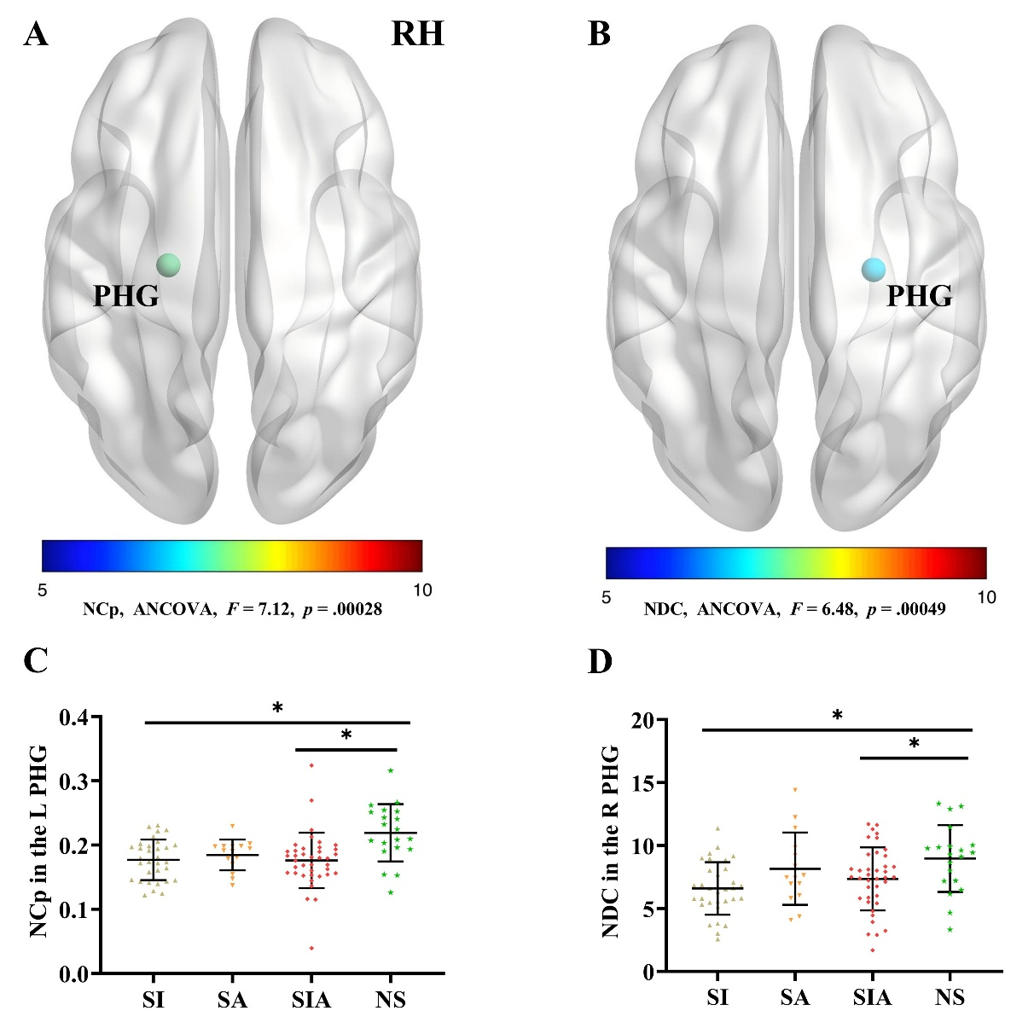
Figure S1. Four-group one-way ANCOVA and post hoc results for nodal metrics among adolescents with MDD. Panels (A) and (B) show the main effects for the NCp of the L PHG and the NDC of the R PHG, respectively. The four-group one-way ANCOVA was conducted among adolescents in the SI, SA, SIA, and NS groups, with age, sex, years of education, HAMA score, HAMD score, and antidepressant use included as covariates. All reported p values are uncorrected. Main effects were tested separately for each nodal metric across the 90 AAL regions and were evaluated using a Bonferroni-corrected significance threshold of p < .00056. Panels (C) and (D) show the post hoc pairwise comparisons. For the six post hoc pairwise comparisons, the uncorrected p values were compared with a Bonferroni-corrected significance threshold of p < .0083. Points represent individual observations, and error bars represent the mean ± standard deviation. *p < .0083.
Abbreviations: AAL, Automated Anatomical Labeling; ANCOVA, analysis of covariance; HAMA, 14-item Hamilton Anxiety Rating Scale; HAMD, 17-item Hamilton Depression Rating Scale; L, left; MDD, major depressive disorder; NCp, nodal clustering coefficient; NDC, nodal degree centrality; NS, no suicidal ideation or suicide attempts; PHG, parahippocampal gyrus; R, right; RH, right hemisphere; SA, suicide attempt; SI, suicidal ideation; SIA, suicidal ideation and suicide attempts.

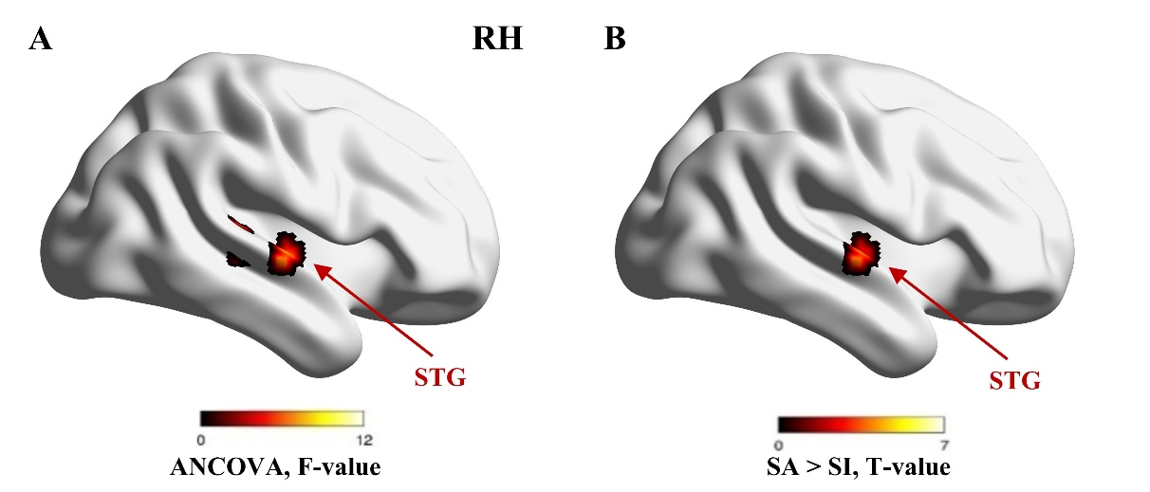
Figure S2. Three-group one-way ANCOVA and exploratory post hoc results for L PHG seed-based functional connectivity among adolescents with MDD in the SI, SA, and SIA groups. Panel (A) shows the R STG cluster, for which the omnibus main effect did not meet the cluster-level FWE-corrected significance threshold (p-FWE = .050). Panel (B) shows an exploratory post hoc pairwise contrast. Both analyses were adjusted for age, sex, years of education, HAMA score, HAMD score, and antidepressant use, and the pairwise contrast was restricted to the cluster identified by the omnibus one-way ANCOVA. Statistical significance was defined using a voxel-level threshold of p < .005 (uncorrected) and a cluster-level FWE-corrected threshold of p < .05. Color bars indicate F values in Panel (A) and T values in Panel (B).
Abbreviations: ANCOVA, analysis of covariance; FWE, family-wise error; HAMA, 14-item Hamilton Anxiety Rating Scale; HAMD, 17-item Hamilton Depression Rating Scale; L, left; RH, right hemisphere; MDD, major depressive disorder; PHG, parahippocampal gyrus; SA, suicide attempt; SI, suicidal ideation; SIA, suicidal ideation and suicide attempts; STG, superior temporal gyrus.

References

1. Beck AT, Kovacs M, Weissman A (1979): Assessment of suicidal intention: the Scale for Suicide Ideation. J Consult Clin Psychol. 47:343-352.
2. Zheng YP, Zhao JP, Phillips M, Liu JB, Cai MF, Sun SQ, et al. (1988): Validity and reliability of the Chinese Hamilton Depression Rating Scale. Br J Psychiatry. 152:660-664.
3. Vaccarino AL, Evans KR, Sills TL, Kalali AH (2008): Symptoms of anxiety in depression: assessment of item performance of the Hamilton Anxiety Rating Scale in patients with depression. Depress Anxiety. 25:1006-1013.
4. Alphs L, Fu DJ, Williamson D, Turkoz I, Jamieson C, Revicki D, et al. (2020): Suicide Ideation and Behavior Assessment Tool (SIBAT): Evaluation of Intra- and Inter-Rater Reliability, Validity, and Mapping to Columbia Classification Algorithm of Suicide Assessment. Psychiatry Res. 294:113495.

