Table S1. Multicomponent exercise intervention session plan.
Part | Content | Example | Time (minutes)
Warm-up | Joint mobility exercises | Head, shoulder, body rotation, wrist and ankle movement, chest expansion movement, side movement. | 5
Main-part | Aerobic, resistance, and balance exercise | Stationary bike, walking; using resistance bands, exercise balls, and body-weight exercises; tandem standing, single-leg stance, and stepping practice | 55-60
Cool-down | Relaxation stretching | Upper limb, lower limb, and torso stretching | 5

Table S2. FITT principles for multicomponent exercise intervention
FITT principles
Exercise Type | Aerobic Exercise | Resistance Training | Balance Training
Frequency  (days/week) | 3 | 3 | 3
Intensity | 40%-80% HRR | RPE = 6-8 | RPE = 2-3
Duration  (minutes/session) | 30 | 15-20 | 10
Abbreviations: HRR: heart rate reserve; FITT: frequency, intensity, time, and type; RPE: ratings of perceived exertion.
Table S3. Baseline characteristics of the participants (intention-to-treat method using multiply imputed data).
Characteristic | ME (n = 52) | TAU (n = 50) | χ² / t | p
Sex (% female) | 63.46 | 54.90 | 0.78 | 0.377
Age (SD), years | 56.02 (5.79) | 57.69 (8.10) | -1.20 | 0.232
Height (SD), cm | 164.37 (7.98) | 165.84 (7.81) | -0.95 | 0.345
Weight (SD), kg | 70.78 (11.62) | 73.09 (11.11) | -1.03 | 0.304
BMI (SD), kg/m² | 26.13 (3.38) | 26.58 (3.64) | -0.64 | 0.523
WC (SD), cm | 94.17 (10.17) | 95.04 (9.17) | -0.46 | 0.649
WHR(SD) | 0.94 (0.08) | 0.96 (0.08) | -1.28 | 0.203
Duration of illness (SD), years | 27.54 (7.28) | 28.27 (6.99) | -0.52 | 0.602
Number of hospitalizations (SD), times | 50.54 (12.52) | 48.76 (15.56) | 0.64 | 0.525
PANSS total (SD) | 73.81 (11.29) | 73.22 (12.59) | 0.25 | 0.804
PANSS positive (SD) | 17.15 (4.79) | 17.32 (4.24) | -0.19 | 0.853
PANSS negative (SD) | 21.81 (4.11) | 21.86 (6.66) | -0.05 | 0.962
PANSS general (SD) | 34.88 (5.32) | 34.04 (6.08) | 0.75 | 0.457
Chlorpromazine equivalent (SD), mg/day | 665.34 (392.31) | 629.17 (344.08) | 0.50 | 0.620
Currently married (%) | 11.65% | 15.53% | -0.90 | 0.344
Education (SD), years | 12.87 (2.40) | 12.22 (2.23) | 1.42 | 0.158
Physical activity level (SD), MET-min/week | 500.29 (95.16) | 507.75 (70.57) | -0.45 | 0.652
Abbreviations: BMI, body mass index; ME, multicomponent exercise; MET: metabolic equivalent of task; mg/day = milligram per day; PANSS: positive and negative syndrome scale; SD, standard deviation; TAU, treatment as usual; WC: waist circumference; WHR: waist to hip ratio.
Table S4. Results of primary outcomes by group (intention-to-treat method using multiply imputed data).
 | ME (n = 52) | TAU (n = 50) | Between-group difference  (95% CI) | Group×time ª
 | Mean difference  from baseline ^{b} | Mean difference  from baseline ^{b} | Between-group difference  (95% CI) | F | p | η p²
SPPB total score | 0.87  (0.55, 1.18)** | -0.38  (-0.69, -0.07)* | 1.12  (0.56, 1.67)** | 32.03 | < 0.001 | 0.24
5-STS, s | -1.58  (-2.05, -1.12)** | 0.57  (0.10, 1.03)* | -2.06  (-3.25, -0.87)* | 43.17 | < 0.001 | 0.30
4mWT, s | -0.78  (-0.98, -0.58)** | 0.04  (-0.16, 0.23) | -0.53  (-0.88, -0.18)* | 34.92 | < 0.001 | 0.26
Balance score | 0.55  (0.32, 0.77)** | 0.13  (-0.09, 0.35) | 0.43  (0.23, 0.63)** | 6.93 | 0.019 | 0.07
Abbreviations: 4mWT, 4m walking test; 5-STS, 5-repetition sit-to-stand test; ME, multicomponent exercise; SPPB, short physical performance battery; TAU, treatment as usual. T0: at baseline; T1: at post-intervention.
ª Adjusted for age and sex.
^{b} within-group comparison was tested.
* p < 0.05; ** p < 0.001.
Table S5. Results of secondary outcomes by group (intention-to-treat method using multiply imputed data).
 | ME (n = 52) | TAU (n = 50) | Between-group difference  (95% CI) | Group×time ª
 | Mean difference  from baseline ^{b} | Mean difference  from baseline ^{b} | Between-group difference  (95% CI) | F | p ^{c} | η p²
6MWT distance, m | 39.30  (15.14, 64.46) | 0.94  (-22.97, 24.84) | 4.17  (-29.86, 38.19) | 7.36 | 0.187 | 0.06
TUGT, s | -1.59  (-1.92, -1.25)** | -0.003  (-0.34, 0.33) | -1.40  (-2.27, -0.53)* | 44.55 | < 0.001 | 0.31
HGS, kg | 2.08  (1.37, 2.79)** | -0.03  (-0.74, 0.67) | 2.15  (-0.17, 4.48) | 17.86 | < 0.001 | 0.15
30s-STS, times | 1.45  (0.48, 2.43) | 0.48  (-0.49, 1.44) | 1.24  (-0.35, 2.84) | 2.13 | 0.187 | 0.02
ASMM, kg | 0.72  (0.06, 1.39) | -0.19  (-0.85, 0.46) | 0.52  (-0.98, 2.02) | 4.24 | 0.183 | 0.04
ASMI, kg/m² | 0.13  (-0.06, 0.32) | -0.06  (-0.25, 0.12) | 0.04  (-0.37, 0.45) | 2.53 | 0.187 | 0.02
Abbreviations: 6MWT, six-minute walking test; 30s-STS, 30-second sit-to-stand test; ASMI, appendicular skeletal muscle mass index; ASMM, appendicular skeletal muscle mass; HGS, handgrip strength; ME, multicomponent exercise; TAU, treatment as usual; TUGT, time up and go test. T0: at baseline; T1: at post-intervention.
ª Adjusted for age and sex.
^{b} within-group comparison was tested.
^{c} p values adjusted for 6 comparisons using the Benjamini-Hochberg method.
* p < 0.05; ** p < 0.001.

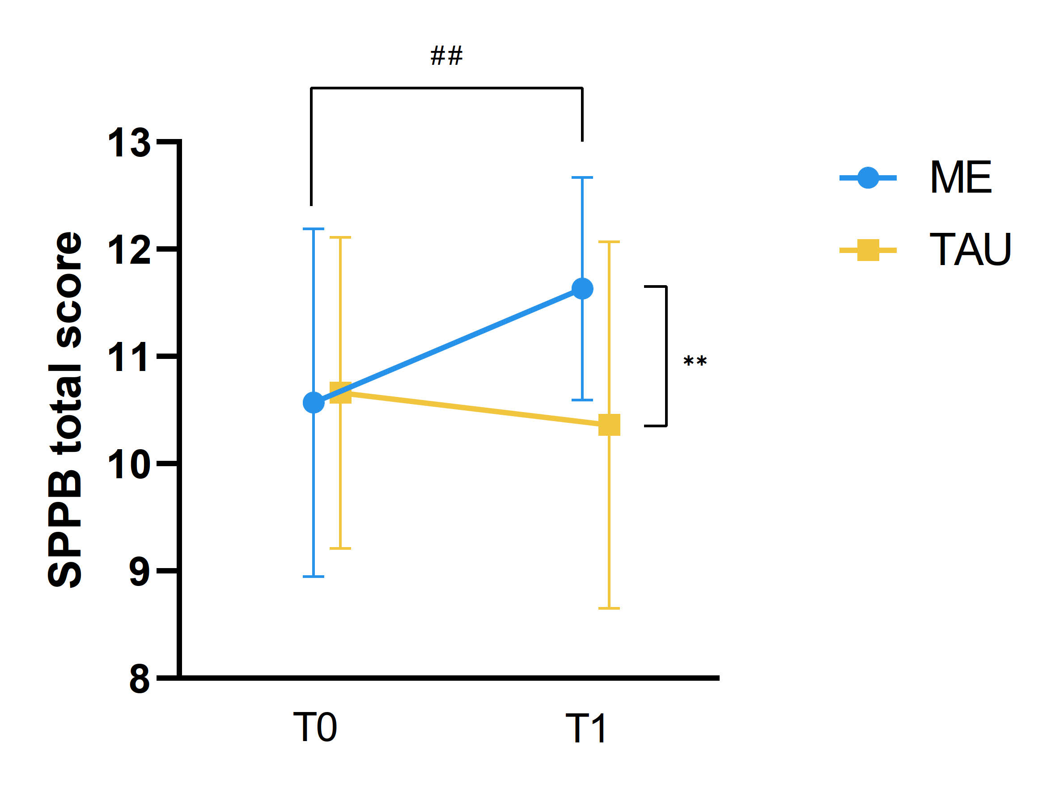
Figure S1. Changes in SPPB total score (points) over time in the multicomponent exercise group and the treatment as usual group.
Abbreviations: ME, Multicomponent Exercise; TAU, Treatment as Usual; SPPB, short physical performance battery; T0, baseline; T1, post 12-week intervention.
* p < 0.05, ** p < 0.001 for group × time interaction.
# p < 0.05, ## p < 0.001 for within-group differences.

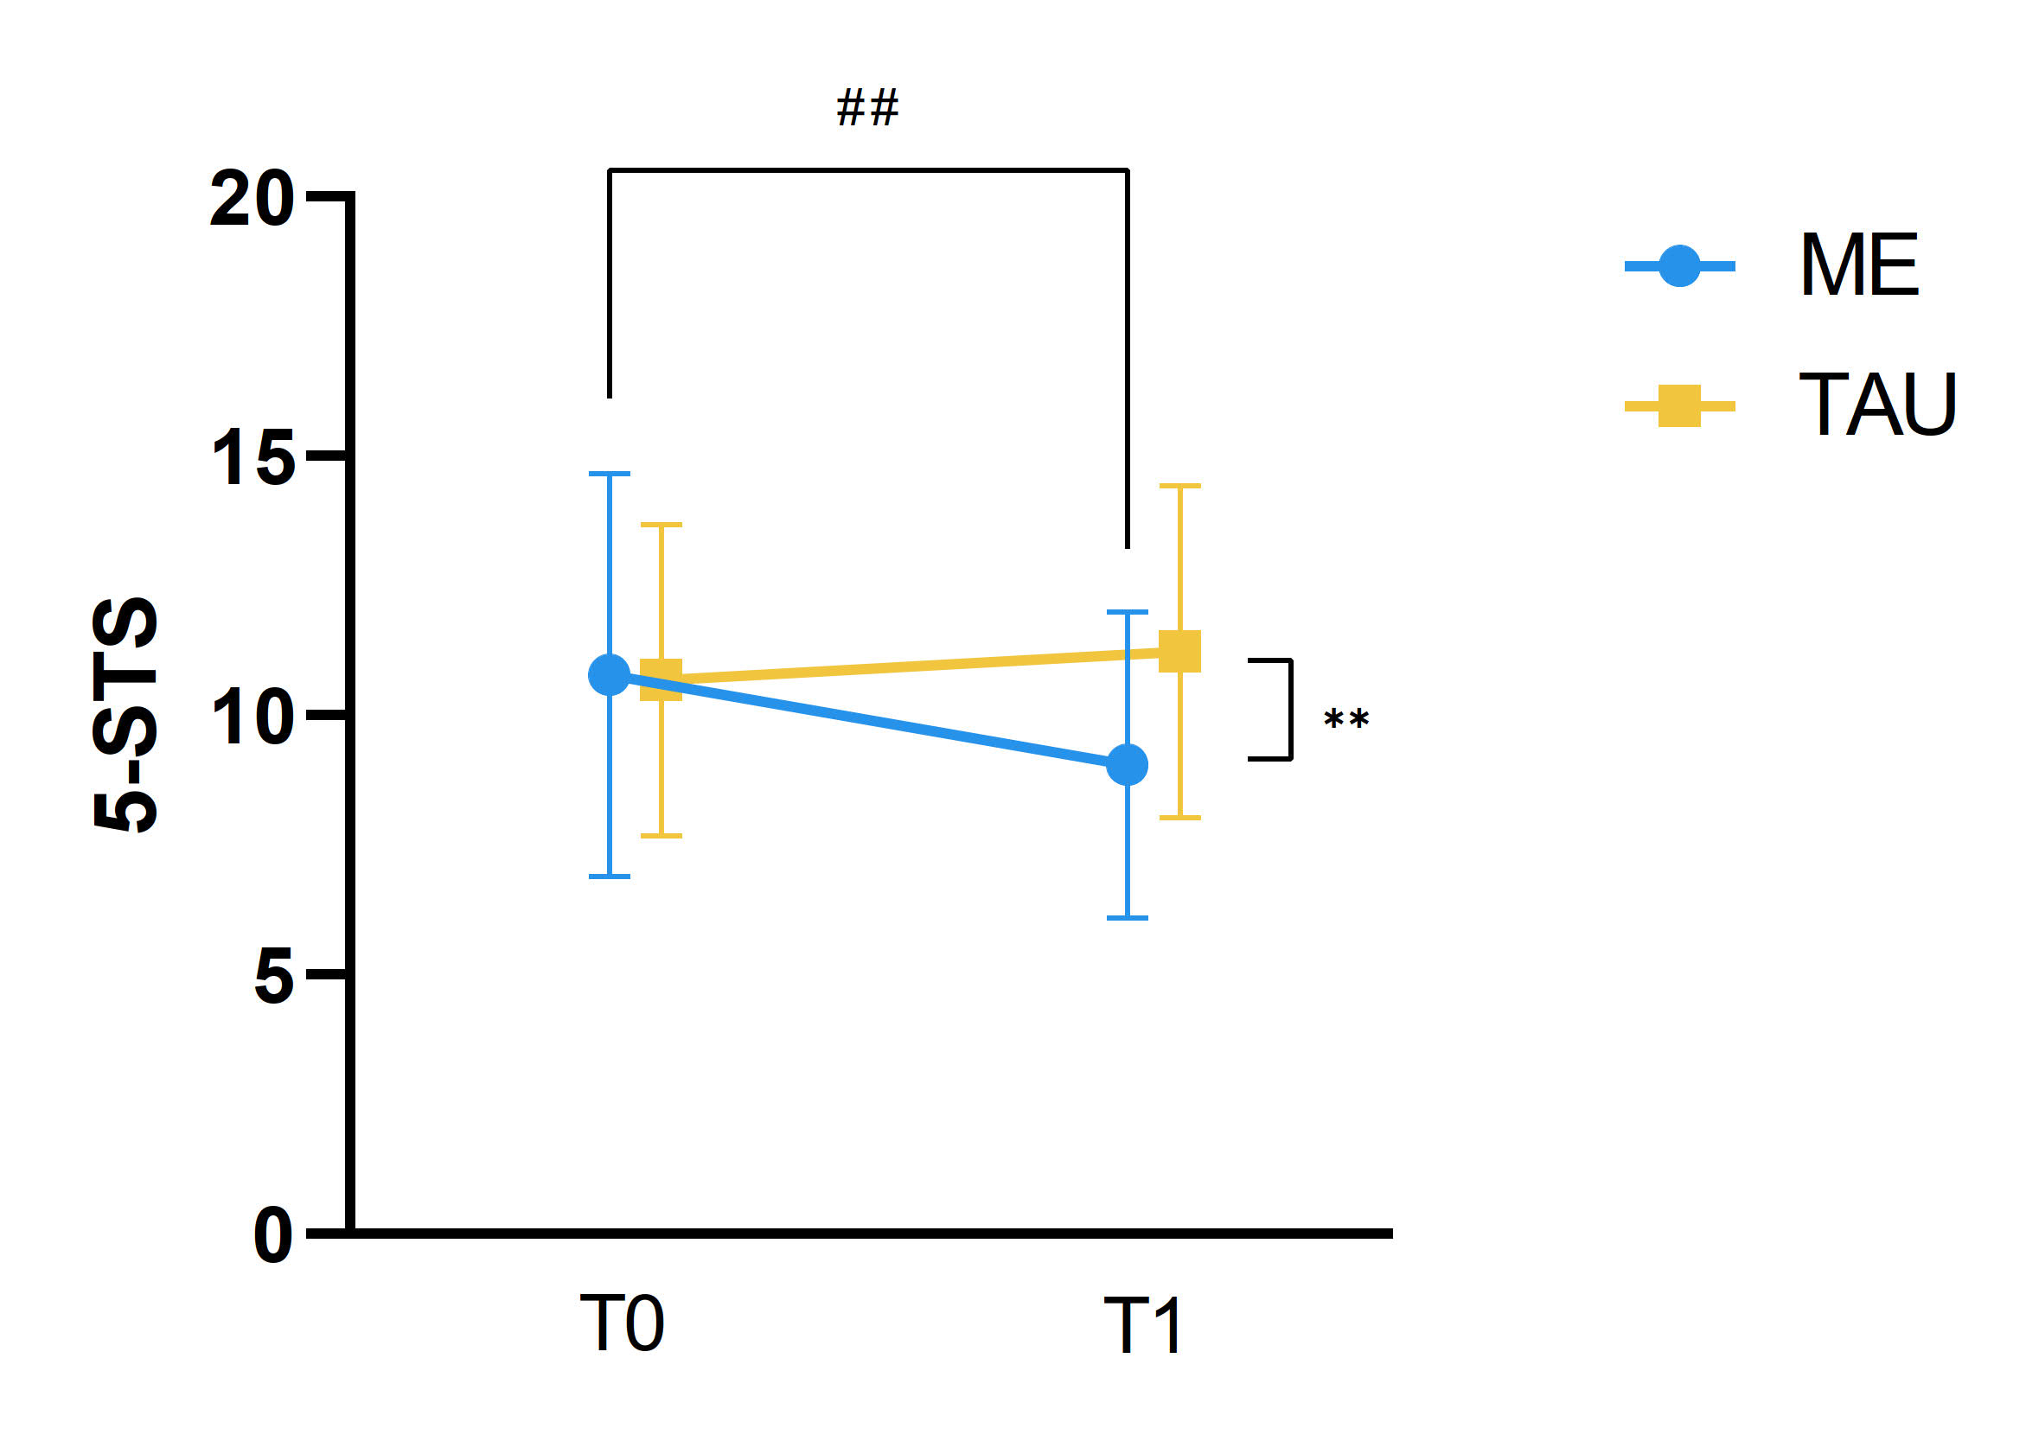
Figure S2. Changes in 5-STS time (s) over time in the multicomponent exercise group and the treatment as usual group.
Abbreviations: ME, Multicomponent Exercise; TAU, Treatment as Usual; 5-STS, 5-repetition sit-to-stand test; T0, baseline; T1, post 12-week intervention.
* p < 0.05, ** p < 0.001 for group × time interaction.
# p < 0.05, ## p < 0.001 for within-group differences.

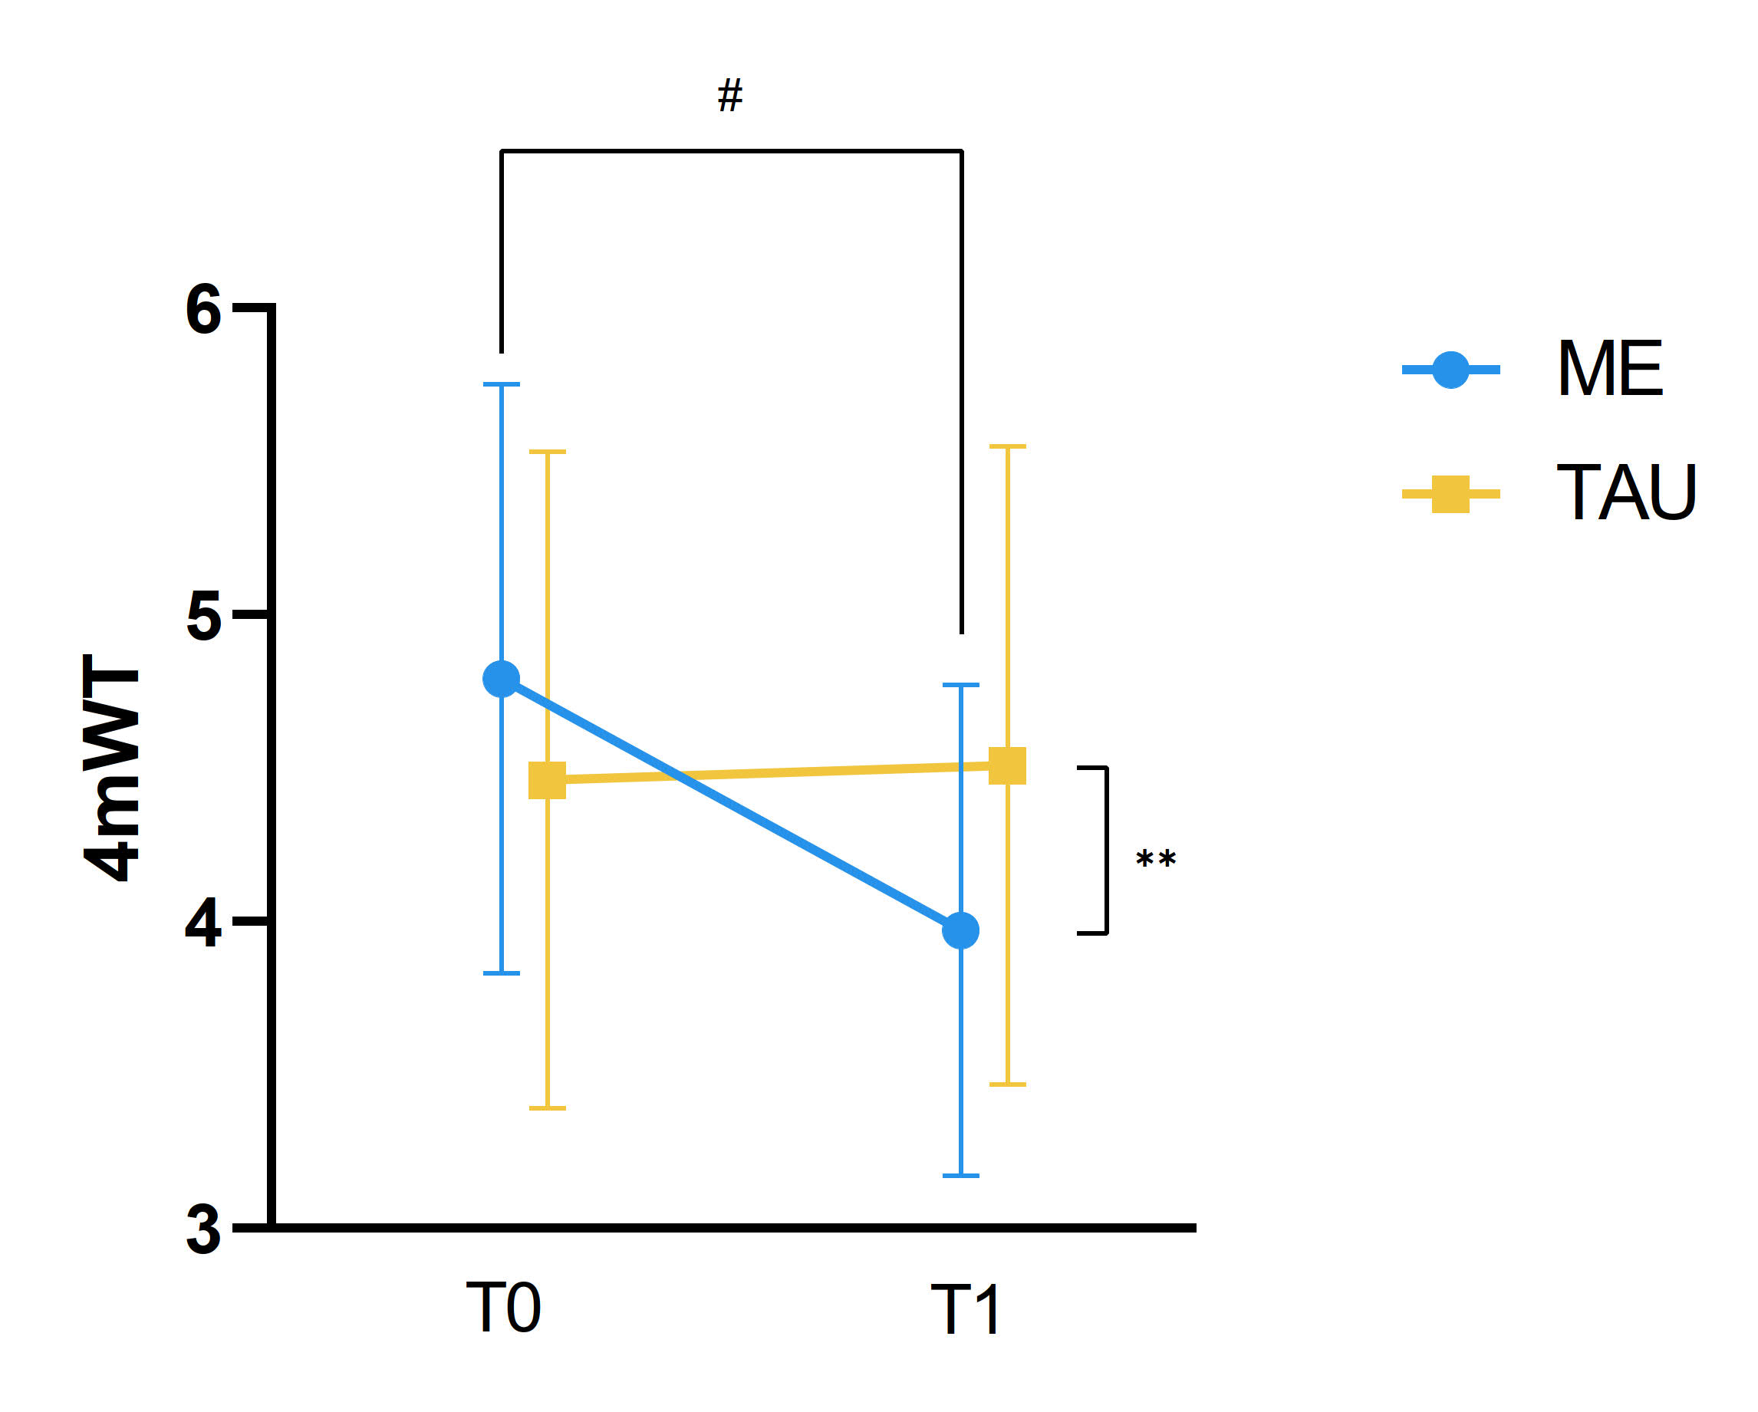
Figure S3. Changes in 4mWT time (s) over time in the multicomponent exercise group and the treatment as usual group.
Abbreviations: ME, Multicomponent Exercise; TAU, Treatment as Usual; 4mWT, 4m walking test; T0, baseline; T1, post 12-week intervention.
* p < 0.05, ** p < 0.001 for group × time interaction.
# p < 0.05, ## p < 0.001 for within-group differences.
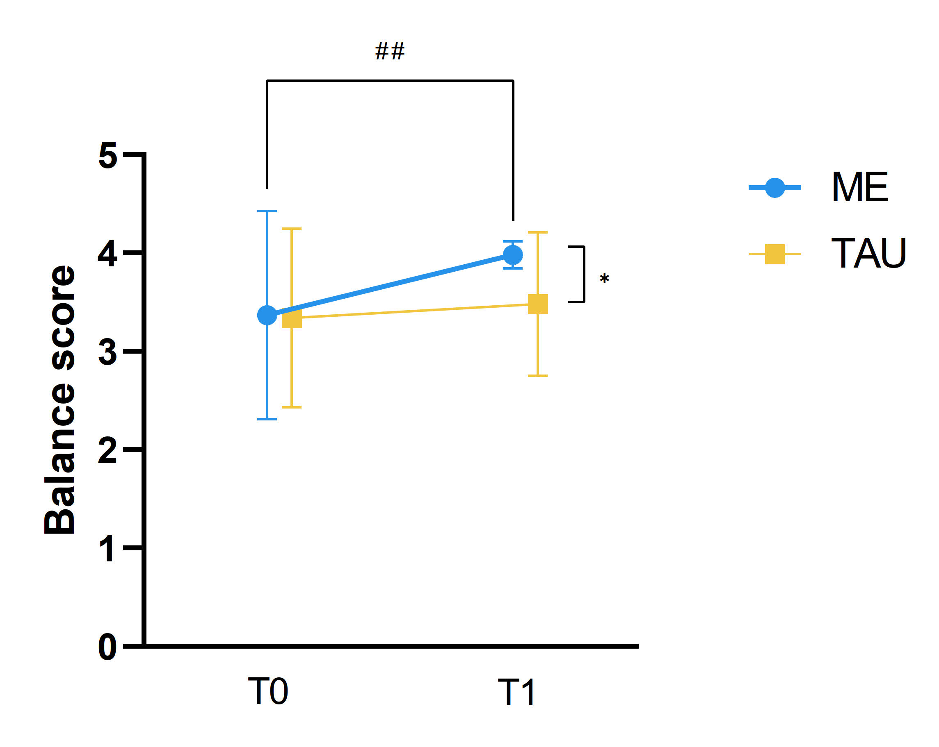
Figure S4. Changes in balance score (points) over time in the multicomponent exercise group and the treatment as usual group.
Abbreviations: ME, Multicomponent Exercise; TAU, Treatment as Usual; T0, baseline; T1, post 12-week intervention.
* p < 0.05, ** p < 0.001 for group × time interaction.
# p < 0.05, ## p < 0.001 for within-group differences.

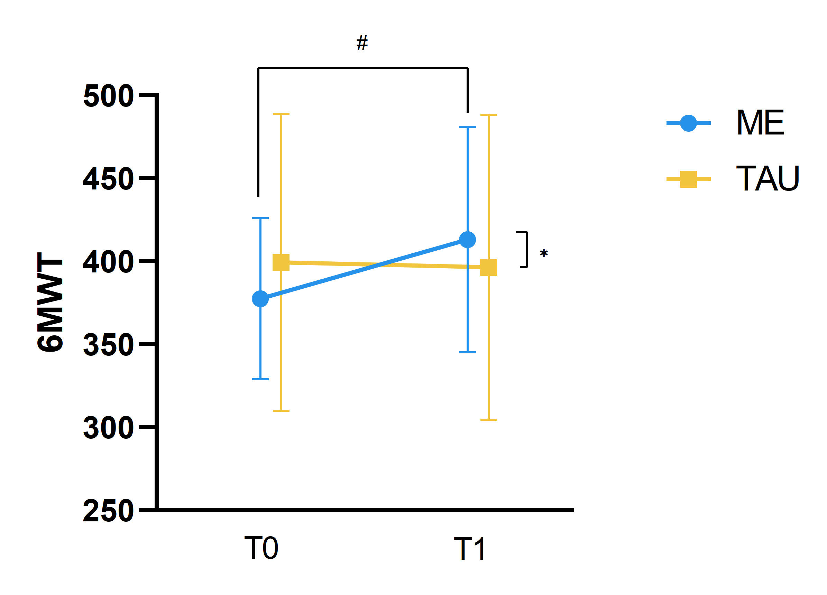
Figure S5. Changes in 6MWT distance (m) over time in the multicomponent exercise group and the treatment as usual group.
Abbreviations: ME, Multicomponent Exercise; TAU, Treatment as Usual; 6MWT: 6 minute walking test; T0, baseline; T1, post 12-week intervention.
* p < 0.05, ** p < 0.001 for group × time interaction.
# p < 0.05, ## p < 0.001 for within-group differences.

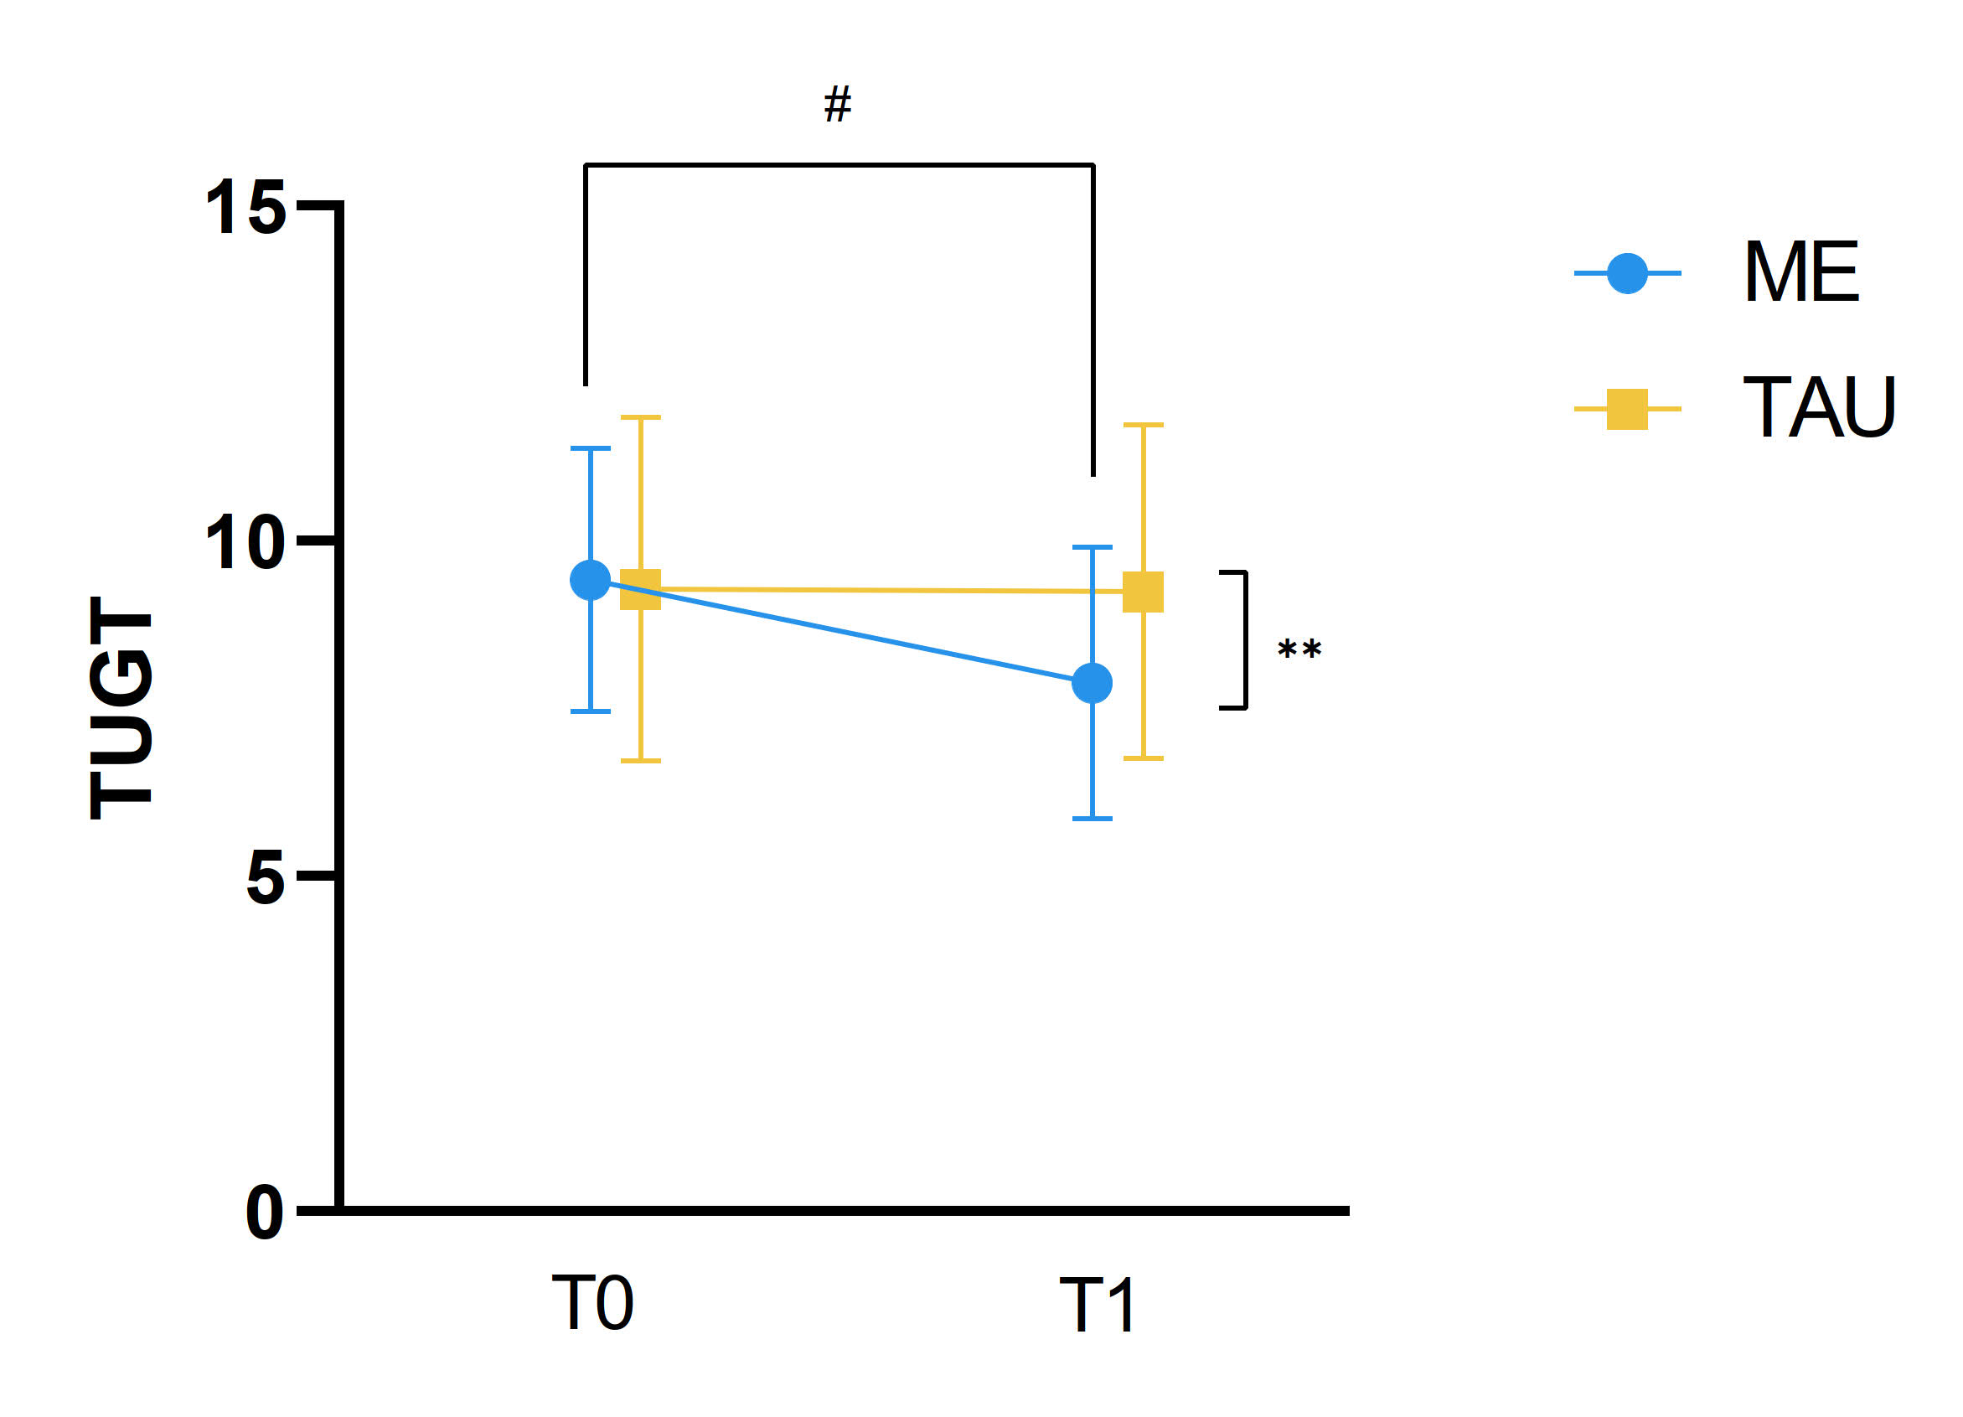
Figure S6. Changes in TUGT time (s) over time in the multicomponent exercise group and the treatment as usual group.
Abbreviations: ME, Multicomponent Exercise; TAU, Treatment as Usual; TUGT: time up and go test; T0, baseline; T1, post 12-week intervention.
* p < 0.05, ** p < 0.001 for group × time interaction.
# p < 0.05, ## p < 0.001 for within-group differences.

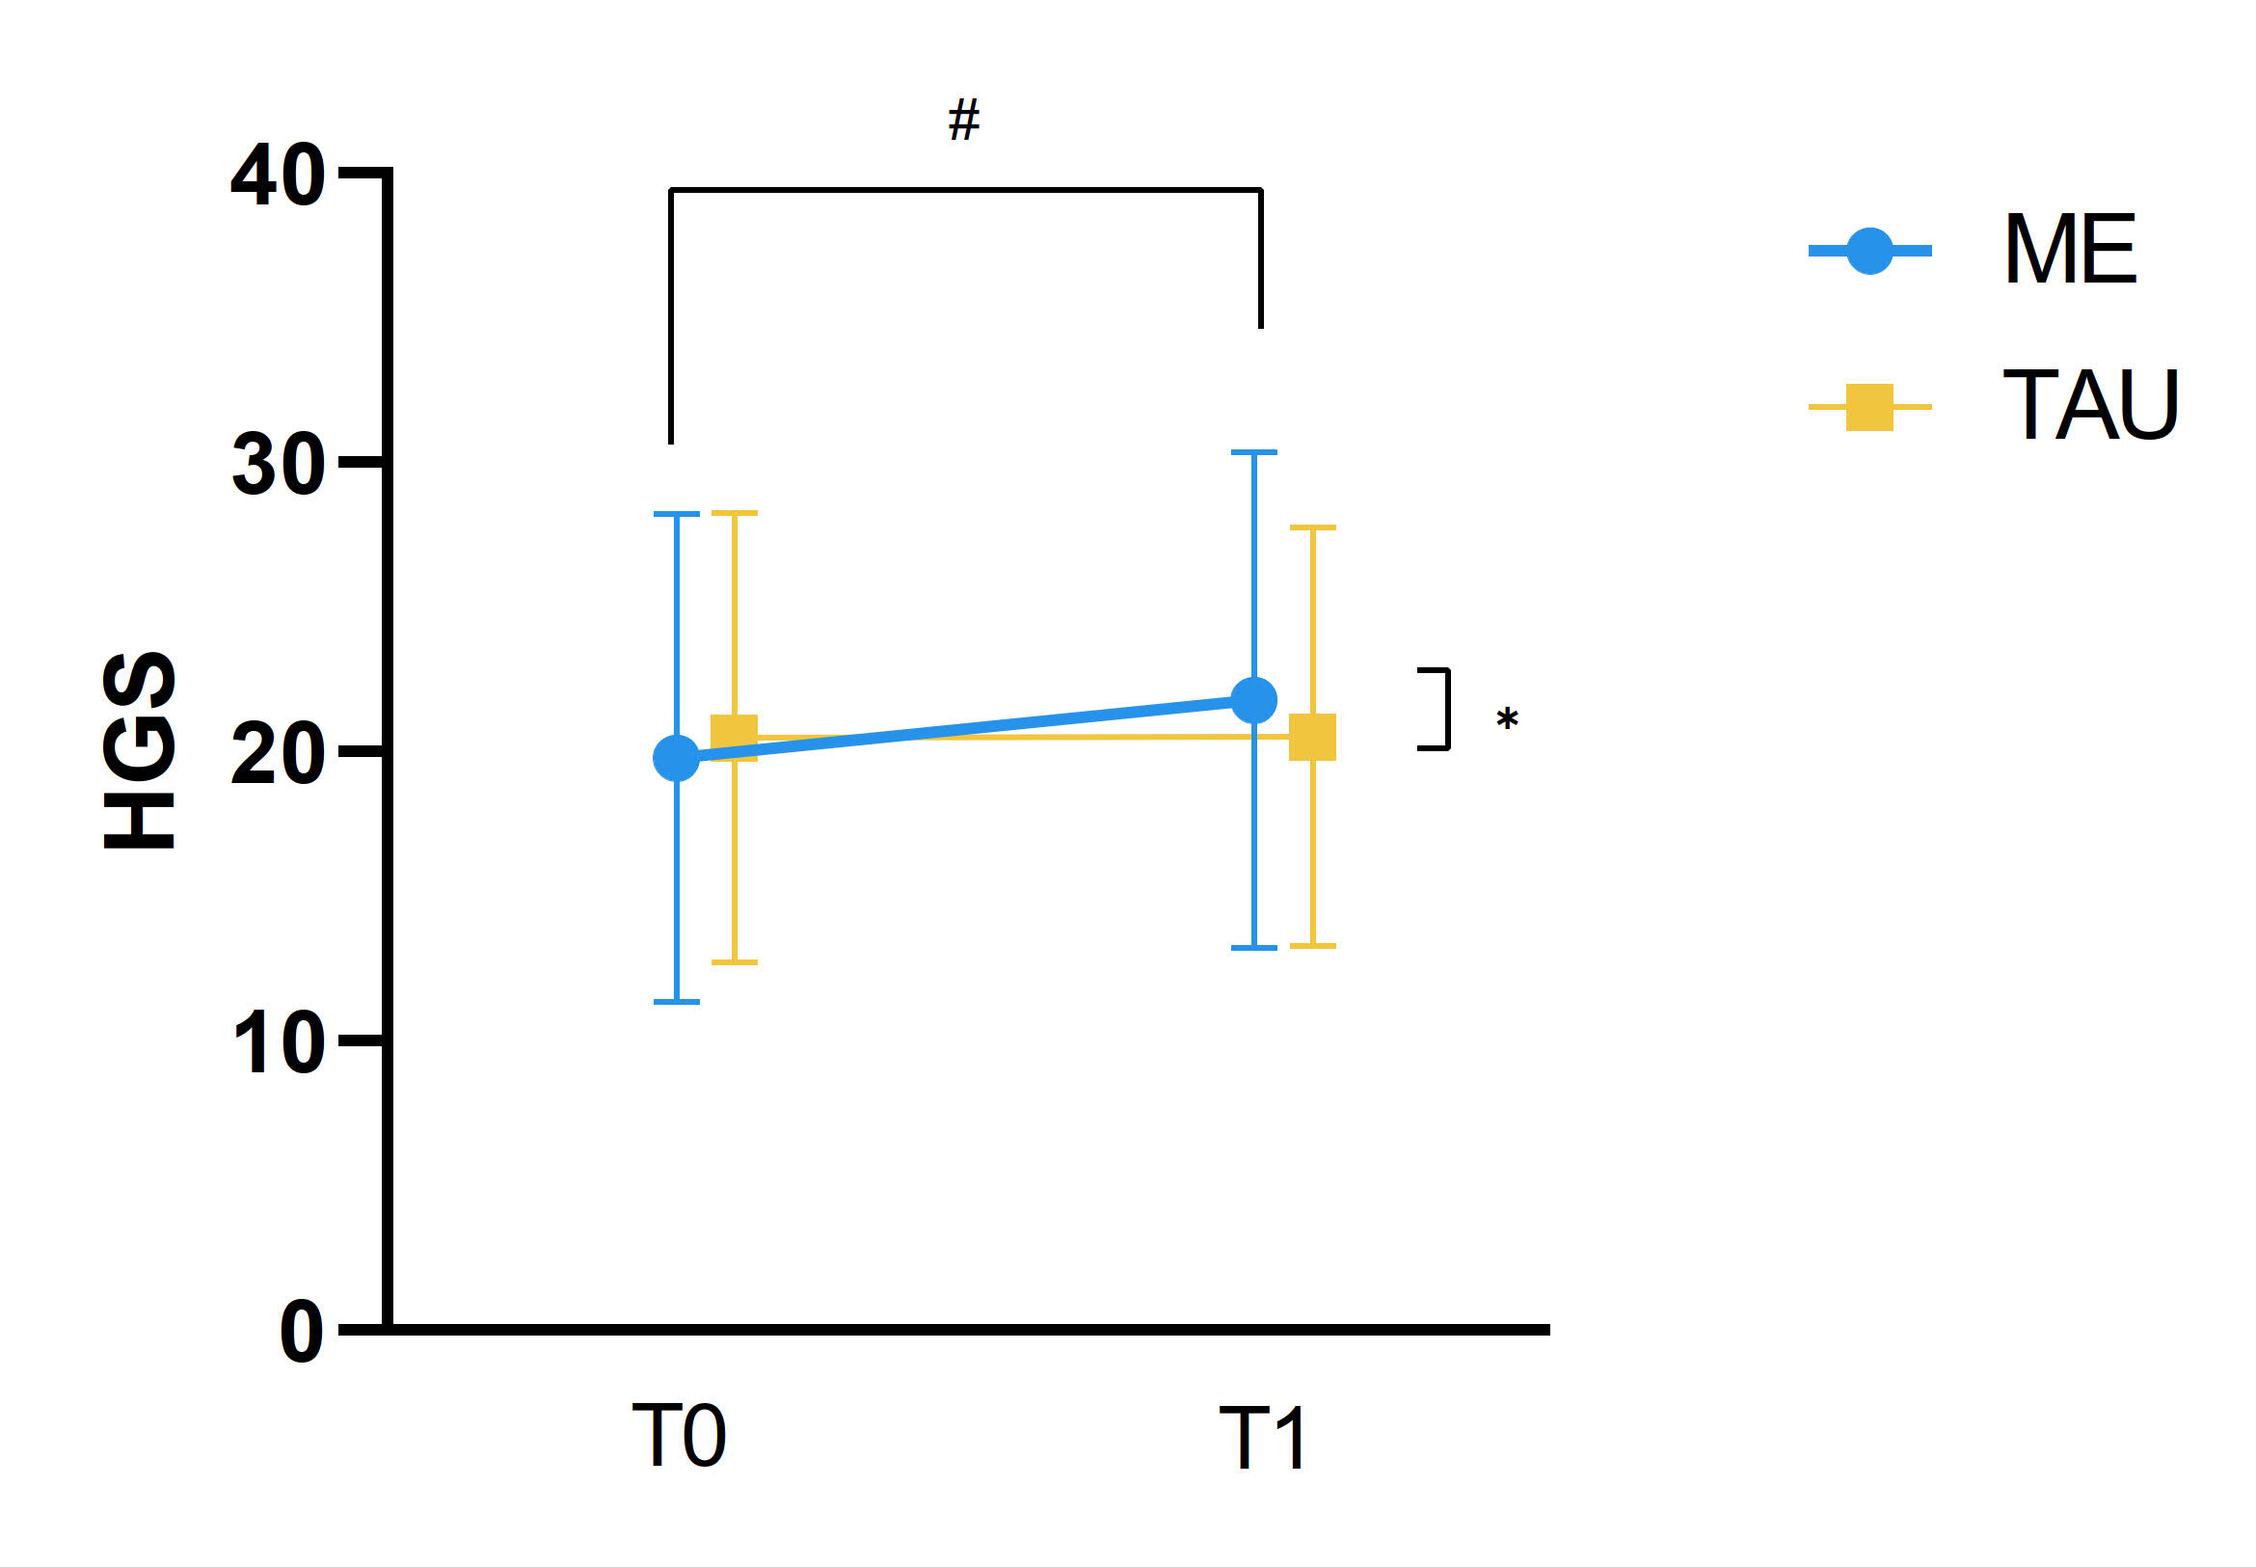
Figure S7. Changes in HGS (kg) over time in the multicomponent exercise group and the treatment as usual group.
Abbreviations: ME, Multicomponent Exercise; TAU, Treatment as Usual; HGS, handgrip strength; T0, baseline; T1, post 12-week intervention.
* p < 0.05, ** p < 0.001 for group × time interaction.
# p < 0.05, ## p < 0.001 for within-group differences.

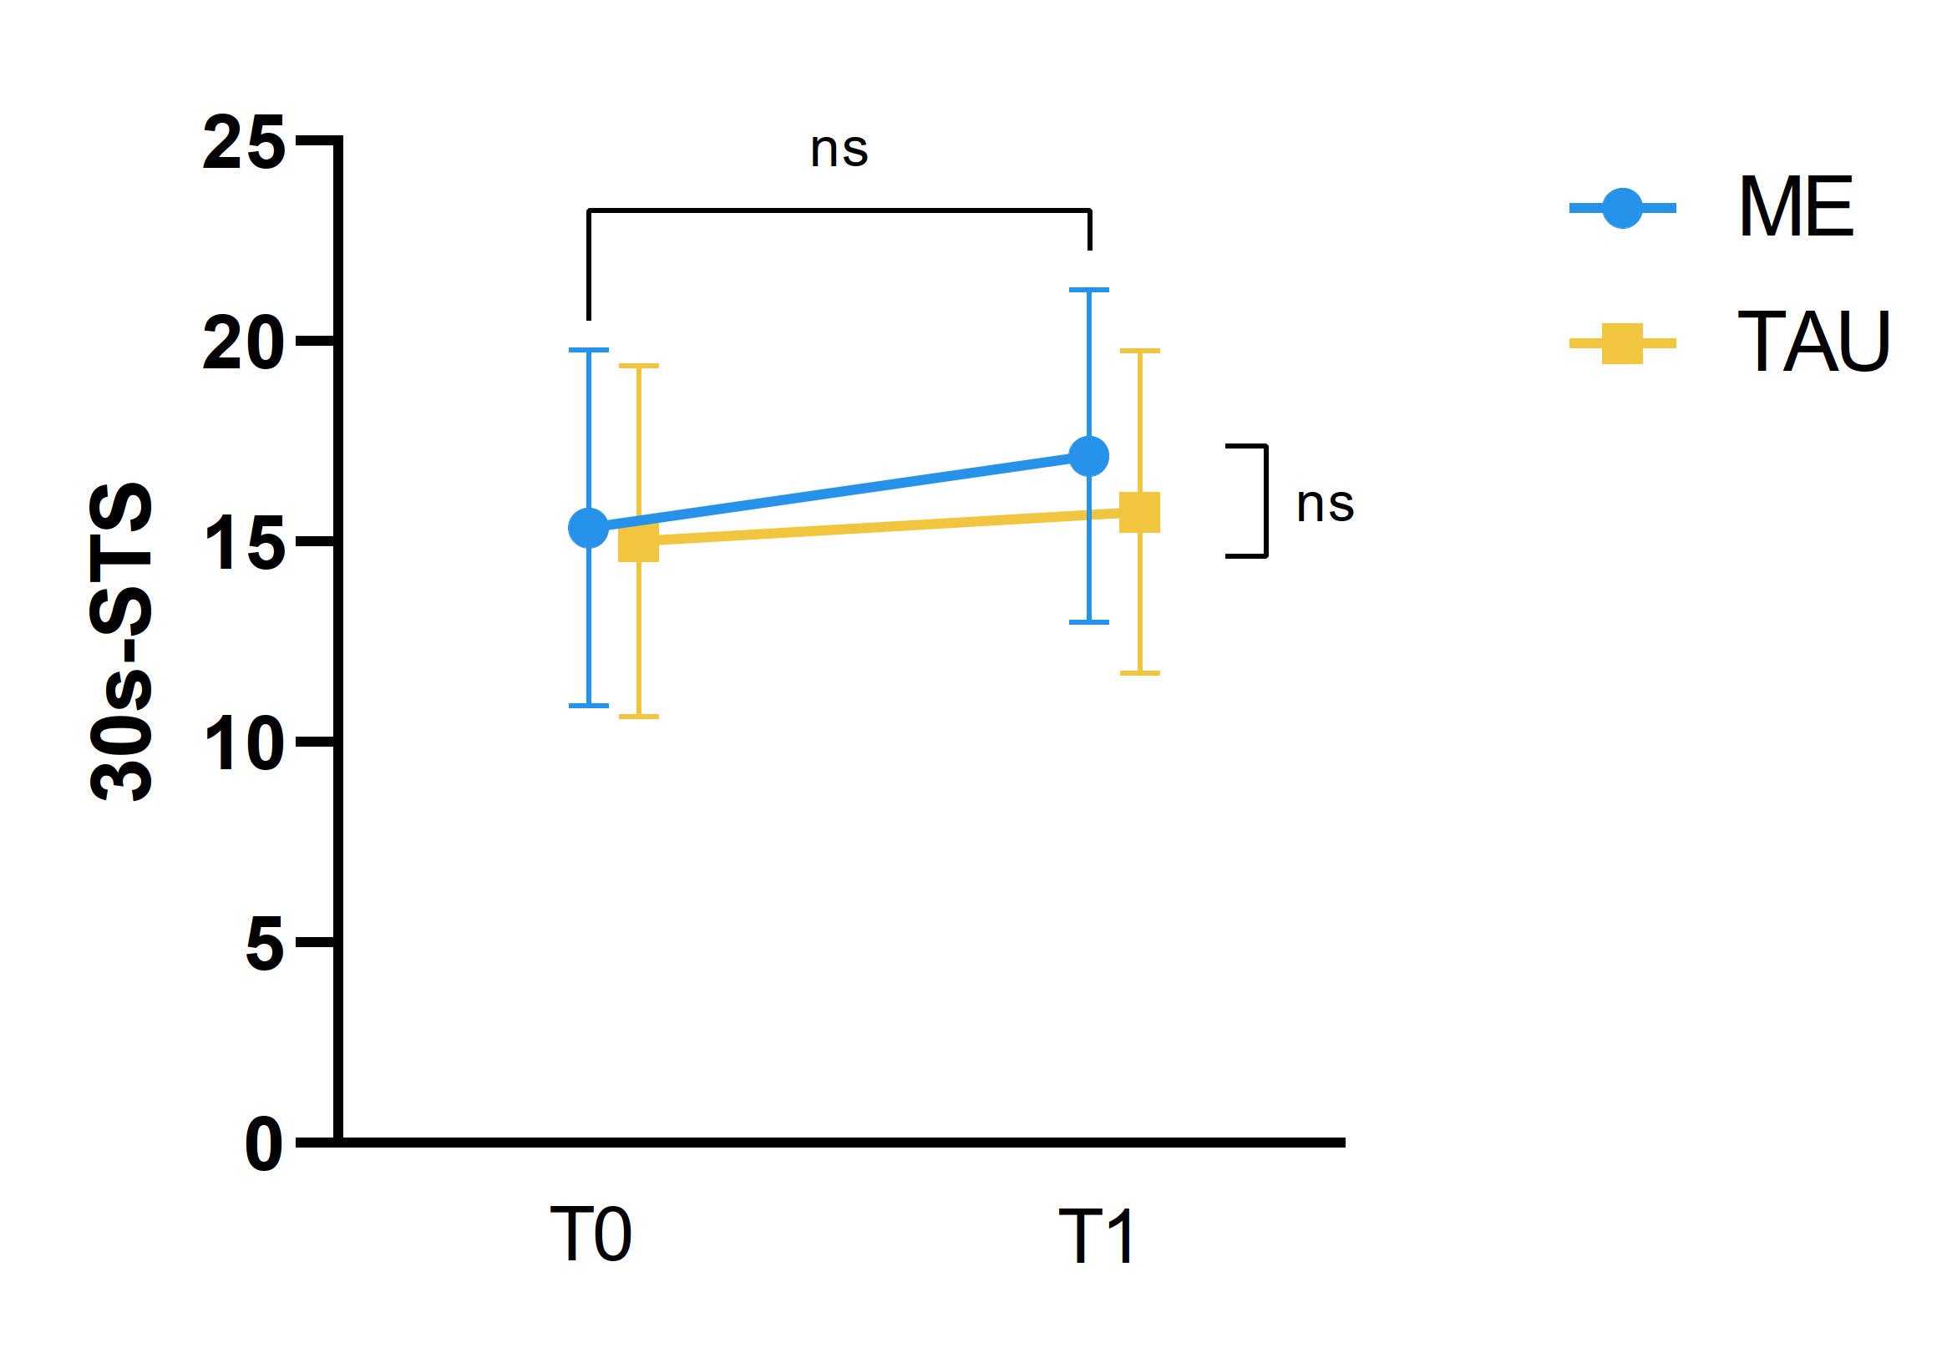
Figure S8. Changes in 30s-STS (times) over time in the multicomponent exercise group and the treatment as usual group.
Abbreviations: ME, Multicomponent Exercise; TAU, Treatment as Usual; 30s-STS, 30-second sit-to-stand test; T0, baseline; T1, post 12-week intervention.
* p < 0.05, ** p < 0.001 for group × time interaction.
# p < 0.05, ## p < 0.001 for within-group differences.

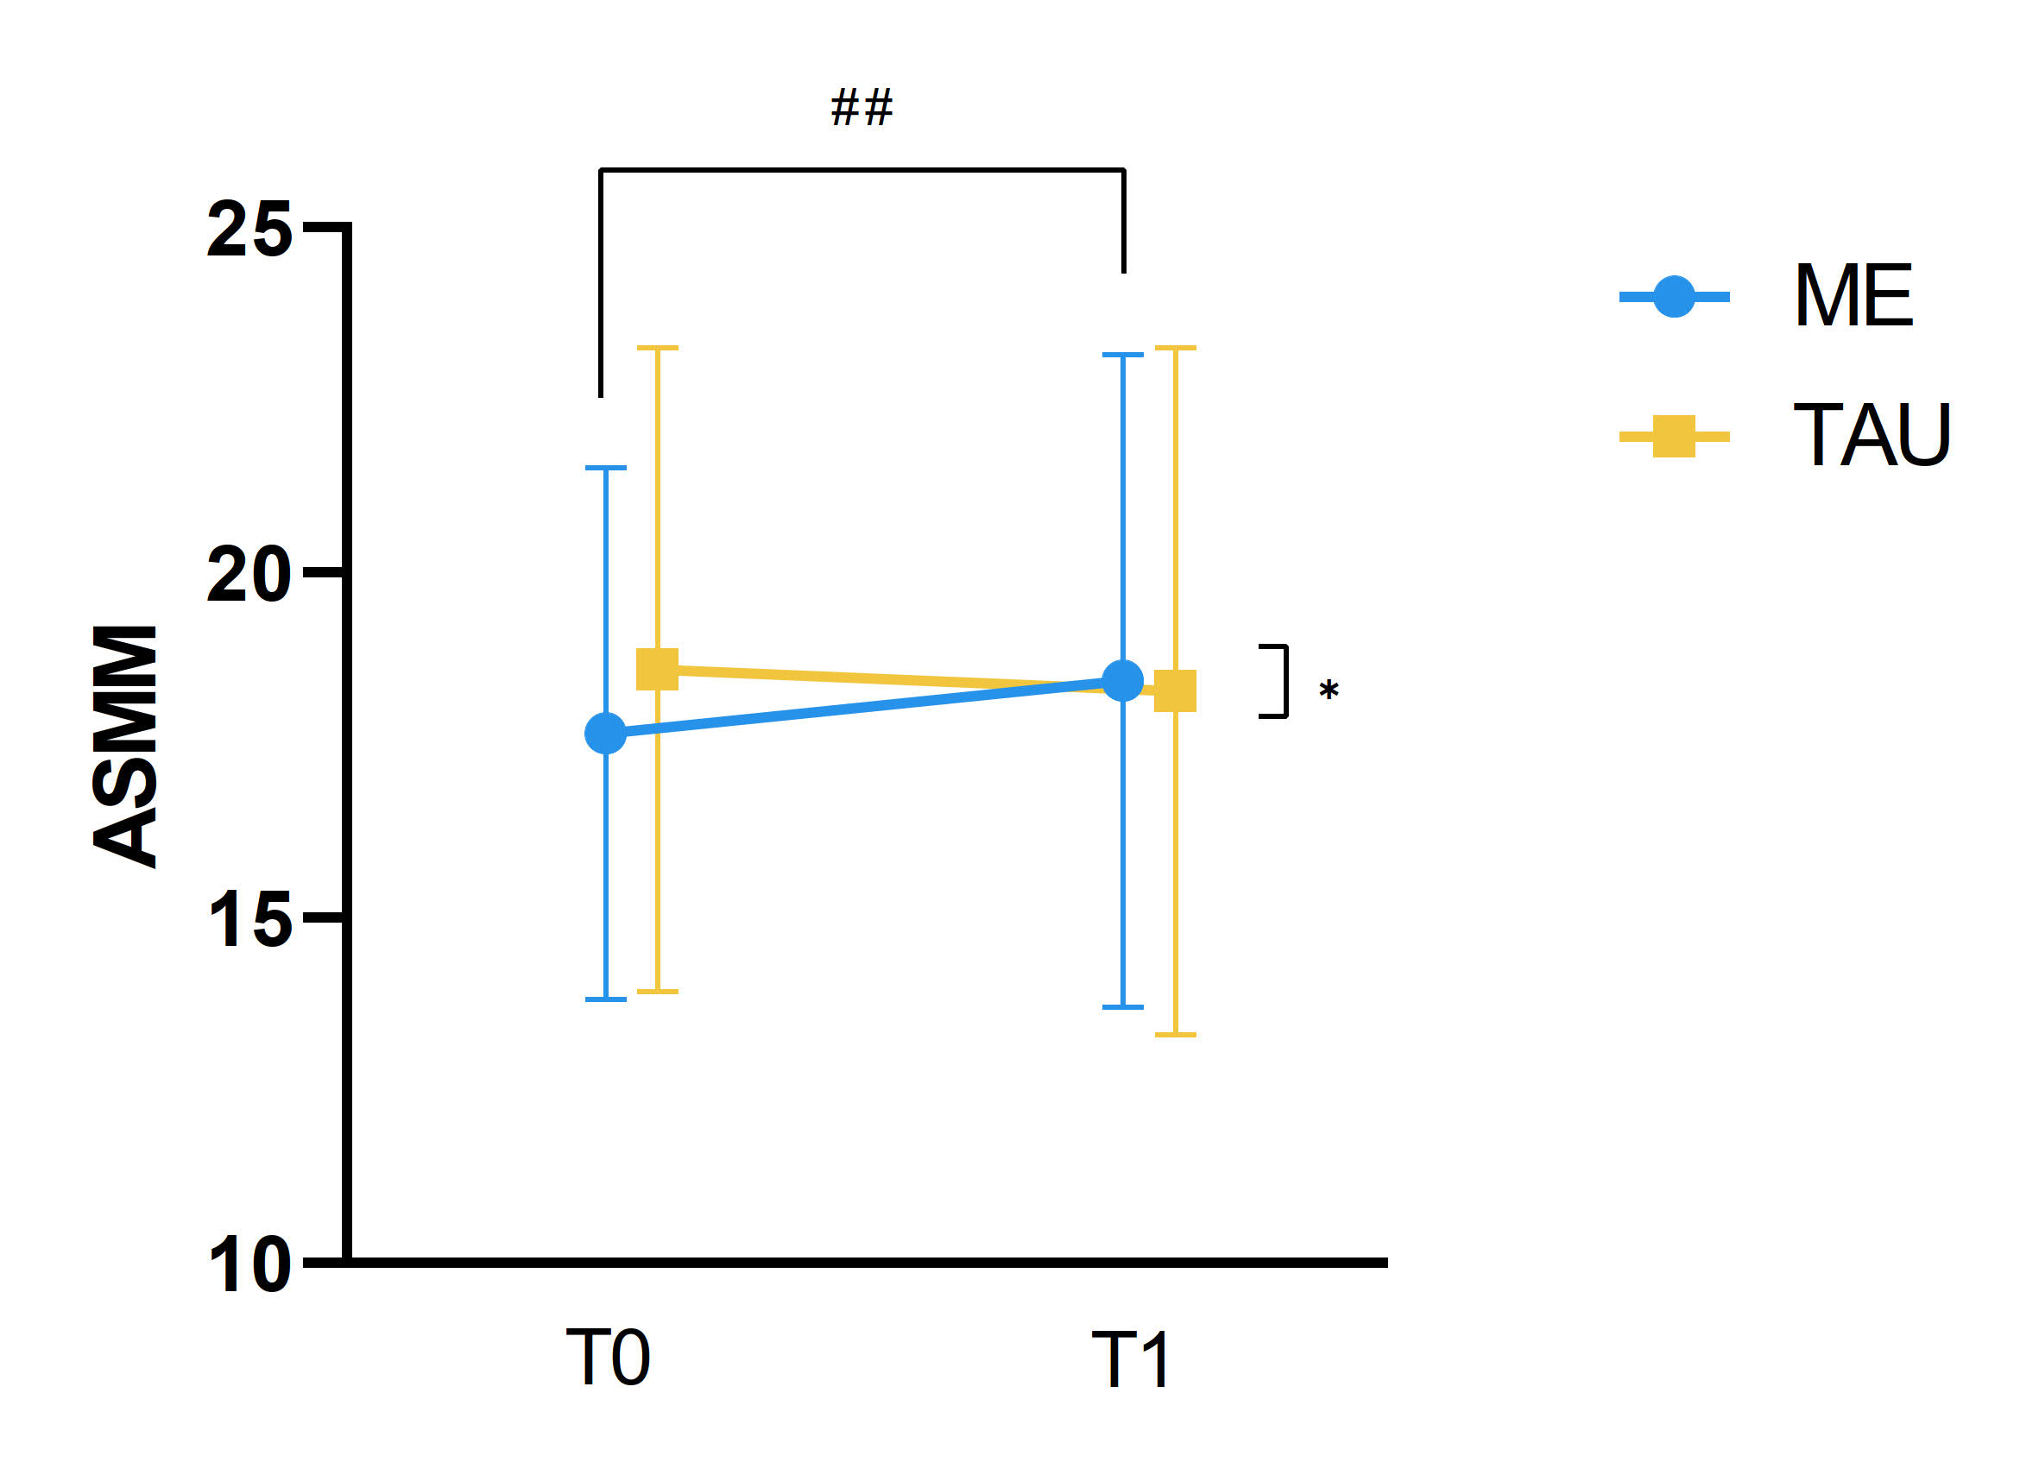
Figure S9. Changes in ASMM (kg) over time in the multicomponent exercise group and the treatment as usual group.
Abbreviations: ME, Multicomponent Exercise; TAU, Treatment as Usual; ASMM: appendicular skeletal muscle mass; T0, baseline; T1, post 12-week intervention.
* p < 0.05, ** p < 0.001 for group × time interaction.
# p < 0.05, ## p < 0.001 for within-group differences.

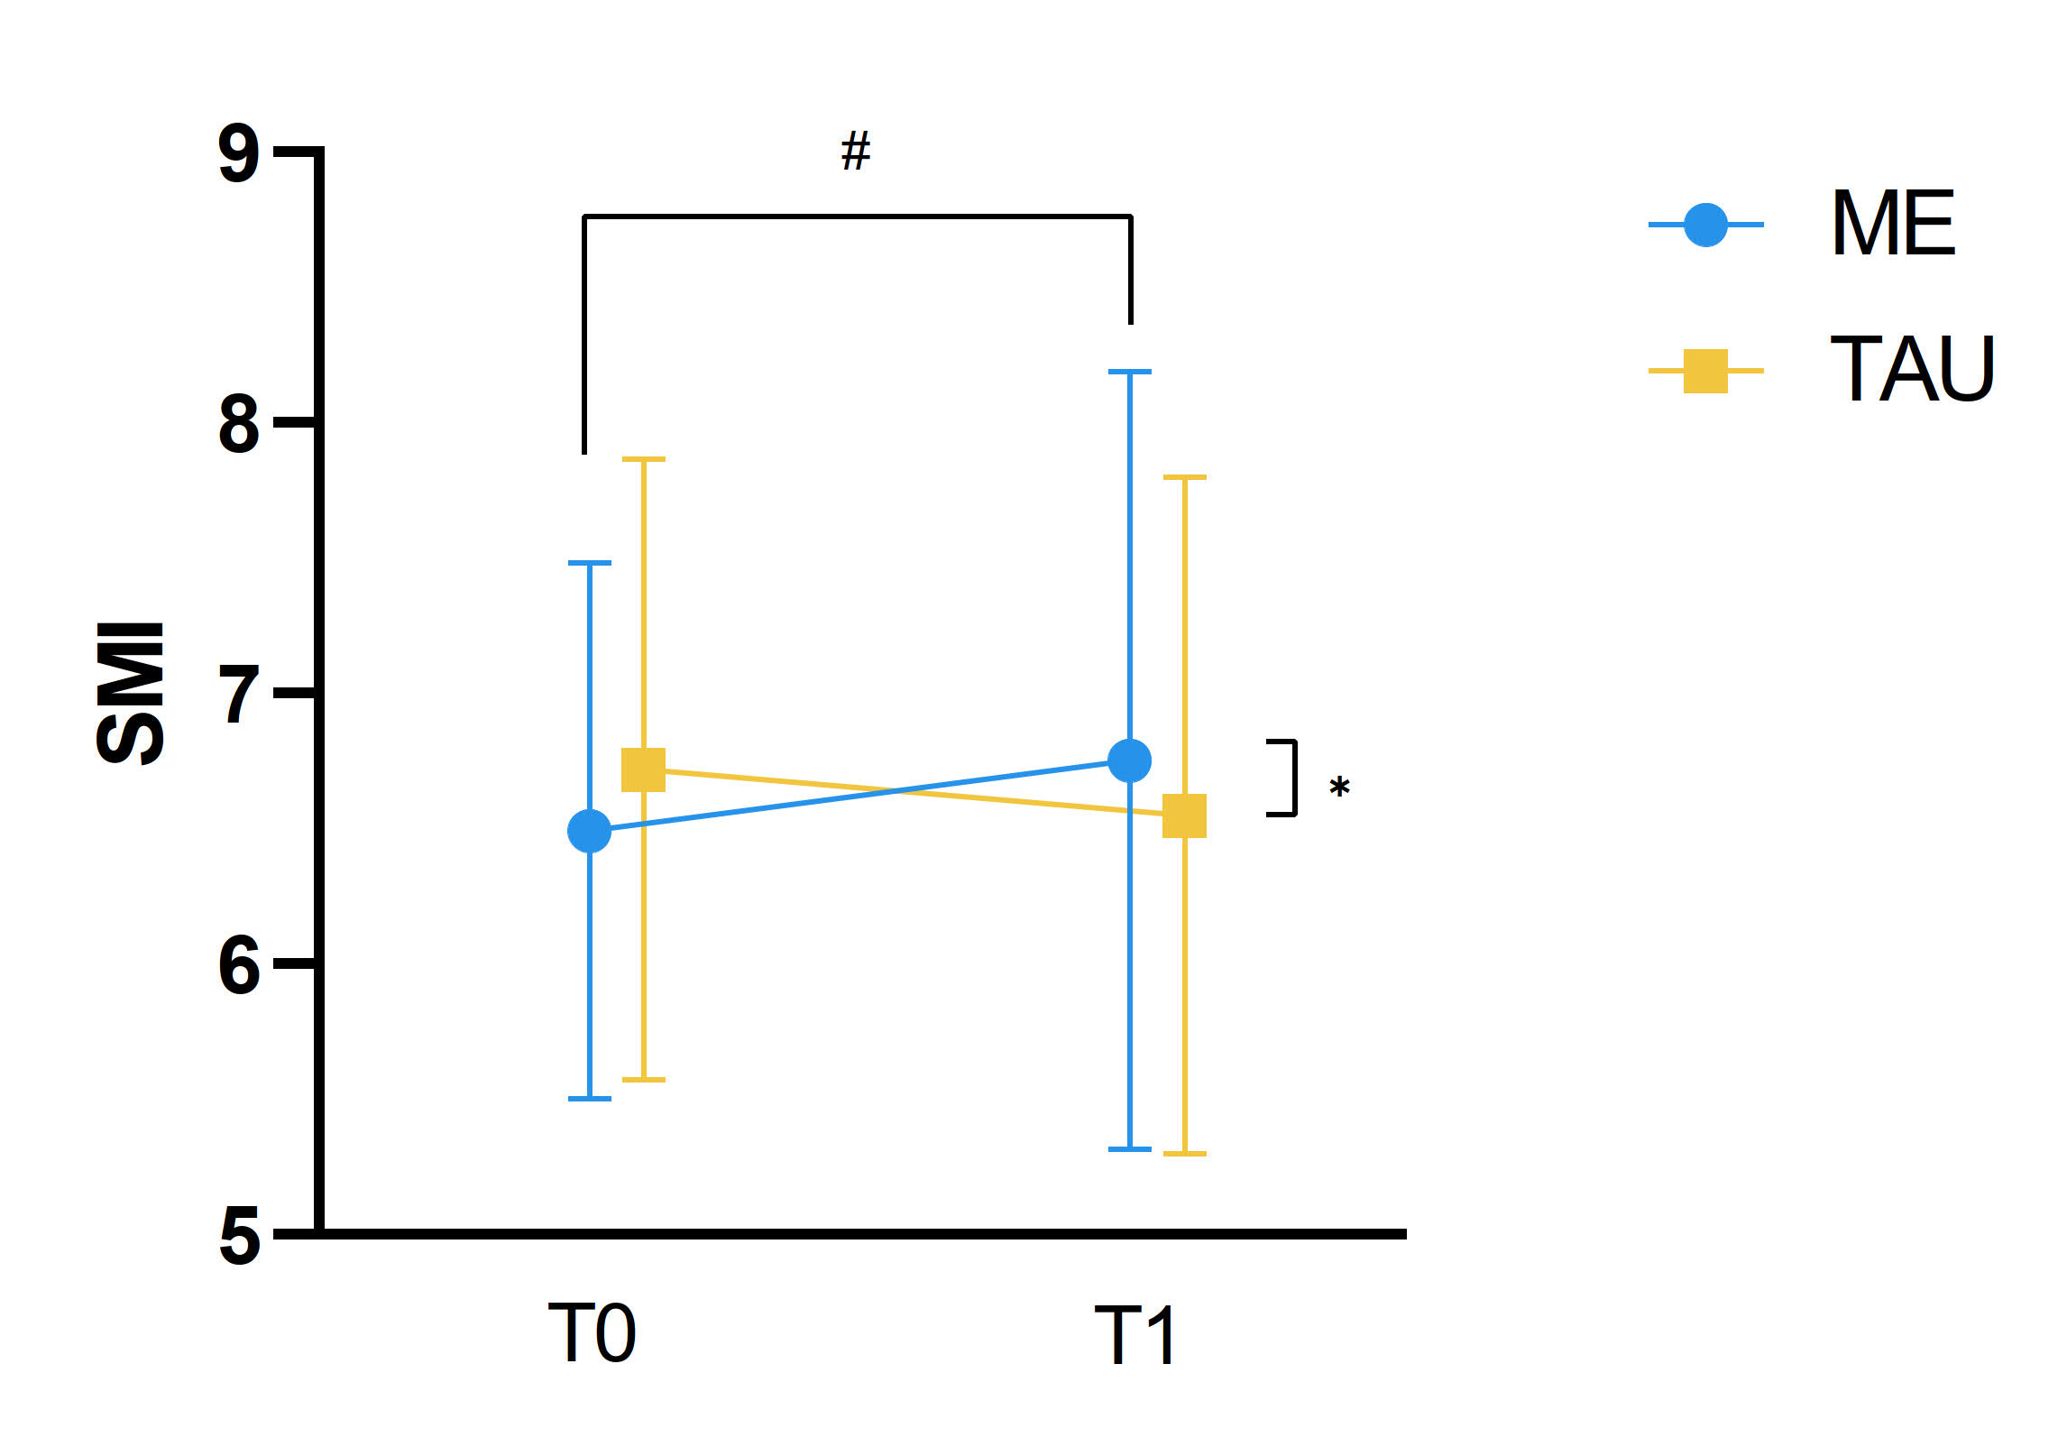
Figure S10. Changes in SMI (kg/m²) over time in the multicomponent exercise group and the treatment as usual group.
Abbreviations: ME, Multicomponent Exercise; TAU, Treatment as Usual; SMI: appendicular skeletal muscle mass index; T0, baseline; T1, post 12-week intervention.
* p < 0.05, ** p < 0.001 for group × time interaction.
# p < 0.05, ## p < 0.001 for within-group differences.

