This file includes:

Supplementary Table
Supplementary Figure

Supplementary Table 1 Search strategy for PubMed
Step | Search strategy
#1 | (Exercise) or (Exercises) or (Exercise, Physical) or (Exercises, Physical) or (Physical Exercise) or (Physical Exercises) or (Exercise, Isometric) or (Exercises, Isometric) or (Isometric Exercises) or (Isometric Exercise) or (Exercise, Aerobic) or (Aerobic Exercise) or (Aerobic Exercises) or (Exercises, Aerobic) or (Exercise Training) or (Exercise Trainings) or (Training, Exercise) or (Trainings, Exercise) or (Physical Activity) or (Activities, Physical) or (Activity, Physical) or (Physical Activities) or (Active Breaks) or (Activity Breaks) or (Acute Exercise) or (Acute Exercises) or (Exercise, Acute) or (Exercises, Acute)
#2 | (Child) or (Children) or (Adolescent) or (Adolescents) or (Adolescence) or (Adolescents, Female) or (Adolescent, Female) or (Female Adolescent) or (Female AdolescentsAdolescents, Male) or (Adolescent, Male) or (Male Adolescent) or (Male Adolescents) or (Youth) or (Youths) or (Teens) or (Teen) or (Teenagers) or (Teenager)
#3 | (Attention Deficit Disorder with Hyperactivity) or (ADHD) or (ADDH) or (Attention Deficit Disorders with Hyperactivity) or (Attention Deficit Hyperactivity Disorders) or (Attention Deficit Hyperactivity Disorder) or (Attention Deficit-Hyperactivity Disorder) or (Attention Deficit-Hyperactivity Disorders) or (Deficit-Hyperactivity Disorder, Attention) or (Deficit-Hyperactivity Disorders, Attention) or (Disorder, Attention Deficit-Hyperactivity) or (Disorders, Attention Deficit-Hyperactivity) or (Hyperkinetic Syndrome) or (Syndromes, Hyperkinetic) or (Attention Deficit Disorder) or (Attention Deficit Disorders) or (Deficit Disorder, Attention) or (Deficit Disorders, Attention) or (Disorder, Attention Deficit) or (Disorders, Attention Deficit) or (Brain Dysfunction, Minimal) or (Dysfunction, Minimal Brain) or (Minimal Brain Dysfunction)
#4 | (Randomized controlled trial) or (Clinical Trials, Randomized) or (Trials, Randomized Clinical) or (Controlled Clinical Trials, Randomized) or (Randomized Clinical Trial)
#5 | #1 AND #2 AND #3 AND #4

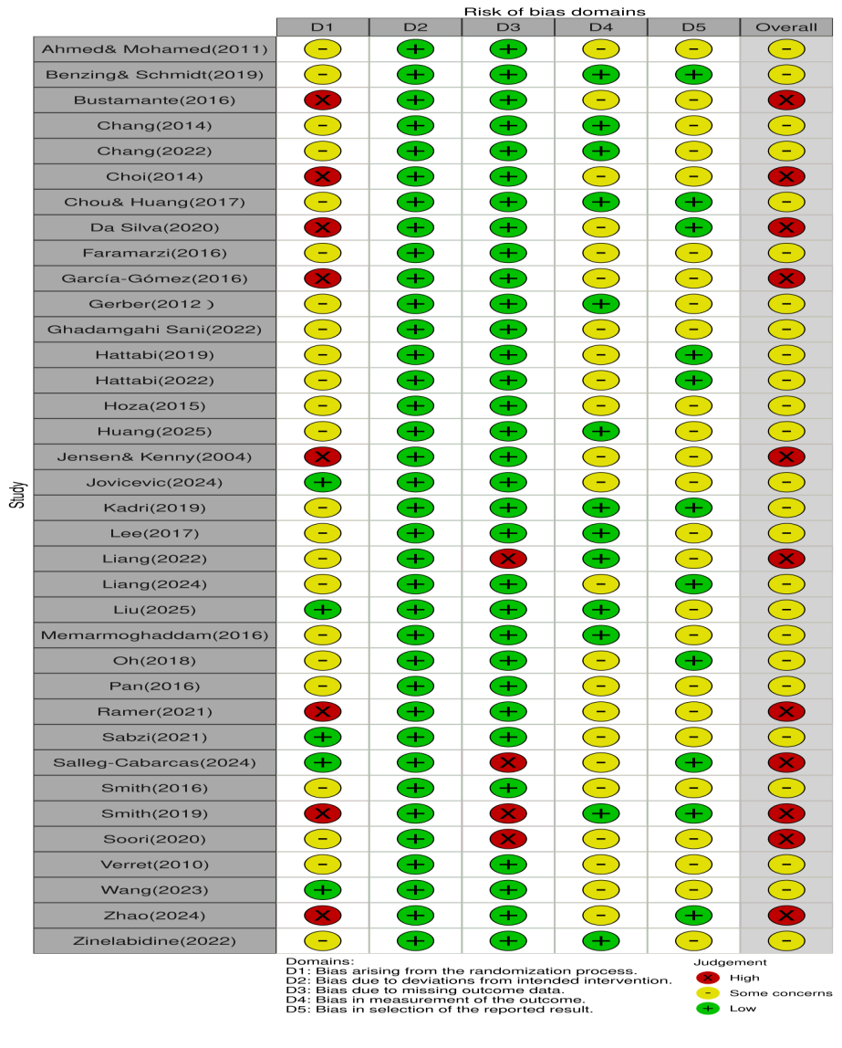
Supplementary Figure 1 Risk of bias results
Supplementary Figure 2 Regression Analysis Result Chart of Attention

Supplementary Figure 3 Regression Analysis Result Chart of Behavioral problems
Supplementary Figure 4 Regression Analysis Result Chart of Emotional function
Supplementary Figure 5 Leave-one-out sensitivity analysis of attention
Supplementary Figure 6 Leave-one-out sensitivity analysis of behavioral problems

Supplementary Figure 7 Leave-one-out sensitivity analysis of emotional function

Supplementary Figure 8 Attention influence analysis

Supplementary Figure 9 Behavioral problems influence analysis

Supplementary Figure 10 Emotional function influence analysis

Supplementary Table 2 Basic features of the included studies
First author (year) | Participant description |  |  | Intervention measures |  |  |  |  |  | Control condition | Outcome indicators
First author (year) | Sample  Size  (IG/CG) | Age  (years) | BMI  (kg/m²) | Content | Type of exercise | Intensity | Duration per session(min)/Duration per week(h) | Weekly Frequency | Weeks | Control condition | Outcome indicators
Ahmed& Mohamed(2011)[37] | 42/42 | 13.85 | 18.29 | Aerobic activity | AE | MI | 45/2.25 | 3 | 10 | Daily life | ①②③
Benzing& Schmidt(2019)[38] | 28/23 | 10.43 | 17.87 | Motion-sensing game | CME | MHI | 30/1.5 | 3 | 8 | Waiting | ①
Bustamante(2016)[39] | 19/16 | 9.08 | 22.15 | Structured sports games | CME | MI | 60/5 | 5 | 10 | Sedentary games | ①②
Chang(2014)[40] | 14/13 | 8.49 | 17.06 | Exercise in water | AE | MI | 90/3 | 2 | 8 | Waiting | ①
Chang(2022)a[41] | 16/16 | 8.36 | na | Table tennis | CE | MI | 60/3 | 3 | 12 | Daily life | ①
Chang(2022)b[41] | 16/16 | 8.38 | na | Motion-sensing game | CME | MHI | 60/3 | 3 | 12 | Daily life | ①
Choi(2014)[42] | 13/17 | 15.9 | na | Aerobic activity | AE | MI | 90/4.5 | 3 | 6 | Educational activities | ①②
Chou& Huang(2017)[43] | 24/25 | 10.5 | 19.33 | Yoga | AE | MI | 40/1.33 | 2 | 8 | Daily life | ①
Da Silva(2020)[44] | 10/10 | 12 | 19.72 | Swimming | AE | MI | 45/1.5 | 2 | 8 | Daily life | ③
Faramarzi(2016)[45] | 10/10 | 8.6 | na | Sensory Integration Training | CME | na | 45/1.5 | 2 | 6 | Daily life | ①②
García-Gómez(2016)[46] | 9/5 | 10.43 | na | Equestrianism | CE | MI | 45/1.5 | 2 | 12 | Daily life | ①②③
Gerber(2012)[47] | 18/19 | 11.27 | na | Summer camp training | CME | na | 60/5 | 5 | 2.5 | Standardized Parental Guidance | ①
Ghadamgahi Sani(2022)[48] | 20/20 | 7.64 | na | Perceptual motor exercises | CME | na | 42.5/2.125 | 3 | 7 | Neurofeedback training | ①
Hattabi(2019)[49] | 20/20 | 9.85 | 17.55 | Swimming | AE | MI | 90/4.5 | 3 | 12 | Daily life | ①
Hattabi(2022)[50] | 20/20 | 9.85 | 17.55 | Swimming | AE | MI | 90/4.5 | 3 | 12 | Daily life | ①②③
Hoza(2015)[19] | 49/45 | 6.83 | 17.29 | Structured PE class | CME | MHI | 31/3.5 | 7 | 12 | sitting meditation | ①②③
Huang(2025)[51] | 12/12 | 10.21 | 18.04 | Roller skating | CE | MHI | 80/2.67 | 2 | 24 | Waiting | ①
Jensen& Kenny(2004)[52] | 11/8 | 9.99 | na | Yoga | AE | MI | 60/1 | 1 | 20 | Cooperative activities | ①②③
Jovicevic(2024)[53] | 20/19 | 10 | na | Systematic training | CE | na | 60/2 | 2 | 12 | Mindfulness | ②③
Kadri(2019)[54] | 20/20 | 14.35 | na | Taekwondo | CE | MHI | 50/1.67 | 2 | 78 | Daily life | ①
Lee(2017)[55] | 6/6 | 8.83 | 15.94 | Integrated Activities | CE | MI | 60/3 | 3 | 12 | Daily life | ①
Liang(2022)[14] | 40/40 | 8.33 | 16.68 | Aerobic combined with neurocognitive exercise | CME | MI | 60/3 | 3 | 12 | Daily life | ①
Liang(2024)[56] | 15/15 | 8.62 | 16.3 | Various ball sports | CE | MHI | 60/3 | 3 | 12 | Daily life | ②③
Liu(2025)[57] | 40/40 | 14.74 | 20.91 | Structured PE class | CME | MHI | 60/1 | 1 | 12 | Daily life | ①②③
Memarmoghaddam(2016)[58] | 19/17 | 8.3 | 16.72 | Running and various ball sports | CE | MHI | 90/4.5 | 3 | 8 | Daily life | ①
Oh(2018)[59] | 17/17 | 8.15 | na | Equestrianism | CE | MI | 60/2 | 2 | 12 | Medication therapy | ①②③
Pan(2016)[60] | 16/16 | 8.9 | 17.59 | Table tennis | CE | MI | 70/2.33 | 2 | 12 | Daily life | ①②③
Ramer(2021)[61] | 19/16 | 9.05 | na | Structured activities | AE | MI | 90/7.5 | 5 | 10 | Static game | ②
Sabzi(2021)[62] | 20/20 | 9.45 | 17.1 | Running in water | AE | MI | 30/1.5 | 3 | 8 | Daily life | ①②③
Salleg-Cabarcas(2024)[63] | 22/22 | 10.5 | na | Fighting sports game | CE | MHI | 45/2.25 | 3 | 12 | Waiting | ②③
Smith(2016)[64] | 42/38 | 7.41 | na | Cognition, physical activity, behavior management | CME | na | 120/6 | 3 | 15 | Routine treatment | ①②
Smith(2019)[65] | 13/16 | 7.14 | na | Cognition, physical activity, behavior management | CME | na | 120/6 | 3 | 15 | Routine treatment | ①
Soori(2020)[66] | 26/17 | 12.53 | 25.24 | High-Intensity Interval Training | AE | MHI | 20/1 | 3 | 6 | Daily life | ①②
Verret(2010)[67] | 10/11 | 9.1 | 17.4 | Integrated course | CE | MHI | 45/2.25 | 3 | 10 | Daily life | ①②③
Wang(2023)[68] | 15/15 | 6.49 | na | Yoga | AE | MI | 20/1 | 3 | 16 | Daily life | ③
Zhao(2024)[69] | 40/40 | 8.4 | na | Motion-sensing game | CME | MHI | 30/1.5 | 3 | 4 | Waiting | ①②
Zinelabidine(2022)[70] | 19/22 | 10.16 | 18.35 | Dance | AE | MHI | 45/1.5 | 2 | 8 | Daily life | ①
Note: ①Attention; ②Behavior problems; ③Emotional function; AE: Aerobic exercise; CE: Comprehensive exercise; CME: Cognitive-Motor exercise; MI: Moderate intensity; MHI: Moderate to high intensity; na indicates that there is no data for this item.

Supplementary Table 3 Subgroup analysis results
Subgroup |  | Outcome | K | N_IC | N_CC | Hedges'g  (95%CI) | P-value | Q | I²  (%) | I²-l2  (%) | I²-l3  (%) | τ²-l2 | τ²-l3 | Power  (%) | Pm
Population | Children | ① | 72 | 524 | 490 | 0.64(0.13,1.15) | 0.02 | 410.98 | 93 | 9 | 84 | 0.15 | 1.35 | 65 | 0.26
Population | Adolescents | ① | 10 | 147 | 139 | 1.16(0.11,2.21) | 0.04 | 66.32 | 91 | 0 | 91 | 0 | 0.89 | 54 | 0.26
Population | Children | ② | 68 | 333 | 311 | 0.68(0.20,1.16) | <0.01 | 316.53 | 87 | 6 | 81 | 0.05 | 0.73 | 80 | 0.87
Population | Adolescents | ② | 6 | 117 | 109 | 0.55(-0.01,1.09) | 0.05 | 14.63 | 66 | 66 | 0 | 0.13 | 0 | 48 | 0.87
Population | Children | ③ | 40 | 226 | 209 | 0.83(0.20,1.46) | 0.01 | 228.99 | 86 | 0 | 86 | 0 | 0.93 | 71 | 0.55
Population | Adolescents | ③ | 12 | 88 | 85 | 0.71(-0.54,1.96) | 0.13 | 38.98 | 87 | 66 | 21 | 0.38 | 0.12 | 44 | 0.55
Exercise  intensity | Moderate  intensity | ① | 39 | 295 | 288 | 0.72(-0.13,1.57) | 0.09 | 295.52 | 95 | 10 | 95 | 0.26 | 2.28 | 31 | 0.77
Exercise  intensity | Moderate to  high intensity | ① | 28 | 263 | 244 | 0.87(0.36,1.38) | <0.01 | 133.11 | 86 | 29 | 58 | 0.21 | 0.41 | 51 | 0.77
Exercise  intensity | Moderate  intensity | ② | 49 | 181 | 172 | 0.68(0.01,1.34) | 0.05 | 203.43 | 85 | 11 | 74 | 0.12 | 0.78 | 44 | 0.94
Exercise  intensity | Moderate to  high intensity | ② | 19 | 197 | 181 | 0.70(-0.06,1.45) | 0.06 | 107.43 | 89 | 3 | 86 | 0.02 | 0.6 | 82 | 0.94
Exercise  intensity | Moderate  intensity | ③ | 33 | 161 | 150 | 0.77(0.11,1.42) | 0.03 | 160.66 | 82 | 10 | 72 | 0.09 | 0.64 | 57 | 0.73
Exercise  intensity | Moderate to  high intensity | ③ | 18 | 131 | 124 | 0.96(-0.52,2.43) | 0.15 | 103.58 | 94 | 0 | 94 | 0 | 1.36 | 83 | 0.73
Exercise  frequency  (per week) | Low (<3) | ① | 34 | 198 | 189 | 0.62(-0.38,1.62) | 0.20 | 253.92 | 95 | 5 | 89 | 0.13 | 2.26 | 23 | 0.2
Exercise  frequency  (per week) | Moderate (=3) | ① | 41 | 388 | 360 | 0.90(0.39,1.41) | <0.01 | 206.08 | 90 | 17 | 73 | 0.17 | 0.74 | 69 | 0.2
Exercise  frequency  (per week) | High (>3) | ① | 7 | 85 | 80 | 0.24(-1.07,1.56) | 0.51 | 14.31 | 74 | 0 | 74 | 0 | 0.24 | 35 | 0.2
Exercise  frequency  (per week) | Low (<3) | ② | 38 | 119 | 106 | 0.28(0.18,0.39) | <0.01 | 27.55 | 0 | 0 | 0 | 0 | 0 | 17 | <0.01
Exercise  frequency  (per week) | Moderate (=3) | ② | 26 | 249 | 240 | 1.17(0.42,1.92) | <0.01 | 238.09 | 93 | 33 | 60 | 0.44 | 0.81 | 61 | <0.01
Exercise  frequency  (per week) | High (>3) | ② | 10 | 82 | 74 | -0.10(-0.30,0.09) | 0.15 | 10.44 | 0 | 0 | 0 | 0 | 0 | 5 | <0.01
Exercise  frequency  (per week) | Low (<3) | ③ | 30 | 121 | 107 | 0.36(0.01,0.73) | 0.05 | 57.34 | 48 | 0 | 48 | 0 | 0.11 | 43 | <0.01
Exercise  frequency  (per week) | Moderate (=3) | ③ | 20 | 144 | 142 | 1.38(0.48,2.28) | <0.01 | 111.17 | 85 | 6 | 79 | 0.07 | 0.86 | 63 | <0.01
Exercise  frequency  (per week) | High (>3) | ③ | 2 | 49 | 45 | -0.16(-0.44,0.13) | 0.65 | 0.20 | 0 | na | na | na | na | na | <0.01
Types of  Exercise | Aerobic  exercise | ① | 24 | 219 | 214 | 0.97(-0.32,2.26) | 0.12 | 236.14 | 96 | 1 | 95 | 0.03 | 3.53 | 30 | <0.01
Types of  Exercise | Comprehensive  exercise | ① | 27 | 125 | 118 | 1.06(0.43,1.70) | <0.01 | 133.92 | 85 | 51 | 34 | 0.56 | 0.38 | 61 | <0.01
Types of  Exercise | Cognitive  combined exercise | ① | 31 | 327 | 297 | 0.31(0.10,0.53) | <0.01 | 50.18 | 50 | 0 | 50 | 0 | 0.07 | 51 | <0.01
Types of  Exercise | Aerobic  exercise | ② | 27 | 151 | 140 | 1.03(0.03,2.04) | 0.05 | 165.28 | 89 | 23 | 66 | 0.34 | 0.96 | 48 | 0.17
Types of  Exercise | Comprehensive  exercise | ② | 29 | 108 | 101 | 0.72(-0.01,1.44) | 0.05 | 84.52 | 76 | 0 | 76 | 0 | 0.55 | 70 | 0.17
Types of  Exercise | Cognitive  combined exercise | ② | 18 | 191 | 179 | 0.12(-0.19,0.42) | 0.37 | 27.75 | 48 | 0 | 48 | 0 | 0.05 | 10 | 0.17
Types of  Exercise | Aerobic  exercise | ③ | 20 | 121 | 115 | 1.19(0.30,2.08) | 0.02 | 113.69 | 85 | 38 | 46 | 0.42 | 0.51 | 78 | 0.14
Types of  Exercise | Comprehensive  exercise | ③ | 22 | 108 | 101 | 0.73(-0.27,1.73) | 0.12 | 93.61 | 87 | 0 | 87 | 0 | 1.10 | 38 | 0.14
Types of  Exercise | Cognitive  combined exercise | ③ | 10 | 85 | 78 | 0.19(-4.04,4.41) | 0.68 | 19.92 | 79 | 0 | 79 | 0 | 0.21 | 0 | 0.14
①: Attention; ②:Behavioral problems; ③: Emotional function; Hedges’g: the effect size applied in the pooled analysis; I²: proportion of heterogeneity; τ²: Variance; K: number of included effect sizes; P-value: statistical significance of the pooled effects; Pm= P value of the difference between subgroups; 95%CI: 95% confidence interval; Q: Cochran's Q statistic; power: statistical power; na = no data.

