Contents of supplementary appendix
Table S1 | Literature Search Strategy | Page 2
Figure S1 | Literature selection process | Page 4
Table S2 | Basic characteristics of the included studies | Page 5
Table S3 | Qualitative Interview Guide | Page 7
Table S4 | Basic Information on Delphi Experts | Page 8
Table S5-12 | The Expert Consultation Process | Page 9
Table S13 | Item Analysis Results | Page 19
Figure S2 | The parallel analysis scree plot | Page 22
Figure S3 | ROC Curve | Page 23
Table S14 | Coordinates of the Curves | Page 24
Table S15 | StDSS-OA | Page 27

Literature Search Strategy:
This study conducted a systematic search across five Chinese and English databases: PubMed, Web of Science, PsycINFO, China National Knowledge Infrastructure (CNKI), and Wanfang Data Knowledge Service Platform. The search time frame was set from the date each database was established to December 8, 2024. When constructing the search strategy, a combination of subject headings and free-text terms was employed. Specific English search terms included “subthreshold depression,” “Older Adult,” and “qualitative research.” Chinese search terms included “elderly/seniors,” “subthreshold depression/subclinical depression,” “qualitative research/experience/focus group/ phenomenology/grounded theory,” “current status/current situation/cross-sectional study/epidemiological study,” and others. An example of the complete search strategy is shown in Table S1(using a PubMed search as an example):
Table S1 Example of a PubMed Search Strategy for Subthreshold Depression in Older Adults
Search | Search Query | Number of Articles
#1 | ((((((Aged[MeSH Terms]) OR (Elderly[MeSH Terms])) OR (Ageing[Title/Abstract])) OR (Elder*[Title/Abstract])) OR (Geriatric[Title/Abstract])) OR (Old people[Title/Abstract])) OR (Older Adult[Title/Abstract]) | 3755441
#2 | (((((minor depression) OR (subthreshold depression)) OR (subsyndromal depression)) OR (subclinical depression)) OR (subthreshold depressive symptoms)) OR (subclinical depressive conditions) | 19246
#3 | ((((qualitative research) OR (experience)) OR (focus group)) OR (phenomenology)) OR (grounded theory) | 1457731
#4 | ((((((qualitative research) OR (experience)) OR (focus group)) OR (phenomenology)) OR (grounded theory)) AND ((((((minor depression) OR (subthreshold depression)) OR (subsyndromal depression)) OR (subclinical depression)) OR (subthreshold depressive symptoms)) OR (subclinical depressive conditions))) AND (((((((Aged[MeSH Terms]) OR (Elderly[MeSH Terms])) OR (Ageing[Title/Abstract])) OR (Elder*[Title/Abstract])) OR (Geriatric[Title/Abstract])) OR (Old people[Title/Abstract])) OR (Older Adult[Title/Abstract])) | 609

Literature selection process:
Through a systematic search strategy, this study identified a total of 3,087 records from the five target databases. Following deduplication, 1,854 duplicate records were removed, leaving 1,233 records for title and abstract screening. Two researchers independently reviewed the titles and abstracts, during which 1,006 records were excluded. A total of 227 articles were therefore assessed for full-text eligibility. Following full-text assessment, 215 articles were excluded for the following reasons: lack of relevant outcomes (n = 167), publication in a language other than Chinese or English (n = 12), participants younger than 60 years (n = 22), no full text available (n = 5), and case reports or reviews (n = 9). Ultimately, 12 studies were included for evidence extraction and item generation. The detailed study-selection process is shown in Figure S1. 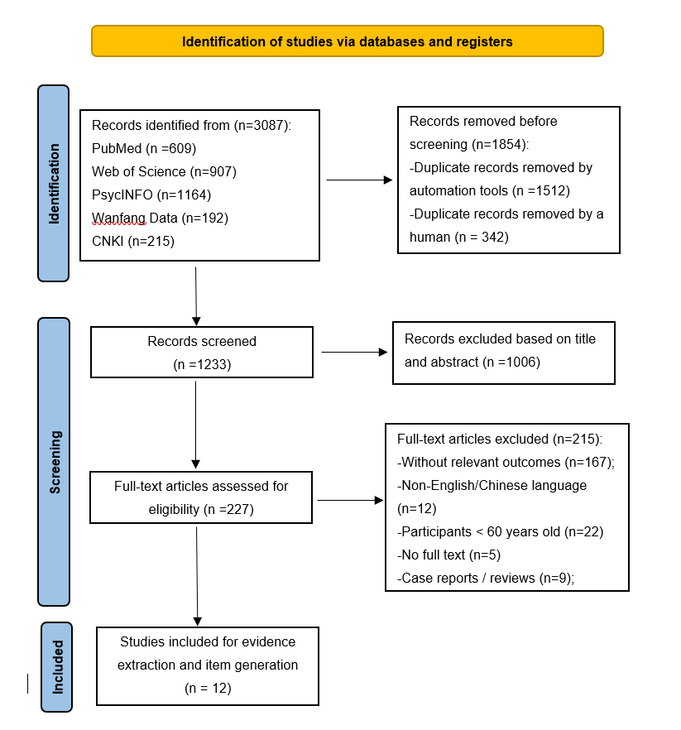
Figure S1. Literature selection process and exclusion details

Table S2 Basic characteristics of the included studies
No. |  | Author (Year) | Country | Age (years) | Sample size | Males | Subthreshold depressive symptoms
1 | Cui Xueyan（2021） |  | China | ≥60 | 430 | 189 | Physical pain, difficulty moving, or reduced social functioning
2 | Yao Lingqiao（2018） |  | China | ≥60 | 368 | 122 | Has only one hobby; reports a decline in memory; reports a decline in life satisfaction
3 | Liu Shunfang（2023） |  | China | ≥60 | 234 | 77 | Lack of people to talk to, limited social interaction, fewer group activities, chronic pain, suffering from two to three chronic conditions, and infrequent physical exercise
4 | Shu Jiaojiao（2019） |  | China | ≥60 | 546 | 292 | Prolonged bed rest and a decline in activities of daily living
5 | Borges et al.（2020） |  | Brazil | 72.1 | 315 | 100 | Self-reported frailty
6 | chen et al.  (2023) |  | China | ≥60 | 1617 | 920 | Cognitive impairment, slow gait, poor balance, prolonged reaction time and frailty
7 | Bauer et al.  (2000) |  | Germany | ≥60 | 86 | 43 | Health concerns, weariness with life
8 | Ludvigsson et al.  (2015) |  | Sweden | ≥60 | 27 | 15 | Fear of losing the ability to manage their own affairs, becoming dependent or losing their autonomy; reports of a greater degree of physical decline and associated suffering compared with non-depressed patients
9 | Chachamovich  et al.（2008） |  | Globe | ≥60 | 4316 | 1801 | Negative attitudes towards quality of life and ageing
10 | Weinberger et  al.(2009) |  | America | ≥65 | 268 | 96 | Poor subjective sense of well-being
11 | Vaccaro et al.  (2017) |  | Italy | 70-74 | 1254 | 582 | Perceiving one’s body to be older than one’s actual age (but not as a complication) and greater perceived stress resulting from negative life events
12 | Alexandrino-Silva  et al. (2011) |  | Brazil | ≥60 | 367 | 114 | Perceived lack of social support

Table S3 Qualitative Interview Guide
1. How have you been feeling lately? Do you often feel down or experience mood swings?
2. When you’re feeling down, what do you usually do to cheer yourself up?
3. What kinds of things usually interest you? Have you lost interest in certain activities recently?
4. What has caused you to no longer enjoy activities you used to like?
5. How often do you usually participate in social or group activities? Has this changed?
6. Do you feel a lack of connection with others or a lack of support?
7. How would you describe your physical condition lately? Have you experienced any discomfort or pain? Have these physical discomforts affected your daily life or mood?
8. How do you view your health? Are you concerned about any health issues?
9. What health issues are causing you particular distress?
10. When you feel you need help, is it easy for you to express this to your family?
11. Are there times when you feel lonely or neglected?
12. What are your hopes or goals for the future? Are there things that make you feel worried or helpless?
Is there anything from today’s discussion that you feel is important but wasn’t mentioned?

Table S4 Basic Information on Delphi Experts（n=15）
No. | Age | Education | Years of Experience (years) | Professional Title | Field of Specialization
1 | 61 | Ph.D. | 39 | Professor | Applied Psychology
2 | 59 | Master’s | 37 | Professor | Nursing Education
3 | 48 | Ph.D. | 22 | Professor | Nursing Education
4 | 45 | Bachelor’s | 25 | Senior Nurse Practitioner | Clinical Nursing
5 | 49 | Master’s | 25 | Consultant | Psychiatry
6 | 49 | Master’s | 16 | Senior Registrar | Psychiatry
7 | 43 | Master’s | 12 | Associate Professor | Psychology
8 | 54 | Bachelor’s | 34 | Deputy Senior Nurse Practitioner | Nursing Management
9 | 45 | Master’s | 20 | Professor | Ageing Population and Health
10 | 43 | Ph.D. | 11 | Lecturer | Psychological Counselling
11 | 59 | Master’s | 37 | Deputy Consultant | Clinical Medicine
12 | 48 | Ph.D. | 30 | Associate Professor | Clinical Nursing
13 | 61 | Master’s | 42 | Senior Nurse Practitioner | Nursing Management
14 | 43 | Ph.D. | 18 | Professor | Nursing Education
15 | 43 | Master’s | 21 | Deputy Senior Nurse Practitioner | Clinical Nursing

The Expert Consultation Process
- Expert Enthusiasm
Two rounds of expert consultation were conducted in this study. In the first round, 16 questionnaires were distributed, and 15 valid questionnaires were returned, resulting in an effective response rate of 93.8%. The effective response rate for the second round of consultation was 100.0%.
2. Expert Authority
The expert authority coefficients (Cr) were 0.887 in the first round and 0.864 in the second round. The authority coefficients of experts in both rounds were greater than 0.7, indicating that the selected experts had a high level of authority and that the expert consultation results were reliable. The detailed results are presented in Tables S5, S6, S7.
Table S5 Frequency distribution of experts’ judgment basis (n=15)
Judgment basis | First round Large n (%) | Medium n (%) | Small n (%) | Second round Large n (%) | Medium n (%) | Small n (%)
Practical experience | 14 (93.33) | 1 (6.67) | 0 (0.00) | 12 (80.00) | 3 (20.00) | 0 (0.00)
Theoretical analysis | 11 (73.33) | 4 (26.67) | 0 (0.00) | 10 (66.67) | 5 (33.33) | 0 (0.00)
Domestic and international literature | 3 (20.00) | 8 (53.33) | 4 (26.67) | 5 (33.33) | 10 (66.67) | 0 (0.00)
Intuitive judgment | 3 (20.00) | 9 (60.00) | 3 (20.00) | 0 (0.00) | 9 (60.00) | 6 (40.00)

Table S6 Frequency distribution of experts’ familiarity level (n=15)
Familiarity level | First round n (%) | Second round n (%)
Very familiar | 9 (60.00) | 8 (53.33)
Relatively familiar | 5 (33.30) | 5 (33.30)
Generally familiar | 1 (6.67) | 2 (13.33)
Less familiar | 0 | 0
Unfamiliar | 0 | 0

Table S7 Statistics of expert authority coefficients in two rounds
Round | Ca | Cs | Cr
First round | 0.966 | 0.807 | 0.887
Second round | 0.947 | 0.780 | 0.864

- Results of Expert Consultation
A total of 15 experts participated in this study. The Kendall’s coefficient of concordance (W) values for the dimensions and items of the scale ranged from 0 to 1, and all P values were <0.01, indicating statistically significant agreement among experts. The detailed results are shown in Table S8.
Table S8 Kendall’s W coefficient and significance test results of expert consultation
Round | Number of items | W | χ² | P value
First round | 34 | 0.17 | 84.01 | 0.01
Second round | 26 | 0.36 | 134.565 | 0.01
All 15 experts agreed with the five-dimensional structure of the initial scale. Using a coefficient of variation (CV) <0.25 and an importance mean score >3.5 as the criteria for item retention, the CV values of all items ranged from 0.07 to 0.36 in the first round. The results are presented in Table S9.

Table S9 Importance evaluation of each item in the first round of expert consultation
Item | Mean importance score | Standard deviation (S) | Coefficient of variation (CV) | Full score rate (%)
A | 4.87 | 0.35 | 0.07 | 86.67
B | 4.27 | 0.80 | 0.19 | 46.67
C | 4.67 | 0.49 | 0.10 | 66.67
D | 4.40 | 0.74 | 0.17 | 53.55
E | 4.40 | 0.74 | 0.17 | 53.55
A1 | 4.33 | 0.98 | 0.23 | 60.00
A2 | 4.67 | 0.72 | 0.16 | 80.00
A3 | 4.40 | 1.12 | 0.25 | 73.33
A4 | 4.60 | 0.74 | 0.16 | 73.33
A5 | 4.47 | 0.64 | 0.14 | 53.33
A6 | 4.47 | 0.83 | 0.19 | 66.67
A7 | 3.80 | 1.15 | 0.30 | 40.00
B8 | 3.87 | 1.30 | 0.34 | 33.30
B9 | 4.47 | 0.83 | 0.19 | 66.67
B10 | 4.27 | 1.44 | 0.34 | 73.33
B11 | 4.47 | 0.83 | 0.19 | 66.67
B12 | 4.47 | 1.13 | 0.25 | 80.00
B13 | 4.13 | 1.51 | 0.36 | 66.67
C14 | 4.40 | 1.40 | 0.32 | 80.00
C15 | 4.27 | 1.39 | 0.33 | 66.67
C16 | 4.07 | 1.39 | 0.34 | 53.33
C17 | 4.40 | 1.06 | 0.24 | 66.67
C18 | 4.13 | 1.46 | 0.35 | 66.67
C19 | 4.33 | 1.11 | 0.26 | 66.67
D20 | 4.27 | 0.82 | 0.19 | 60.00
D21 | 4.27 | 0.80 | 0.19 | 46.67
D22 | 3.67 | 1.23 | 0.34 | 20.00
D23 | 4.47 | 0.83 | 0.19 | 66.67
D24 | 4.67 | 0.72 | 0.16 | 80.00
D25 | 4.73 | 0.70 | 0.15 | 86.67
D26 | 4.00 | 1.41 | 0.35 | 53.33
D27 | 4.33 | 1.11 | 0.26 | 66.67
D28 | 4.40 | 1.18 | 0.27 | 73.33
D29 | 4.20 | 1.42 | 0.34 | 66.67
E30 | 4.67 | 0.49 | 0.10 | 66.67
E31 | 4.47 | 1.06 | 0.24 | 73.33
E32 | 4.47 | 1.06 | 0.24 | 73.33
E33 | 4.27 | 1.22 | 0.29 | 60.00
E34 | 4.40 | 1.06 | 0.24 | 66.67
First-round expert consultation results
During the first round of expert consultation, items 7, 8, 10, 13, 14, 15, 16, 18, 19, 22, 26, 27, 28, 29, and 33 were deleted because their CV values exceeded 0.25. Based on expert suggestions and discussions among the research team, the scale items were revised as shown in Table S10.
Table S10 Modifications after the first round of expert consultation
Adjustment | Item | Item content
Deleted items | 7 | I lack confidence in life or feel unable to cope with challenges in life.
 | 8 | I am only interested in one particular thing and have little interest in other things.
 | 10 | I feel a lack of interest or indifference toward people, things, or the surrounding environment.
 | 13 | I am dissatisfied with my quality of life and no longer feel satisfied or happy as I did before.
 | 14 | I have no one to communicate with or share my feelings with.
 | 15 | My interpersonal interactions have decreased, and I have few opportunities to interact with friends or family.
 | 16 | I choose not to participate in any group activities and avoid doing things with others.
 | 18 | My relationship with family members has become tense, or communication has become difficult.
 | 19 | My social functioning has declined, making it difficult to adapt to social activities and daily life.
 | 22 | I lose my balance or am prone to falling.
 | 26 | I have difficulty with bowel movements or constipation.
 | 27 | I feel tired or easily become physically exhausted, even without excessive activity.
 | 28 | I do not want to or cannot get up and move around, and the time I remain inactive has become longer.
 | 29 | My recent physical health condition is worse than before, and I experience physical discomfort.
 | 33 | When talking about declines in my physical functioning (such as decreased physical strength or mobility difficulties), I feel extremely distressed or anxious.
Added items | 11 | I have difficulty adapting to everyday social situations.
 | 12 | I choose not to participate in group activities.
 | 14 | I tend to get into arguments or have disagreements with others.
 | 15 | My interpersonal interactions have decreased, and I have few opportunities to communicate with friends or family.
 | 19 | I have trouble concentrating.
 | 21 | I don’t feel like getting up and moving around; I feel tired.
Modified items | 3 | Original version: I have the urge to cry or cannot control my emotions.  Revised version: I have the urge to cry.
 | 5 | Original version: I have no hope for the future.  Revised version: I tend to think the worst of things.
 | 6 | Original version: I feel that I have no value.  Revised version: I feel useless or have low self-worth.
 | 11 | Original version: I feel a lack of vitality, feel tired when doing things, or lack motivation.  Revised version: I feel a lack of energy.
 | 15 | Original version: My social functioning has weakened, making it difficult to adapt to social activities and daily life.  Revised version: I have difficulty adapting to everyday social situations.
 | 23 | Original version: I am slower when doing things or responding, my movements and thinking have become slower, and I have difficulty concentrating or understanding things.  Revised version: I’m slower than usual at doing things or reacting.
 | 34 | Original version: I feel that my physical aging is more severe than my actual age, and I feel weaker or experience more physical discomfort than people of the same age.  Revised version: I feel that I am aging significantly.
Second-round expert consultation results
In the second round of expert consultation, using a coefficient of variation (CV) <0.25 and a mean importance score >3.5 as the criteria for item selection, the CV values of all items ranged from 0.07 to 0.31. The detailed results are presented in Table S11
Table S11 Importance evaluation of each item in the second round of expert consultation
Dimension/Item | Mean importance score | Standard deviation (S) | Coefficient of variation (CV) | Full score rate (%)
A | 4.80 | 0.41 | 0.09 | 80.00
B | 4.67 | 0.49 | 0.10 | 66.67
C | 4.87 | 0.35 | 0.07 | 86.67
D | 4.80 | 0.56 | 0.12 | 86.67
E | 4.80 | 0.41 | 0.09 | 80.00
A1 | 4.40 | 0.51 | 0.12 | 40.00
A2 | 4.73 | 0.46 | 0.10 | 73.33
A3 | 2.67 | 0.82 | 0.31 | 6.67
A4 | 4.67 | 0.49 | 0.10 | 66.67
A5 | 4.60 | 0.51 | 0.11 | 60.00
A6 | 4.53 | 0.52 | 0.11 | 53.33
B7 | 4.53 | 0.64 | 0.14 | 60.00
B8 | 4.73 | 0.59 | 0.13 | 80.00
B9 | 4.33 | 0.72 | 0.17 | 46.67
B10 | 4.73 | 0.59 | 0.13 | 80.00
C11 | 4.73 | 0.46 | 0.10 | 73.33
C12 | 4.60 | 0.51 | 0.11 | 60.00
C13 | 4.60 | 0.51 | 0.11 | 60.00
C14 | 4.73 | 0.46 | 0.10 | 73.33
C15 | 4.67 | 0.62 | 0.13 | 73.33
D16 | 4.80 | 0.41 | 0.09 | 80.00
D17 | 3.07 | 0.88 | 0.29 | 13.33
D18 | 4.80 | 0.41 | 0.09 | 80.00
D19 | 4.47 | 0.52 | 0.12 | 46.67
D20 | 4.80 | 0.56 | 0.12 | 86.67
D21 | 4.87 | 0.35 | 0.07 | 86.67
D22 | 4.73 | 0.59 | 0.13 | 80.00
E23 | 4.67 | 0.62 | 0.13 | 73.33
E24 | 4.80 | 0.41 | 0.09 | 80.00
E25 | 4.67 | 0.62 | 0.13 | 73.33
E26 | 4.60 | 0.51 | 0.11 | 60.00
During the second round of expert consultation, items 3 and 17 were deleted because their CV values exceeded 0.25. Based on expert suggestions and discussions among the research team, further modifications were made to the scale items, as shown in Table S12.
Table S12 Modifications after the second round of expert consultation
Adjustment | Item | Item content
Deleted items | 3 | I have the urge to cry.
 | 4 | I feel emotionally heavy or have a feeling of oppression.
 | 7 | I have little interest in most things.
 | 15 | My interpersonal interactions have decreased, and I have few opportunities to communicate with friends or family.
 | 17 | I find it more difficult to move around than before, and sometimes I cannot perform simple daily activities (such as dressing, cooking, or bathing).
Modified items | 2 | Original version: I get easily annoyed or angry.  Revised version: I get easily annoyed or lose my temper.
 | 5 | Original version: I do not hold hope for the future.  Revised version: I tend to think the worst of things.
 | 8 | Original version: I have lost interest in activities that I used to enjoy.  Revised version: Things that used to interest me or that I’m usually interested in no longer seem interesting to me.
 | 10 | Original version: I feel somewhat bored with life or no longer enjoy life as much as before.  Revised version: I feel somewhat bored with life.
 | 13 | Original version: No one cares about my life or feelings.  Revised version: I feel lonely; no one cares about my life or feelings.
 | 16 | Original version: My physical condition is worse than before, and I have persistent pain or discomfort in certain parts of my body.  Revised version: I have persistent pain or discomfort in some parts of my body.
 | 18 | Original version: I am slower when doing things or responding.  Revised version: I’m slower than usual at doing things or reacting.
 | 22 | Original version: My sleep quality is poor (such as insomnia, early awakening, or frequent awakenings).  Revised version: The quality of my sleep is worse than usual.
 | 23 | Original version: I am more sensitive to negative events in life (such as family problems or financial difficulties) than before or feel greater stress.  Revised version: I feel greater stress from negative events in life (such as family problems or financial difficulties).
 | 25 | Original version: I worry that I will lose my ability to live independently or be unable to manage my daily affairs independently.  Revised version: I am worried about losing my ability to live independently.
After deletion, modification, and addition of items, the Chinese Subthreshold Depression Screening Scale for Older Adults Version 2.0 was established, consisting of five dimensions and 21 items.

Table S13. Item Analysis Results
Item | Mean |  | t | p | r | Cronbach’s α after deletion
Item | High-score group | Low-score group
A1 | 3.25±0.751 | 1.95±0.888 | 7.113 | ＜0.001 | 0.559 | 0.877
A2 | 3.52±0.664 | 1.89±0.784 | 10.459 | ＜0.001 | 0.618 | 0.876
A3 | 2.91±0.884 | 1.75±0.839 | 6.798 | ＜0.001 | 0.503 | 0.879
A4 | 2.84±1.055 | 1.70±0.930 | 5.561 | ＜0.001 | 0.478 | 0.881
B5 | 3.34±0.888 | 1.82±0.815 | 8.397 | ＜0.001 | 0.606 | 0.876
B6 | 3.50±0.792 | 1.98±0.821 | 9.036 | ＜0.001 | 0.571 | 0.877
B7 | 3.05±0.806 | 1.70±0.765 | 8.07 | ＜0.001 | 0.578 | 0.877
B8 | 3.16±0.914 | 1.61±0.813 | 8.343 | ＜0.001 | 0.583 | 0.877
C9 | 3.57±0.873 | 1.77±0.859 | 9.728 | ＜0.001 | 0.592 | 0.877
C10 | 2.27±0.727 | 1.64±0.838 | 5.931 | ＜0.001 | 0.456 | 0.88
C11 | 2.43±0.789 | 1.61±0.754 | 6.89 | ＜0.001 | 0.467 | 0.88
C12 | 3.59±0.871 | 2.41±0.948 | 5.652 | ＜0.001 | 0.521 | 0.879
D13 | 3.59±0.923 | 2.48±0.849 | 5.691 | ＜0.001 | 0.558 | 0.877
D14 | 3.20±0.878 | 2.36±0.942 | 5.488 | ＜0.001 | 0.412 | 0.882
D15 | 3.61±0.841 | 2.55±1.066 | 5.422 | ＜0.001 | 0.448 | 0.882
D16 | 2.68±1.073 | 2.30±1.047 | 5.11 | ＜0.001 | 0.496 | 0.879
D17 | 3.34±1.077 | 2.41±1.127 | 4.103 | ＜0.001 | 0.435 | 0.882
D18 | 2.82±0.843 | 1.77±0.743 | 6.359 | ＜0.001 | 0.473 | 0.88
E19 | 3.68±0.708 | 1.68±0.708 | 13.068 | ＜0.001 | 0.726 | 0.871
E20 | 3.80±0.632 | 1.93±0.789 | 12.413 | ＜0.001 | 0.72 | 0.872
E21 | 3.52±0.902 | 1.80±0.668 | 10.158 | ＜0.001 | 0.66 | 0.874
Analysis using the critical ratio method, correlation coefficients, and Cronbach’s alpha revealed that no items failed to meet the criteria. Ultimately, 5 dimensions and 21 items were retained.
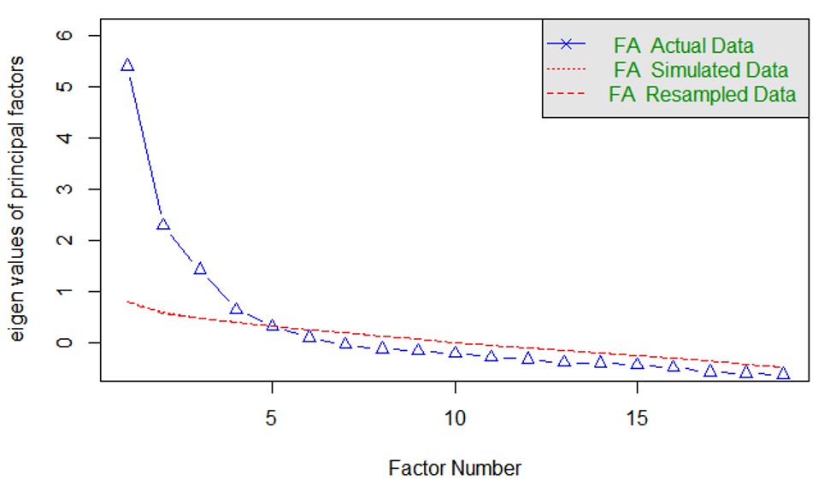
Figure S2. The parallel analysis scree plot

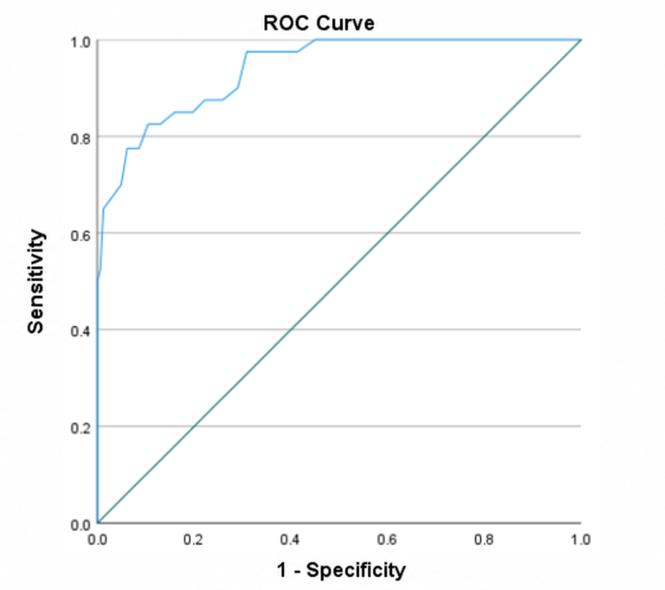
Figure S3. ROC Curve
The area under the ROC curve (AUC) was 0.939 (P < 0.001, 95% CI: 0.902–0.977), indicating good discriminative performance of the StDSS-OA in distinguishing participants classified as screen-positive and screen-negative according to the GDS-15.
Table S14. Coordinates of the Curves
Positive when greater than or equal to this value | Sensitivity | 1－Specificity | Youden Index
18 | 1 | 1 | 0
19.5 | 1 | 0.975 | 0.025
20.5 | 1 | 0.963 | 0.037
21.5 | 1 | 0.957 | 0.043
22.5 | 1 | 0.932 | 0.068
23.5 | 1 | 0.914 | 0.086
24.5 | 1 | 0.901 | 0.099
25.5 | 1 | 0.889 | 0.111
26.5 | 1 | 0.877 | 0.123
27.5 | 1 | 0.852 | 0.148
28.5 | 1 | 0.84 | 0.16
29.5 | 1 | 0.809 | 0.191
30.5 | 1 | 0.784 | 0.216
31.5 | 1 | 0.759 | 0.241
32.5 | 1 | 0.753 | 0.247
33.5 | 1 | 0.735 | 0.265
34.5 | 1 | 0.71 | 0.29
35.5 | 1 | 0.667 | 0.333
36.5 | 1 | 0.642 | 0.358
37.5 | 1 | 0.593 | 0.407
38.5 | 1 | 0.556 | 0.444
39.5 | 1 | 0.537 | 0.463
40.5 | 1 | 0.512 | 0.488
41.5 | 1 | 0.475 | 0.525
42.5 | 1 | 0.451 | 0.549
43.5 | 0.975 | 0.414 | 0.561
44.5 | 0.975 | 0.383 | 0.592
45.5 | 0.975 | 0.358 | 0.617
46.5 | 0.975 | 0.309 | 0.666
47.5 | 0.9 | 0.29 | 0.61
48.5 | 0.875 | 0.259 | 0.616
49.5 | 0.875 | 0.222 | 0.653
50.5 | 0.85 | 0.198 | 0.652
51.5 | 0.85 | 0.173 | 0.677
52.5 | 0.85 | 0.16 | 0.69
53.5 | 0.825 | 0.13 | 0.695
54.5 | 0.825 | 0.105 | 0.72
55.5 | 0.775 | 0.086 | 0.689
56.5 | 0.775 | 0.062 | 0.713
57.5 | 0.7 | 0.049 | 0.651
58.5 | 0.675 | 0.031 | 0.644
59.5 | 0.65 | 0.012 | 0.638
60.5 | 0.525 | 0.006 | 0.519
61.5 | 0.5 | 0 | 0.5
62.5 | 0.475 | 0 | 0.475
64 | 0.45 | 0 | 0.45
66 | 0.375 | 0 | 0.375
67.5 | 0.275 | 0 | 0.275
69 | 0.25 | 0 | 0.25
70.5 | 0.225 | 0 | 0.225
72.5 | 0.2 | 0 | 0.2
74.5 | 0.175 | 0 | 0.175
76 | 0.1 | 0 | 0.1
78.5 | 0.075 | 0 | 0.075
84 | 0.05 | 0 | 0.05
90.5 | 0.025 | 0 | 0.025
94 | 0 | 0 | 0
Youden's J was calculated as sensitivity + specificity - 1. Its maximum value was 0.720 at a threshold of 54.5, corresponding to a sensitivity of 82.5% and a specificity of 89.5% relative to GDS-15-defined screening status. Because complete StDSS-OA total scores are integers, this threshold corresponds to a provisional screening cutoff of 55. This cutoff was selected and evaluated in the same sample and requires independent validation. It should not be interpreted as a diagnostic threshold for subthreshold depression.
Table S15. StDSS-OA
Dimension | Items | Degree
Negative Emotional Experience | 1. I feel down or gloomy | Never | Occasionally | Sometimes | Often | Always
Negative Emotional Experience | 2. I get easily annoyed or lose my temper | Never | Occasionally | Sometimes | Often | Always
Negative Emotional Experience | 3. I tend to think the worst of things | Never | Occasionally | Sometimes | Often | Always
Negative Emotional Experience | 4. I feel useless or have low self-worth | Never | Occasionally | Sometimes | Often | Always
Interest and Vitality Reduction | 5. Things that used to interest me or that I’m usually interested in no longer seem interesting to me | Never | Occasionally | Sometimes | Often | Always
Interest and Vitality Reduction | 6. I feel a lack of energy | Never | Occasionally | Sometimes | Often | Always
Interest and Vitality Reduction | 7. I feel somewhat bored with life | Never | Occasionally | Sometimes | Often | Always
Interpersonal Relationship System Disturbance | 8. I have difficulty adapting to everyday social situations | Never | Occasionally | Sometimes | Often | Always
Interpersonal Relationship System Disturbance | 9. I choose not to participate in group activities | Never | Occasionally | Sometimes | Often | Always
Interpersonal Relationship System Disturbance | 10. I feel lonely; no one cares about my life or feelings | Never | Occasionally | Sometimes | Often | Always
Interpersonal Relationship System Disturbance | 11. I tend to get into arguments or have disagreements with others | Never | Occasionally | Sometimes | Often | Always
Physiological and Cognitive Function Decline | 12. I’m slower than usual at doing things or reacting | Never | Occasionally | Sometimes | Often | Always
Physiological and Cognitive Function Decline | 13. I have trouble concentrating | Never | Occasionally | Sometimes | Often | Always
Physiological and Cognitive Function Decline | 14. My appetite has decreased, and I don’t feel like eating | Never | Occasionally | Sometimes | Often | Always
Physiological and Cognitive Function Decline | 15. I don’t feel like getting up and moving around; I feel tired | Never | Occasionally | Sometimes | Often | Always
Physiological and Cognitive Function Decline | 16. The quality of my sleep is worse than usual | Never | Occasionally | Sometimes | Often | Always
Fear of decline | 17. I am worried about my health and feel that I have some physical problems | Never | Occasionally | Sometimes | Often | Always
Fear of decline | 18. I am worried about losing my ability to live independently | Never | Occasionally | Sometimes | Often | Always
Fear of decline | 19. I feel that I am aging significantly | Never | Occasionally | Sometimes | Often | Always
Scoring instructions for the StDSS-OA:
Each item is scored on a 5-point Likert scale: 1 = Never, 2 = Occasionally, 3 = Sometimes, 4 = Often, 5 = Always. The total score is the sum of all 19 items, ranging from 19 to 95. Higher total scores indicate greater severity of subthreshold depressive symptoms. A provisional cutoff of ≥55 suggests a positive screening result and warrants further clinical assessment. For missing responses, if ≤2 items are missing, replace with the dimension mean; if >2 items or >20% of items are missing, exclude the questionnaire.

