Additional File 9: Forest Plots for Each Meta-Analysis Subgroup
NOTE: For all forest plots below, the average estimate of effect (represented by a diamond at the bottom of the figure) is shown only if heterogeneity was not significant (I²<60%)
Randomized controlled trials (RCTs)
Training courses/workshops – adults – behaviour outcome – standardized mean difference (SMD) measure
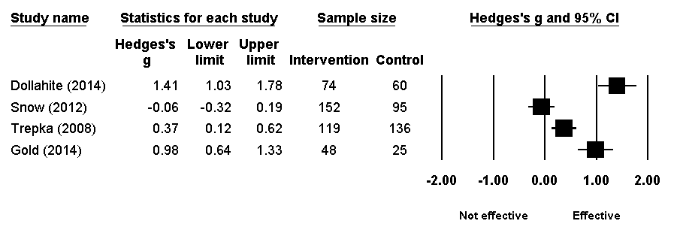

Training courses/workshops – adults – knowledge outcome – SMD measure
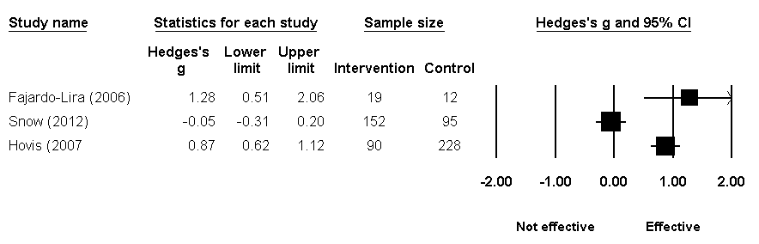

Training courses/workshops – children/youth – behaviour outcome –SMD measure
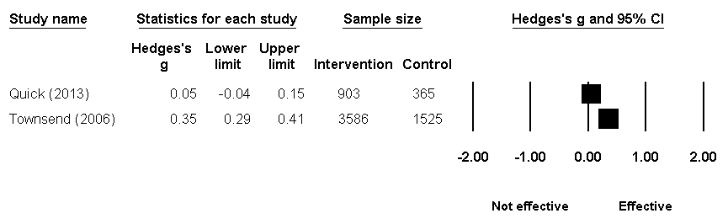

Media campaigns/messaging – adults – behavioural intentions outcome – SMD measure
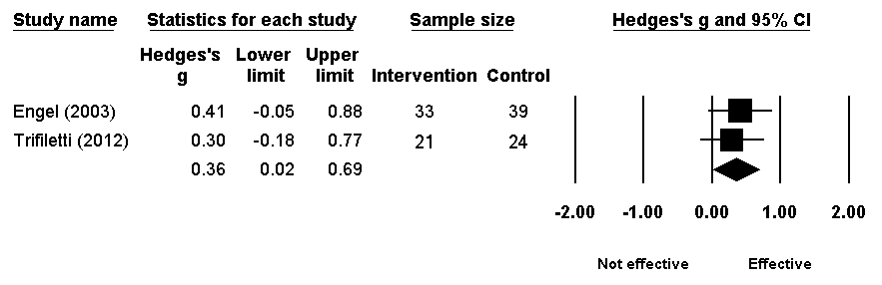

Media campaigns/messaging – adults – behaviour outcome – SMD measure
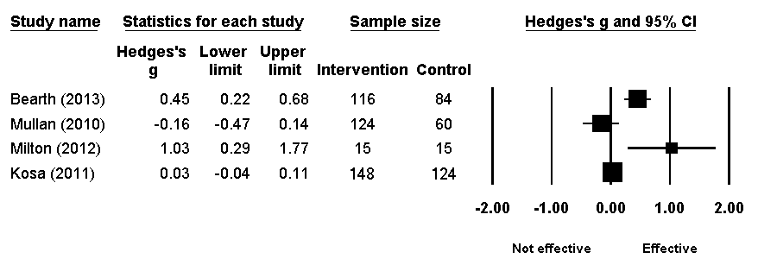

Media campaigns/messaging – adults – knowledge outcome – SMD measure
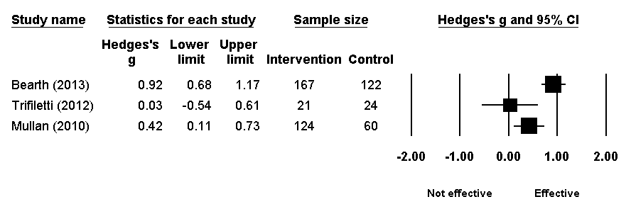

Media campaigns/messaging – adults – attitudes outcome – SMD measure
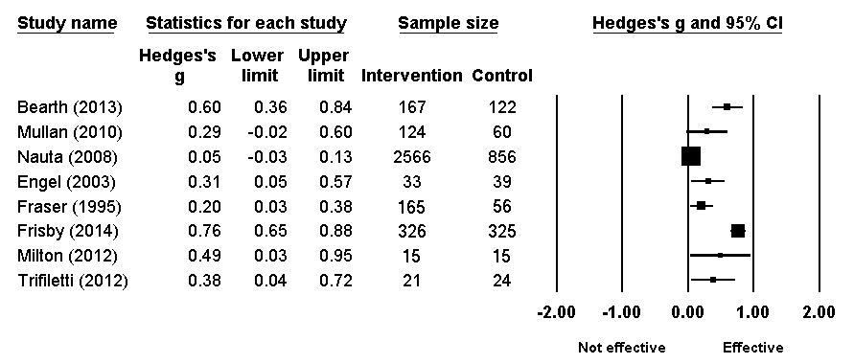

Non-randomized controlled trials (NRTs)

Training courses/workshops – adults – behaviour outcome –SMD measure
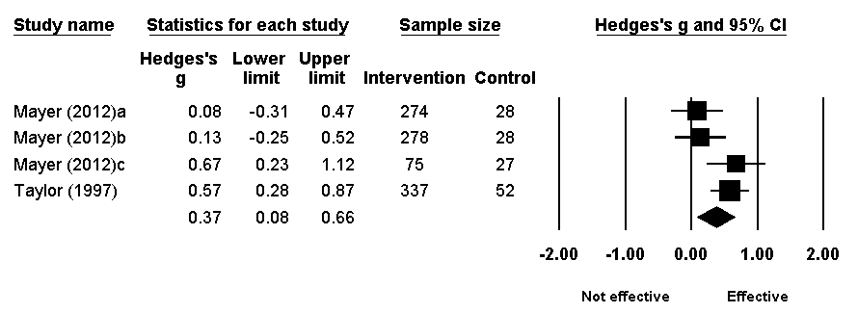

Training courses/workshops – adults – knowledge outcome –SMD measure
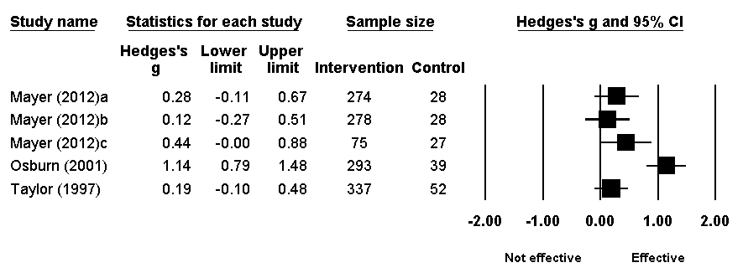
Training courses/workshops – adults – attitudes outcome –SMD measure
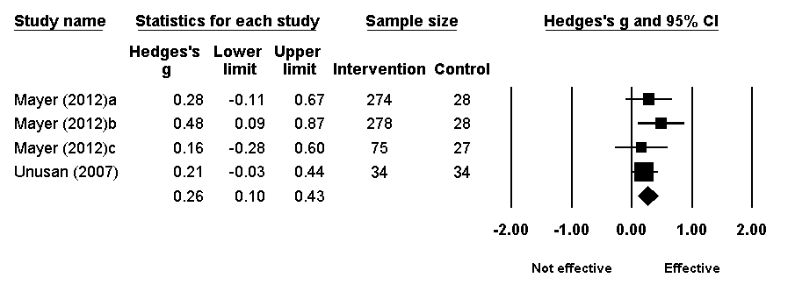

Training courses/workshops – children/youth – behaviour outcome –SMD measure
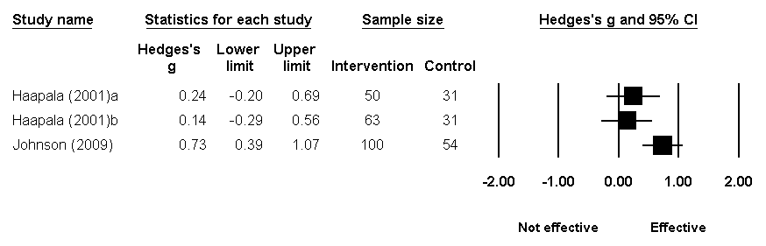

Training courses/workshops – children/youth – knowledge outcome –SMD measure
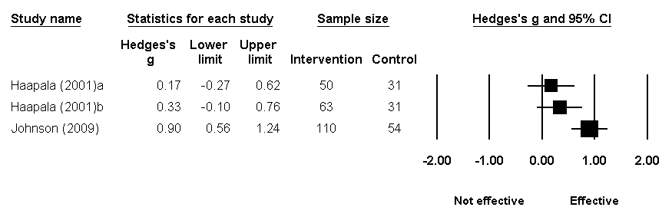

Media campaigns/messaging – adults – behaviour outcome – relative risk (RR) measure (shown on log scale)
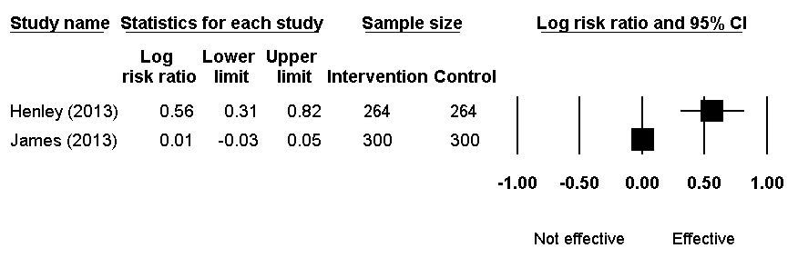

Media campaigns/messaging – adults – attitudes outcome – RR measure (shown on log scale)
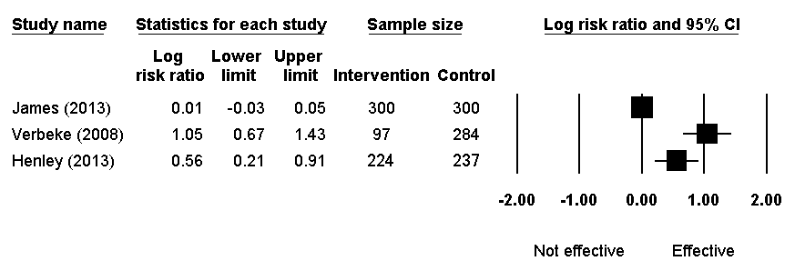

Uncontrolled before-and-after studies

Training courses/workshops – educators – behaviour outcome – SMD measure
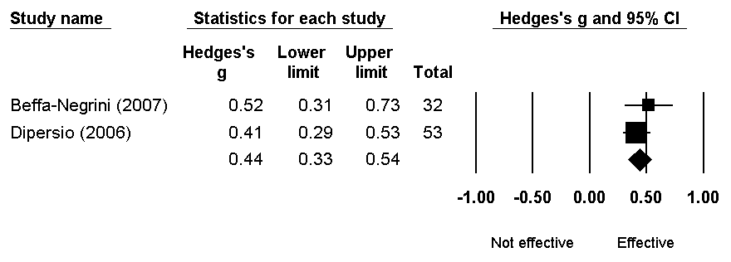

Training courses/workshops – educators – knowledge outcome – RR measure (shown on log scale)
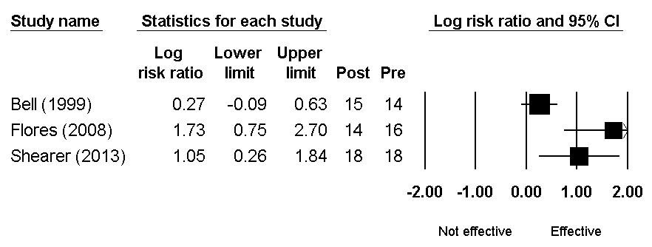

Training courses/workshops – educators – attitudes outcome – RR measure (shown on log scale)
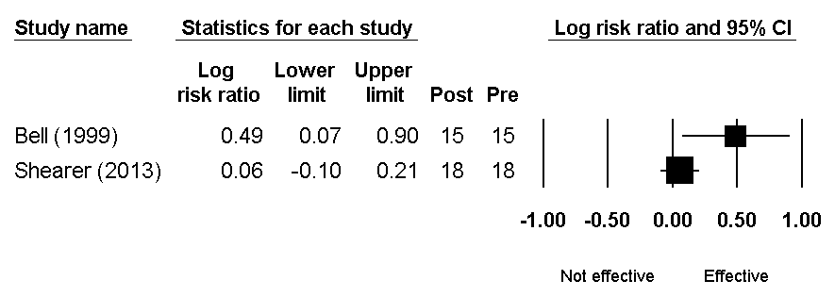

Training courses/workshops – adults – behaviour outcome – SMD measure
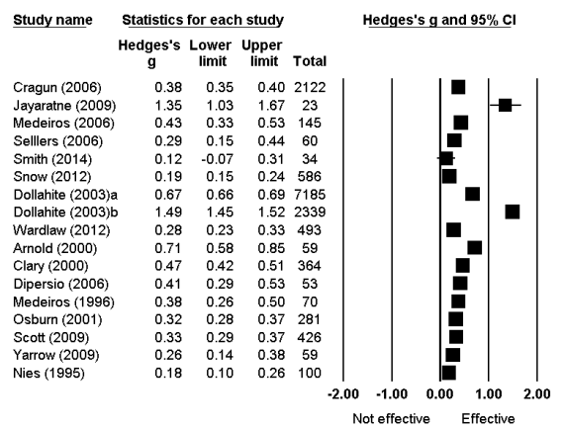

Training courses/workshops – adults – behaviour outcome – RR measure (shown on log scale)

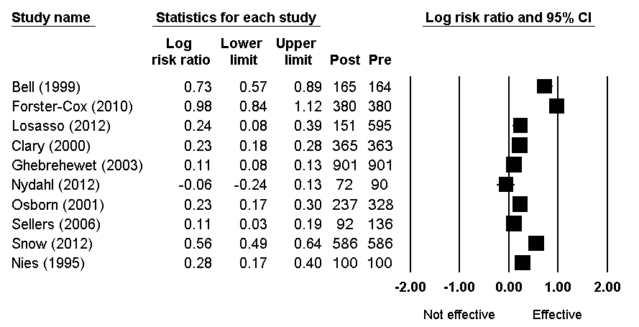
Training courses/workshops – adults – knowledge outcome – SMD measure
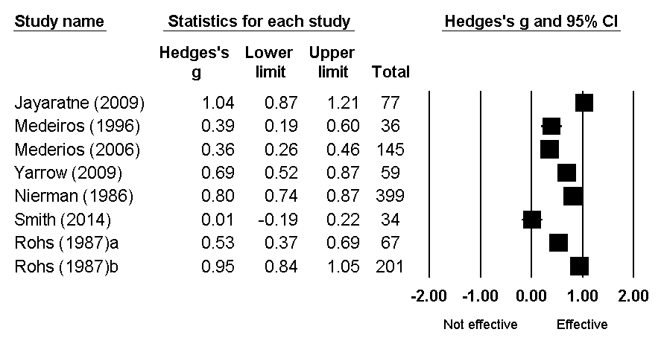

Training courses/workshops – adults – knowledge outcome – RR measure (shown on log scale)
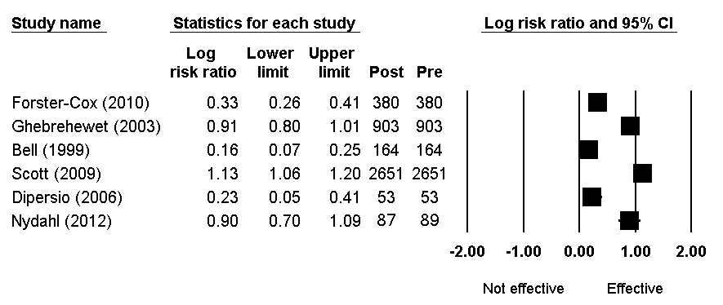

Training courses/workshops – adults – attitudes outcome – SMD measure
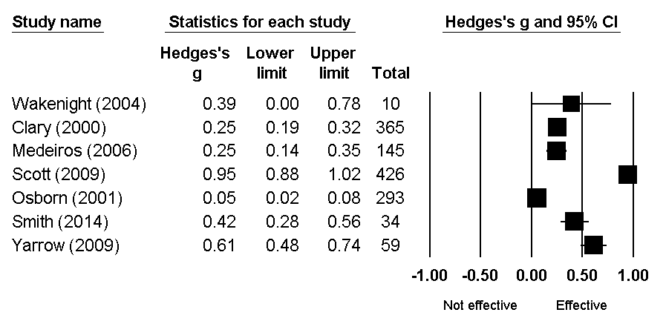

Training courses/workshops – adults – attitudes outcome – RR measure (shown on log scale)
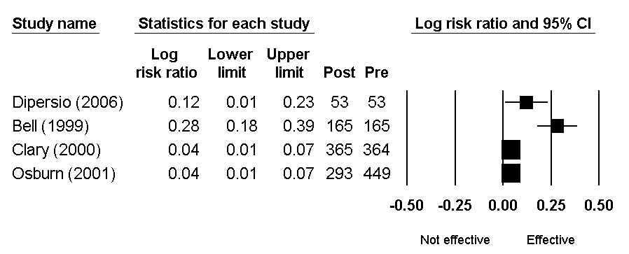

Training courses/workshops – children/youth – behaviour outcome – SMD measure
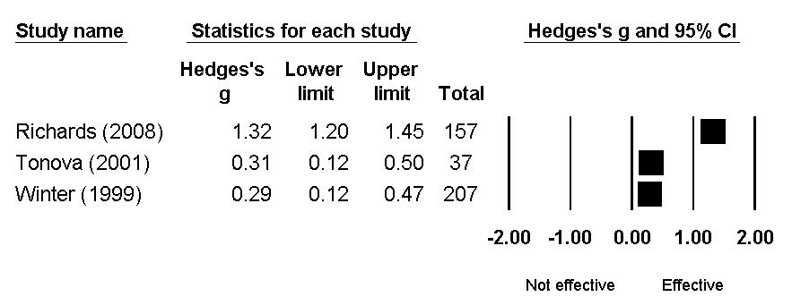

Training courses/workshops – children/youth – behaviour outcome – RR measure (shown on log scale)
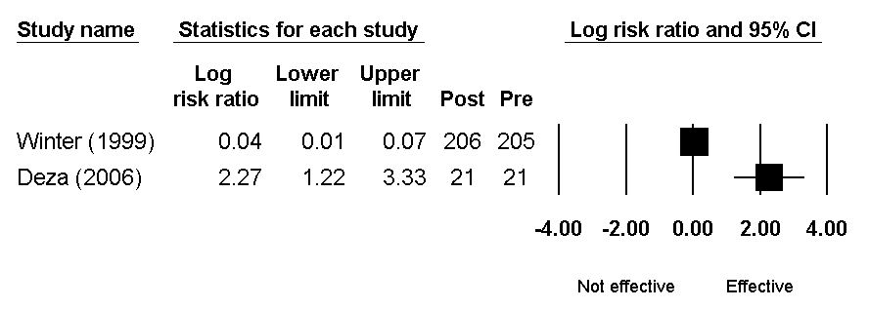

Training courses/workshops – children/youth – knowledge outcome – SMD measure
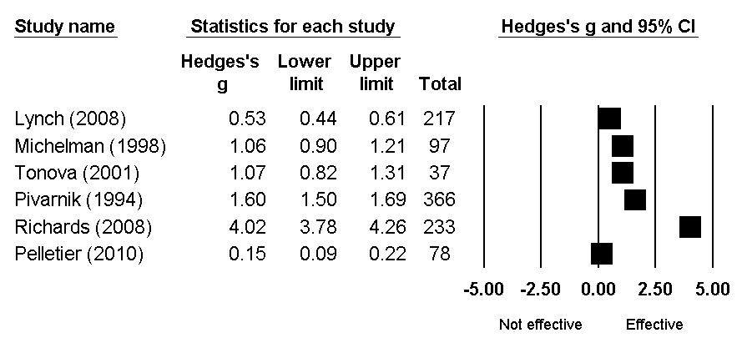
Training courses/workshops – children/youth – knowledge outcome – RR measure (shown on log scale)
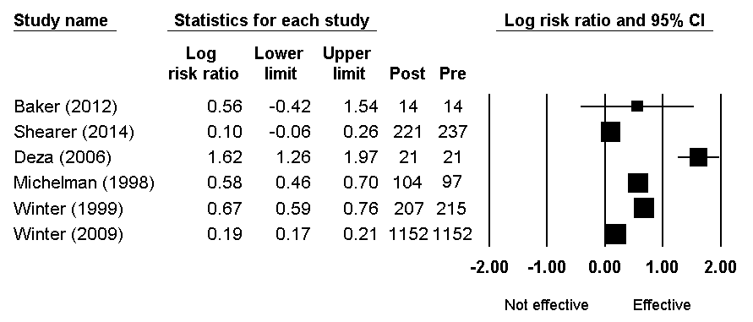

Training courses/workshops – children/youth – attitudes outcome – SMD measure
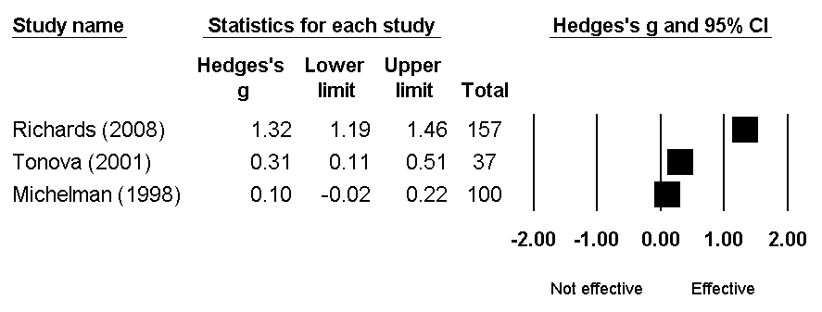

Media campaigns/messaging – adults – behaviour outcome – RR measure (shown on log scale)
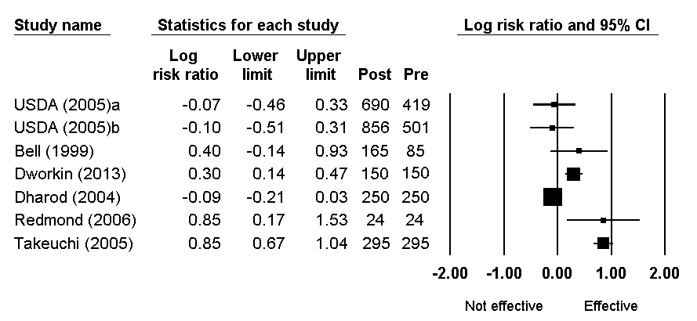

Media campaigns/messaging – adults – knowledge outcome – RR measure (shown on log scale)
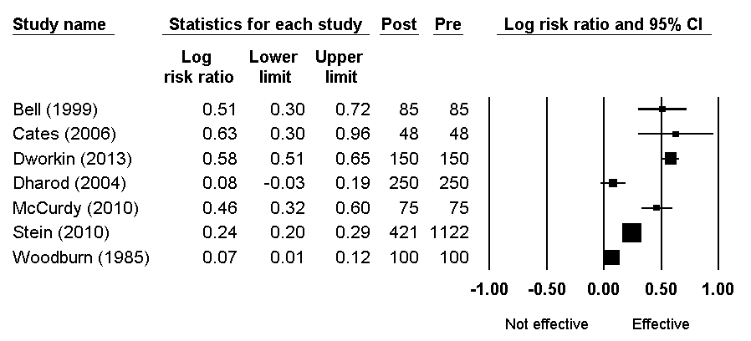

Media campaigns/messaging – adults – attitudes outcome – SMD measure
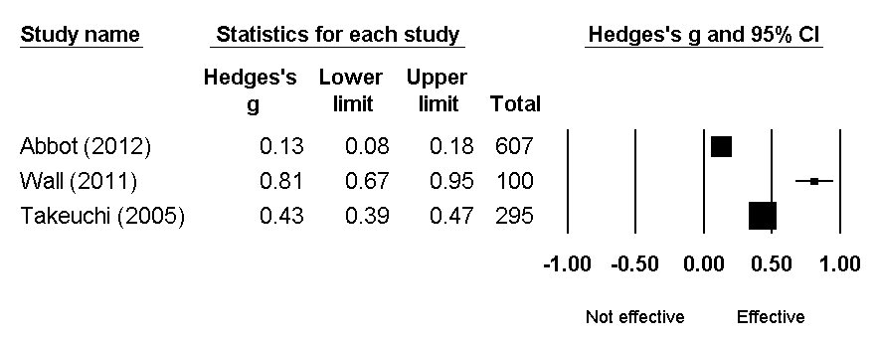

Media campaigns/messaging – adults – attitudes outcome – RR measure (shown on log scale)
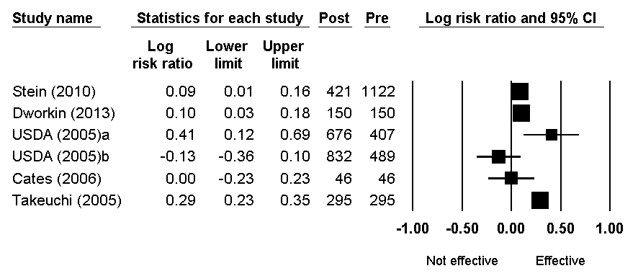

Media campaigns/messaging – adults – stages of change outcome – RR measure (shown on log scale)
