Additional file 1 – Technical appendix - dynamic transmission model for Italy
Model description
An age-structured dynamic transmission model developed in Matlab software (version R2013A) using the same basic structure as the models by Brisson et al.[,] was adapted and fitted to the seroprevalence of varicella in Italy without vaccination using an empirical contact matrix. The model predicts both varicella and zoster diseases over a lifetime with and without vaccination to reflect the full picture of the disease burden related to varicella-zoster virus (VZV), however, outcomes of the model on herpes zoster are not discussed here. All details of a similar dynamic model adapted for France are reported in Ouwens et al.[].
The model structure shows varicella disease states as susceptible, latent or exposed, infectious, and recovered; and zoster disease states as susceptible, infectious, and recovered. The normal disease progression (before vaccination) is shown in black, and the post vaccination disease states are shown in red (Additional file - Figure 1). After vaccination, people can become fully-protected or partially-protected and primary vaccine failures are shown to remain in the varicella susceptible state. After two doses of varicella vaccination, most partially-protected vaccine recipients become fully-protected. Breakthrough cases are assumed to be milder than naturally-acquired cases and to result in lower infection and reactivation rates.
Model inputs
The key model inputs used for the Italian adaptation are given in Additional file - Table 1. All input parameters and vaccine assumptions used in the model are given in Additional file - Table 2.
Briefly, birth rate was calculated from Italian national statistics as a fraction of the annual birth cohort out of the total Italian population. The force of infection (FOI) was estimated based on a pooled estimate of age-specific Italian incidence data divided into 8 age groups (ages 1 year, 1–4 years, 5–9 years, 10–14 years, 15–24 years, 25–44 years, 45–64 years, and 65 years). It was assumed that on average 98% of individuals 65 years of age and older will have had varicella and that the proportion of susceptible individuals in each age group decreases exponentially. The Who Acquires Infection From Whom (WAIFW) matrix was based on the empirically-derived contact matrix from Mossong et al. [] for Italy. The rate of VZV reactivation was age-dependent and estimated to match the Italian zoster incidence data. The proportion of primary vaccine failures (corresponding to subjects with no seroconversion) was assumed to be 5% []. Vaccine-induced immunity was assumed to wane over time, with an average duration of 17 years after 1 dose [] and lifelong protection after 2 doses.
Calibration and model fit to Italian data
In order to validate the WAIFW matrix, this matrix was used to estimate the FOI. The estimated FOI was found to be comparable to the FOI derived from the pooled data, using the resulting ‘percent susceptible by age’. A second validation of the matrix was performed: the results (percent susceptible) derived from running the dynamic model with the WAIFW matrix, were compared to the pooled published estimates. The results show that the WAIFW matrix provides a very close estimation of the published data (Appendix Table 3).

Appendix Table 1 Key model inputs to adapt the model for Italy
Parameter | Source
Demographic parameters | Istat []
Varicella seroprevalence | Gabutti et al. 2008 []
Contact matrix | Mossong et al. 2008 [5]
Force of infection‡ | Bonanni et al. 2008 [], Coudeville et al. 2004 [], Nardone et al. 2007 [], Thiry et al. 2004 [], Gabutti et al. 2008 [8], Giaquinto et al. [], Salmaso et al. []
‡A pooled estimate was used to derive the force of infection for Italy. It was assumed that these data have a lognormal distribution.

Appendix Table 2 Model parameters
Parameter | Description | Value | Source
Demographic parameters
Birth | Fraction of annual birth cohort/total Italian population | 0.00937 | ISTAT [7]
Biological parameters
σ | Latent period of varicella (avg 14 days) | 26.07 | Brisson et al. 2000 [1]
α | Infectious period of varicella (avg 7 days) | 52.14 | Brisson et al. 2000 [1]
δ | Waning natural immunity (avg 10 years) | 0.1 | Expert opinion
g * λ (a) | Exogenous boosting against zoster (100%) | 100% * λ | Brisson et al. 2000 [1]
Vaccine parameters
Introduction time | Number of years before maximum vaccination coverage is reached | 3 | Assumption
Tv (1st dose) | Varicella vaccine efficacy (% successfully vaccinated and temporarily protected) | 65% or 75% | 65% (Prymula et al. 2014 [5])
P (1st dose) | Varicella vaccine failures (%) | 5% | Prymula et al. 2014 [5]
1-Tv-P (1st dose) | Varicella vaccine-recipients partially protected (%) | 20% or 30% | 100%-Tv-P
2nd dose efficacy | Varicella vaccine efficacy (dose 2) for protected | 100% | Assumption
 | Varicella vaccine efficacy (dose 2) for partial responder | 89% | Assumption
 | Varicella vaccine efficacy (dose 2) for primary failure | 75% | Assumption
Wv1 | Waning rate for 1 dose of varicella vaccine (duration 17 years) | 0.0588 | Silverman et al. 2009 [6]
Wv2 | Waning rate for 2 doses of varicella vaccine (lifelong protection) | 1e⁻⁶ | Expert opinion
Ki * λ (a) | Rate of exogenous boosting | 0.91 * λ (a) | Brisson et al. 2000 [1]
h | Relative VZV reactivation after varicella vaccination | 0.167 | Brisson et al. 2000 [1]
b * λ (a) | Rate of infection among vaccinated susceptibles | 0.73 * λ (a) | Brisson et al. 2000 [1]
m | Relative infectiousness of infected vaccine-recipients versus non-vaccine-recipients | 0.5 | Brisson et al. 2000 [1]
Note: VZV, varicella zoster virus

Appendix Table 3 Estimates of percent susceptible
Age group | Overall estimate | Estimated ML* | Model estimate
0 | 95% | 95% | 96%
5 | 59% | 60% | 60%
10 | 28% | 28% | 28%
15 | 19% | 19% | 18%
25 | 12% | 11% | 11%
45 | 3% | 3% | 3%
65 | 1% | 1% | 1%
80 | 1% | 1% | 1%
*ML: Maximum likelihood to feed the model parameters

Additional file - Figure 1 Model Structure (Reproduced with permission [3]
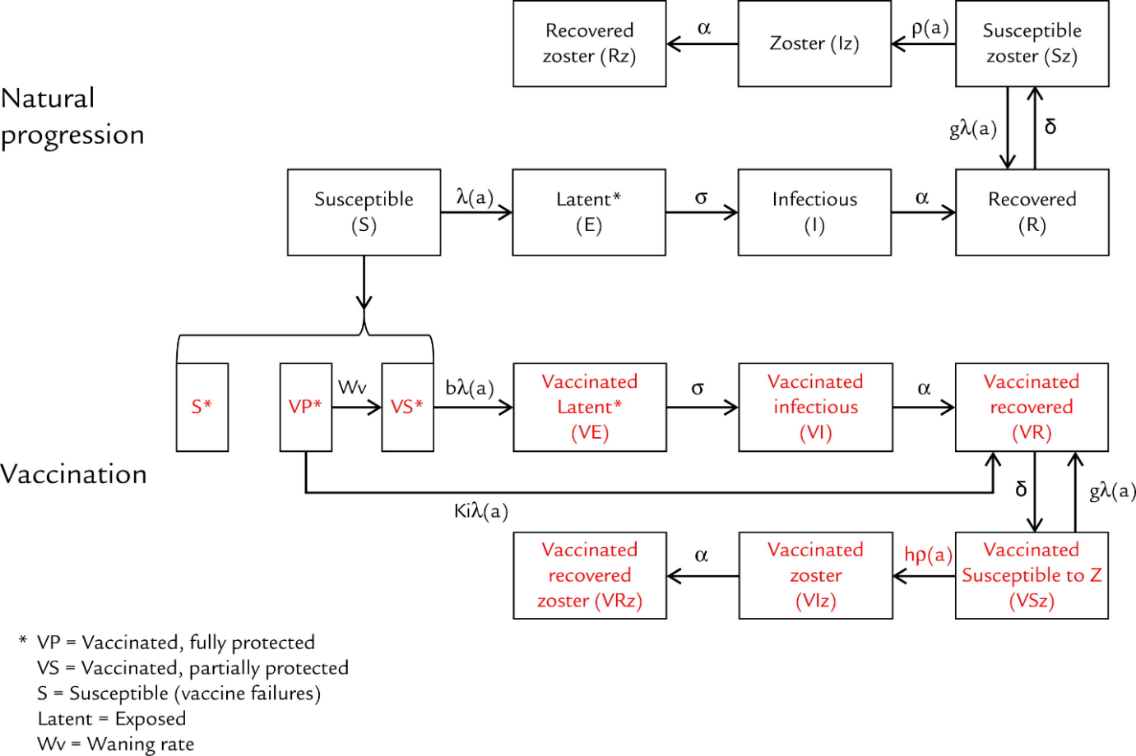
Legend: VP (Vaccinated, fully protected), VS (Vaccinated, partially protected), S (Susceptible, vaccine failures), Latent = Exposed, Wv = waning rate
Note: all other letters are described in Additional file – Table 2

List of abbreviations
FOI: Force of infection, ML: Maximum likelihood, M popn: Million population, S: Susceptible, vaccine failures, VP: Vaccinated, fully protected, VS: Vaccinated, partially protected, VZV: varicella-zoster virus, WAIFW: Who Acquires Infection From Whom, Wv: waning rate, y: year

References

Brisson M, Edmunds WJ, Gay NJ Law B, De Serres G. Modelling the impact of immunization on the epidemiology of varicella zoster virus. Epidemiol Infect 2000; 125:651-69.
Brisson M, Melkonyan G, Drolet M, De Serres G, Thibeault R, De Wals P. Modeling the impact of one- and two-dose varicella vaccination on the epidemiology of varicella and zoster. Vaccine. 2010 Apr 26; 28(19):3385-97.
Ouwens MJ, Littlewood KJ, Sauboin C, Téhard B, Denis F, Boëlle PY, Alain S. The impact of 2-dose routine measles, mumps, rubella, and varicella vaccination in france on the epidemiology of varicella and zoster using a dynamic model with an empirical contact matrix. Clin Ther. 2015 Apr 1;37(4):816-829
Mossong J, Hens N, Jit M, Beutels P, Auranen K, Mikolajczyk R et al. Social Contacts and Mixing Patterns Relevant to the Spread of Infectious Diseases. Plos Medicine, March 2008; vol 5, Issue 3; e74.
Prymula R, Bergsaker MR, Esposito S, Gothefors L, Man S, Snegova N et al. Protection against varicella with two doses of combined measles-mumps-rubella-varicella vaccine versus one dose of monovalent varicella vaccine: a multicentre, observer-blind, randomised, controlled trial. Lancet. 2014; 383:1313–1324.
Silverman B, Hemo B, Friedman N. Varicella vaccine effectiveness in an Israeli health maintenance organisation. Abstract presented at: 27th Annual Meeting of the European Society for Paediatric Infectious Diseases; June 9–13, 2009; Brussels, Belgium.
ISTAT 2008: Italy’s National Census Bureau. Available at: http://www.indexmundi.com/g/g.aspx?c=it&v=29. Accessed on 22-Sep-2014.
Gabutti G, Rota M, Guido M, De Donno A, Bella A, Ciofi degli Atti ML et al. and the Seroepidemiology Group. The epidemiology of Varicella Zoster Virus infection in Italy. BMC Public Health 2008, 8:372
Bonanni P, Boccalini S, Bechini A, Banz K. Economic evaluation of varicella vaccination in Italian children and adolescents according to different intervention strategies: the burden of uncomplicated hospitalised cases. Vaccine. 2008 Oct 16; 26(44):5619-26.
Coudeville L, Brunot A, Giaquinto C, Lucioni C, Dervaux B. Varicella Vaccination in Italy. An Economic Evaluation of Different Scenarios. Pharmacoeconomics 2004; 22 (13): 839-855
Nardone A, de Ory F, Carton M, Cohen D, van Damme P, Davidkin I et al. The comparative sero-epidemiology of varicella zoster virus in 11 countries in the European region. Vaccine 25 (2007) 7866–7872
Thiry N, Beutels P, Tancredi F, Romanò L, Zanetti A, Bonanni P et al. An economic evaluation of varicella vaccination in Italian adolescents. Vaccine 2004: 22(27-28): 3546–62
Giaquinto C, Sturkenboom M, Mannino S, Arpinelli F, Nicolosi A, Cantarutti L; Gruppo di studio sulla varicella in età pediatrica (Pedianet Varicella Study Group). [Epidemiology and outcomes of varicella in Italy: results of a prospective study of children (0-14 years old) followed up by pediatricians (Pedianet study)]. Ann Ig. 2002; 14(4 Suppl 6):21-7
Salmaso S, Mandolini D, Scalia Tomba G, Esposito N. La prevenzione della varicella in Italia: strategie di vaccinazione [Prevention of varicella in Italy: vaccination strategies]. Ann Ig. 2002; 14 (4 Suppl 6): 35-44

