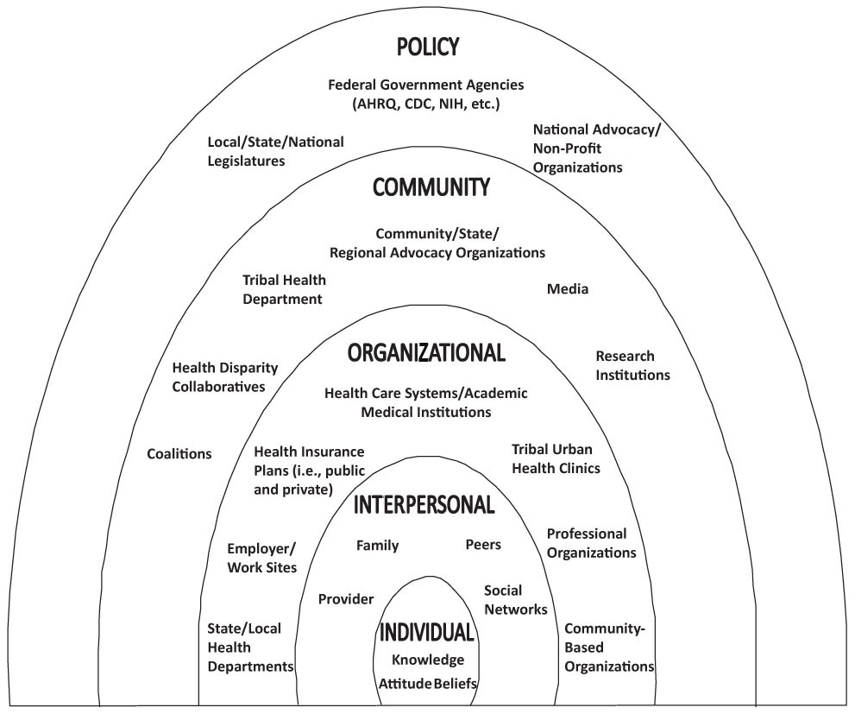
Figure S1: Social Ecological Model (CDC, 2013). Published in accordance with the non-copyright laws of the Centers of Disease Control and Prevention

