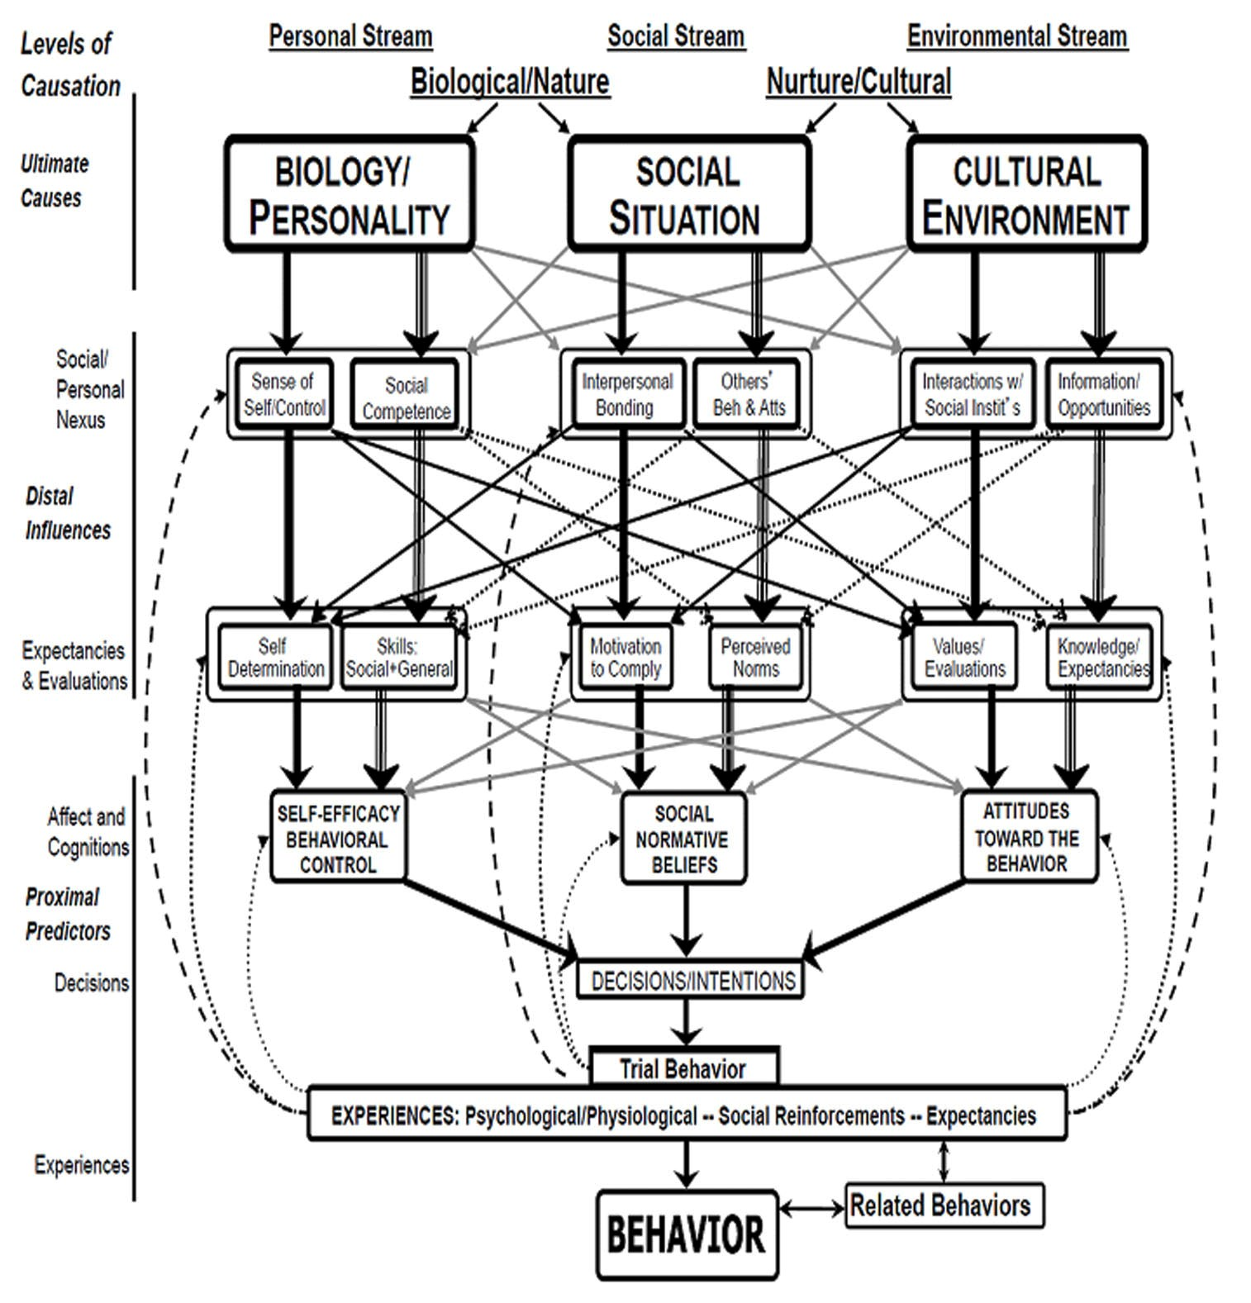
Figure S2: Theory of Triadic Influence (Flay et al, 2009). Published with permission from John Wiley and Sons through Copyright Clearance Center.

