Additional file 1
Supplementary Tables 2
Supplementary Table 1. Weights used to create mean weighted tariffs for health care resources based on the distribution of medical care seek in Venezuela in six health facilities. 2
Supplementary Table 2. Total costs of vaccination and difference between interventions compared (No vaccination, Quadrivalent and Bivalent). Scenarios 1, 3, 5 and 7. Millions of bolívares fuertes (VEF) of 2015. Venezuela 3
Supplementary Table 3. Total QALYs, total costs, and incremental cost-effectiveness ratios for scenarios 1, 3, 5 and 7. Millions of bolívares fuertes (VEF) of 2015. Venezuela 4
Supplementary Table 4: Micro-costing after detection of cervical intraepithelial neoplasia grade 1 (CIN1), due to Oncogenic types. Bolívares fuertes (VEF), 2015. Venezuela 5
Supplementary Table 5: Micro-costing of newly detected cervical intraepithelial neoplasia grade 1(CIN1) due to Oncogenic types. Bolívares fuertes (VEF), 2015. Venezuela 6
Supplementary Table 6: Micro-costing of cervical intraepithelial neoplasia grade 2/3 (CIN2/3) detected. Bolívares fuertes (VEF), 2015. Venezuela 7
Supplementary Table 7: Micro-costing of cervical intraepithelial neoplasia grade 2/3 (CIN2/3) newly detected. Bolívares fuertes (VEF), 2015. Venezuela 8
Supplementary Table 8: Micro-costing of regular screening. Bolívares fuertes (VEF), 2015. Venezuela 9
Supplementary Table 9: Micro-costing of cervical cancer. Bolívares fuertes (VEF), 2015. Venezuela 10
Supplementary Table 10: Micro-costing of Genital Warts. Bolívares fuertes (VEF), 2015. Venezuela 12
Supplementary Table 11: List of unit costs used for analysis. Bolívares fuertes (VEF), 2015. Venezuela 13
Deterministic sensitivity analyses – Tornado graphs 15
Probabilistic sensitivity analyses 22
Supplementary Figure 5. Probabilistic sensitivity analysis – 22

Table S1. Weights used to create mean weighted tariffs for health care resources based on the distribution of medical care seek in Venezuela in six health facilities.

Health Facility 1  (less complex) | Health Facility 2 | Health Facility 3 | Health Facility 4 | Health Facility 5 | Health Facility 6  (most complex)
74% | 26%
74% | 85% |  | 15%
74% | 11% | 11% | 1% | 1% | 1%
Source: adapted from National Health Service (2011)

Table S2. Total costs of vaccination and difference between interventions compared (No vaccination, Quadrivalent and Bivalent). Scenarios 1, 3, 5 and 7. Millions of bolívares fuertes (VEF) of 2015. Venezuela

 |  |  |  | TOTAL COSTS  (millions of VEF) |  |  |  | COSTS DIFFERENCES  (millions of VEF)
 |  |  |  | No vaccination (NV) | Quadrivalent (QV) | Bivalent  (BV) |  | QV-NV | BV-NV | BV-QV
VACCINE COSTS PER SCENARIO
 | 1: Both vaccines = 8.5 US$; 3-dose scheme - FX: 6.3 |  |  | 0 | 40.4 | 40.4 |  | 40.4 | 40.4 | 0
 | 3: Both vaccines = 8.5 US$; 3-dose scheme - FX: 170 |  |  | 0 | 1,089.2 | 1,089.2 |  | 1,089.2 | 1,089.2 | 0
 | 5: BV: 8.5 US$ QV: 13.79 US$; 3-dose scheme - FX: 6.3 |  |  | 0 | 65.5 | 40.4 |  | 65.5 | 40.4 | - 25.1
 | 7: BV: 8.5 US$ QV: 13.79 US$; 3-dose scheme - FX: 170 |  |  | 0 | 1,767.1 | 1,089.2 |  | 1,767.1 | 1,089.2 | - 677.9
Notes: Costs of vaccination (Scenarios 1, 3, 5 and 7). Costs are expressed in millions of VEF, 2015. NV: No vaccination, QV: Quadrivalent, BV: Bivalent, FX: Foreign exchange rate (VEF per US$), CC: Cancer cases; VEF; Venezuelan bolívar fuerte; US$: United States dollar

Table S3. Total QALYs, total costs, and incremental cost-effectiveness ratios for scenarios 1, 3, 5 and 7. Millions of bolívares fuertes (VEF) of 2015. Venezuela
Scenario |  | Quadrivalent vs  No vaccination |  |  |  | Bivalent vs  No vaccination |  |  |  | Bivalent vs  Quadrivalent
 |  | ∆QALYs | ∆COSTS | ICUR |  | ∆QALYs | ∆COSTS | ICUR |  | ∆QALYs | ∆COSTS | ICUR
Scenario
 | 1: Both vaccines = 8.5 US$; 3-dose scheme - FX: 6.3 | 4.395 | -792.2 | cost saving |  | 4.486 | -722.4 | cost saving |  | 91 | 69.8 | 0.77
 | 3: Both vaccines = 8.5 US$; 3-dose scheme - FX: 170 | 4.395 | 256.6 | 0.06 |  | 4.486 | 326.4 | 0.07 |  | 91 | 69.8 | 0.77
 | 5: BV: 8.5 US$ QV:13.79 US$; 3-dose scheme - FX: 6.3 | 4.395 | -767.1 | cost saving |  | 4.486 | -722.4 | cost saving |  | 91 | 44.7 | 0.49
 | 7: BV: 8.5 US$ QV:13.79 US$; 3-dose scheme - FX: 170 | 4.395 | 934.5 | 0.21 |  | 4.486 | 326.4 | 0.07 |  | 91 | -608.1 | cost saving
Notes: Results for a cohort of 264,489 women (discount rate = 5%). Costs and ICURs are expressed in millions of VEF, 2015. FX: exchange rate (VEF per US$); QALYs: quality-adjusted life years; VEF; Venezuelan bolívar fuerte; US$: United States dollar; ICURs: Incremental Cost Utility Ratio; GDP per capita 2015: 0.16 million of Bolivars.

Table S4: Micro-costing after detection of cervical intraepithelial neoplasia grade 1 (CIN1), due to Oncogenic types. Bolívares fuertes (VEF), 2015. Venezuela

Resources | Quantities | Resource use | Unit cost (4) | Total cost
Medical consultation with gynecologist (1) (3) | 3 | 80% | 684.81 | 1,643.55
Biopsy (1) (3) | 1 | 80% | 561.31 | 449.05
Cytology (1) (3) | 2 | 80% | 366.59 | 586.54
Colposcopy (1) | 2 | 80% | 659.47 | 1,055.15
Cryotherapy (2) (3) | 1 | 30% | 3,499.90 | 1,049.97
Electrosurgical excision with loop (LEEP) (1) (3) | 1 | 30% | 34,999.01 | 10,499.70
 |  |  |  | 15,283.96
Notes: (1) Source of quantities: Medina Francisco et al. Cáncer de cuello uterino. Consenso Nacional para el diagnóstico y tratamiento 2010. Rev Venez Oncol 2011, (2) Source of quantities: Cortiñas Paula, Centeno Indira, Sánchez Lander Jorge, Martin David. Reunión de Consenso en Virus de Papiloma Humano 2008. Gac Méd Caracas 1009; (3) Source of resource use data: Consulta Instituto de Oncología Dr. Luis Razetti; (4) See supplementary Table 11

Table S5: Micro-costing of newly detected cervical intraepithelial neoplasia grade 1(CIN1) due to Oncogenic types. Bolívares fuertes (VEF), 2015. Venezuela

Resources | Quantities | Resource use | Unit cost (4) | Total cost
Medical consultation with gynecologist (1) (3) | 3 | 70% | 684.81 | 1,438.11
Cytology (1) (3) | 1 | 70% | 366.59 | 256.61
Colposcopy (1) | 1 | 70% | 659.47 | 461.63
Biopsy (1) (3) | 1 | 70% | 561.31 | 392.92
Cryotherapy (2) (3) | 1 | 20% | 3,499.90 | 699.98
Electrosurgical excision with loop (LEEP) (1) (3) | 1 | 50% | 34,999.01 | 17,499.51
 |  |  |  | 20,748.75
Notes: (1) Source of quantities: Medina Francisco et al. Cáncer de cuello uterino. Consenso Nacional para el diagnóstico y tratamiento 2010. Rev Venez Oncol 2011, (2) Source of quantities: Cortiñas Paula, Centeno Indira, Sánchez Lander Jorge, Martin David. Reunión de Consenso en Virus de Papiloma Humano 2008. Gac Méd Caracas 1009; (3) Source of resource use data: Consulta Instituto de Oncología Dr. Luis Razetti; (4) See supplementary Table 11

Table S6: Micro-costing of cervical intraepithelial neoplasia grade 2/3 (CIN2/3) detected. Bolívares fuertes (VEF), 2015. Venezuela

Resources | Quantities (1) | Resource use (2) | Unit cost (3) | Total cost
Medical consultation with gynecologist | 3 | 80% | 684.81 | 1,643.55
Cytology | 1 | 80% | 366.59 | 293.27
Colposcopy | 2 | 80% | 659.47 | 1,055.15
Biopsy | 1 | 80% | 561.31 | 449.05
Electrosurgical excision with loop (LEEP) | 1 | 60% | 34,999.01 | 20,999.41
Conization with cold scalpel | 1 | 30% | 13,048.27 | 3,914.48
 |  |  |  | 28,354.90
Notes: (1) Source of quantities: Medina Francisco et al. Cáncer de cuello uterino. Consenso Nacional para el diagnóstico y tratamiento 2010. Rev Venez Oncol 2011, (2) Source of resource use data: Consulta Instituto de Oncología Dr. Luis Razetti; (3) See supplementary Table 11

Table S7: Micro-costing of cervical intraepithelial neoplasia grade 2/3 (CIN2/3) newly detected. Bolívares fuertes (VEF), 2015. Venezuela

Resources | Quantities (1) | Resource use (2) | Unit cost (3) | Total cost
Medical consultation with gynecologist | 3 | 70% | 684.81 | 1,438.11
Cytology | 1 | 70% | 366.59 | 256.61
Colposcopy | 2 | 70% | 659.47 | 923.25
Biopsy | 1 | 70% | 561.31 | 392.92
Electrosurgical excision with loop (LEEP) | 1 | 40% | 34,999.01 | 13,999.60
Conization with cold scalpel | 1 | 40% | 13,048.27 | 5,219.31
 |  |  |  | 22,229.80
Notes: (1) Source of quantities: Medina Francisco et al. Cáncer de cuello uterino. Consenso Nacional para el diagnóstico y tratamiento 2010. Rev Venez Oncol 2011, (2) Source of resource use data: Consulta Instituto de Oncología Dr. Luis Razetti; (3) See supplementary Table 11

Table S8: Micro-costing of regular screening. Bolívares fuertes (VEF), 2015. Venezuela

Resources | Quantities (1) | Resource use (2) | Unit cost (3) | Total cost
Medical consultation with gynaecologist | 2 | 100% | 1,240.00 | 2,480.00
Papanicolaou | 1 | 100% | 462.50 | 462.50
 |  |  |  | 2,942.50
Notes: (1) Source of quantities: Medina Francisco et al. Cáncer de cuello uterino. Consenso Nacional para el diagnóstico y tratamiento 2010. Rev Venez Oncol 2011, (2) Source of resource use data: Consulta Instituto de Oncología Dr. Luis Razetti; (3) See supplementary Table 11

Table S9: Micro-costing of cervical cancer. Bolívares fuertes (VEF), 2015. Venezuela
Resources |  | Quantities | Resource use | Unit cost (4) | Total cost
Cáncer Cervical - stage IA1 |  |  | 3.5%
 | Day of hospitalization (1) (3) | 2 | 70% | 3,704.59 | 5,186.43
 | Hysterectomy, simple (1) (3) | 1 | 40% | 92,720.87 | 37,088.35
 | Conization with ASA or cold (1) (3) | 1 | 30% | 13,048.27 | 3,914.48
 | Chest x-ray (1) (3) | 1 | 70% | 1,073.83 | 751.68
 | Consultation with oncologist / gynecologist (1) (3) | 3 | 70% | 684.81 | 1,438.11
 | Laboratory (3) | 1 | 70% | 2,110.86 | 1,477.61
 | Preoperative evaluation (consultation) (3) | 1 | 70% | 2,043.20 | 1,430.24
 | Magnetic resonance imaging of abdomen and pelvis (3) | 1 | 50% | 8,007.35 | 4,003.67
 | Biopsy (3) | 1 | 70% | 561.31 | 392.92
 | Subtotal |  |  |  | 55,683.49
Cáncer Cervical - stage IA2, IB1, IIA1 |  |  | 36.8%
 | Day of hospitalization (1) (3) | 2 | 70% | 3,704.59 | 5,186.43
 | Radical hysterectomy (1) (3) | 1 | 70% | 92,720.87 | 64,904.61
 | Biopsy (1) (3) | 1 | 70% | 561.31 | 392.92
 | Chest x-ray (1) (3) | 1 | 70% | 1,073.83 | 751.68
 | Consultation with oncologist / gynecologist (1) (3) | 3 | 70% | 684.81 | 1,438.11
 | MRI of the abdomen and pelvis (1) (3) | 1 | 50% | 8,007.35 | 4,003.67
 | Subtotal |  |  |  | 76,677.42
Cáncer Cervical - stage IB2, IIA2, III y IV |  |  | 59.6%
 | Chest x-ray (per study) (1) (3) | 1 | 80% | 1,073.83 | 859.07
 | Cystoscopy (per study) (1) (3) | 1 | 80% | 2,382.27 | 1,905.81
 | Rectosigmoidoscopy (per study) (1) (3) | 1 | 80% | 2,926.45 | 2,341.16
 | Chemotherapy (per session) (1) (3) | 6 | 80% | 61,706.44 | 49,365.15
 | Radiotherapy (per session) (1) (3) | 25-30 | 80% | 265,144.02 | 212,115.22
 | Brachytherapy (per session) (3) | 4 | 80% | 37,565.61 | 120,209.94
 | Consultation with a medical oncologist (3) | 8 | 80% | 1,060.58 | 6,787.69
 | Consultation with readiotherapist (3) | 6 | 80% | 1,590.86 | 7,636.15
 | Hospitalization due to complications (per day) (3) | 5 | 20% | 3,704.59 | 3,704.59
 | Nuclear magnetic resonance (3) | 1 | 10% | 4,003.67 | 400.37
 | Abdominoplasty (3) | 1 | 60% | 5,168.88 | 3,101.33
 | Subtotal |  |  |  | 408,426.47
Total (weighted average) |  |  |  |  | 273,787.53
Notes: (1) Source of quantities: Medina Francisco et al. Cáncer de cuello uterino. Consenso Nacional para el diagnóstico y tratamiento 2010. Rev Venez Oncol 2011, (2) Source of quantities: Cortiñas Paula, Centeno Indira, Sánchez Lander Jorge, Martin David. Reunión de Consenso en Virus de Papiloma Humano 2008. Gac Méd Caracas 1009; (3) Source of resource use data: Instituto de Oncología Dr. Luis Razetti; (4) See supplementary Table 11

Table S10: Micro-costing of Genital Warts. Bolívares fuertes (VEF), 2015. Venezuela
Resources | Quantities (1) | Resource use (1) | Unit cost (2) | Total cost
Medical consultation with specialist doctor | 3 | 100% | 616.57 | 1,849.70
Pap smear | 1 | 90% | 366.59 | 329.93
Colposcopy | 3 | 60% | 659.47 | 1,187.04
Imiquimod self-treatment | 1 | 60% | 841.04 | 504.62
Cryotherapy (session) | 1 | 20% | 3,499.90 | 699.98
15-15% Podofilin / cauterization or excision (per session) | 3 | 10% | 599.06 | 179.72
Surgery | 1 | 25% | 19,266.40 | 4,816.60
 |  |  |  | 9,567.58
Notes: (1) Source of quantities and resource use: Instituto de Oncología Dr. Luis Razetti; (2) See supplementary Table 11

Table S11: List of unit costs used for analysis. Bolívares fuertes (VEF), 2015. Venezuela

Item | Unit cost  (VEF)
15-25% Podofilin / cauterization or excision | 599
Abdominoplasty | 5,169
Biopsy | 529
Brachytherapy | 37,566
Chemotherapy drugs | 61,706
Colposcopy | 659
Consultation with Gynecologist | 685
Consultation with Gynecologist II | 1,240
Consultation with radiotherapist | 1,591
Consultation with specialist doctor | 617
Conventional surgery (cold scalpel) (neck conization) | 13,048
Cryotherapy | 3,500
Cystoscopy | 2,382
External Radiotherapy | 265,144
Hospitalization day | 3,705
Imiquimod self-treatment: 5% cream (80%) or 3.75% cream (20%) | 841
Magnetic resonance imaging of abdomen and pelvis | 8,007
Magnetic resonance, with contrast | 4,004
Oncologist Consultation | 1,061
Papanicolaou / Cytology | 367
Preoperative evaluation (consultation) | 2,043
Preoperative profile | 2,111
Radical Hysterectomy | 92,721
Rectoscopy | 2,926
Surgery Electrosurgery (Ib, A) | 9,752
Surgery Radiofrequency (electrosurgery or Leep) | 34,999
Torax X-ray, two projections | 1,074
Notes: Unit costs were obtained from six local health facilities. Values are weighted averages according to the information of supplementary table 1 and are expressed in 2015 Bolívares Fuertes (VEF)

Deterministic sensitivity analyses – Tornado graphs

Abbreviations: COSTS_Genital Wart = Costs of genital warts management; COSTS_Cancer = Costs of cervical cancer management; COSTS_Vaccine Cervarix™ = Costs of quadrivalent vaccine; COSTS_Vaccine Gardasil = Costs of bivalent vaccine; T_prob: HPVlr_NoHPV = transition probability to regress from low-risk HPV to no HPV; T_prob: HPVOnc_NoHPV = Transition probability to regress from infection with oncogenic HPV to no HPV; T_prob: HPVOnc_CIN1 = Transition probability to progress from infection with oncogenic HPV to CIN1; T_prob: CIN1Onc_CIN23 = Transition probability to progress from infection with oncogenic HPV and CIN1 to CIN2/3; T_prob: CIN23_Cancer = Transition probability to progress from CIN2/3 to cancer; T_prob: CIN1Onc_cured = Transition probability to cure from oncogenic HPV infection with CIN1; T_prob: CIN23_Cured = Transition probability to cure from CIN2/3; T_prob: Cancer_Cured = Transition probability to cure from cervical cancer; Vac_eff_1618_Cervarix™ = Vaccine efficacy for oncogenic types with quadrivalent vaccine; Vac_eff_1618_Gardasil = Vaccine efficacy for oncogenic types with bivalent vaccine; Vac_eff_other_Gardasil = Vaccine efficacy for non-vaccine oncogenic HPV types with bivalent vaccine; Perc_HPV_6_11 = Proportion of HPV 6 and 11 in genital warts; Perc_other_CC = Proportion of non-vaccine oncogenic HPV types among Cervical Cancer; Perc_HPVOnc = Proportion of HPV 16 and 18 among Cervical Cancer.

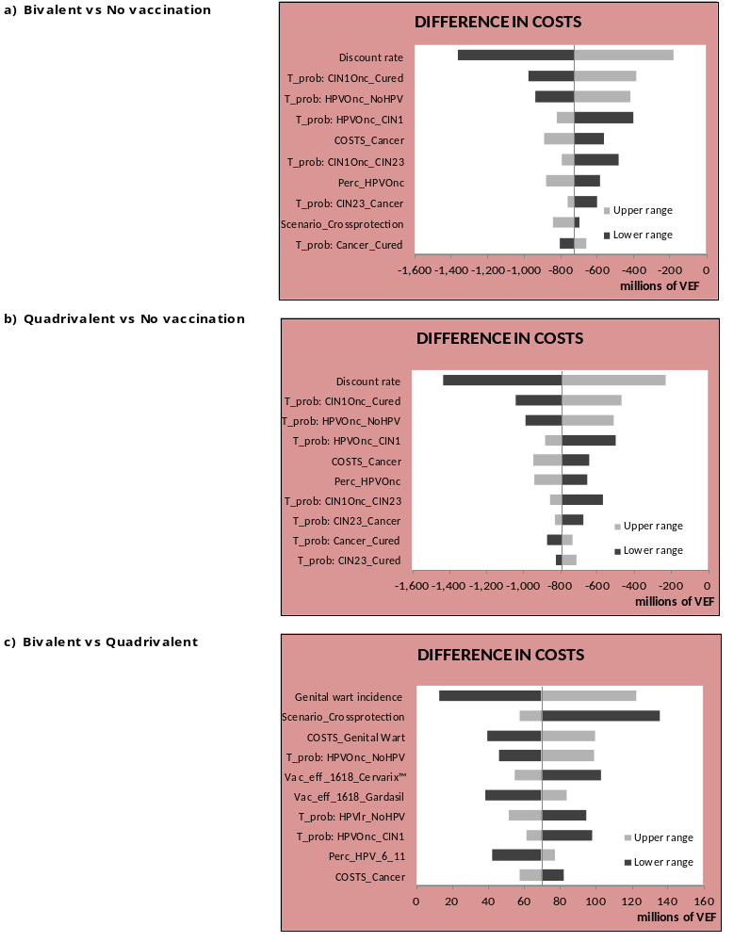

Figure S1 above. Deterministic sensitivity analysis – Scenario 1: Tornado graph for costs differences in scenario 1 (same vaccine price per dose of 8.5 US$, exchange rate of 6.3 US$, scheme of 3 doses). Discount rate = 5%.

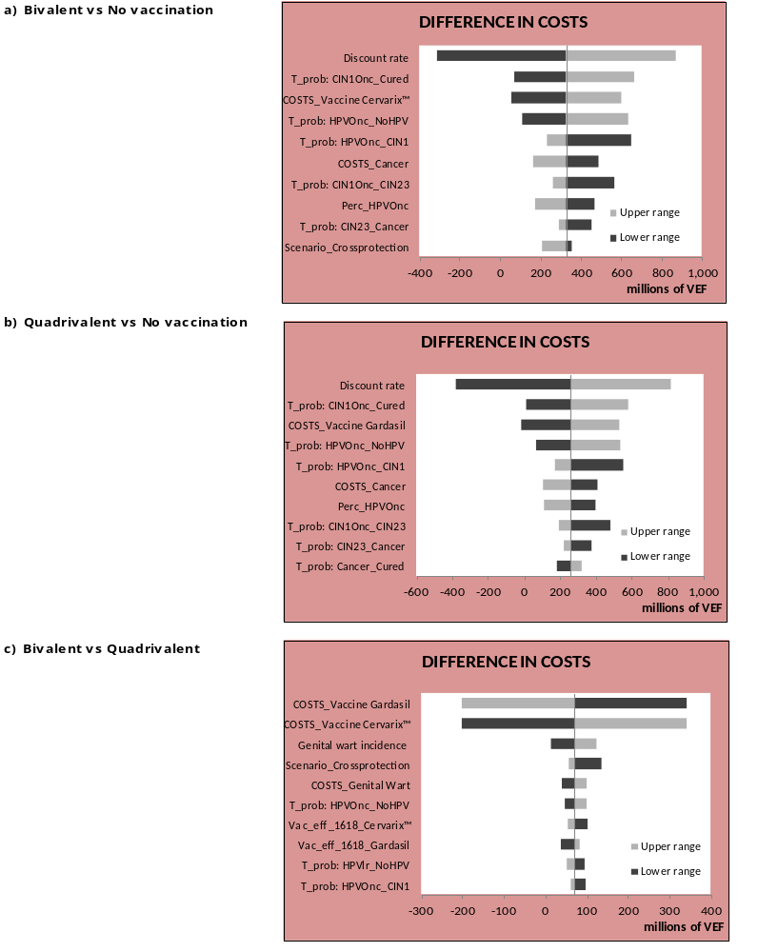

Figure S2 above. Deterministic sensitivity analysis – Scenario 3: Tornado graph for costs differences in scenario 3 (same vaccine price per dose of 8.5 USD, exchange rate of 170 US$, scheme of 3 doses). Discount rate = 5%.

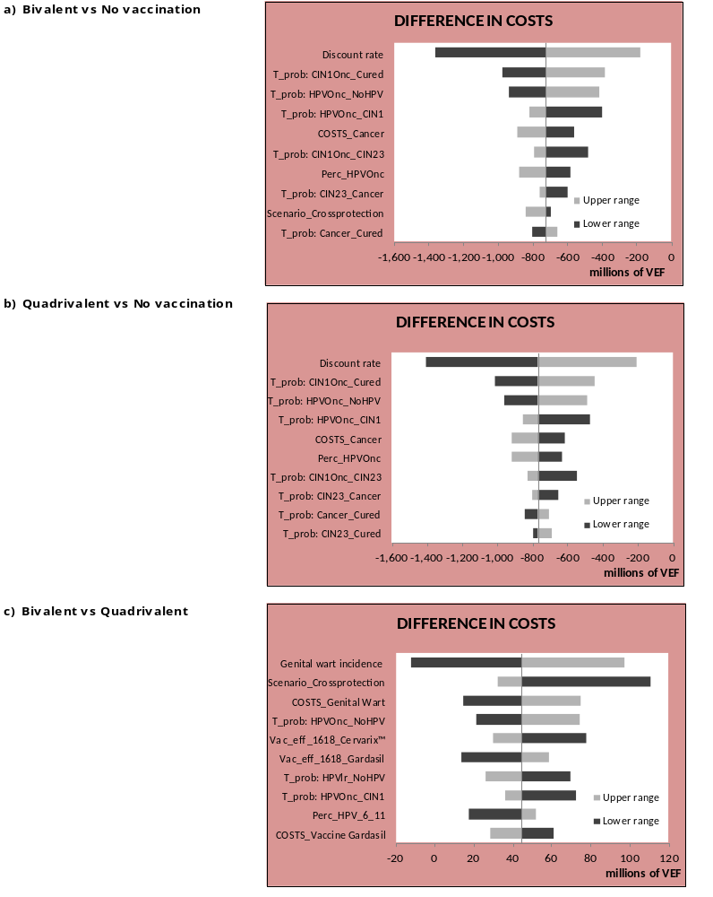

Figure S3 above. Deterministic sensitivity analysis – Scenario 5: Tornado graph for costs differences in scenario 5 (Vaccine price per dose of 8.5 US$ for bivalent and 12 US$ for quadrivalent, exchange rate of 6.3 US$, scheme of 3 doses). Discount rate = 5%.

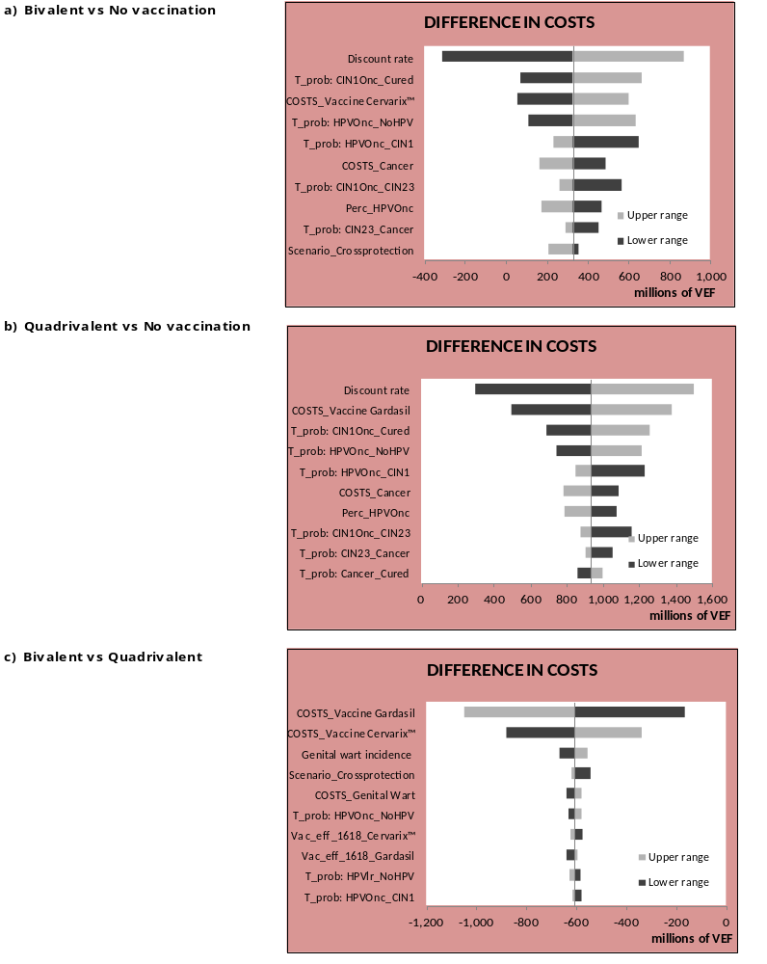

Figure S4 above. Deterministic sensitivity analysis – Scenario 7: Tornado graph for costs differences in scenario 7 (Vaccine price per dose of 8.5 US$ for bivalent and 12 US$ for quadrivalent, exchange rate of 170 US$, scheme of 3 doses). Discount rate = 5%.

Figure S5 below. Deterministic sensitivity analysis – Scenario 6: Tornado graph for costs differences in scenario 7 (Vaccine price per dose of 8.5 US$ for bivalent and 13.79 US$ for quadrivalent, exchange rate of 170 US$, scheme of 2 doses). Discount rate = 5%.
A) Scenario 6
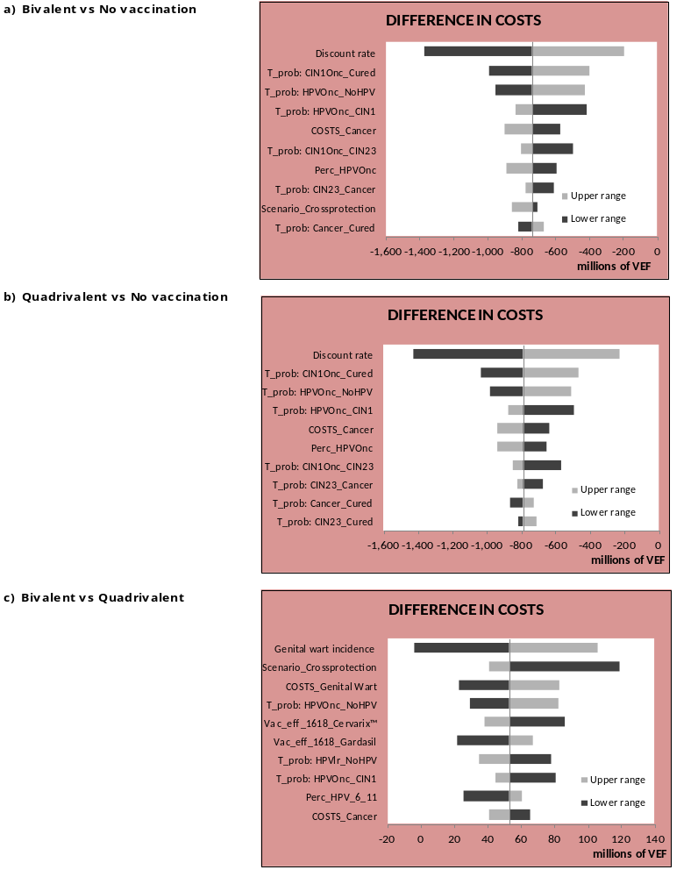

Figure S6 below. Deterministic sensitivity analysis – Scenario 8: Tornado graph for costs differences in scenario 7 (Vaccine price per dose of 8.5 US$ for bivalent and 13.79 US$ for quadrivalent, exchange rate of 170 US$, scheme of 2 doses). Discount rate = 5%.
B) Scenario 8
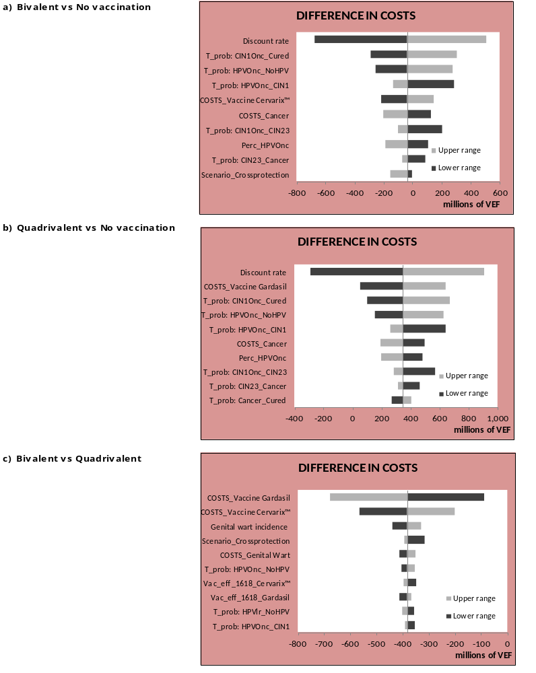

Probabilistic sensitivity analyses

Figure S5. Probabilistic sensitivity analysis –
Scatter plots for A.) costs and B.) QALYs differences, C.) Cost-effectiveness acceptability curves (probability of being the most cost-effective intervention) for scenario 1 (same vaccine price per dose of 8.5 US$, exchange rate of 6.3 US$, scheme of 3 doses), scenario 3 (same vaccine price per dose of 8.5 US$, exchange rate of 170 US$, scheme of 3 doses), scenario 5 (vaccine price per dose of 8.5 US$ for bivalent and 13.79 US$ for quadrivalent, exchange rate of 6.3 US$, scheme of 3 doses) and scenario 7 (vaccine price per dose of 8.5 US$ for bivalent and 13.79 US$ for quadrivalent, exchange rate of 170 US$, scheme of 3 doses). Discount rate = 5%. Also shown scenarios with 2 doses: Scenario 6 (vaccine price per dose of 8.5 US$ for Bivalent and 13.79 US$ for Quadrivalent, exchange rate of 6.3 VEF, scheme of 2 doses) and scenario 8 (vaccine price per dose of 8.5 US$ for bivalent and 13.79 US$ for quadrivalent, exchange rate of 170 VEF, scheme of 2 doses). Discount = rate 5%.

Scenario 1

A) | B)
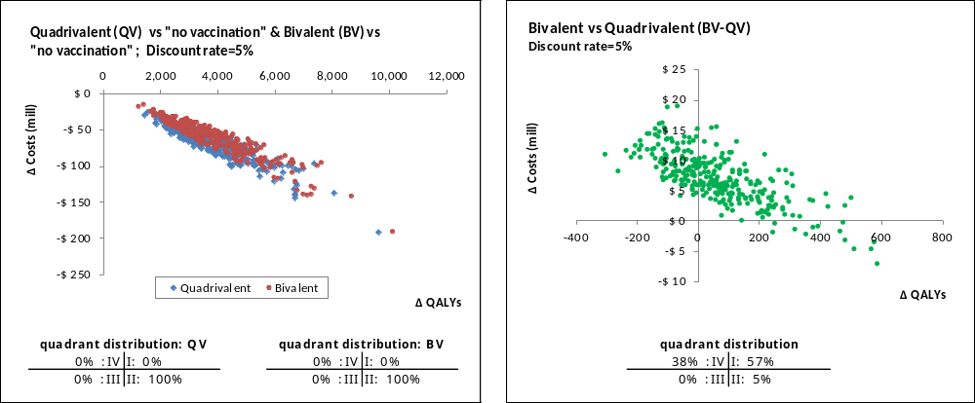

C)
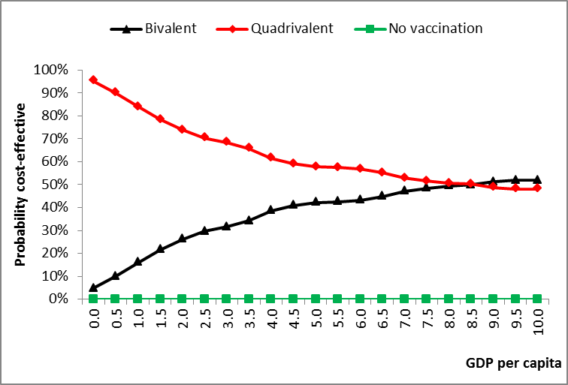
Scenario 3

A) | B)
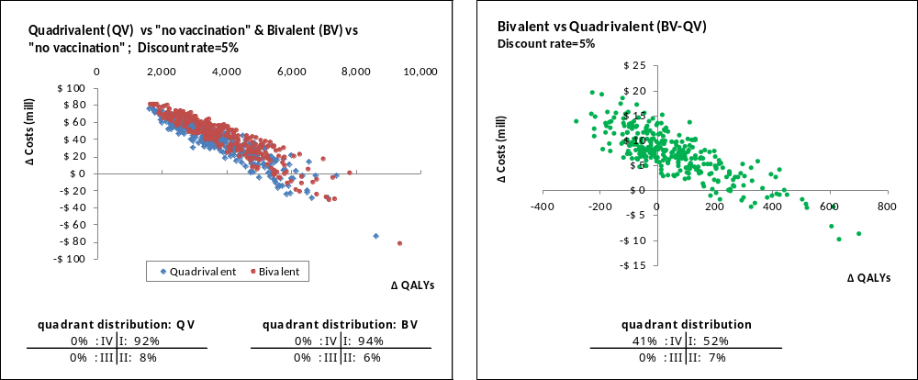

C)
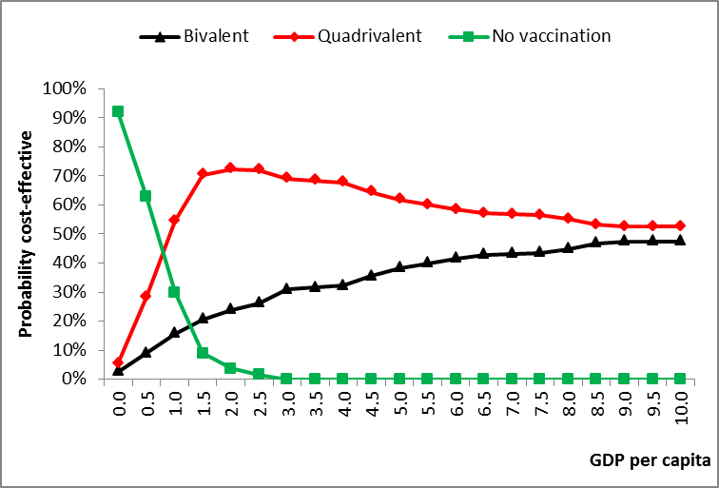
Scenario 5

A) | B)
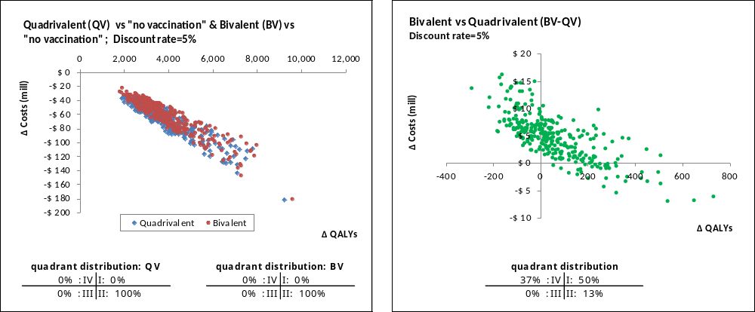

C)
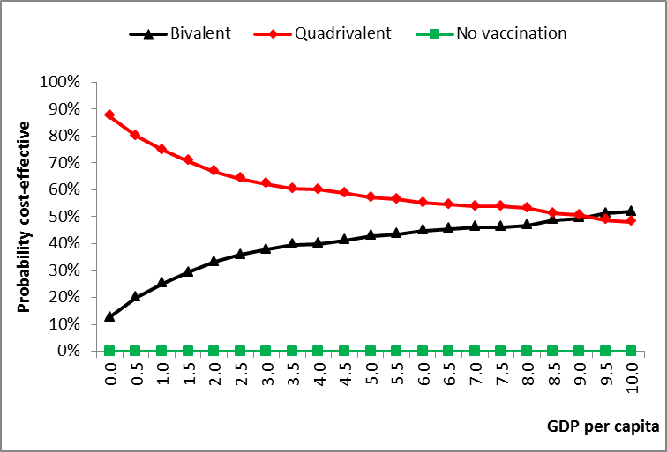

Scenario 7

A) | B)
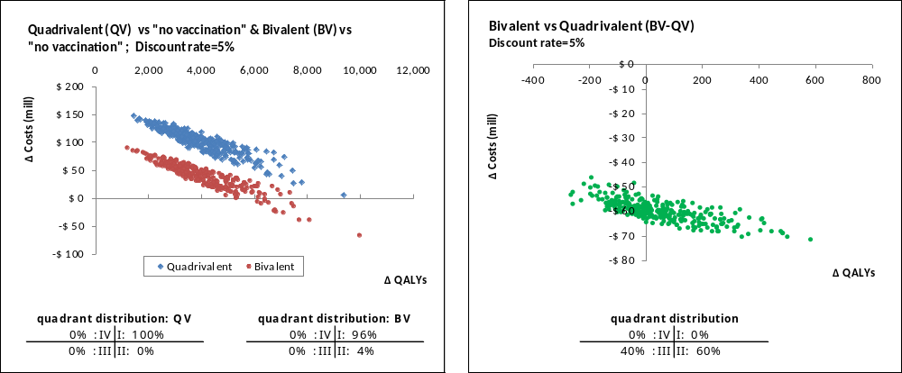

C)
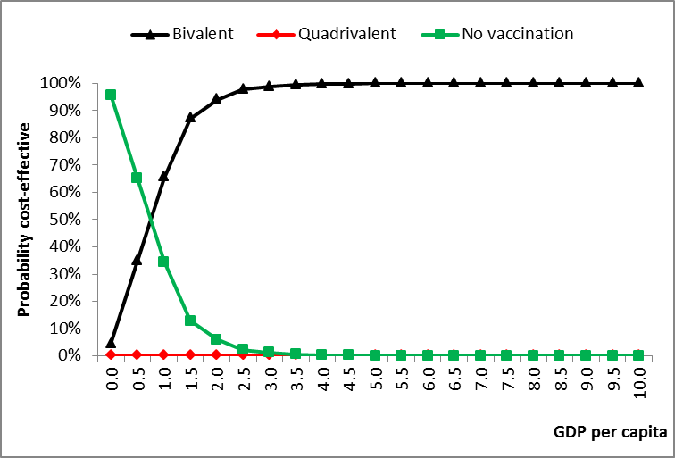
Scenario 6

A) | B)

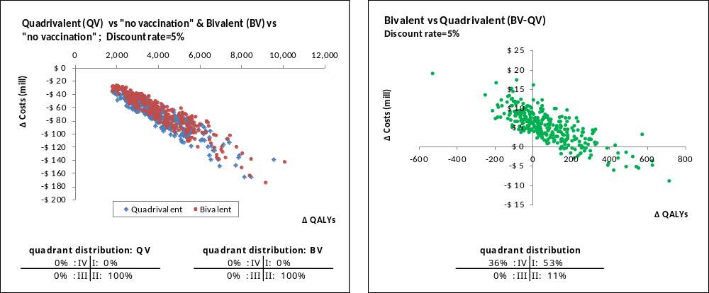

C)
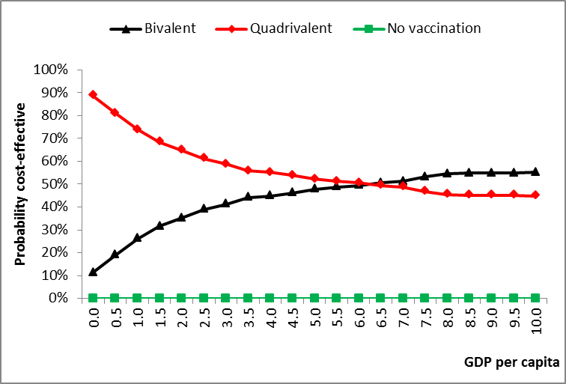
Scenario 8

A) | B)

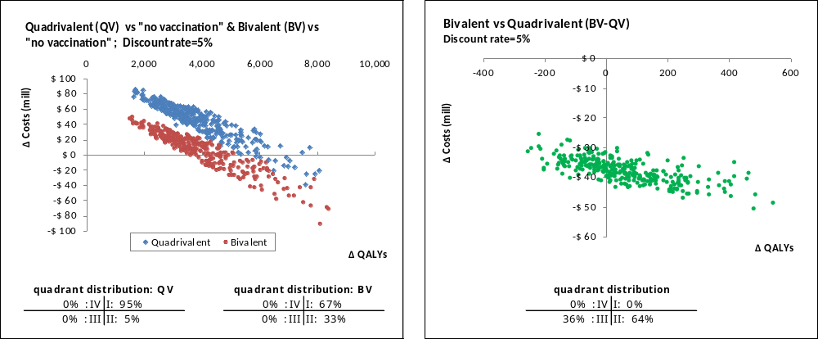

C)
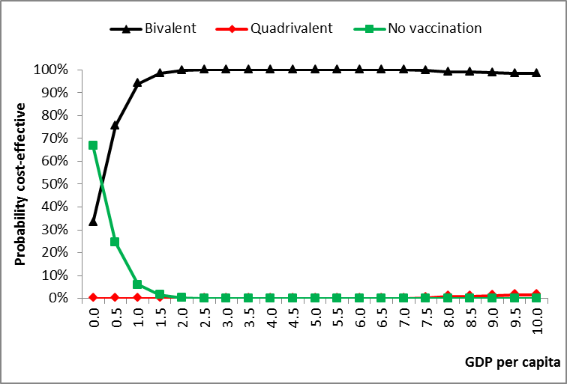

National Health Services, UK. Technical Guide to the formulae for 2014-15 and 2015- 16 revenue allocations to Clinical Commissioning Groups and Area Teams. https://www.england.nhs.uk/wp-content/uploads/2014/03/tech-guide-rev-allocs.pdf Accessed Nov 2, 2015
GDP Per Capita (Current Prices, National Currency) Data for All Countries. 2015. EconomyWatch.com's Econ Stats database. http://www.economywatch.com/economic-statistics/economic-indicators/GDP_Per_Capita_Current_Prices_National_Currency/ Accessed November 2, 2015

