Appendix 1: P.A.R.T.Y. Defence Attitudes and Behaviours Questionnaire
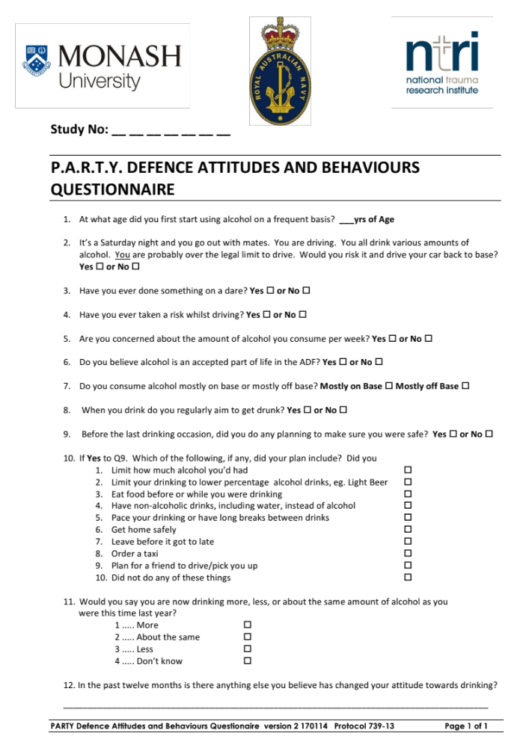

Appendix 2: P.A.R.T.Y. Defence In-Hospital Program

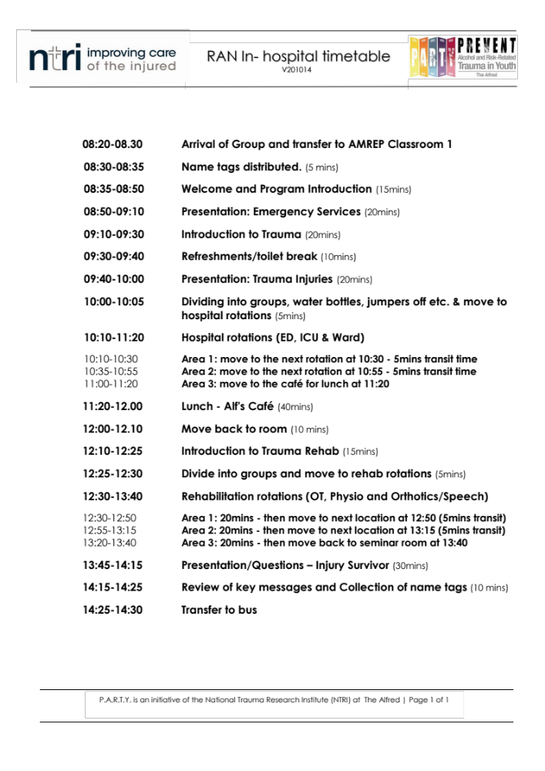

Appendix 3: P.A.R.T.Y. Defence On-Base program

