Additional File 4- Search Strategy for Databases (June 5, 2015)
PubMed Database Search:
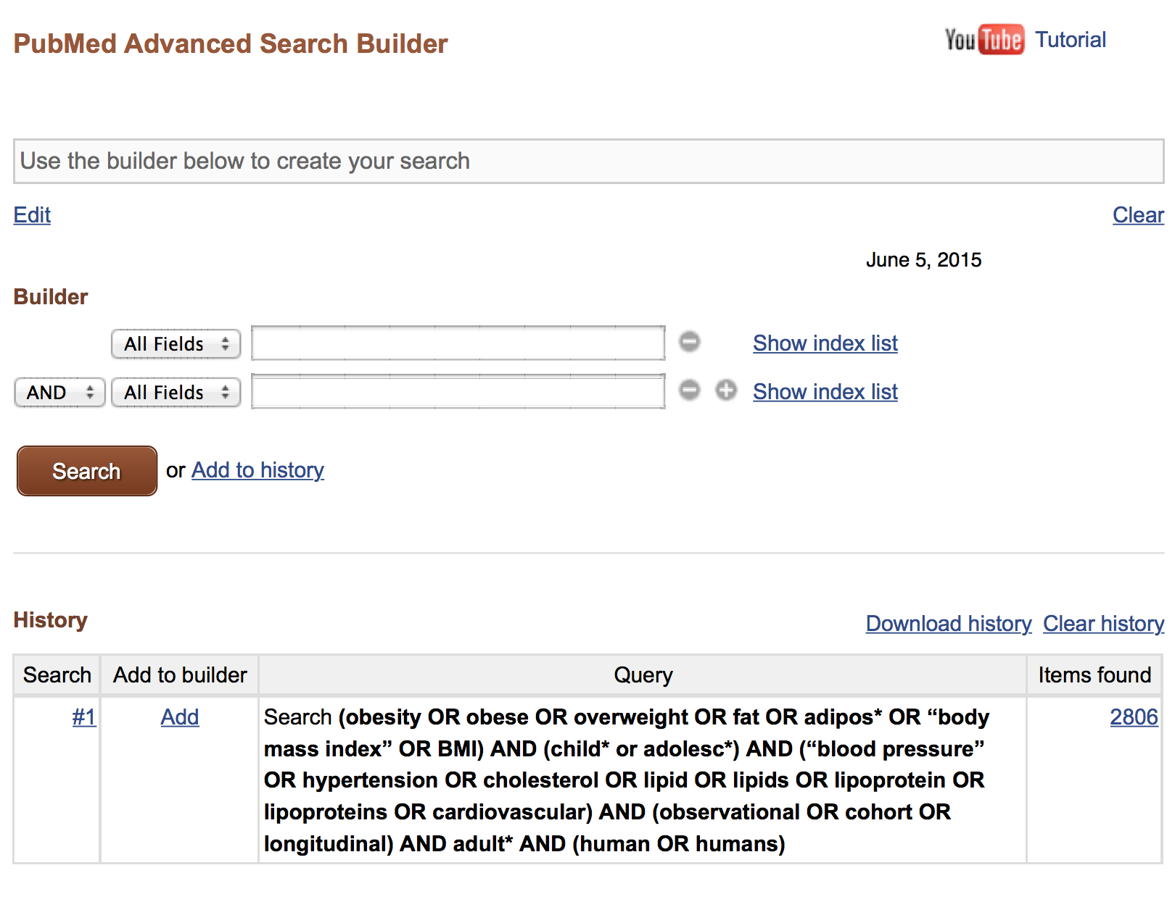
Web of Science Database Search
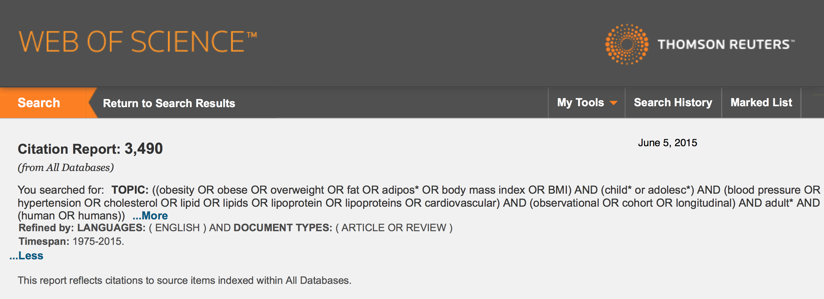

Scopus Database Search
