Supplementary Material

Ability of ecological deprivation indices to measure social inequalities in a French cohort

Authors:
Sofia Temam^{1,2,3}, Raphaëlle Varraso^{1,3}, Carole Pornet⁴, Margaux Sanchez^{1,2,3}, Aurélie Affret^{2,5}, Bénédicte Jacquemin^{1,3,6,7,8} Françoise Clavel-Chapelon^{2,5}, Grégoire Rey⁹, Stéphane Rican¹⁰, Nicole Le Moual^{1,3}

¹ INSERM, U1168, VIMA: Aging and chronic diseases. Epidemiological and public health approaches, Villejuif, France
² Univ Paris Sud, Le Kremlin-Bicêtre, France
³ Univ Versailles St-Quentin-en-Yvelines, UMR-S 1168, F-78180, Montigny le Bretonneux, France
⁴ Agence Régionale de Santé (ARS) Basse-Normandie, Caen, France
⁵ INSERM, U1018, Centre for Research in Epidemiology and Population Health (CESP), Mode de vie, gènes et santé: épidémiologie intégrée trans-générationnelle, Villejuif, France
⁶ Centre for Research in Environmental Epidemiology (CREAL), Barcelona, Spain
⁷ Universitat Pompeu Fabra (UPF), Barcelona, Spain
⁸ CIBER Epidemiología y Salud Pública (CIBERESP), Barcelona, Spain
⁹ INSERM, CépiDc, Le Kremlin-Bicêtre, France
¹⁰ Université Paris Ouest Nanterre La Défense, LADYSS, Laboratoire dynamiques sociales et recompositions des espaces, Nanterre, France

* Corresponding author:
Sofia Temam: sofia.temam@inserm.fr

Table S1 Variables included in each area-based deprivation index (n=44,709 IRIS)

 | FDep | FEDI | Townsend
Distribution
Mean ±SD | -0.1 ±0.8 | 0.0 ±4.1 | 0.02 ±3.2
Min-Max | -4.2 – 4.6 | -11.7 – 51.1 | -8.9 – 19.3
Census-derived variables included |  | (weight)
Unemployment | x | x (0.47) | x
Blue-collar workers and employees in the labour force | x | x (0.37) | -
Median income per consumption unit or household | x | - | -
Second-year university level (≥ 15 years and older) | x | - | -
Single-parent household | - | x (0.41) | -
Foreigners in total population | - | x (0.23) | -
Low level of education (≥ 15 years and older) | - | x (0.19) | -
Households without a car | - | x (0.52) | x
Households not owner occupied | - | x (0.55) | x
Households without access to central or electric heating | - | x (0.34) | -
Primary residences with >1 person/room | - | x (0.11) | x
Households with ≥ 6 occupants persons |  | x (0.45) | -
±SD= standard deviation
FDep=French Deprivation index, FEDI=French European Deprivation Index (variables are weighted)
Table S2: Associations between individual- and area-level SEP with smoking initiation and overweight among women who did not move between 1991 and 2005 (n=39,130)
 | Smoking  OR (95%CI) | Overweight  OR (95%CI)
Educational level
5-level university [ref.] | - | -
3-/4-level university | 0.96 (0.90-1.03) | 1.01 (0.94-1.09)
High school to 2-level university | 0.61 (0.58-0.64) | 1.31 (1.23-1.39)
< High school | 0.42 (0.39-0.45) | 1.80 (1.66-1.95)
p-value for trend | <0.0001 | <0.0001
FDep
Quintile 1 [ref.] | - | -
Q2 | 0.85 (0.80-0.90) | 1.14 (1.07-1.21)
Q3 | 0.83 (0.78-0.88) | 1.26 (1.18-1.34)
Q4 | 0.79 (0.75-0.84) | 1.29 (1.20-1.37)
Quintile 5 | 0.73 (0.68-0.78) | 1.44 (1.34-1.55)
p-value for trend | <0.0001 | <0.0001
FEDI
Quintile 1 [ref.] | - | -
Q2 | 1.01 (0.95-1.07) | 1.01 (0.95-1.08)
Q3 | 1.03 (0.97-1.10) | 1.04 (0.98-1.11)
Q4 | 1.05 (0.99-1.11) | 1.09 (1.02-1.16)
Quintile 5 | 1.07 (0.99-1.14) | 1.17 (1.08-1.26)
p-value for trend | 0.03 | <0.0001
Townsend
Quintile 1 [ref.] | - | -
Q2 | 1.01 (0.95-1.08) | 0.98 (0.92-1.05)
Q3 | 1.07 (1.01-1.14) | 1.00 (0.94-1.07)
Q4 | 1.14 (1.08-1.22) | 0.95 (0.89-1.02)
Quintile 5 | 1.52 (1.41-1.63) | 0.95 (0.88-1.02)
p-value for trend | <0.0001 | 0.11
OR (95% CI) = odd ratio (95% confidence interval), adjusted for age, with SAS GENMOD procedure
Smoking was defined as ever-smoker (ref) vs. never smoker
Overweight status was defined as a Body Mass Index <25kg/m² (ref) vs. ≥25kg/m²
FDep=French Deprivation index, FEDI=French European Deprivation Index
Q1=least deprived quintile (reference); Q5=most deprived quintile.

Figure S1 Flow-chart: selection of the study population (n=63,888)
Figure S2 Distribution of the E3N population in the whole France deprivation indices quintiles
Study population
n=63,888
Missing values
- Residential addresses (n=462)
i.e. 302 women were living outside France and 160 addresses could not be geocoded
- Area-based deprivation indices (n=424)
- Educational level (n=2824)
- Smoking status (n=1115)
- Body Mass Index (n=2698)

Women who completed the 2005 questionnaire
n=71,411

Quintiles weighted by IRIS population

Unweighted quintiles

IRIS = regrouped statistical information blocks
Weighted quintiles contain approximately 25% of the French population in each ones;
unweighted quintiles contain approximately 25% of the score distribution
FDep=French Deprivation index, FEDI=French European Deprivation Index
Q1=least deprived; Q5=most deprived

Figure S3 Associations between individual-level and three area-based deprivation indices with smoking status stratified by age
p =0.001
p <.0001
p <.0001
p <.0001
p <.0001
p =0.42
p <.0001
p <.0001
OR (95% CI) = odd ratios (95% confidence intervals)
Smoking status: ever-smokers (ref) vs. never smokers
FDep=French Deprivation index, FEDI=French European Deprivation Index
Educational level (EL) was categorised in 4 classes (EL-1=5-level university; EL-2=3-/4-level university diploma; EL-3= high school to 2-level university diploma; EL-4=<high school diploma), with 5-level university diploma as the reference
Q1=least deprived (reference); Q5=most deprived. P-values on the figure are p-values for trend
Figure S4 Comparison of the associations between three area-based deprivations indices with smoking status according to weighted and unweighted quintiles
p <.0001
p <.0001

p <.0001
p <.0001
p <.0001
p <.0001
ORa (95% CI) = odd ratios adjusted for age (95% confidence intervals)
Smoking status: ever-smokers (ref) vs. never smokers
Weighted quintiles: contains approximately 25% of the French population in each ones; unweighted quintiles contain approximately 25% of the score distribution
FDep=French Deprivation index, FEDI=French European Deprivation Index
Q1=least deprived (reference); Q5=most deprived
P-values on the figure are p-values for trend
Figure S5 Comparison of associations between three area-based deprivation indices with overweight status according to weighted and unweighted quintiles
p <.0001
p <.0001

p <.0001
p=0.03
..0
p=0.004
p <.0001
ORa (95% CI) = odd ratios adjusted for age (95% confidence intervals)
Overweight status was defined as a Body Mass Index <25kg/m² (ref) vs. >=25kg/m²
Weighted quintiles contain approximately 25% of the French population in each ones; unweighted quintiles contain approximately 25% of the score distribution
FDep=French Deprivation index, FEDI=French European Deprivation Index
Q1=least deprived (reference); Q5=most deprived
P-values on the figure are p-values for trend

Figure S6 Geographical distribution of the three deprivation indices at IRIS level in France
FEDI
Townsend Index
FDep
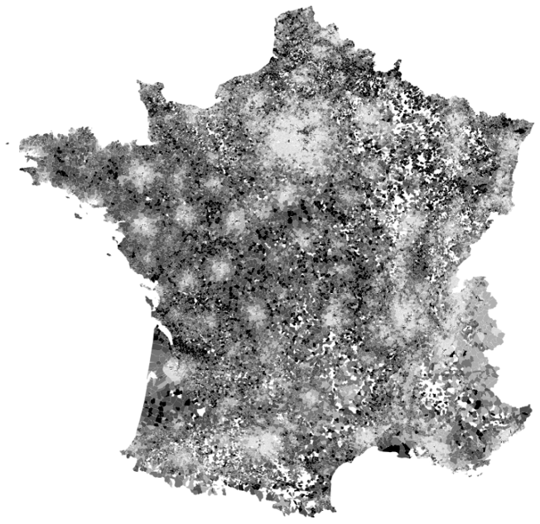
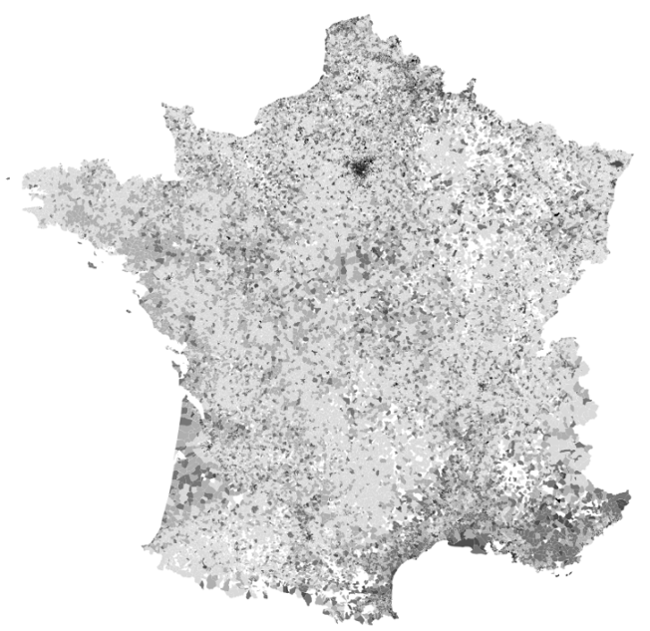
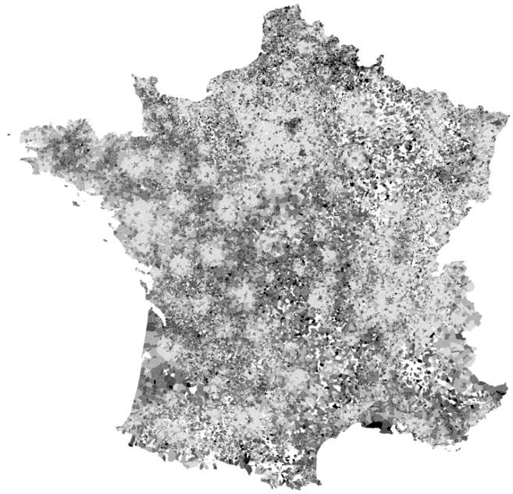

IRIS = regrouped statistical information blocks
FDep=French Deprivation index, FEDI=French European Deprivation Index
Quintiles (Q) are weighted by the IRIS population
Communes with at least 5000 inhabitants are divided in IRIS containing on average 2000 inhabitants, while smaller towns form one IRIS each.

