Annex 2: Structure of the MINDMAP project
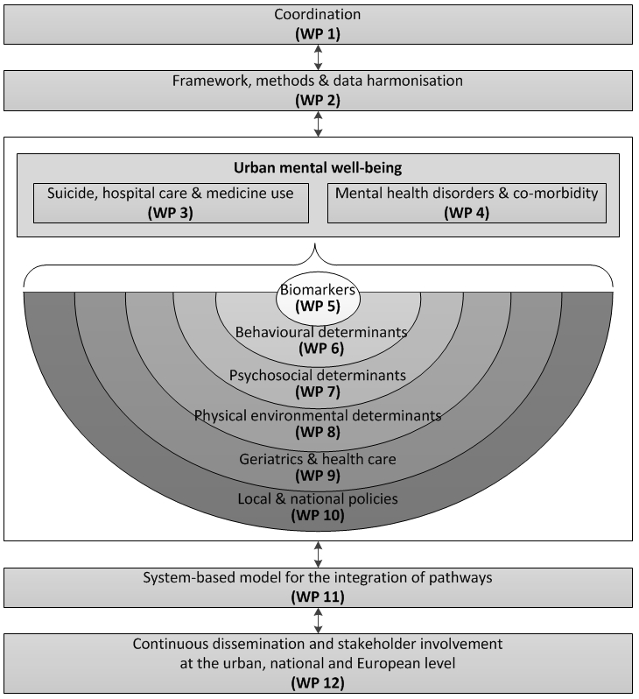
Note: WP = Work Package

