Additional file 2
Figure S1. Association between mental health status and employment stability by partner/marital status among men and women. Spanish National Health Survey, 2006.
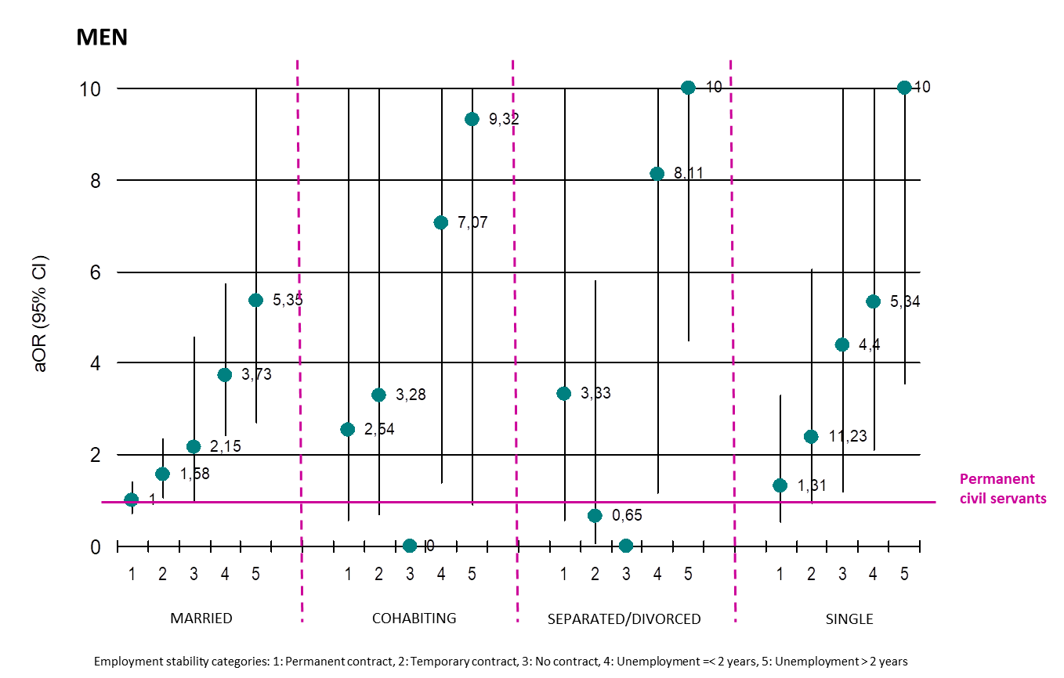

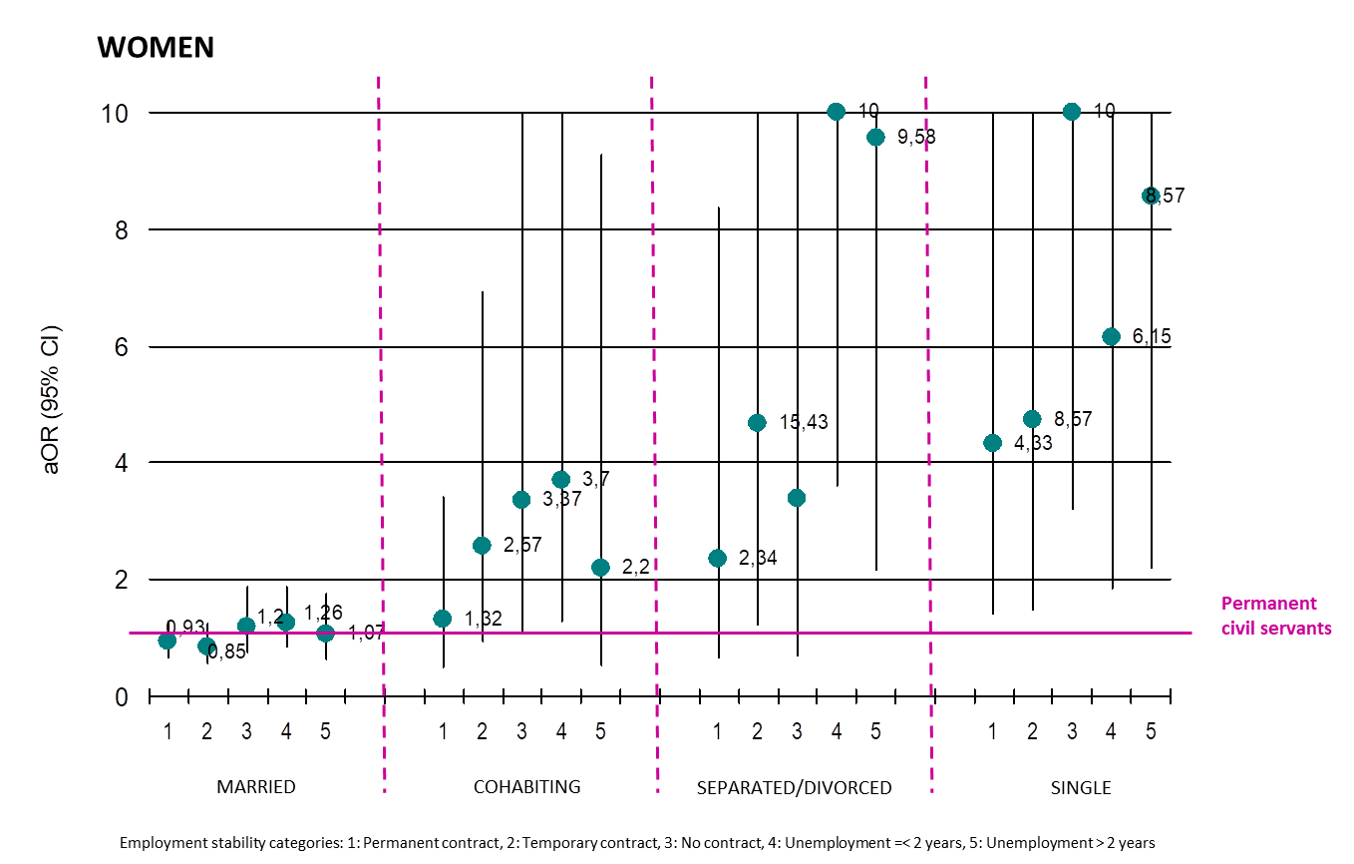

Note: the upper IC limit has been truncated in value 10 for graphic reasons.

