Target Area boundaries for each intervention and comparison site

This document provides maps of the boundaries for the Target Areas in each intervention and comparison site. Each map also shows the primary location for the observer during observation periods and locations where the urban street greening interventions will be implemented at each intervention site.

Key
X = Observer location

= Target area boundary

= Location where the urban street greening interventions will be implemented

Maps drawn using: www.digimap.edina.ac.uk
© Crown Copyright and Database Right (2018). Ordnance Survey (Digimap Licence)

Intervention site 1

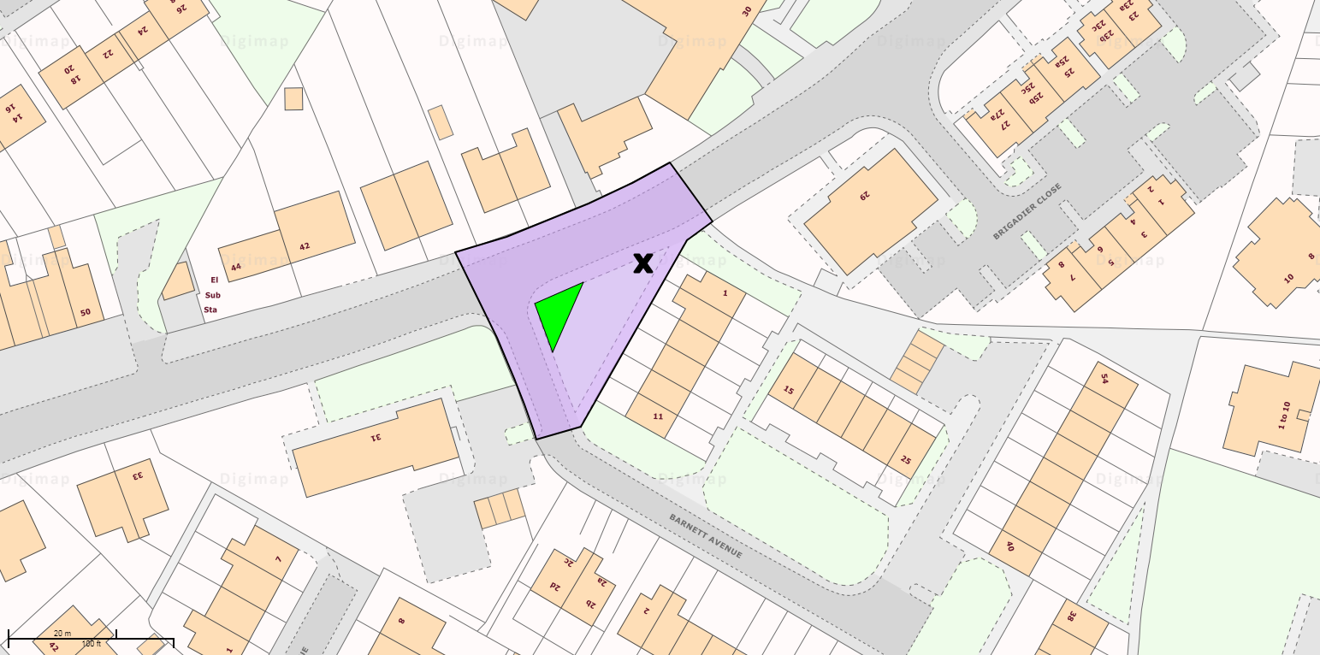

Comparison site 1A

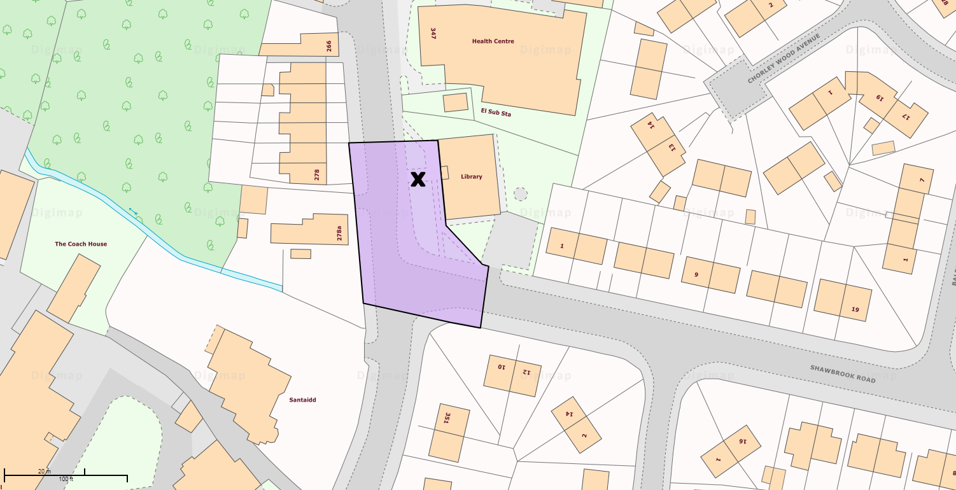

Comparison site 1B

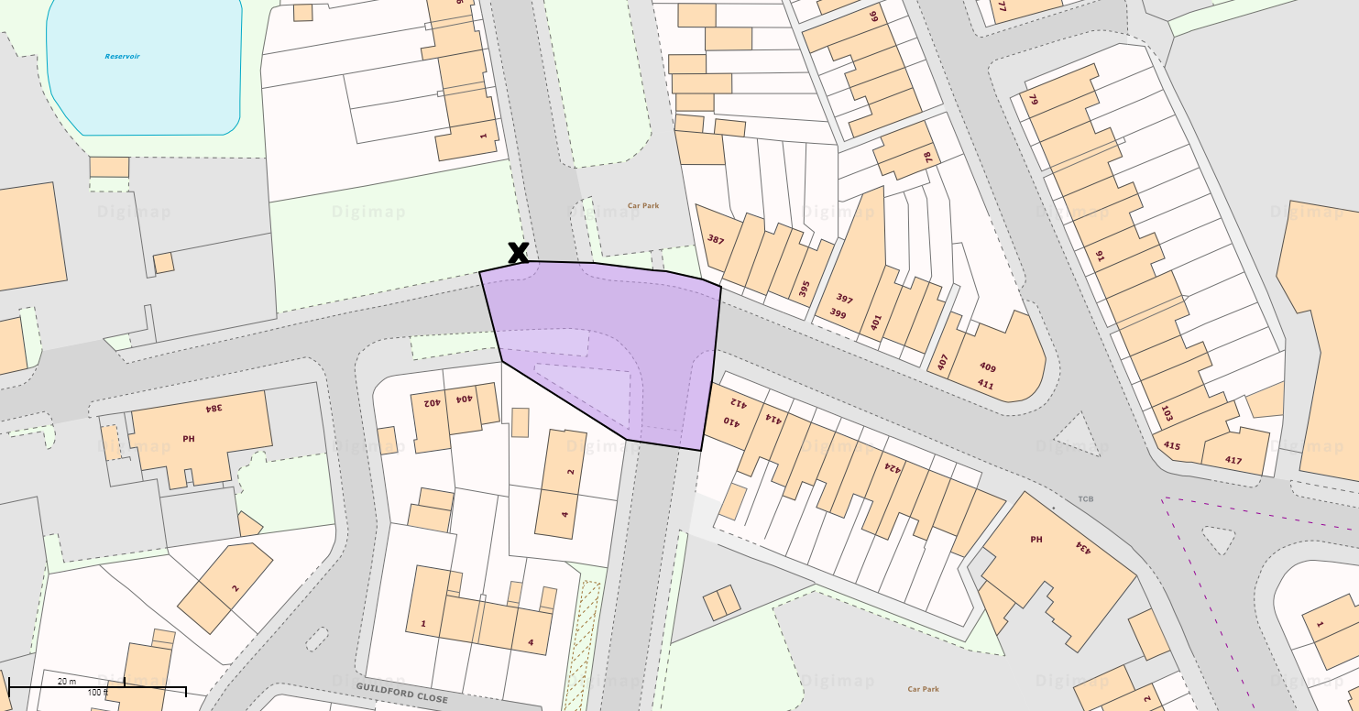

Intervention site 2

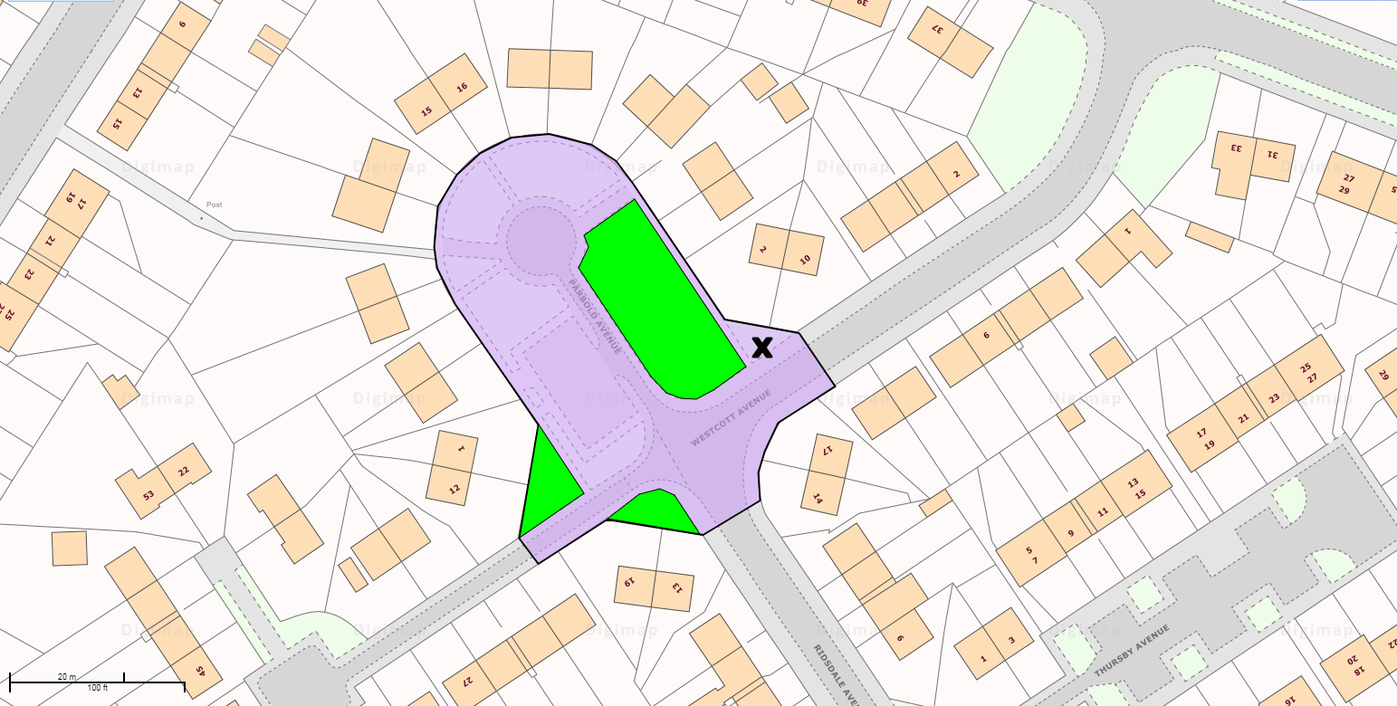

Comparison site 2A

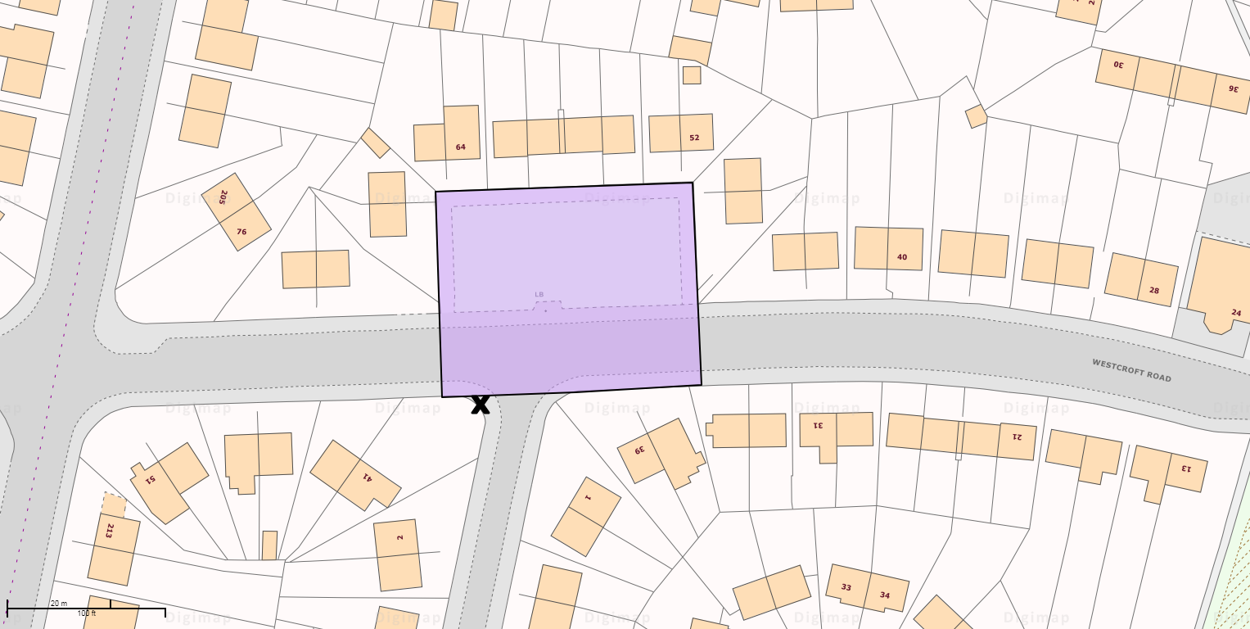

Comparison site 2B

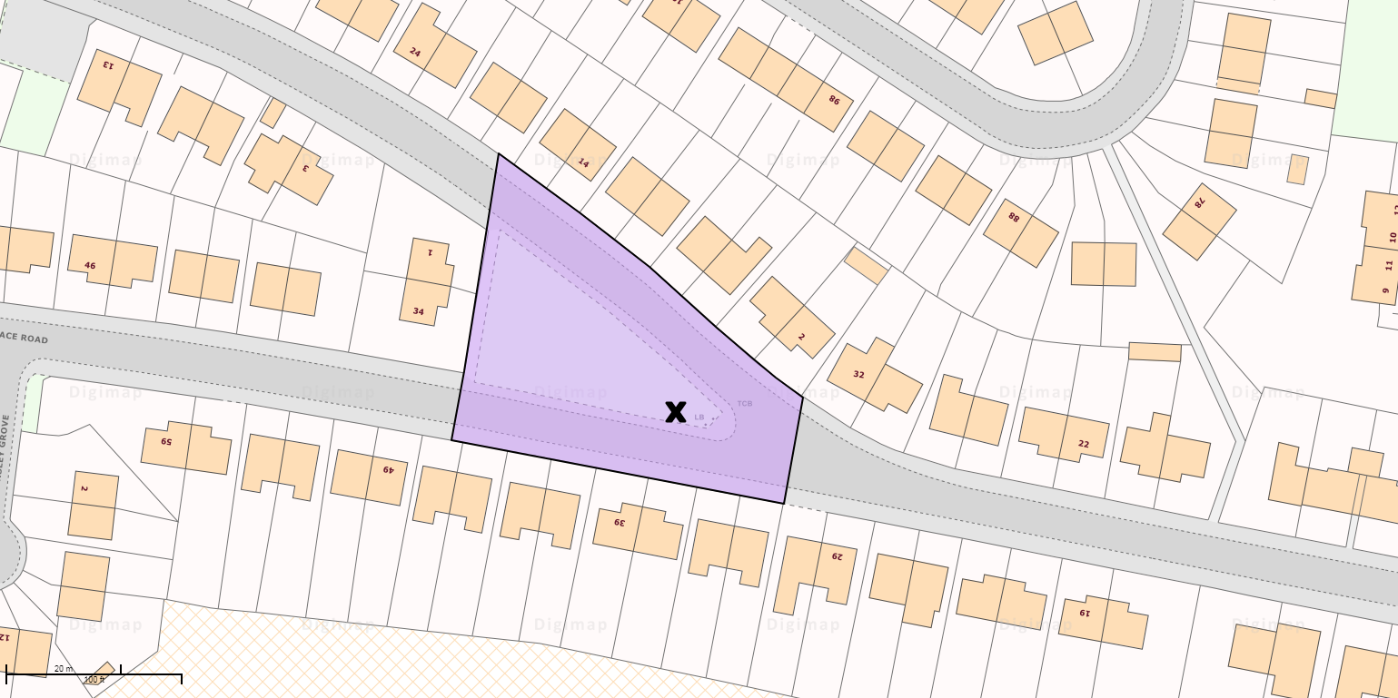

Intervention site 3

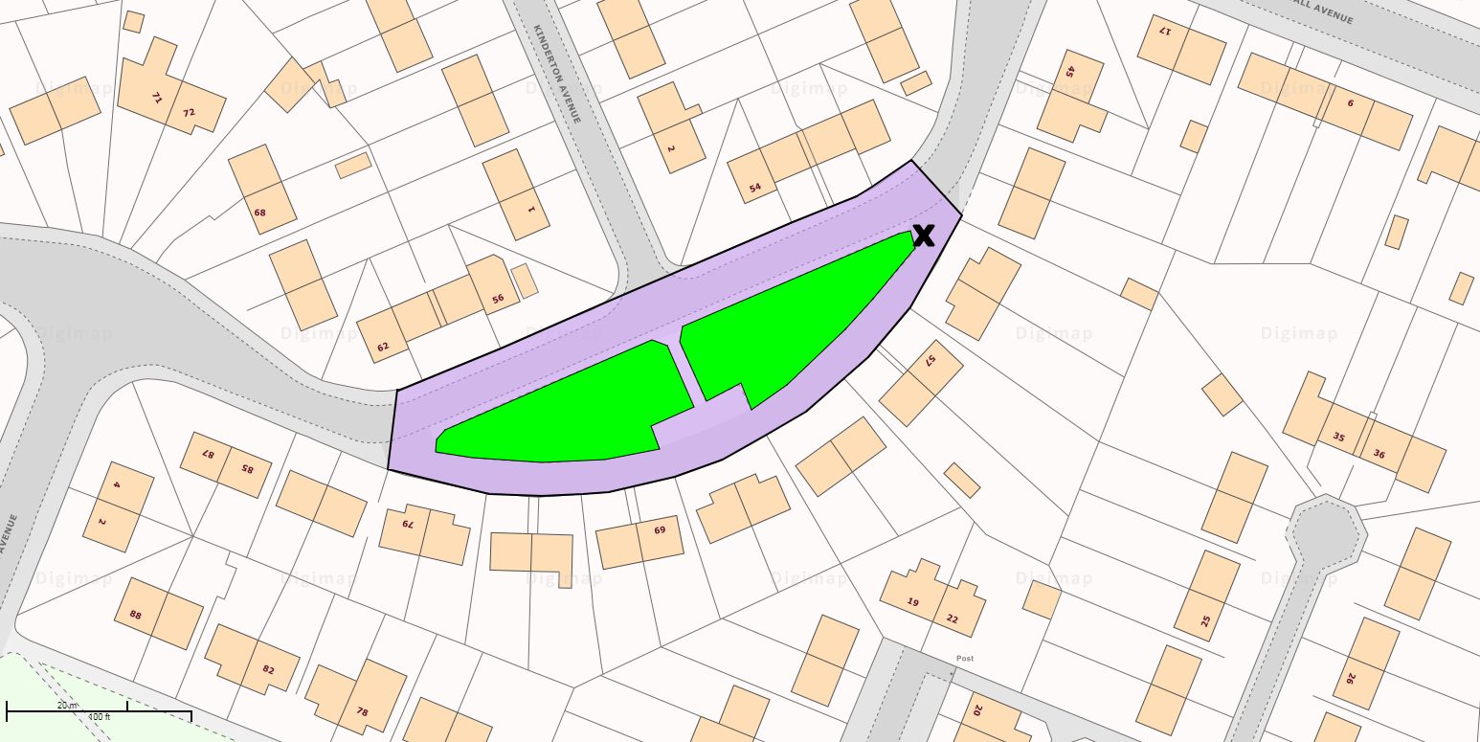

Comparison site 3A

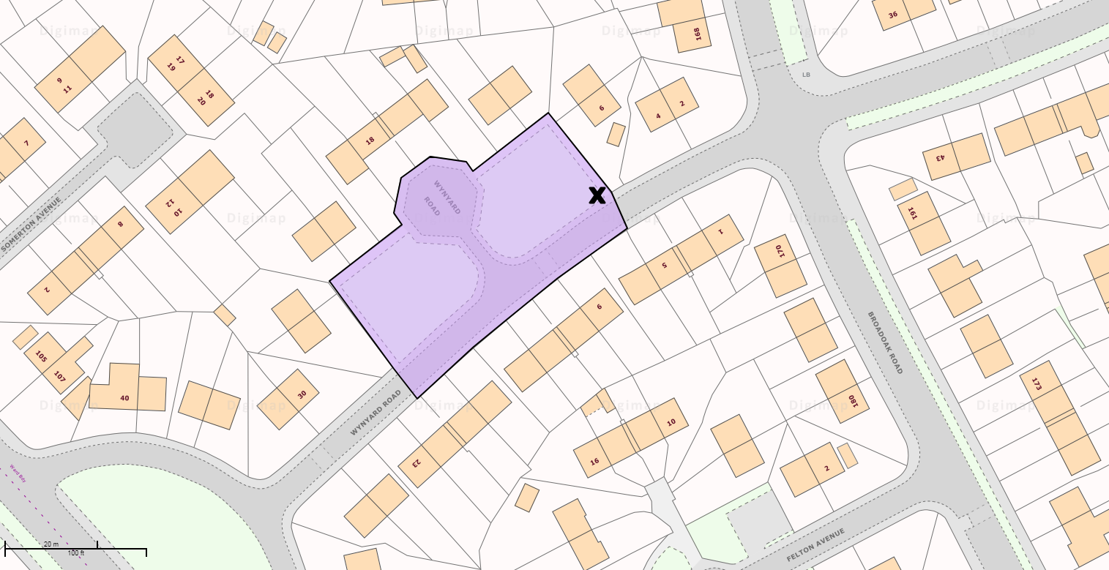

Comparison site 3B

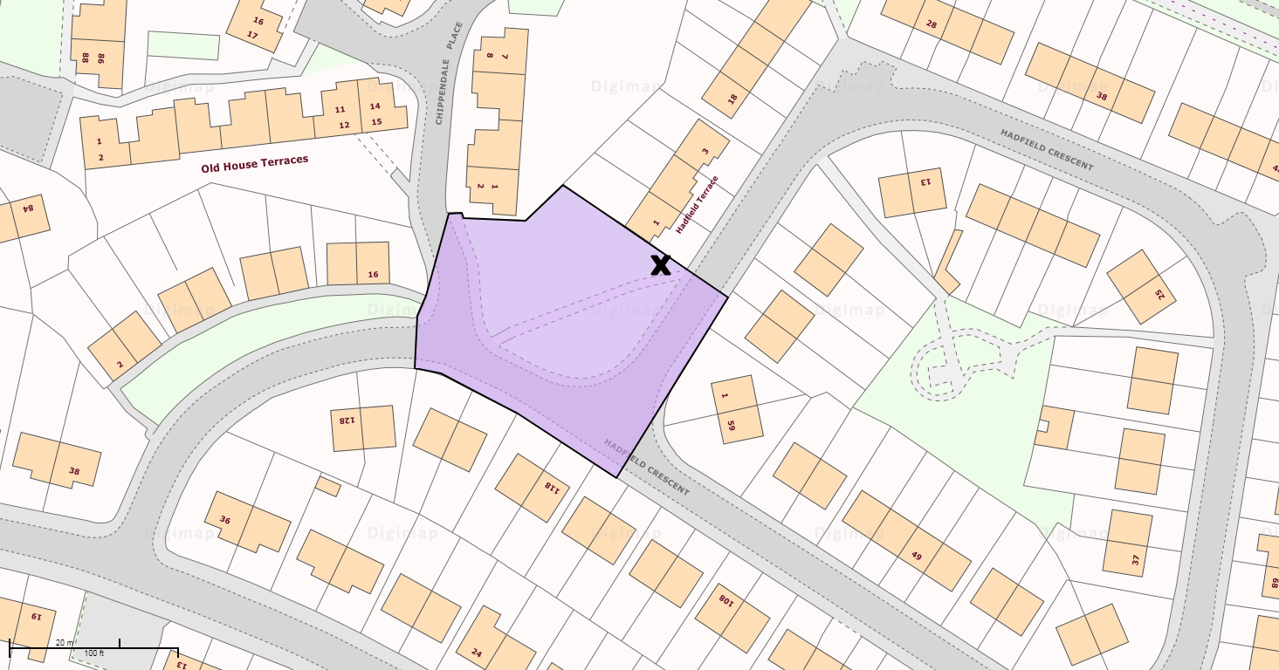
Intervention site 4

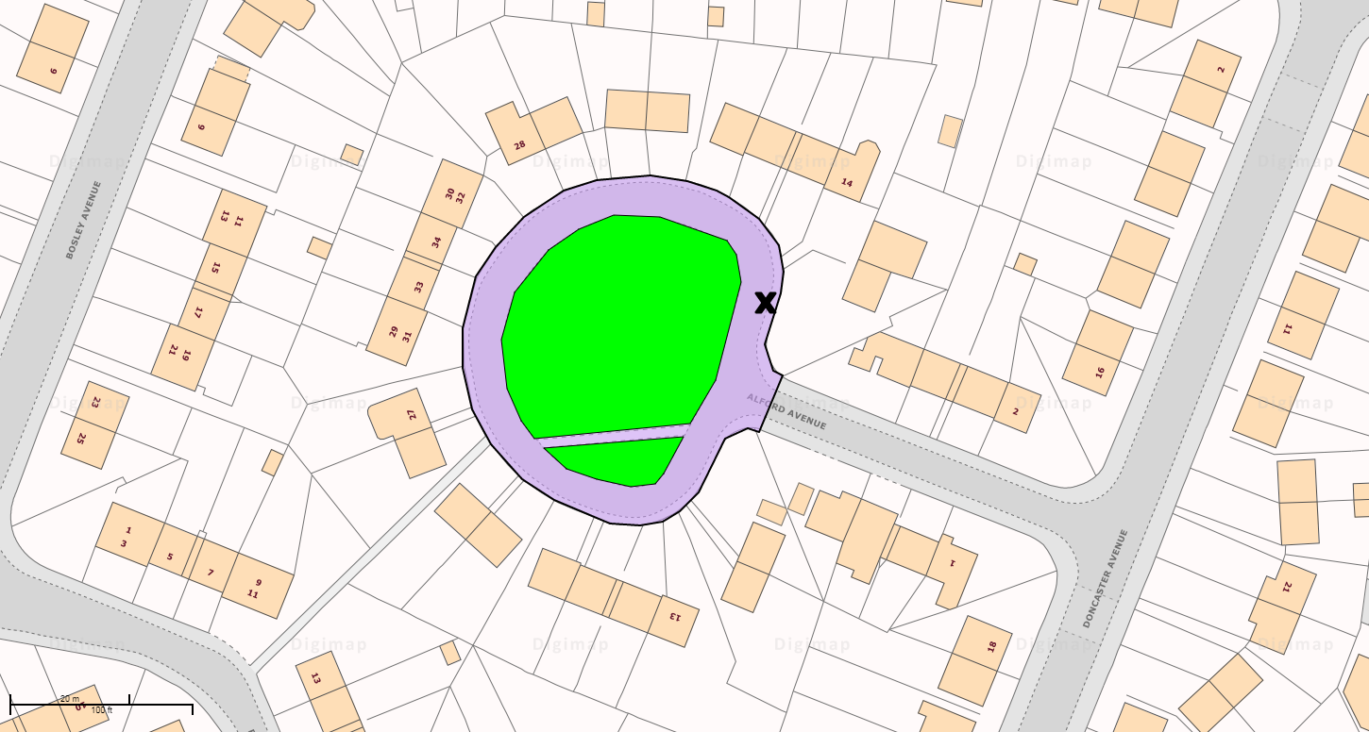
Comparison site 4A

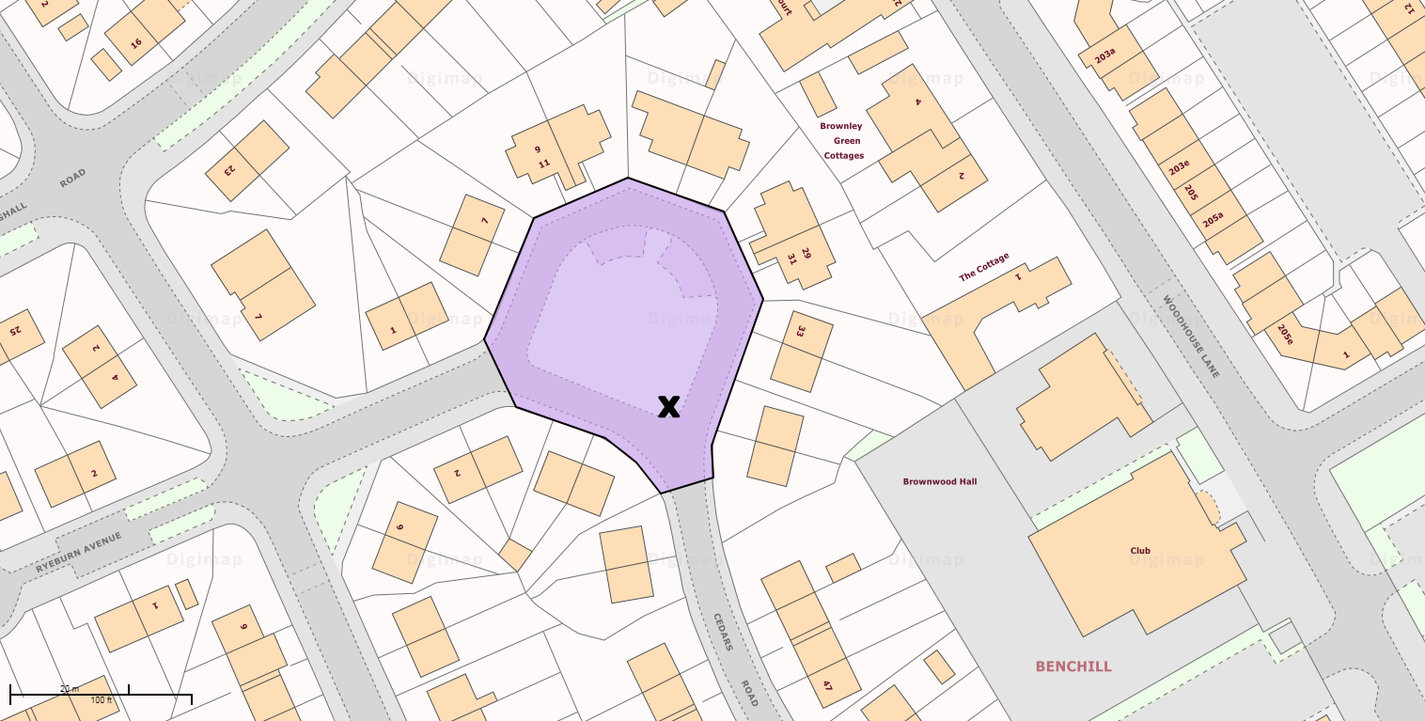

Comparison site 4B

