Appendix 1: Descriptive statistics for all variables included in the study
 | The Netherlands |  | Other countries |  | Total sample
 | Pre-treatment  Mean (SD) | After treatment  Mean (SD) | Pre-treatment  Mean (SD) | After treatment  Mean (SD) | Pre-treatment  Mean (SD) | After treatment  Mean (SD)
Loneliness (binary indicator used as outcome in DiD) | 0.28 (0.45) | 0.28(0.39) | 0.33 (0.47) | 0.22 (0.41) | 0.33 (0.46) | 0.22 (0.41)
Gender (2-female; 1-male) | 1.5 (0.50) | 1.54 (0.49) | 1.54 (0.49) | 1.54 (0.49) | 1.54 (0.49) | 1.54 (0.49)
Country of origin (1=born in a country of interview; 0=born outside country of interview) | 0.95 (0.22) | 0.93 (0.25) | 0.91 (0.28) | 0.91 (0.28) | 0.92 (0.27) | 0.91 (0.28)
Age (from 55 to 104) | 66.16 (8.64) | 67.73 (8.59) | 67.52 (8.92) | 68.63 (9.18) | 67.36 (8.89) | 68.55 (9.14)
Number of children (from 0 to 17) | 2.46 (1.69) | 2.34 (1.43) | 2.16 (1.53) | 2.14 (1.44) | 2.19 (1.55) | 2.16 (1.44)
Household size (1 to 10) | 1.98 (0.67) | 1.93 (0.65) | 2.04 (0.87) | 2.03 (0.85) | 2.04 (0.85) | 2.02 (0.84)
Type of settlement (1-urban; 0-rural) | 0.79 (0.41) | 0.78 (0.41) | 0.75 (0.43) | 0.66 (0.47) | 0.75 (0.42) | 0.68 (0.47)
Marital status (1-married; 0 non-married | 0.85 (0.35) | 0.79 (0.41) | 0.77 (0.42) | 0.73 (0.44) | 0.78 (0.41) | 0.73 (0.44)
Help received from others (1-yes; 0-no) | 0.25 (0.43) | 0.18 (0.38) | 0.24 (0.42) | 0.19 (0.39) | 0.24 (0.43) | 0.19 (0.39)
Depressed (1-yes; 0-no) | 0.19 (0.39) | 0.17 (0.37) | 0.25 (0.43) | 0.26 (0.44) | 0.25 (0.43) | 0.25 (0.43)
Presence of chronic diseases (1-yes; 0-no) | 0.71 (0.45) | 0.73 (0.44) | 0.78 (0.41) | 0.78 (0.41) | 0.78 (0.41) | 0.78 (0.41)
Mobility (1-limited; 0-non-limited) | 0.45 (0.49) | 0.51 (0.50) | 0.46 (0.49) | 0.44 (0.49) | 0.46 (0.48) | 0.45 (0.49)
* Pre-treatment – includes data from wave 1 collected in 2004
** After treatment – includes data from wave 4 and wave 5 collected in 2011 and 2013.

Appendix 2:
Table 1: Countries and their loadings to synthetic the Netherlands
Country | Unit weight
Austria | 0.000
Belgium | 0.000
Germany | 0.043
Denmark | 0.000
Italy | 0.182
France | 0.000
Sweden | 0.665
Spain | 0.000
Switzerland | 0.110

Appendix 3 – placebo tests related to SCM
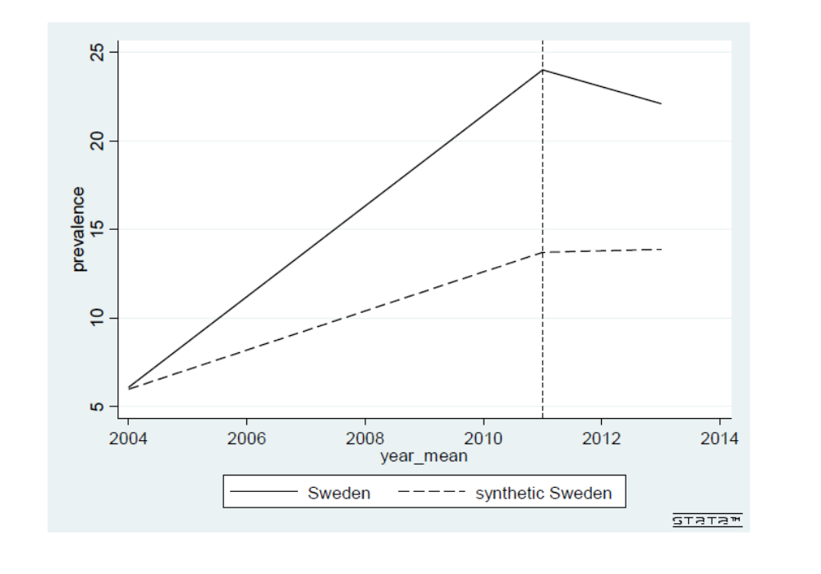
Figure 2: Placebo test with Sweden as treated unit

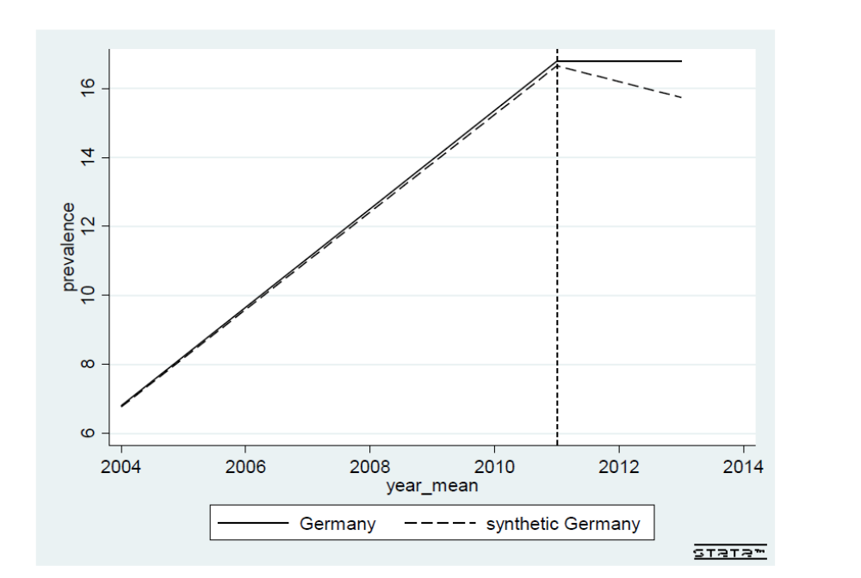
Figure 3: Placebo test when Germany is used as a treated unit

T-test for period = 0 country Austria (control) and the Netherlands (treated)
 | Mean control | Mean treated | Difference | t-test
Loneliness | 0.221 | 0.241 | 0.020 | 2.36*
Gender (2-female; 1-male) | 1.573 | 1.531 | -0.042 | 4.44*
Country of origin (1=born in a country of interview; 0=born outside country of interview) | 0.914 | 0.940 | 0.026 | 3.37*
Age (from 55 to 104) | 68.309 | 67.219 | -1.091* | 6.57*
Number of children (from 0 to 17) | 2.017 | 2.381 | 0.363 | 10.69*
Household size (1 to 10) | 1.913 | 1.948 | 0.036 | 2.40*
Type of settlement (1-urban; 0-rural) | 0.640 | 0.780 | 0.140 | 16.20*
Marital status (1-married; 0 non-married) | 0.659 | 0.831 | 0.172 | 14.16*
Help received from others (1-yes; 0-no) | 0.216 | 0.214 | -0.002 | 0.16
Depressed (1-yes; 0-no) | 0.196 | 0.176 | -0.020 | 2.66*
Presence of chronic diseases (1-yes; 0-no) | 0.765 | 0.728 | -0.037 | 4.47*
Mobility (1-limited; 0-non-limited) | 0.482 | 0.481 | -0.001 | 0.15
*p<0.05
Appendix 4 - balancing t-tests for each of the DiD models

T-test for period = 0 country Belgium (control) and the Netherlands (treated)
 | Mean control | Mean treated | Difference | t-test
Loneliness | 0.290 | 0.241 | -0.049 | 5.95*
Gender (2-female; 1-male) | 1.540 | 1.531 | -0.009 | 1.04
Country of origin (1=born in a country of interview; 0=born outside country of interview) | 0.909 | 0.940 | 0.031 | 5.03*
Age (from 55 to 104) | 67.807 | 67.819 | -0.588 | 3.77*
Number of children (from 0 to 17) | 2.132 | 2.381 | 0.249 | 7.85*
Household size (1 to 10) | 1.957 | 1.948 | -0.008 | 0.65
Type of settlement (1-urban; 0-rural) | 0.755 | 0.780 | 0.025 | 3.31*
Marital status (1-married; 0 non-married) | 0.766 | 0.831 | 0.065 | 7.08*
Help received from others (1-yes; 0-no) | 0.244 | 0.214 | -0.030 | 2.98*
Depressed (1-yes; 0-no) | 0.266 | 0.176 | -0.090 | 12.26*
Presence of chronic diseases (1-yes; 0-no) | 0.807 | 0.728 | -0.079 | 10.75*
Mobility (1-limited; 0-non-limited) | 0.449 | 0.481 | 0.031 | 3.57*
*p<0.05

T-test for period =0 country Denmark (control) and the Netherlands (treated)
 | Mean control | Mean treated | Difference | t-test
Loneliness | 0.124 | 0.241 | 0.116 | 14.60*
Gender (2-female; 1-male) | 1.529 | 1.531
Country of origin (1=born in a country of interview; 0=born outside country of interview) | 0.968 | 0.940 | -0.028 | 5.14*
Age (from 55 to 104) | 67.425 | 67.219 | -0.207 | 1.19
Number of children (from 0 to 17) | 2.215 | 2.381 | 0.166 | 4.92*
Household size (1 to 10) | 1.832 | 1.948 | 0.116 | 9.17*
Type of settlement (1-urban; 0-rural) | 0.779 | 0.780 | 0.001 | 0.05
Marital status (1-married; 0 non-married) | 0.759 | 0.831 | 0.072 | 7.15*
Help received from others (1-yes; 0-no) | 0.299 | 0.214 | -0.086 | 6.86*
Depressed (1-yes; 0-no) | 0.167 | 0.176 | 0.009 | 1.23
Presence of chronic diseases (1-yes; 0-no) | 0.780 | 0.728 | -0.052 | 6.15*
Mobility (1-limited; 0-non-limited) | 0.399 | 0.481 | 0.082 | 8.38*
*p<0.05
T-test for period =0 country France (control) and the Netherlands (treated)
 | Mean control | Mean treated | Difference | t-test
Loneliness | 0.324 | 0.241 | -0.083 | 9.29*
Gender (2-female; 1-male) | 1.565 | 1.531 | -0.034 | 3.77*
Country of origin (1=born in a country of interview; 0=born outside country of interview) | 0.869 | 0.940 | 0.071 | 9.63*
Age (from 55 to 104) | 68.606 | 68.219 | -1.387 | 8.34*
Number of children (from 0 to 17) | 2.227 | 2.381 | 0.154 | 4.53*
Household size (1 to 10) | 1.906 | 1.948 | 0.043 | 3.20*
Type of settlement (1-urban; 0-rural) | 0.587 | 0.780 | 0.193 | 23.03*
Marital status (1-married; 0 non-married) | 0.722 | 0.831 | 0.109 | 10.51*
Help received from others (1-yes; 0-no) | 0.194 | 0.214 | 0.021 | 2.13*
Depressed (1-yes; 0-no) | 0.339 | 0.176 | -0.164 | 20.65*
Presence of chronic diseases (1-yes; 0-no) | 0.798 | 0.728 | -0.070 | 9.06*
Mobility (1-limited; 0-non-limited) | 0.441 | 0.483 | 0.038 | 4.16*
*p<0.05

T-test for period =0 country Germany (control) and the Netherlands (treated)
 | Mean control | Mean treated | Difference | t-test
Loneliness | 0.207 | 0.241 | 0.034 | 4.27*
Gender (2-female; 1-male) | 1.516 | 1.531 | 0.014 | 1.60
Country of origin (1=born in a country of interview; 0=born outside country of interview) | 0.836 | 0.940 | 0.104 | 15.10*
Age (from 55 to 104) | 67.517 | 67.219 | -0.0299 | 1.96
Number of children (from 0 to 17) | 1.951 | 2.381 | 0.429 | 14.03*
Household size (1 to 10) | 1.989 | 1.948 | -0.040 | 3.35*
Type of settlement (1-urban; 0-rural) | 0.615 | 0.780 | 0.165 | 2.23*
Marital status (1-married; 0 non-married) | 0.800 | 0.831 | 0.031 | 3.75*
Help received from others (1-yes; 0-no) | 0.271 | 0.214 | -0.057 | 4.80*
Depressed (1-yes; 0-no) | 0.217 | 0.176 | -0.041 | 5.79*
Presence of chronic diseases (1-yes; 0-no) | 0.820 | 0.728 | -0.092 | 12.48*
Mobility (1-limited; 0-non-limited) | 0.523 | 0.481 | -0.042 | 4.75*
*p<0.05
T-test for period =0 country Italy (control) and the Netherlands (treated)
 | Mean control | Mean treated | Difference | t-test
Loneliness | 0.351 | 0.241 | -0.110 | 12.55
Gender (2-female; 1-male) | 1.537 | 1.531 | -0.006 | 0.67
Country of origin (1=born in a country of interview; 0=born outside country of interview) | 0.988 | 0.940 | -0.048 | 10.99*
Age (from 55 to 104) | 68.177 | 67.219 | -0.958 | 6.07*
Number of children (from 0 to 17) | 1.986 | 2.381 | 0.395 | 12.30*
Household size (1 to 10) | 2.400 | 1.948 | -0.451 | 28.41*
Type of settlement (1-urban; 0-rural) | 0.599 | 0.780 | 0.181 | 21.57*
Marital status (1-married; 0 non-married) | 0.780 | 0.831 | 0.051 | 5.46*
Help received from others (1-yes; 0-no) | 0.154 | 0.214 | 0.061 | 6.12*
Depressed (1-yes; 0-no) | 0.352 | 0.176 | -0.176 | 22.18*
Presence of chronic diseases (1-yes; 0-no) | 0.787 | 0.728 | -0.059 | 7.61*
Mobility (1-limited; 0-non-limited) | 0.444 | 0.481 | 0.037 | 4.05*
*p<0.05

T-test for period =0 country Sweden (control) and the Netherlands (treated)
 | Mean control | Mean treated | Difference | t-test
Loneliness | 0.231 | 0.241 | 0.019 | 1.24
Gender (2-female; 1-male) | 1.527 | 1.531 | 0.003 | 0.37
Country of origin (1=born in a country of interview; 0=born outside country of interview) | 0.919 | 0.940 | 0.021 | 3.74*
Age (from 55 to 104) | 68.692 | 67.219 | -1.473 | 9.40*
Number of children (from 0 to 17) | 2.279 | 2.381 | 0.101 | 3.28*
Household size (1 to 10) | 1.851 | 1.948 | 0.098 | 8.91*
Type of settlement (1-urban; 0-rural) | 0.825 | 0.780 | -0.046 | 6.30*
Marital status (1-married; 0 non-married) | 0.808 | 0.831 | 0.023 | 2.67*
Help received from others (1-yes; 0-no) | 0.223 | 0.214 | -0.009 | 0.84
Depressed (1-yes; 0-no) | 0.183 | 0.176 | -0.007 | 1.04
Presence of chronic diseases (1-yes; 0-no) | 0.782 | 0.728 | -0.054 | 7.00*
Mobility (1-limited; 0-non-limited) | 0.424 | 0.481 | 0.056 | 6.33*
*p<0.05
T-test for period =0 country Spain (control) and the Netherlands (treated)
 | Mean control | Mean treated | Difference | t-test
Loneliness | 0.243 | 0.241 | -0.003 | 0.34
Gender (2-female; 1-male) | 1.538 | 1.531 | -0.007 | 0.86
Country of origin (1=born in a country of interview; 0=born outside country of interview) | 0.957 | 0.940 | -0.017 | 3.45*
Age (from 55 to 104) | 70.031 | 60.219 | -2.813 | 17.36*
Number of children (from 0 to 17) | 2.352 | 2.381 | 0.029 | 0.85
Household size (1 to 10) | 2.379 | 1.948 | -0.430 | 27.80*
Type of settlement (1-urban; 0-rural) | 0.934 | 0.780 | -0.155 | 26.54*
Marital status (1-married; 0 non-married) | 0.790 | 0.831 | 0.041 | 4.74*
Help received from others (1-yes; 0-no) | 0.157 | 0.214 | 0.057 | 5.72*
Depressed (1-yes; 0-no) | 0.324 | 0.176 | -0.148 | 19.48*
Presence of chronic diseases (1-yes; 0-no) | 0.835 | 0.728 | -0.107 | 15.31*
Mobility (1-limited; 0-non-limited) | 0.429 | 0.481 | 0.052 | 5.97*
*p<0.05

T-test for period =0 country Switzerland (control) and the Netherlands (treated)
 | Mean control | Mean treated | Difference | t-test
Loneliness | 0.164 | 0.241 | 0.077 | 8.46*
Gender (2-female; 1-male)
Country of origin (1=born in a country of interview; 0=born outside country of interview) | 0.828 | 0.940 | 0.112 | 10.50*
Age (from 55 to 104) | 1.534 | 1.531 | -0.003 | 0.30
Number of children (from 0 to 17) | 2.040 | 2.381 | 0.341 | 9.05*
Household size (1 to 10) | 1.961 | 1.948 | -0.012 | 0.83
Type of settlement (1-urban; 0-rural) | 0.447 | 0.780 | 0.333 | 34.12*
Marital status (1-married; 0 non-married) | 0.750 | 0.831 | 0.081 | 5.82*
Help received from others (1-yes; 0-no) | 0.152 | 0.214 | 0.063 | 5.94*
Depressed (1-yes; 0-no) | 0.172 | 0.176 | 0.004 | 0.43
Presence of chronic diseases (1-yes; 0-no) | 0.661 | 0.728 | 0.067 | 6.82*
Mobility (1-limited; 0-non-limited) | 0.313 | 0.481 | 0.167 | 16.00*
*p<0.05
T-test for period =0 all 9 countries (controls) and the Netherlands (treated)
 | Mean control | Mean treated | Difference | t-test
Loneliness | 0.246 | 0.241 | -0.005 | 0.78
Gender (2-female; 1-male) | 1.539 | 1.531 | 0.009 | 1.27
Country of origin (1=born in a country of interview; 0=born outside country of interview) | 0.913 | 0.940 | 0.027 | 5.47*
Age (from 55 to 104) | 68.367 | 67.219 | -1.148 | 9.19*
Number of children (from 0 to 17) | 2.142 | 2.381 | 0.238 | 9.77*
Household size (1 to 10) | 2.039 | 1.948 | -0.090 | 7.84*
Type of settlement (1-urban; 0-rural) | 0.705 | 0.780 | 0.074 | 11.88*
Marital status (1-married; 0 non-married) | 0.774 | 0.831 | 0.057 | 7.93*
Help received from others (1-yes; 0-no) | 0.209 | 0.214 | 0.005 | 0.62
Depressed (1-yes; 0-no) | 0.255 | 0.176 | -0.079 | 13.21*
Presence of chronic diseases (1-yes; 0-no) | 0.791 | 0.728 | -0.063 | 11.09*
Mobility (1-limited; 0-non-limited) | 0.441 | 0.481 | 0.040 | 5.70*
*p<0.05

Appendix 5 – pre- treatment tests for DiD estimator
Graph 1: Pre-treatment trends in loneliness using The Netherlands as treated and Sweden as control group

Graph 2: Pre-treatment trends in loneliness using The Netherlands as treated and Germany as control group

Graph 3: Pre-treatment trends in loneliness using The Netherlands as treated and Italy as control group

Graph 4: Pre-treatment trends in loneliness using The Netherlands as treated and Spain as control group

Graph 5: Pre-treatment trends in loneliness using The Netherlands as treated and Denmark as control group

