Prevalence of abuse by type and population
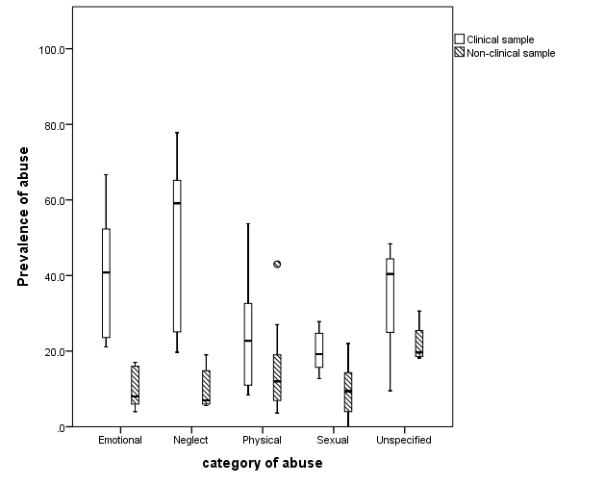
 | Emotional | Neglect | Physical | Sexual | Unspecified
Clinical sample
N studies | 6 | 5 | 6 | 5 | 3
Median  (25th to 75th centile) | 40.8  (23.6 to 52.3) | 59.1  (25.1 to 65.2) | 22.8  (11.0 to 32.6) | 19.2  (15.7 to 24.7) | 40.4  (9.5 to 48.4)
Non-clinical sample
N studies | 10 | 9 | 15 | 14 | 4
Median  (25th to 75th centile) | 8.0  (6.0 to 16.0) | 7.0  (6.0 to 14.8) | 12.0  (6.9 to 23.0) | 9.4  (4.0 to 14.3) | 19.7  (18.6 to 25.5)

