Supplementary Material
Early maternal perceived stress and children’s BMI: longitudinal impact and influencing factors

Beate Leppert*& Kristin Junge*, Stefan Röder, Michael Borte, Gabriele I. Stangl, Rosalind J. Wright, Anja Hilbert, Irina Lehmann* & Saskia Trump*
*authors contributed equally

Content
Table S1: Questionnaire for the assessment of the living environment.

Table S2: Impact of maternal perceived stress levels during pregnancy, year 1 and year 2 on longitudinal BMI z-score development in preschool children (birth-age5).

Table S3: Gender disparity in susceptibility to maternal stress-related BMI development in preschool children age 1-5 years.

Table S4: Comparison of gender-related study characteristics of the analyzed sub-cohort.

Table S5. Characteristics of maternal perceived stress scores of the four different stress dimensions at year 1.

Table S6. Influence of maternal stress during the first year after birth on breastfeeding duration and introduction of solid food.

Table S7: Summary of exploratory factor analysis results of questionnaire items assessing the living environment.

Table S8: Association of different stressors with the maternal stress levels at year 1.

Table S9: Contribution of separation or divorce on perceived maternal stress at year 1.

Figure S1: (A) Associations of different stressors and the four different stress dimensions at year 1. (B) Summary of mediation analysis.

Table S1: Questionnaire for the assessment of the living environment.
How often did you experience the following impairments in your neighborhood?
(just one cross in each line)
 | hardly ever  (1) | sometimes  (2) | often  (3) | usually  (4)
Traffic noise
Commercial noise
Odors and exhausts
Noise from neighbors
Noise from pedestrians
Noise from restaurants/clubs
Graffiti
Vandalism
Dirty streets (e.g. waste, dog excrements)
Attempted break-ins/thefts
Answers were scored as indicated from 1 (hardly ever) to 4 (usually) to calculate a score for exposure to poor living conditions, traffic and residential noise.
Table S2: Impact of maternal perceived stress levels during pregnancy, year 1 and year 2 on longitudinal BMI z-score development in preschool children (birth-age5).
 |  | β estimate _{a} | 95% CI | p-value
Pregnancy | (n=498) | 0.06 | -0.07 – 0.20 | 0.372
Year 1 | (n=491) | 0.23 | 0.08 – 0.37 | 0.002
Year 2 | (n=473) | 0.09 | -0.71 – 0.24 | 0.283
Pregnancy to year 2 | (n=473) | 0.06 | -0.01 – 1.21 | 0.078
a - Estimates derived from general estimation equations (GEE) for BMI z-scores (birth to age 5) as dependent variable, adjusted for gestational week at delivery, mode of delivery, pregnancy cotinine levels and breastfeeding duration (not for pregnancy stress levels).
Table S3: Gender disparity in susceptibility to maternal stress-related BMI development in preschool children age 1-5 years.
 | β estimate _{a} | 95% CI | p-value
Entire cohort (n=491)
Raw | 0.22 | 0.08 – 0.37 | 0.003
adj._{b} | 0.23 | 0.08 – 0.37 | 0.002
Girls only (n=241)
Raw | 0.30 | 0.11 – 0.49 | 0.002
adj. _{b} | 0.30 | 0.11 – 0.49 | 0.002
Boys only (n=250)
Raw | 0.14 | -0.07 – 0.35 | 0.194
adj. _{b} | 0.10 | -0.11 – 0.31 | 0.333
a - Estimates derived from general estimation equations (GEE) for BMI z-scores (birth to age 5) as dependent and maternal stress during the first year of life as independent variable.
b - Adjusted for gestational week at delivery, mode of delivery, pregnancy cotinine levels and breastfeeding duration.

Table S4: Comparison of gender-related study characteristics of the analyzed sub-cohort.
 | girls only  n (%), n=245 _{a} | boys only  n (%), n=253 _{a} | χ²-test
Week of gestation at birth |  |  | 0.747
<37 weeks | 7 (2.9) | 9 (3.6)
37-40 weeks | 158 (64.5) | 150 (59.3)
>40 weeks | 80 (32.6) | 94 (37.1)
Mode of delivery |  |  | 0.962
spontaneous | 191 (80.0) | 196 (77.5)
C-section | 51 (20.8) | 53 (20.9)
others | 3 (1.2) | 4 (1.6)
Birth weight |  |  | 0.35
<3000g | 51 (20.8) | 41 (16.2)
≥3000g – 3500g | 104 (42.4) | 91 (36.0)
≥3500g – 4000g | 69 (28.2) | 82 (32.4)
≥4000g | 21 (8.6) | 39 (15.4)
Household members |  |  | 0.871
2 | 12 (4.9) | 14 (5.6)
3 | 152 (62.3) | 148 (58.7)
≥4 | 80 (32.8) | 90 (35.7)
Breastfeeding |  |  | 0.958
1. -3. Month | 43 (18.5) | 44 (17.8)
1.-6. Month | 78 (33.6) | 88 (35.6)
1.-12. Month | 111 (47.8) | 115 (46.6)
Education _{b} |  |  | 0.822
Low | 4 (1.6) | 2 (0.8)
Medium | 52 (21.2) | 49 (19.4)
High | 189 (77.1) | 202 (79.8)
Household income |  |  | 0.844
<2000€ | 83 (36.1) | 89 (37.2)
2000€ - 4000€ | 132 (57.4) | 130 (54.4)
>4000€ | 15 (6.5) | 20 (8.4)
Separation/divorce _{c} |  |  | 0.832
Yes | 11 (12.2) | 12 (13.2)
No | 79 (87.8) | 79 (86.8)
Pregnancy cotinine level _{d} |  |  | 0.567 _{e}
median [µg/g creatinine] | 1.88 | 1.80
<25%, >75% | 0.72, 5.13 | 0.80, 4.82
a – n may be different from total n due to missing data.
b – Low = 8 yrs of schooling (‘Hauptschulabschluss`); medium = 10 yrs of schooling (`Mittlere Reife`); high = 12 yrs of schooling or more (`(Fach-)hochschulreife’)..
c – Parental separation/divorce in the last 3 years from children’s age 3 years
d – ETS = environmental tobacco smoke (urinary cotinine level at pregnancy).
e – p-value derived from Student’s T-test between group means.
Table S5: Characteristics of maternal perceived stress scores of the four different stress dimensions at year 1.
 | median | min | max | <25% | >75%
Worries | 1.60 | 1.00 | 4.00 | 1.20 | 2.00
Tension | 2.20 | 1.00 | 4.00 | 1.80 | 2.60
Lack of joy | 2.00 | 0.80 | 3.80 | 1.60 | 2.40
Demands | 2.20 | 1.00 | 4.00 | 1.80 | 2.60
Stress dimensions were assessed with the reduced perceived stress questionnaire (PSQ) scored 1 (almost never) to 4 (usually) with 5 questions each, n=498.
Table S6: Influence of maternal stress during the first year after birth on breastfeeding duration and introduction of solid food.
 | β estimate _{a} | 95% CI | p-value
Breastfeeding duration _{b} | -0.01 | -0.10 – 0.08 | 0.798
Introduction to solid food _{b} | -0.03 | -0.15 – 0.09 | 0.622
a - Estimates derived from general estimation equations (GEE) for BMI z-scores (age 1 to age 5) as dependent variable.
b - Breastfeeding and introduction to solid food was assessed in 3-month-intervals during the first year of life.
Table S7: Summary of results of questionnaire items assessing the living environment by the question “How often did you experience the following impairments in your neighborhood?" (n=495).
 | Rotated Factor Loadings
ITEMS | Poor living conditions | Traffic | Residential Noise
Vandalism | 0.828 | -0.026 | 0.023
Graffiti | 0.826 | -0.091 | 0.008
Attempted break-ins/thefts | 0.479 | 0.091 | -0.078
Dirty streets (e.g. waste, dog excrements) | 0.453 | 0.147 | 0.175
Odors/exhausts | 0.001 | 0.797 | -0.028
Traffic noise | 0.009 | 0.793 | 0.002
Commercial noise | 0.006 | 0.362 | 0.080
Noise from pedestrians | -0.091 | 0.002 | 0.885
Noise from neighbours | 0.116 | 0.016 | 0.417
Noise from restaurants/clubs | 0.042 | 0.018 | 0.176
Eigenvalues | 3.35 | 1.43 | 1.03
% of variance | 33.5 | 14.3 | 10.3
α | 0.74 | 0.76 | 0.57
a - Factor loadings over 0.4 appear in bold.
b – Answered on a four-point scale from hardly ever (0) to usually (3).

Table S8: Association of different stressors with the maternal stress levels at year 1. (n=491).
 | Mean Ratio_{a} | 95% CI_{a} | p-value_{b}
Traffic | 1.17 | 1.07 – 1.28 | 0,0003
Residential Noise | 1.15 | 1.05 - 1.26 | 0.0020
Poor Living Conditions | 1.14 | 1.054– 1.25 | 0.0034
Low Household Income^{c} | 1.18 | 1.08 – 1.30 | 0,0003
Low Educational Level | 1.10 | 1.01 – 1.21 | 0.032
Number of Household Members | 1.07 | 0.97 – 1.17 | 0.156
Age of the Mother at Birth | 0.98 | 0.90 – 1.07 | 0.671
a – Standardized mean ratios and confidence intervals (95% CI) derived from linear regression.
b - Bonferroni adjusted significance level, p ≤ 0.007.
c – n=462
Table S9: Contribution of separation or divorce on perceived maternal stress at year 1 (n=191).
dependent variable | β estimate_{a} | 95% CI | p-value_{b}
Total maternal stress | 0.33 | 0.12 – 0.54 | 0.002
Worries | 0.40 | 0.17 - 0.63 | 0.001
Tension | 0.27 | 0.02 - 0.53 | 0.039
Demands | 0.31 | 0.08 – 0.54 | 0.008
Lack of Joy | 0.33 | 0.09 - 0.58 | 0.008
a – Unstandardized estimates derived from linear regression.
b – Bonferroni corrected significance level for two-sided p ≤ 0.01

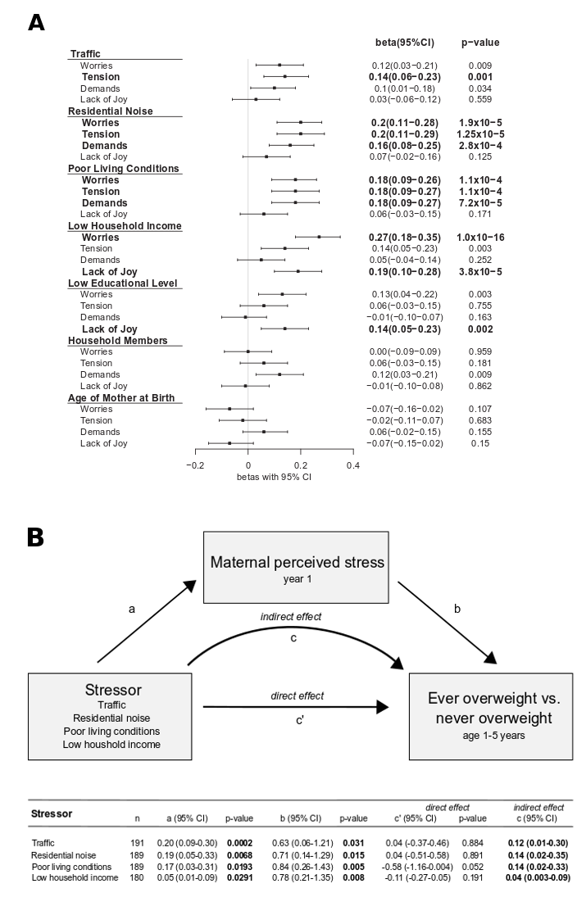
Figure S1: Associations of different stressors and the four different stress dimensions at year 1 (n=489). Shown are forest plots based on β values with 95% confidence intervals. Significant associations are depicted in bold. (B) Summary of mediation analysis. Stressors themselves had no direct effect on girl’s BMI-z-scores but rather mediated their effect by their contribution to the maternal perceived stress level. Logistic regression for path b was adjusted for gestational week at birth, mode of birth and smoking during pregnancy. Confidence intervals for the indirect effects were derived from 5000 bootstrap samples. Confidence intervals, which do not cross 0 indicate significance of the indirect effect.

