Additional file 2

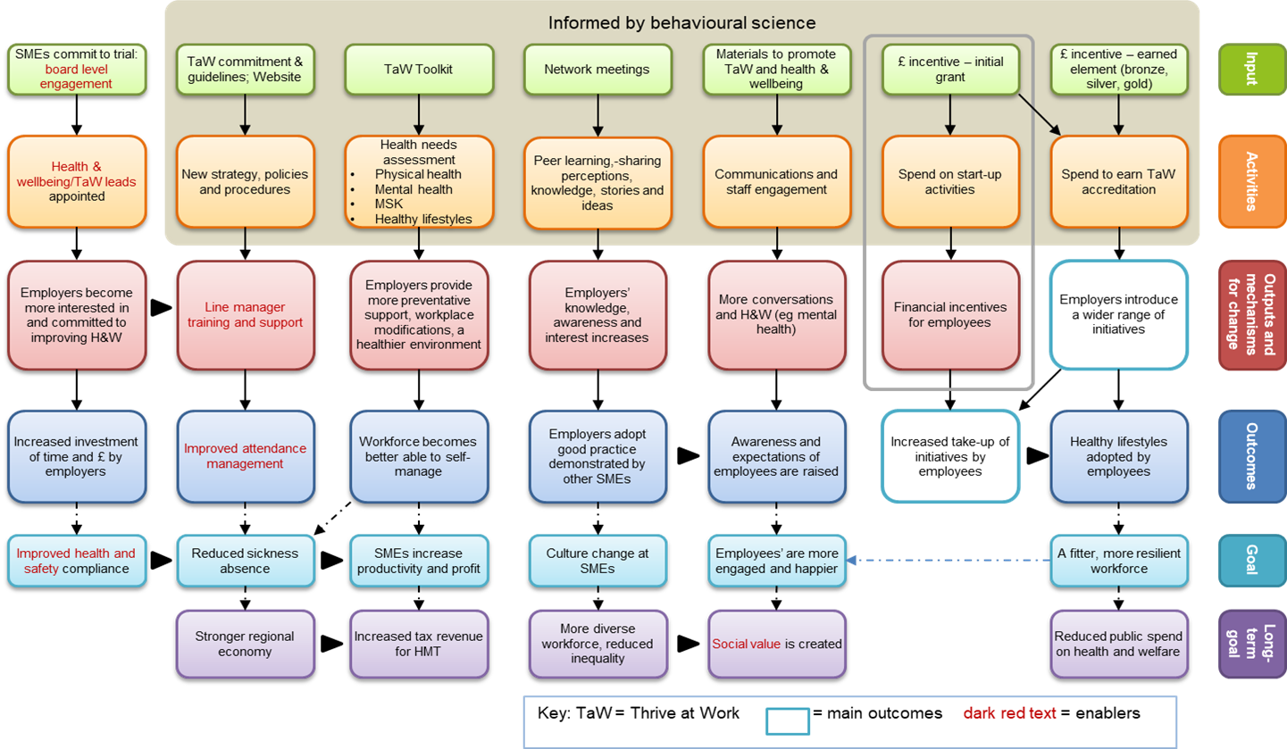
Logic model of the Wellbeing Premium Programme or Thrive at Work

