Example of a running/walking game, designed to mediate cognitive elements of exercising and physical activity

Title: Physical Activity Puzzle-Run/Walk
Description: Starting at point A, participants had to run or walk through an obstacle course (see Fig 1). Boxes containing puzzle pieces (one for each participant) were placed on a desk or something similar at point B. Each time participants ran or walked through the course and reached point B, they were allowed to collect exactly one puzzle piece. Subsequently, they had to carry the piece of the puzzle through the course back to point A for assembly. To ensure equality in terms of different physical capabilities of all participants, the boxes also contained some blank puzzle pieces, which did not contribute to the completion of the puzzle. The game ended after the first six participants had completed the puzzle. All applied puzzles were related to information on exercise and physical activity (e.g. national physical activity guidelines, see Fig 2). If necessary (e.g. due to a large heterogeneity of participants’ physical capabilities), two different obstacle course were used, an easy and a more difficult one.
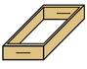

A
B
Start/End
Boxes of puzzle pieces


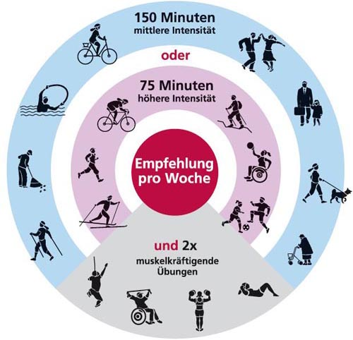
Fig 1. Example of an obstacle course (illustrations: © Rolf Dober)
Fig 2. Example of an applied puzzle

Image source: Titze S, Ring-Dimitriou S, Schober PH, Halbwachs C, Samitz G, Miko HC, et al. Österreichische Empfehlungen für gesundheitswirksame Bewegung. In: Gesundheit Österreich GmbH/Geschäftsbereich Fonds Gesundes Österreich, editors. 2012. http://fgoe.org/sites/fgoe.org/files/2017-10/2012-10-17.pdf. Accessed 10 Sep 2018.

