Additional file 1: Figure S1. Mixed methods research synthesis used for this review (adapted from Heyvaert M et al ⁹)
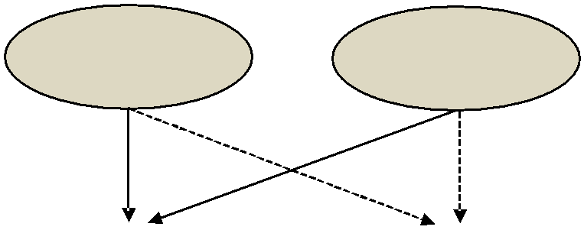

Primary level studies | Qualitative | Quantitative
Primary level studies | studies | studies

Synthesis studies | Qualitative synthesis |  | Quantitative synthesis
 | : done in this study | : not done in this study

