Table S1. Frequency and association of insufficient physical activity among Iranian population according to the sociodemographic, lifestyle, anthropometry and laboratory measurements variables
Variables | Categories | Prevalence Total | Prevalence Male | Prevalence Female
 |  | (95% CI) | (95% CI) | (95% CI)
Total |  | 54.6 % (54.0-55.3) | 45.3 % (44.3-46.3) | 61.9% (61.0-62.7)
Age | 18-24 years | 51.6% (49.6-53.6) | 63.4% (60.8-65.9) | 35.4% (32.4-38.5)
Age | 25-34 years | 55% (53.7-56.3) | 64.7% (63.1-66.3) | 41.8% (39.8-43.7)
Age | 35-44 years | 56.1% (54.7-57.4) | 61.4% (59.7-63.1) | 49.3% (47.2-51.3)
Age | 45-54 years | 54.4% (53-55.8) | 58.2% (56.4-60.1) | 49.4% (47.2-51.6)
Age | 55-64 years | 54.5% (52.9-56.1) | 61.3% (59.2-63.4) | 46.4% (44-48.8)
Residence area | Rural | 47.5% (46.2-48.8) | 37.7% (35.8-39.7) | 54.1% (52.5-55.8)
Residence area | Urban | 57.2% (56.5-58) | 47.8% (46.6-48.9) | 64.8% (63.9-65.8)
Marital status | Never married | 48.5% (46.9-50.2) | 38.4% (36.1-40.7) | 60% (57.7-62.3)
Marital status | Married | 55.6% (54.9-56.4) | 47% (45.9-48.1) | 62.3% (61.4-63.3)
Marital status | Divorced or Living alone | 60.1% (55.5-64.7) | 52.4% (42.1-62.7) | 62% (57-67.1)
Marital status | Widow | 60.7% (57.2-64.2) | 54.8% (37.1-72.6) | 61% (57.4-64.5)
Occupation | Nonpaid & self-paid | 44.6% (43.2-46) | 43.7% (42.3-45.2) | 51.6% (47.3-55.8)
Occupation | Employee | 53.3% (50.7-55.8) | 49.1% (46.1-52.1) | 63.2% (58.7-67.7)
Occupation | Worker | 50.2% (47-53.5) | 48.1% (44.1-52.1) | 54.6% (48.9-60.3)
Occupation | Student | 48.4% (45.4-51.4) | 35.8% (31.7-39.8) | 61% (56.9-65)
Occupation | Soldier | 38.9% (27.2-50.6) | 38.9% (27.2-50.6) | -
Occupation | Unemployed & retired | 53.2% (51.2-55.3) | 50.7% (48.4-53.1) | 60.7% (56.7-64.8)
Occupation | Housekeeper | 62.9% (61.9-63.8) | 67.5% (58.1-76.9) | 62.8% (61.9-63.8)
Education | Illiterate | 56.0% (53.9-58.1) | 47.6% (43.2-52.0) | 58.5% (56.2-60.9)
Education | 1-6 years | 54.3% (52.9-55.6) | 44.1% (41.9-46.3) | 60.6% (58.9-62.2)
Education | 7-12 years | 55.5% (54.5-56.5) | 46.6% (45.1-48.0) | 63.5% (62.2-64.9)
Education | 12< years | 52.8% (51.4-54.2) | 43.3% (41.3-45.2) | 62.1% (60.2-64.0)
Wealth index | 1st quintile (poorest) | 51% (49.4-52.5) | 43.7% (41.3-46.2) | 55.8% (53.8-57.8)
Wealth index | 2nd quintile | 55.4% (53.8-57) | 45.2% (42.8-47.7) | 62.4% (60.4-64.4)
Wealth index | 3rd quintile | 55% (53.5-56.5) | 43.9% (41.6-46.3) | 63.5% (61.6-65.4)
Wealth index | 4th quintile | 58.1% (56.6-59.5) | 47.6% (45.4-49.7) | 66.6% (64.7-68.4)
Wealth index | 5th quintile (richest) | 53.9% (52.5-55.3) | 45.9% (43.9-48) | 61.1% (59.2-63)
Appropriate fruit and vegetable consumption | No | 55.5% (54.8-56.2) | 46.3% (45.2-47.3) | 62.5% (61.6-63.3)
Appropriate fruit and vegetable consumption | Yes | 48% (46.1-50) | 38% (35.1-40.8) | 56.7% (54-59.3)
High salt intake | No | 54.6% (53.6-55.6) | 46.4% (44.9-47.9) | 60.8% (59.5-62.1)
High salt intake | Yes | 59.4% (55.9-63) | 51.1% (43.4-58.7) | 61.2% (57.2-65.1)
Ever daily cigarette smoking | No | 55.5% (54.8-56.2) | 44.1% (42.9-45.3) | 61.9% (61-62.7)
Ever daily cigarette smoking | Yes | 49.2% (47.4-51.1) | 48.5% (46.6-50.5) | 59.9% (52.5-67.3)
Alcohol consumption | No | 54.8% (54.2-55.5) | 45.3% (44.3-46.4) | 61.8% (61-62.7)
Alcohol consumption | Yes | 43% (38.5-47.5) | 42% (37.2-46.8) | 51.5% (37.6-65.4)
Injury | No | 54.9% (54.2-55.6) | 45.5% (44.4-46.5) | 62% (61.1-62.9)
Injury | Yes | 52.4% (50.1-54.7) | 43.8% (40.5-47.1) | 60.4% (57.3-63.5)
Personal car ownership | No | 53.6% (52.7-54.6) | 42.8% (41.2-44.4) | 60.6% (59.4-61.8)
Personal car ownership | Yes | 55.7% (54.8-56.7) | 47.4% (46-48.7) | 63.3% (62-64.5)
Hypertension | No | 54.4% (53.7-55.2) | 44.6% (43.5-45.7) | 62% (61-63)
Hypertension | Yes | 55.9% (54.4-57.4) | 48.1% (45.8-50.4) | 61.7% (59.8-63.6)
Past medical history of cardiovascular disease | No | 56.7% (55.7-57.6) | 47.9% (46.4-49.4) | 63.5% (62.2-64.7)
Past medical history of cardiovascular disease | Yes | 66.4% (59.2-73.5) | 63.9% (54.2-73.6) | 69.6% (59-80.2)
Diabetes mellitus | No | 55.0% (54.0-56.0) | 46.5% (44.9-48.0) | 60.8% (59.5-62.1)
Diabetes mellitus | Yes | 60.0% (56.7-63.2) | 50.5% (45.2-55.7) | 66.2% (62.1-70.2)
Dyslipidemia | No | 55.5% (54.4-56.6) | 46.2% (44.5-47.8) | 62% (60.7-63.4)
Dyslipidemia | Yes | 55.4% (53.3-57.5) | 49.7% (46.3-53.1) | 58.7% (56.1-61.4)
Abdominal obesity | No | 50.8% (49.9-51.6) | 43.2% (42.1-44.3) | 61.3% (60-62.7)
Abdominal obesity | Yes | 59.4% (58.4-60.5) | 52.5% (50.3-54.8) | 61.5% (60.3-62.7)
BMI (body mass index) | Under weight | 53.3% (49.9-56.7) | 45.8% (40.9-50.8) | 59.8% (55.2-64.3)
BMI (body mass index) | Normal weight | 51.5% (50.4-52.6) | 42% (40.3-43.6) | 61.1% (59.5-62.6)
BMI (body mass index) | Over weight | 53.7% (52.5-54.8) | 45.7% (44.1-47.3) | 60.7% (59.2-62.1)
BMI (body mass index) | Obesity | 59.4% (58-60.7) | 51.6% (49.1-54.1) | 62.9% (61.3-64.5)
OR: Odds Ratio, 95% CI: 95% Confidence Interval
*** = p-value < 0.001
** = p-value < 0.01
* = p-value < 0.05

Additional figures:
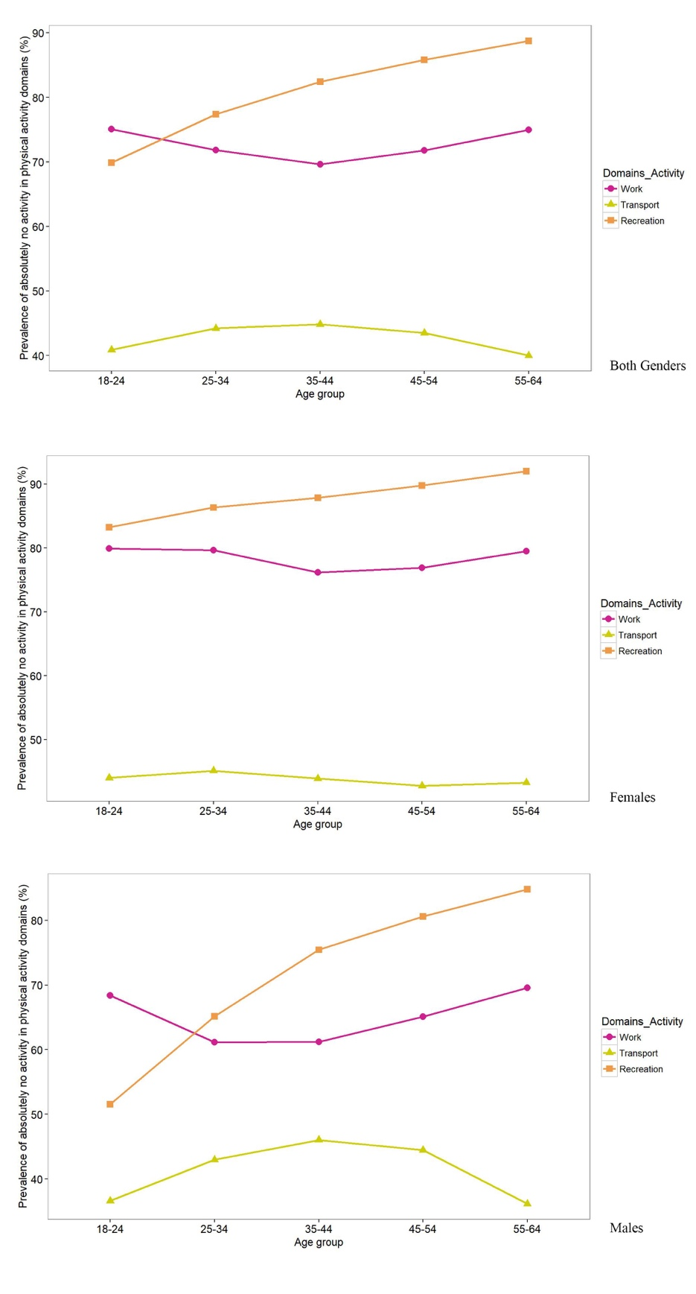
Figure S1. Prevalence of absolutely no activity in physical activity domains among adult Iranian gender and age groups.
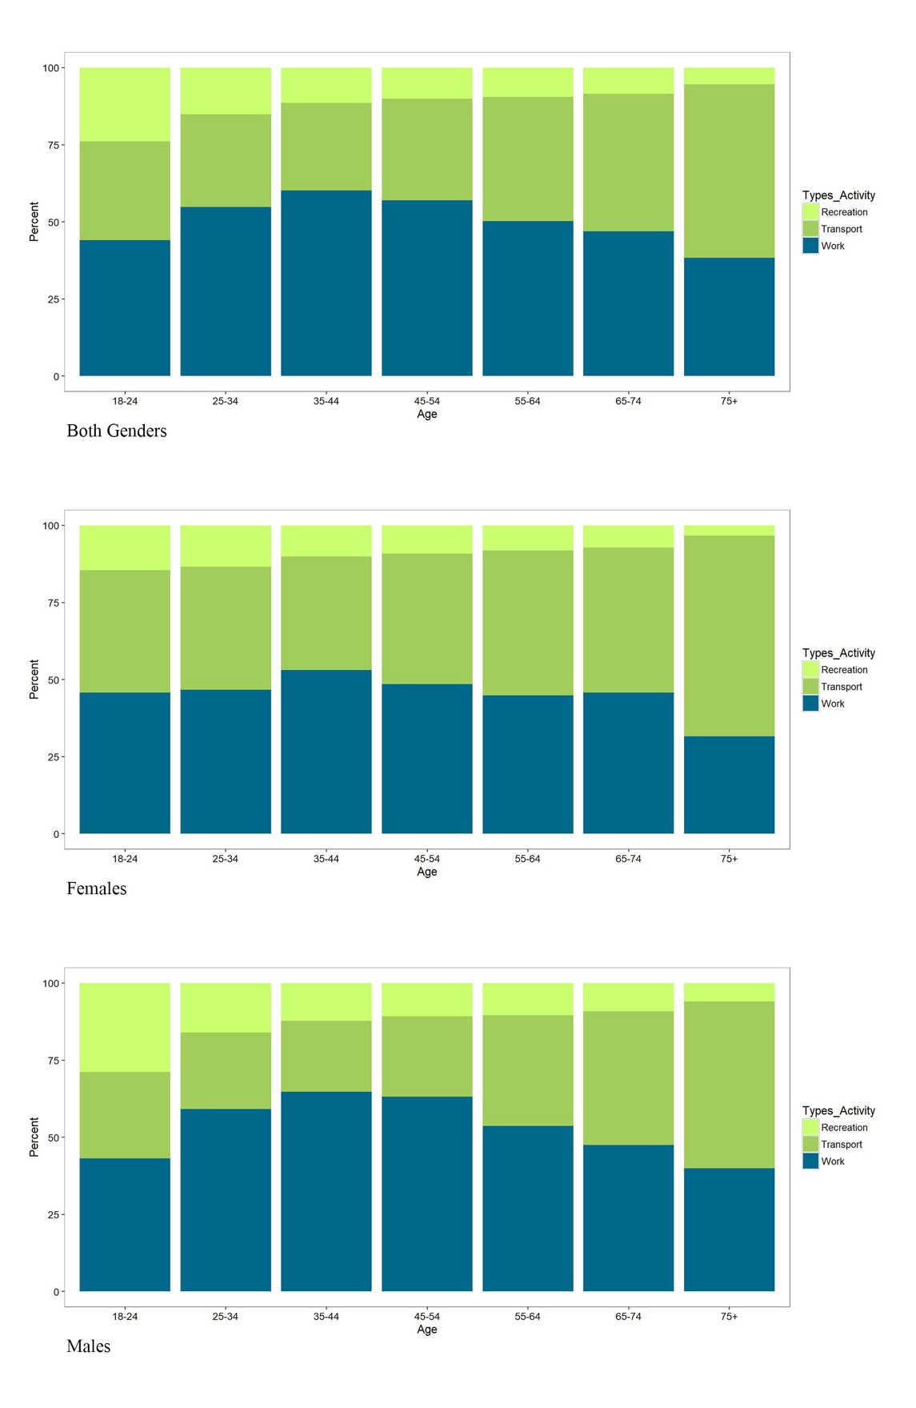
Figure S2. Percentage of physical activity domains’ contribution in total METs among adult Iranian gender and age groups.

