Distribution of the Health Literacy Questionnaire Scales

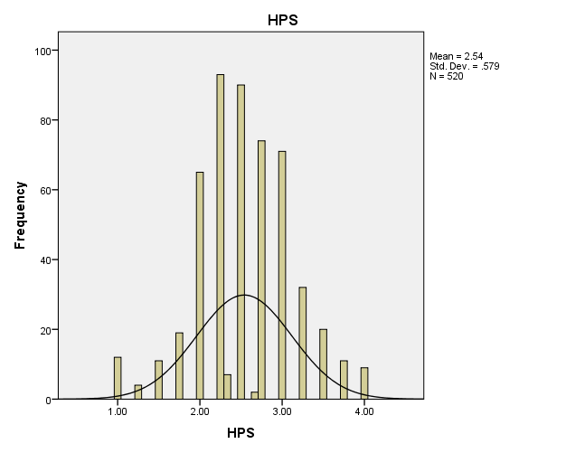
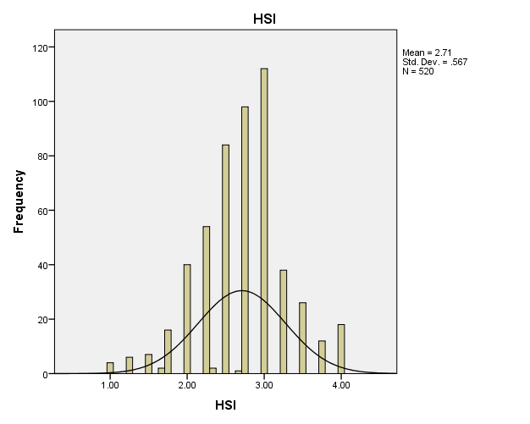

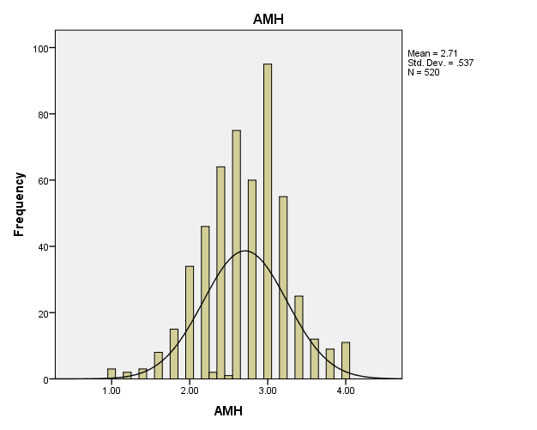

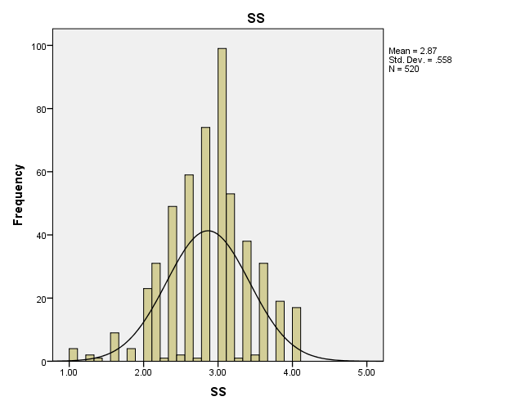

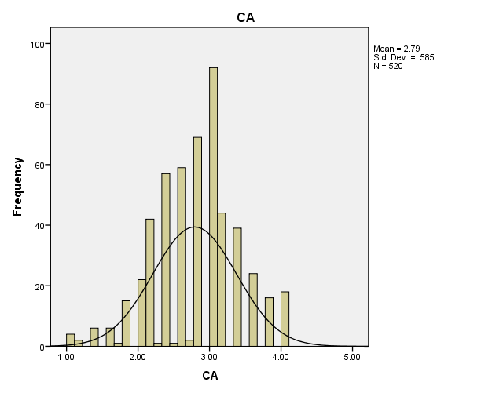

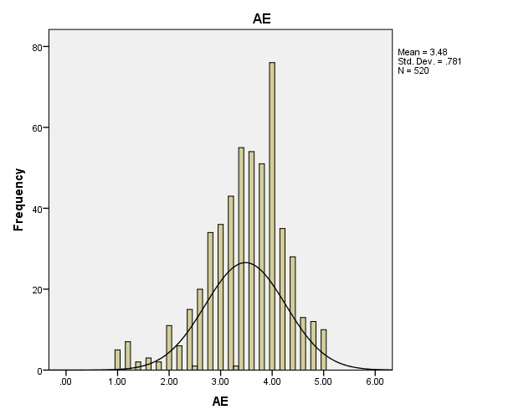

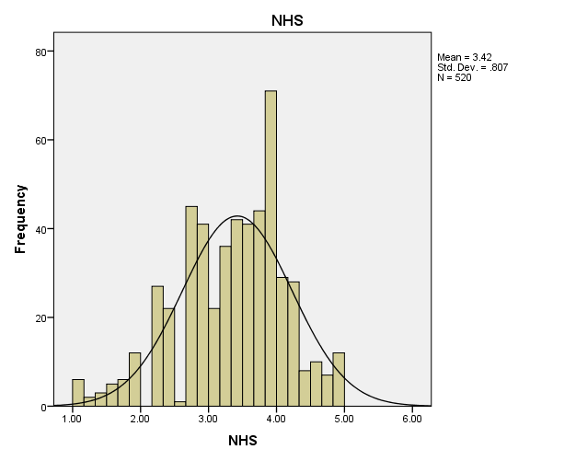

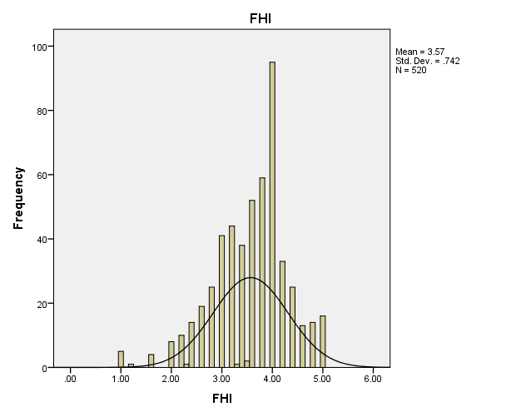

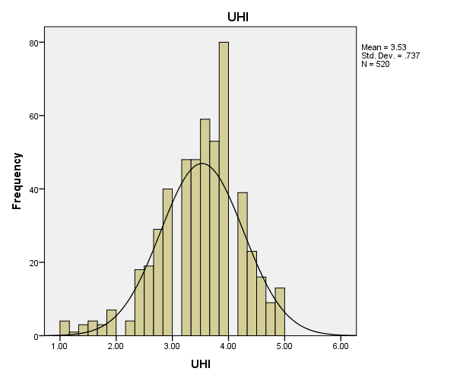

Abbreviations: HPS = Feeling understood and supported by healthcare providers, HSI = Having sufficient information to manage my health, AMH = Actively managing my health, SS = Social support for health, CA = Appraisal of health information, AE = Ability to actively engage with healthcare providers, NHS = Navigating the healthcare system, FHI = Ability to find good health information, UHI = Understand health information

