Additional file 1: Theory of Change of the FIT Plus approach
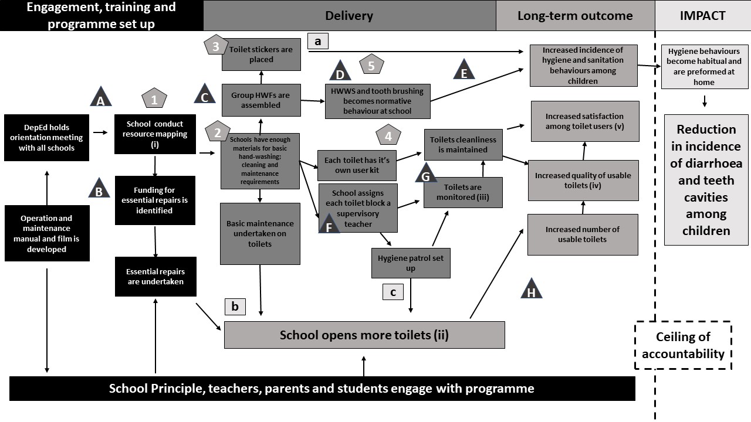

Assumptions  A | Interventions
- Principals are engaged with the programme and have the time to commit to programme  - There are funds available within the community  - PTA will be available and willing to assemble  - Schools will have capacity to run daily group activities  - Group activities will have an effect on individual behaviour  - Schools have capacity to run supervisory activities  - Monitoring will result in cleaning of toilets  - Assumes DepEd have monitoring system in place at time of intervention | - Delivery of O&M manual to assist PTA to conduct resource mapping  - FIT Plus toilet kits and components for group HWF are delivered  - Hygiene stickers are placed at hand-washing locations  - FIT Plus team pay weekly visits to the schools to build capacity and problem solve  - Daily group HWWS and tooth-brushing at school
Rationale | Indicators (i)
- Evidence from systematic reviews that behaviour can be cued by reminders  - Observational evidence that some toilets are kept locked due to disrepair  - Observational evidence that some toilets are kept locked due to inability to keep clean | - Resource mapping tool completed for each school within 1 month of start of intervention period  - Increase in number of toilets open at school as reflected in baseline and end-line figures  - Toilet monitoring tools completed for each school  - 50% increase in toilet quality score in intervention vs control arm by end of intervention  - Satisfaction scores are 20% higher in intervention than control arm.

