Additional File 1: LOESS curves with automatic smoothing parameter selection

Figure S1: Distribution of serum lipids stratified by sex and pubertal stage provided with automatic smoothing parameter selection

 | Boys | Girls
TC* | 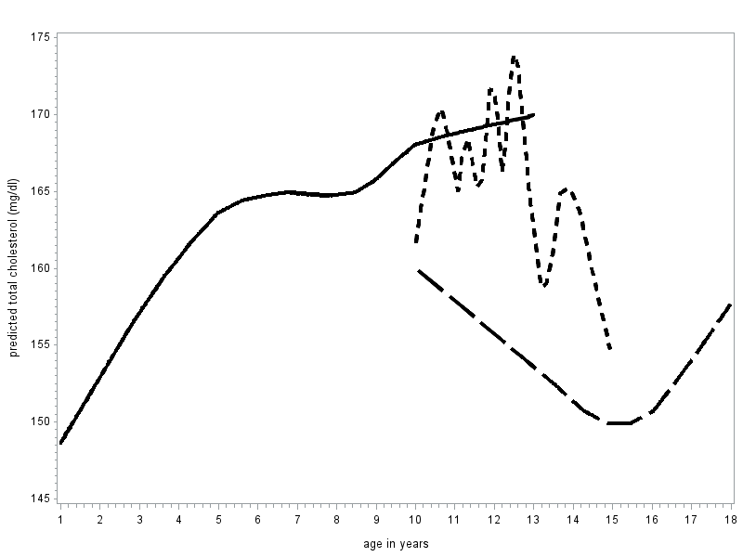 | 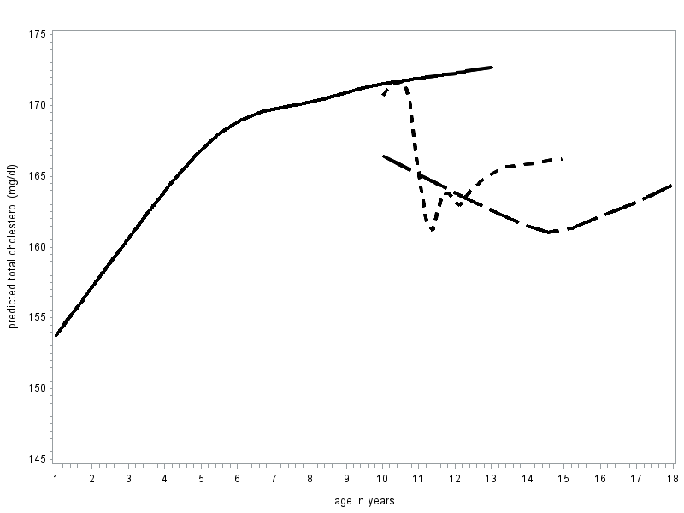
HDL* | 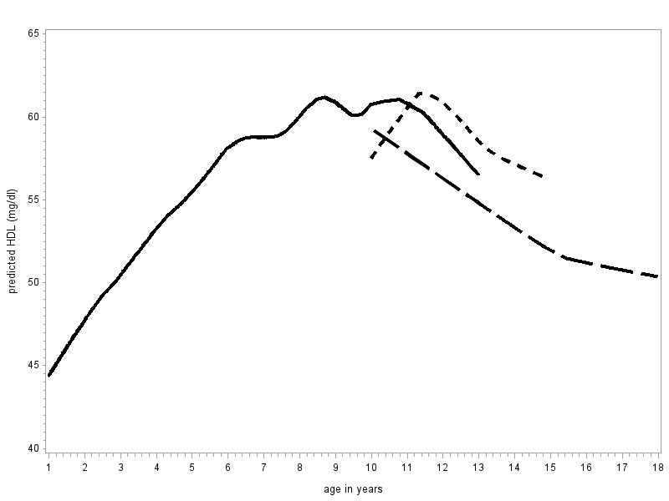 | 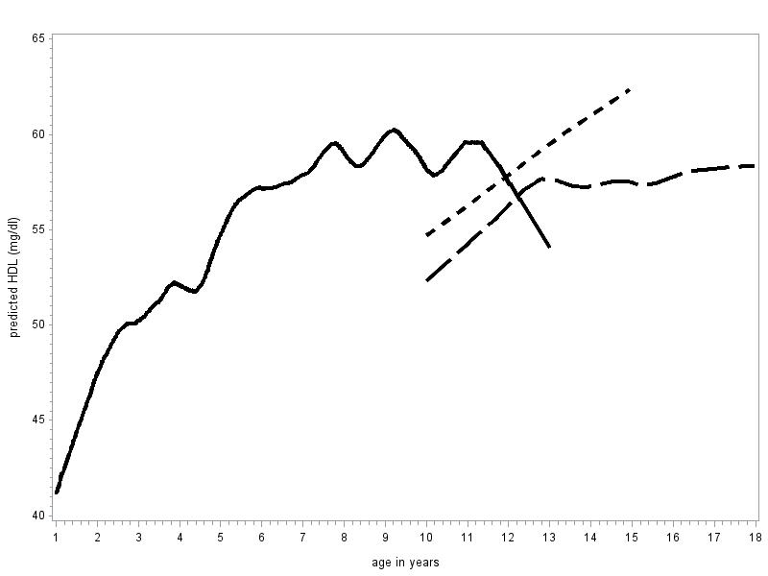
Non-HDL* | 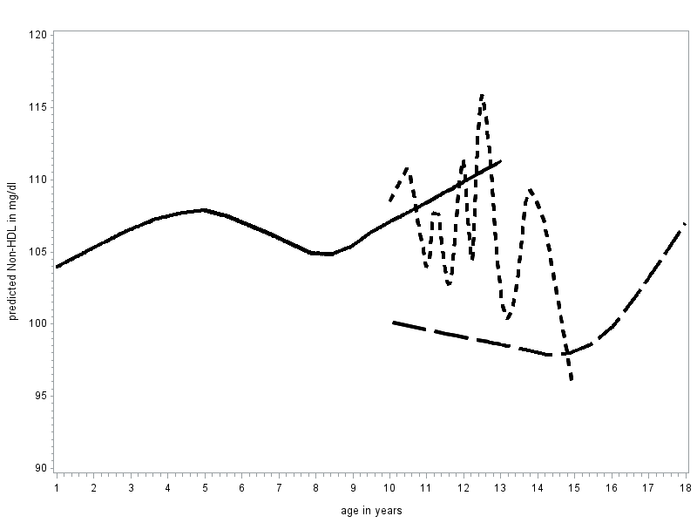 | 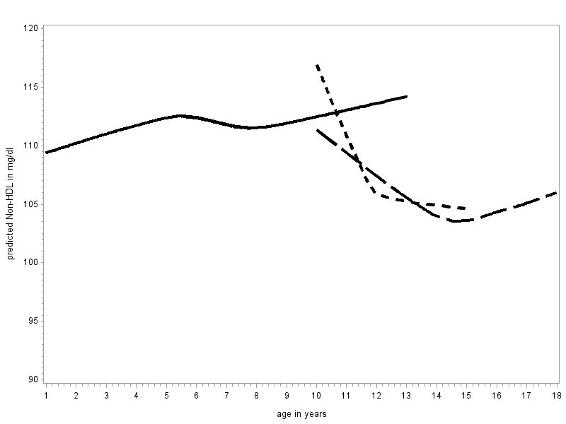

* solid line = prepubescent, short broken line = early/mid-puberty, long broken line = mature/advanced puberty

