Forest plot of subgroup analyses the association between depression risk and ST-SB:
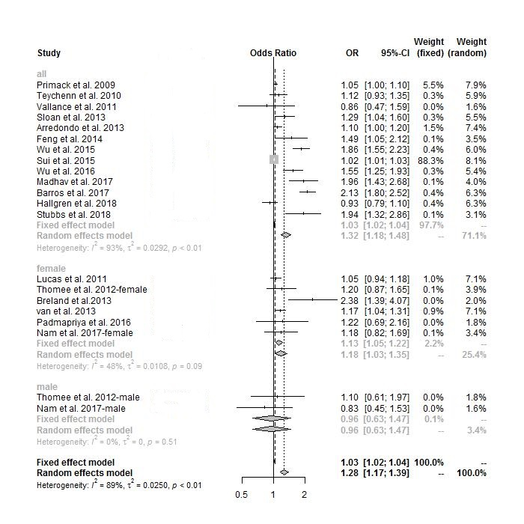
Figure 1. Forest plot of subgroup analyses the association between depression risk and ST-SB (by gender).
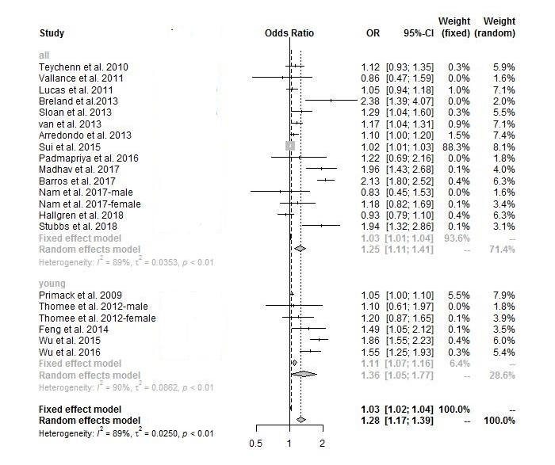
Figure 2. Forest plot of subgroup analyses the association between depression risk and ST-SB (by age).
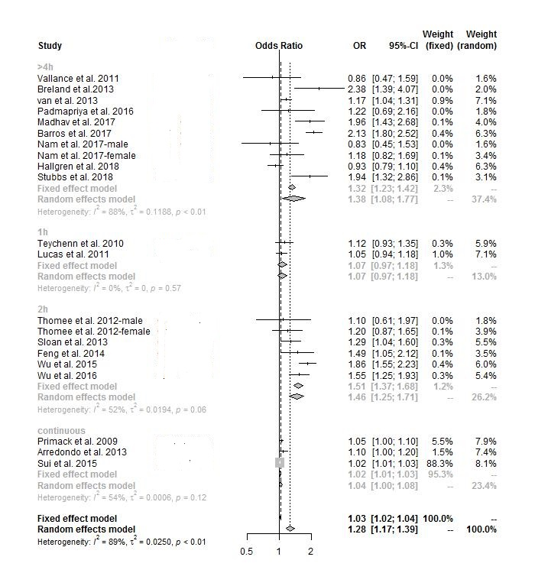
Figure 3. Forest plot of subgroup analyses the association between depression risk and ST-SB (by reference groups).
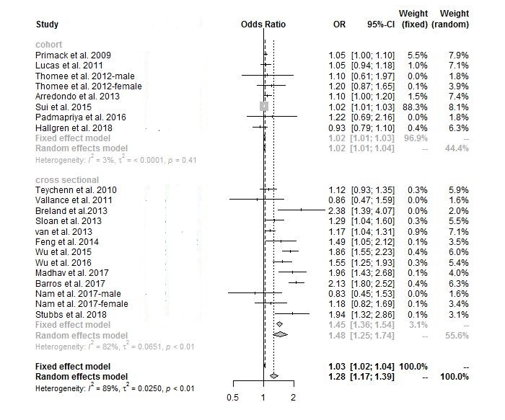
Figure 4. Forest plot of subgroup analyses the association between depression risk and ST-SB (by study design).

