Test for Publication Bias
Begg’s Test
adj. Kendall’s Score (P-Q) = -20
Std. Dev. Of Score = 33.12
Number of studies = 19
Z = -0.60
p = 0.5459
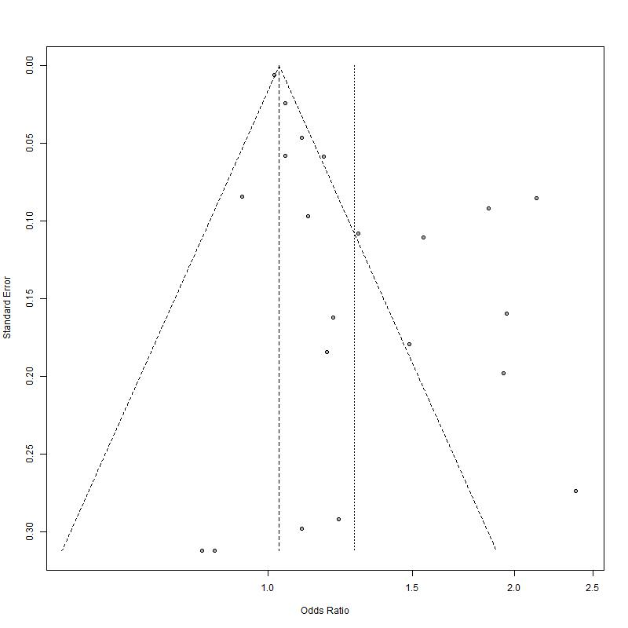
Figure S5. Funnel plot of publication bias.

