Additional file 3: Supplemental analyses on the impact of provincial air pollution exposure on COPD status
Table 3-1: Air pollution exposure status, compared among Control, COPD Risk (undiagnosed) and COPD Diagnosed groups.
 | All | Control group | COPD Risk group (undiagnosed) | COPD Diagnosed group | Risk vs. Control, p value | Diagnosed vs. Control, p value | Risk vs. Diagnosed, p value
 | (n=19,994) | (n=16,161) | (n=3,320) | (n=513)
Living in a ‘high-pollution’ province, n (%) |  |  |  |  | 0.192 | 0.154 | 0.192
Yes | 520  (17.6%) | 2,887  (17.9%) | 559  (16.8%) | 74  (14.4%)
No | 6,474  (82.4%) | 13,274  (82.1%) | 2,761  (83.2%) | 439  (85.6%)
Note: Based on the average monthly provincial Air Quality Index (AQI) levels for the period 2014 to 2017 (48 months), respondents were classified as “living in a ‘high-pollution’ province” if they resided in one of the following Chinese provinces: Hebei, Beijing, Henan, Tianjin, and Xinjiang (Details: see Methods section of main manuscript).
Figure 3-1: Logistic regression showing odds of being at risk for COPD (vs. control group) as a function of predictors, adjusting for covariates including “Living in a ‘high-pollution’ province”
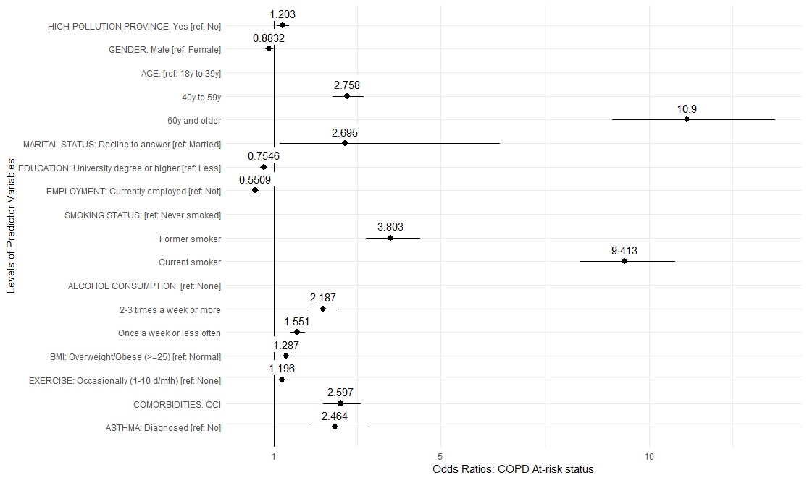
All predictors shown in the graphic reached statistical significance at p<0.05. Tested predictors that did not reach significance include: Not married [ref. Married/living with partner]; Education level Decline to answer [ref. Less than university degree]; Monthly household income after deducting employer welfare benefits: All levels [ref. CNY 7,999 or less]; BMI Underweight [ref. BMI Normal]; BMI Decline to answer [ref. BMI Normal]; Frequent exercise (11+ days/month) [ref. No exercise].

