APPENDIX (supplementary material)
APPENDIX B

Structure of family planning Revealed Cluster: Nigeria
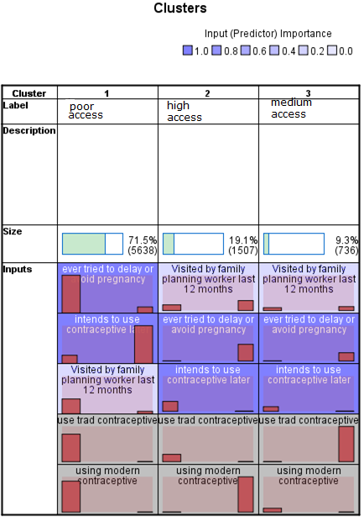

Structure of family planning revealed cluster: Ghana

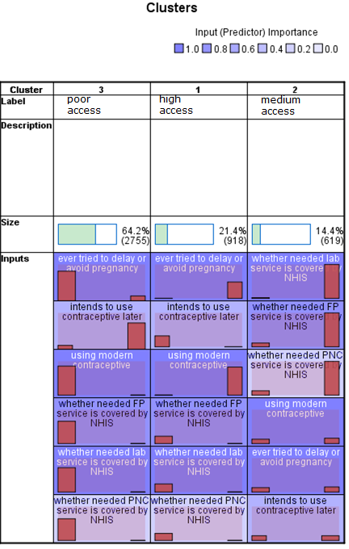

Structure of maternal healthcare services revealed cluster: Nigeria

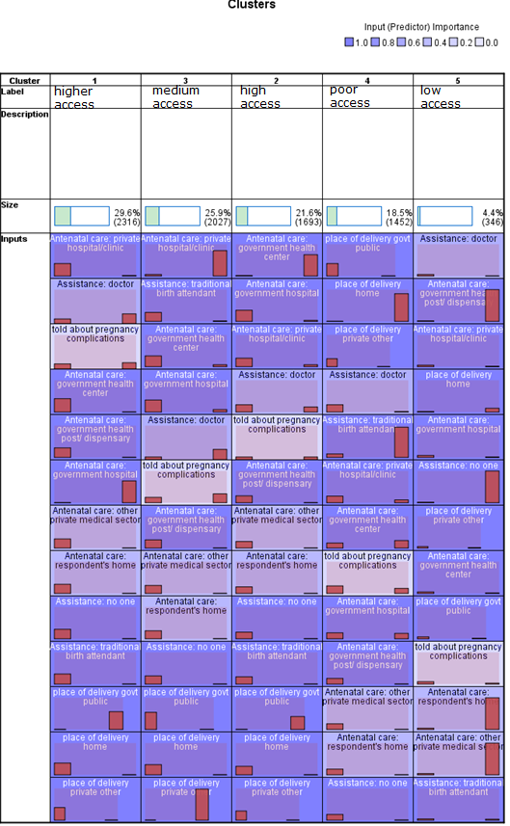

Structure of maternal healthcare services revealed cluster: Ghana

