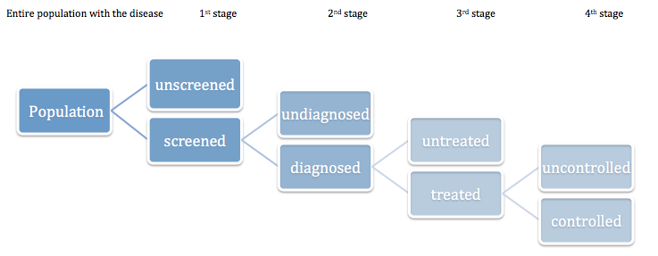

Figure a1 Losses through the care cascade, separately for hypertension and diabetes, where reaching next step is depending on having reached previous step.

