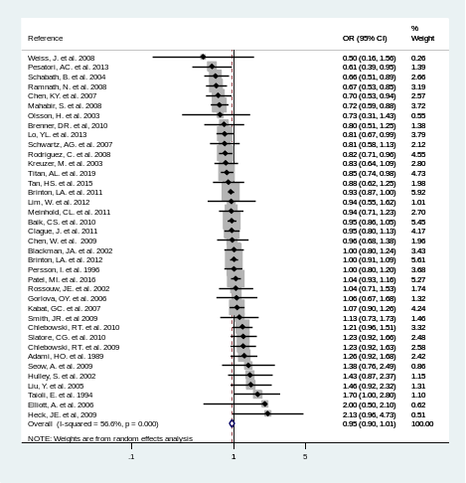  - Hormone use | 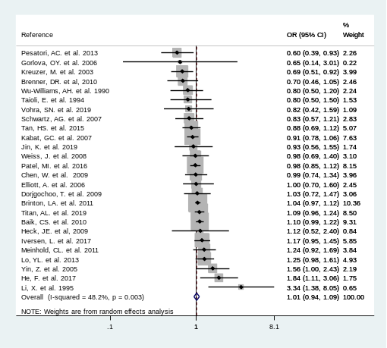  - Oral contraceptive use | 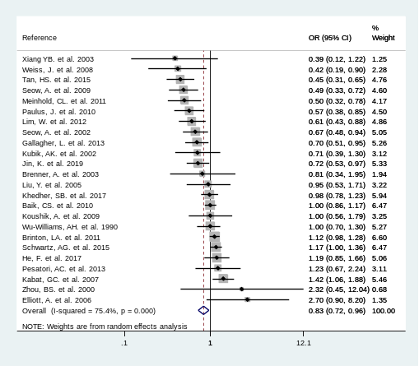  - Parity | 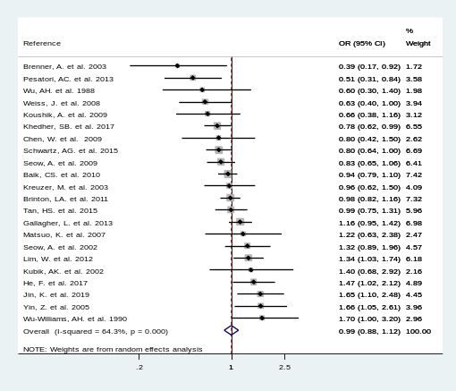  - Age at menopause
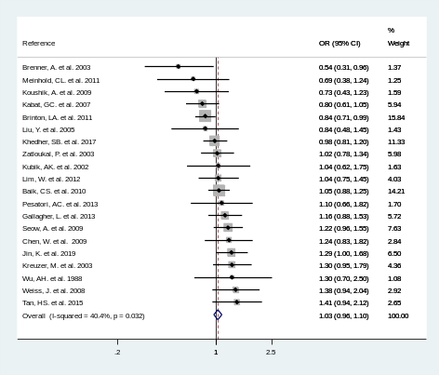  - Age at menarche | 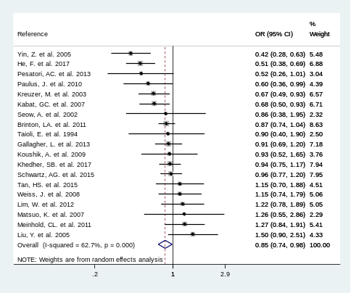  - Age at first birth | 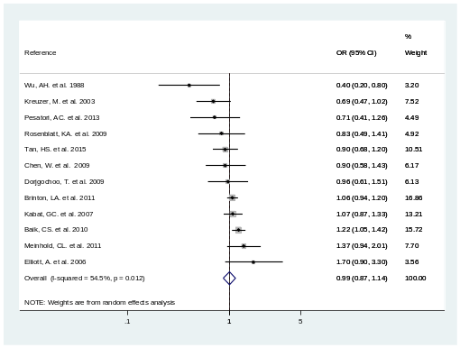  - OC use duration (years) | 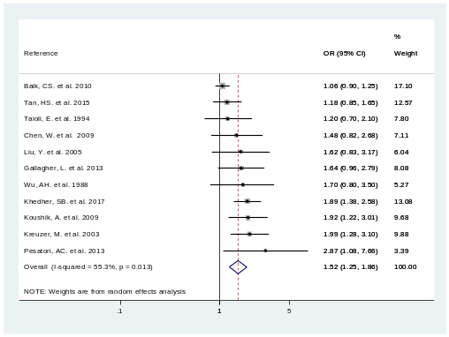  - Menopause type (reason)
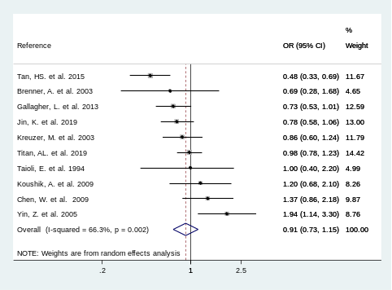  - Number of pregnancy | 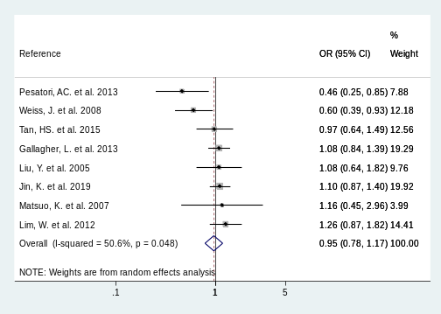  - Reproductive period (years) | 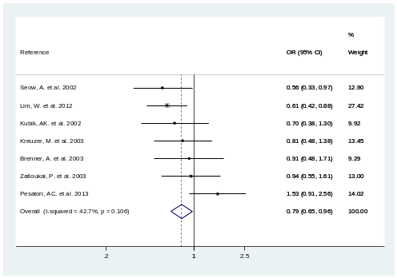  - Menstrual cycle length | 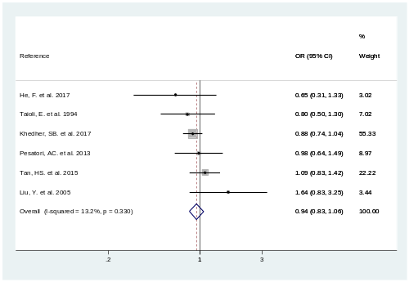  - Breastfeeding
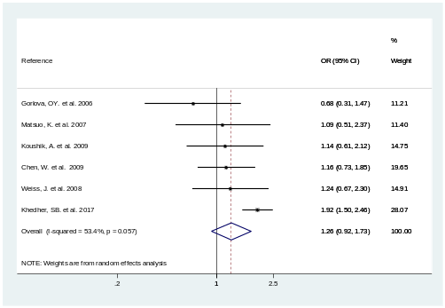  - Menopausal status | 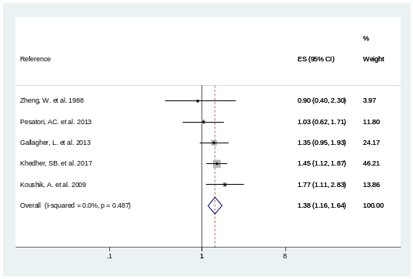  14) Ovariectomy | 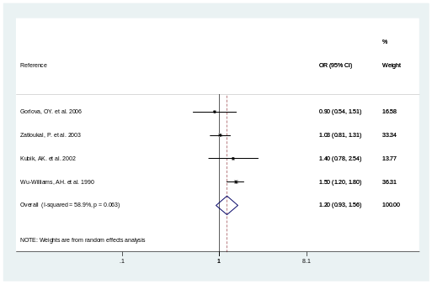  15) Miscarriage | 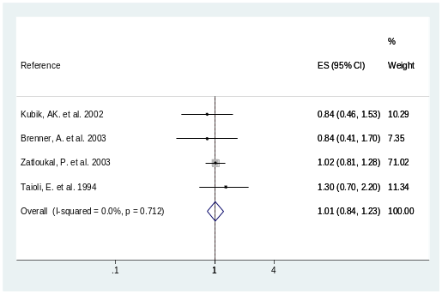  16) Length of menstrual flow
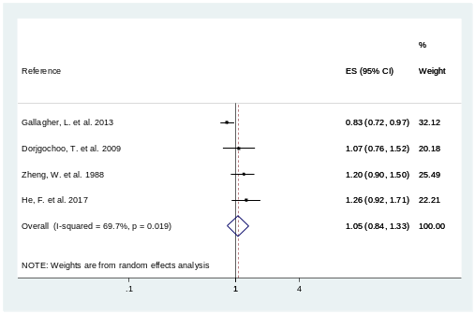  17) Tubal sterilization use | 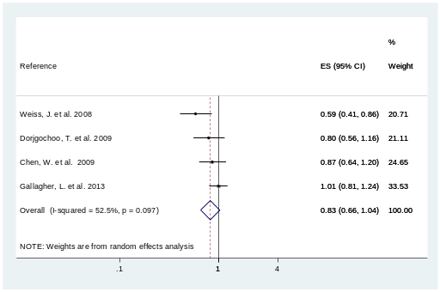  18) Intrauterine device use | 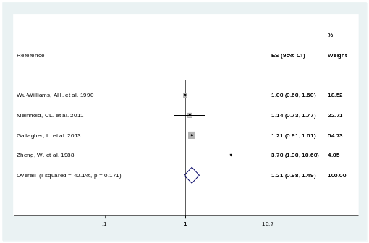  19) Hysterectomy | 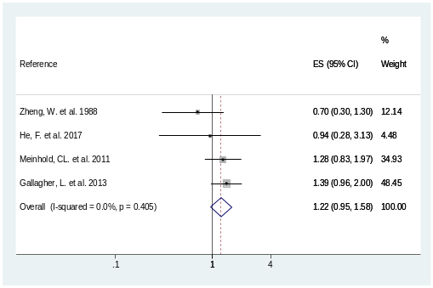  20) Uterine and ovarian all cut
Supplementary Figure S1. Forest plots for overall lung cancer risks in women with reproductive variables.

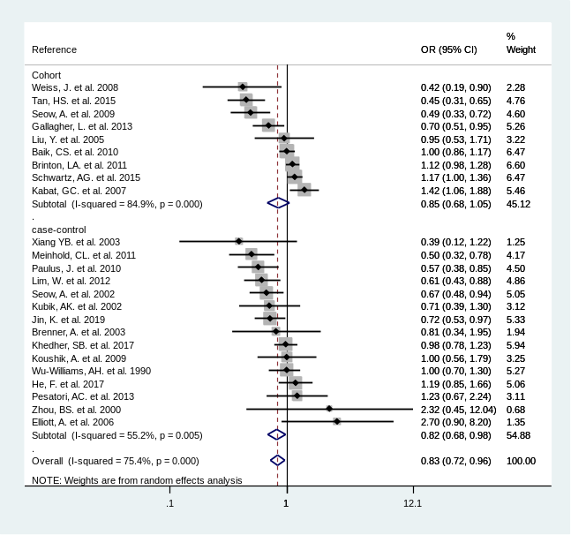  a) | 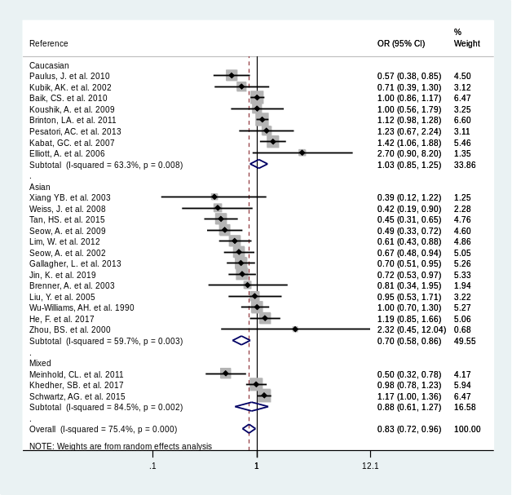  b) | 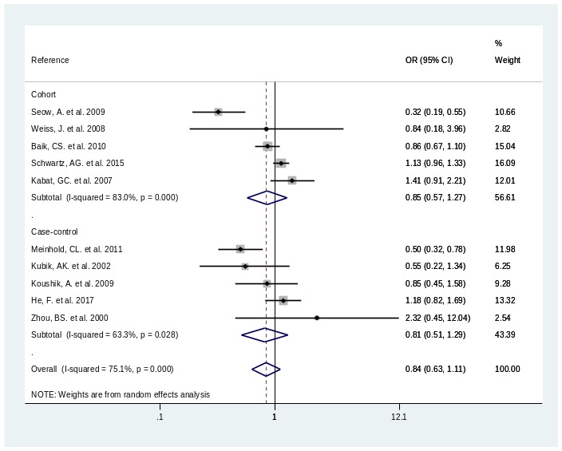  c)
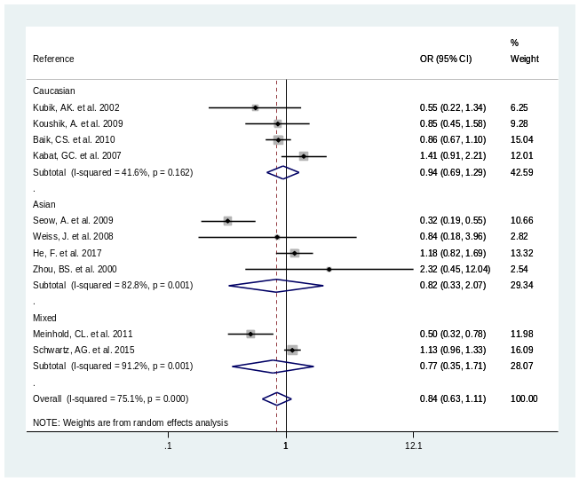  d) | 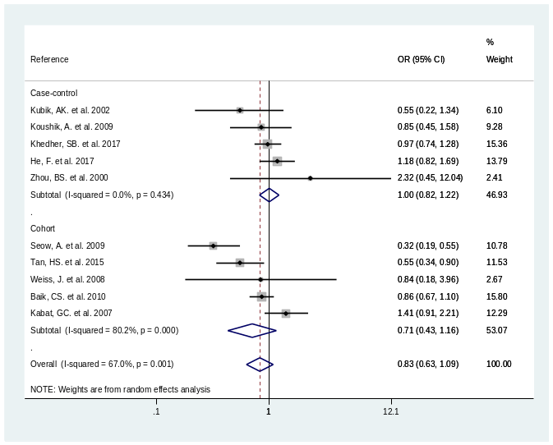  e) | 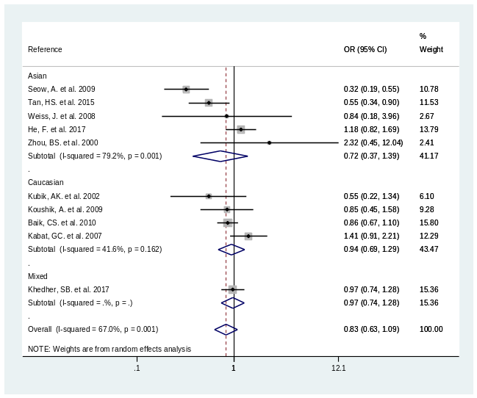  f)
Supplementary Figure S2. Forest plots for the association between parity and lung cancer risks in women (≥3 children vs. 0-2 children ). a) Overall lung cancer risks stratified by study designs; b) Overall lung cancer risks stratified by ethnicity; c) Non-small cell lung cancer risks stratified by study designs; d) Non-small cell lung cancer risks stratified by ethnicity; e) adenocarcinoma risks stratified by study designs; f) adenocarcinoma risks stratified by ethnicity.
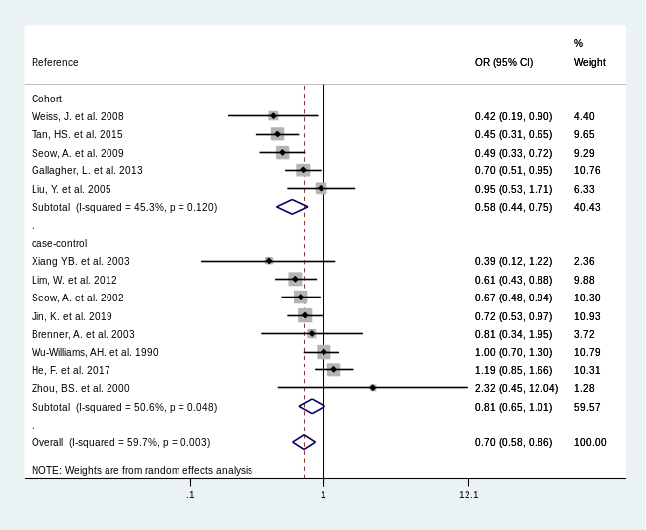  a) | 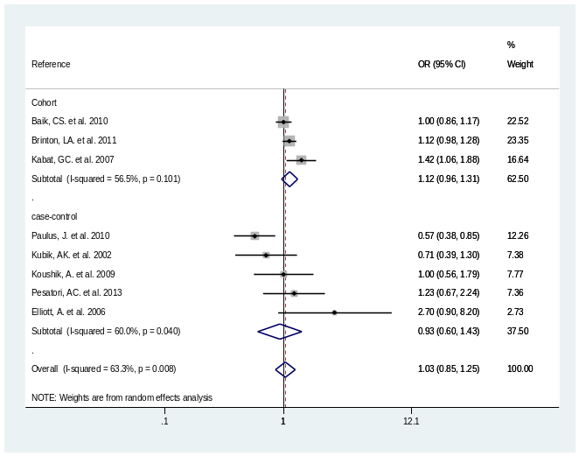  b) | 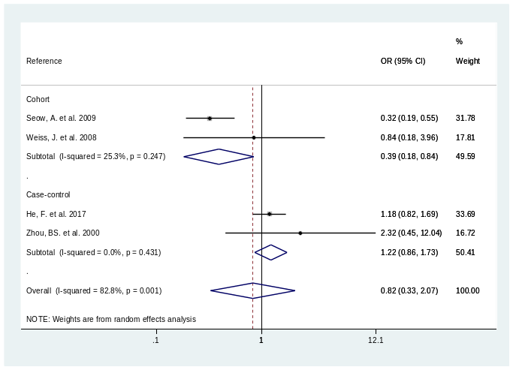  c)
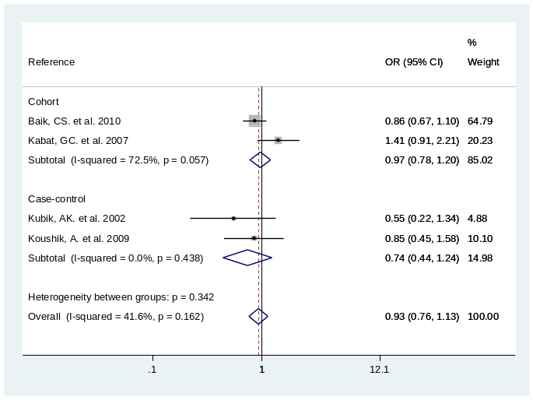  d) | 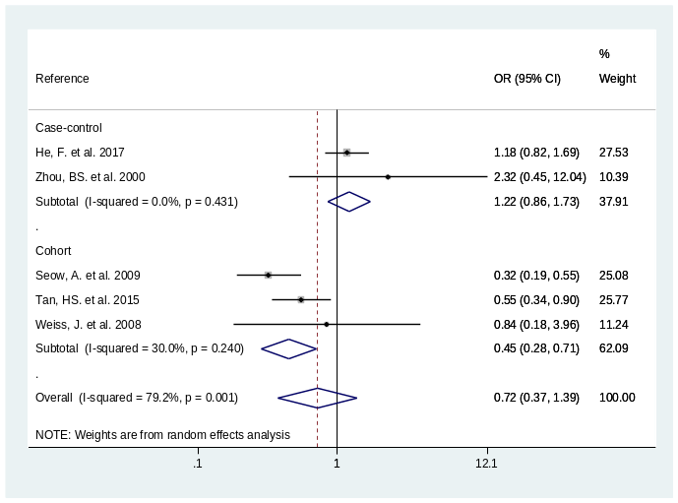  e) | 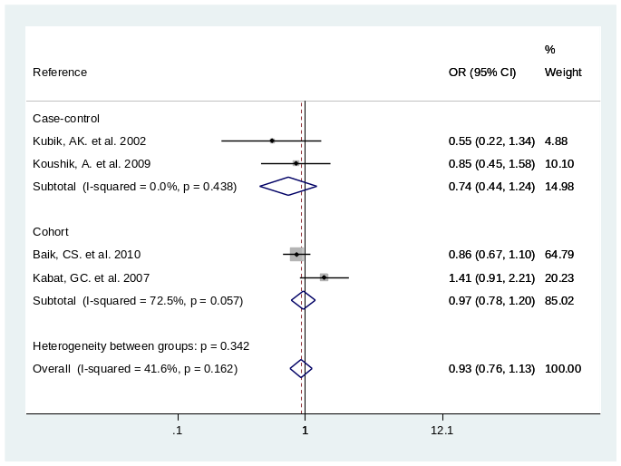  f)
Supplementary Figure S3. Forest plots for the association between parity and lung cancer risks in Asian and Caucasian women stratified by study designs (≥3 children vs. 0-2 children). a) Asian women with lung cancer; b) Caucasian women with lung cancer; c) Asian women with non-small cell lung cancer; d) Caucasian women with non-small cell lung cancer; e) Asian women with adenocarcinoma; f) Caucasian women with adenocarcinoma.
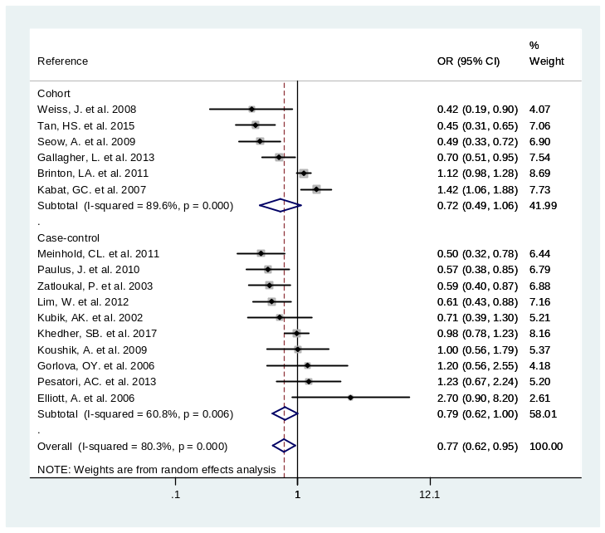  a) | 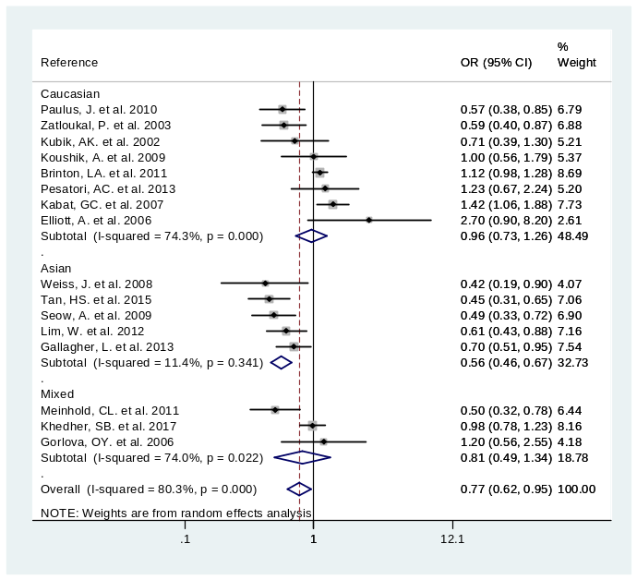  b)
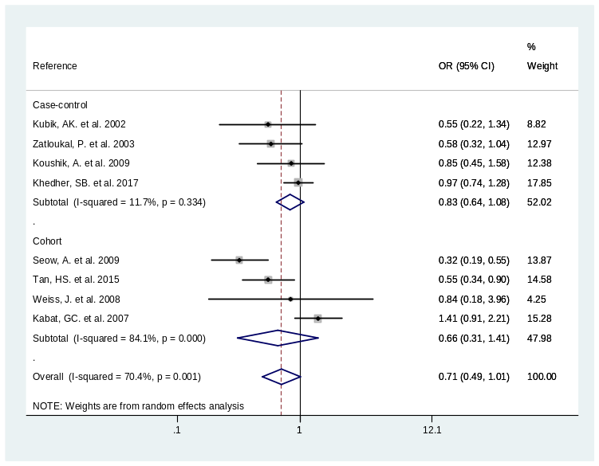  c) | 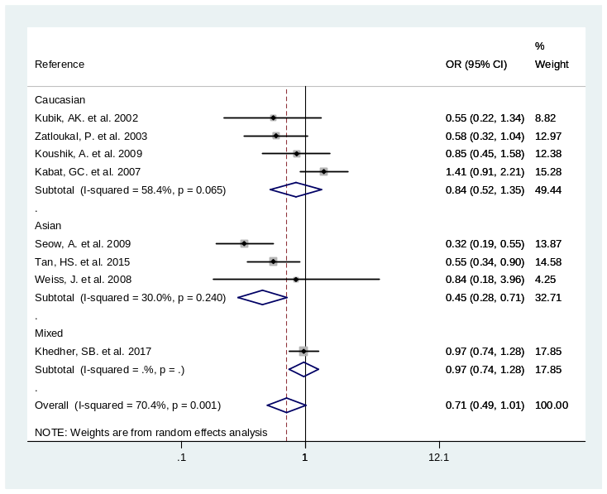  d)
Supplementary Figure S4. Forest plots for the association between parity and lung cancer risks in women (≥1 child vs. nulliparous). a) Overall lung cancer risks stratified by study designs; b) overall lung cancer risks stratified by ethnicity; c) adenocarcinoma risks stratified by study designs; d) adenocarcinoma risks stratified by ethnicity.
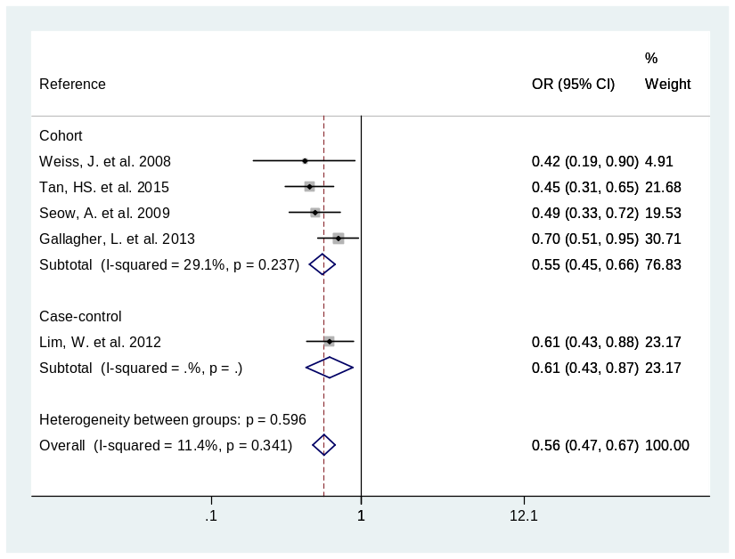  a) | 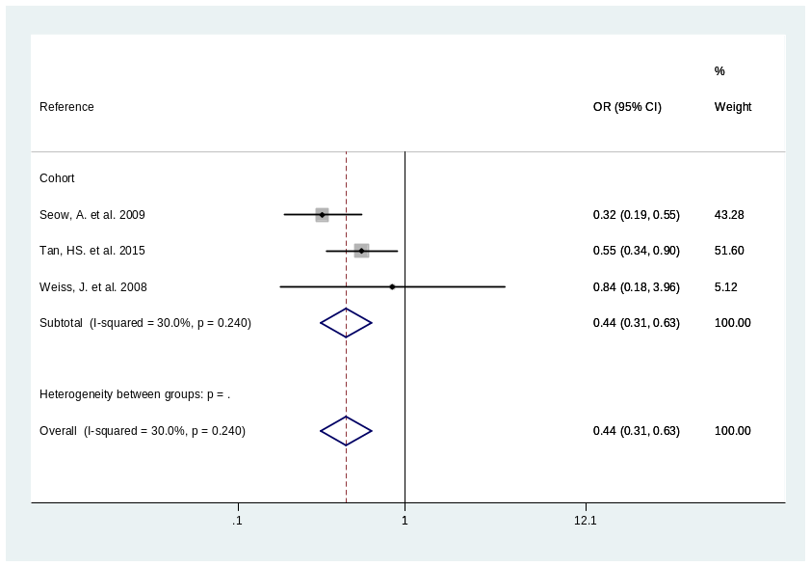  b)
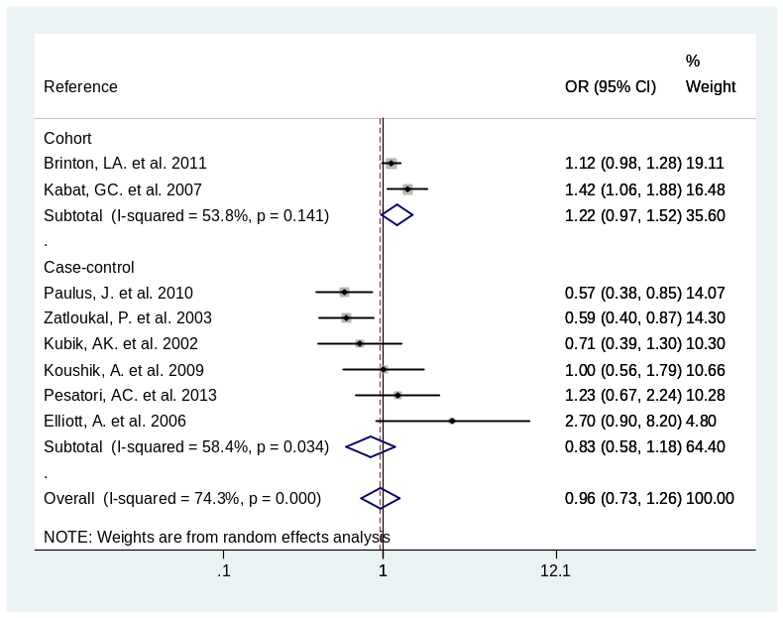  c) | 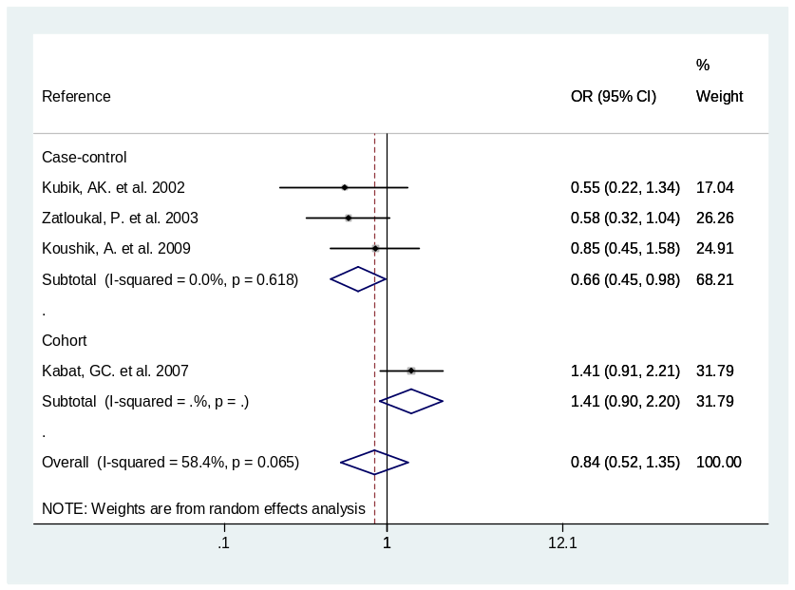  d)
Supplementary Figure S5. Forest plots for the association between parity and lung cancer risks in Asian and Caucasian women stratified by study designs (≥1 child vs. nulliparous). a) Asian women with lung cancer; b) Asian women with adenocarcinoma; c) Caucasian women with lung cancer; d) Caucasian women with adenocarcinoma.
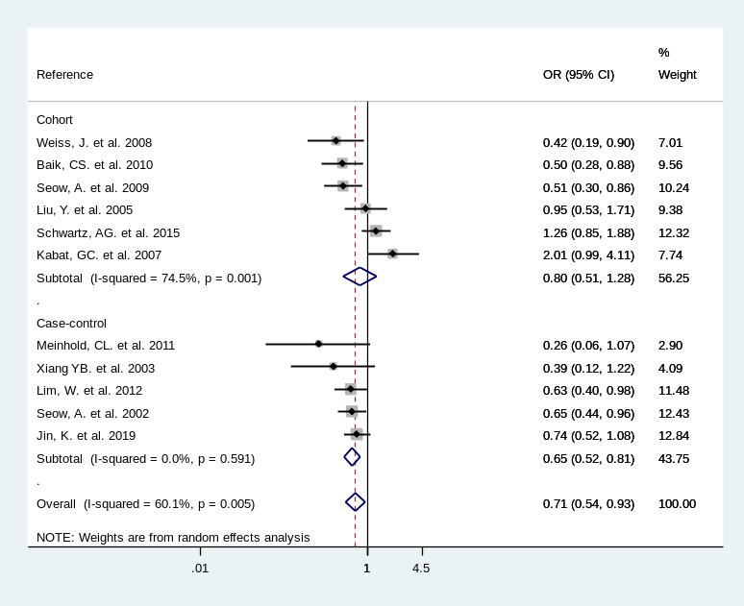  a) | 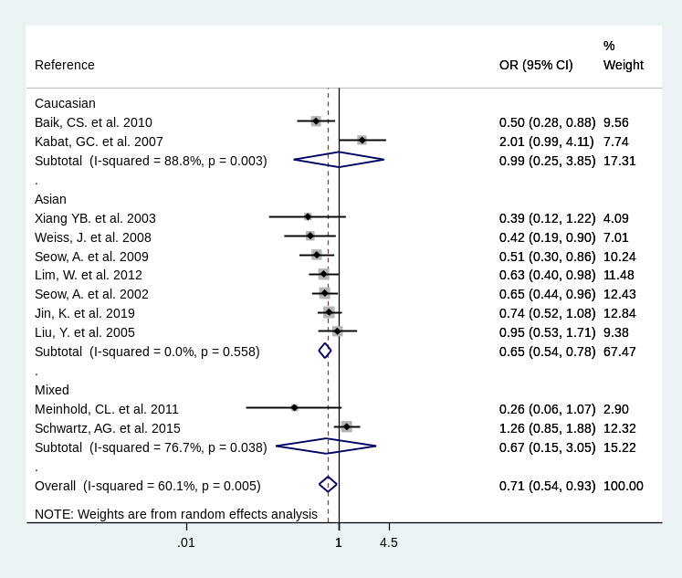  b)
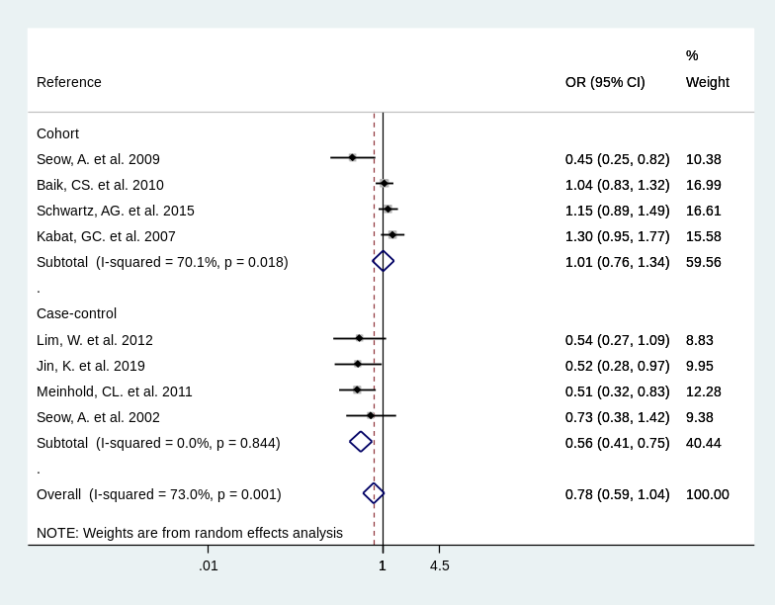  c) | 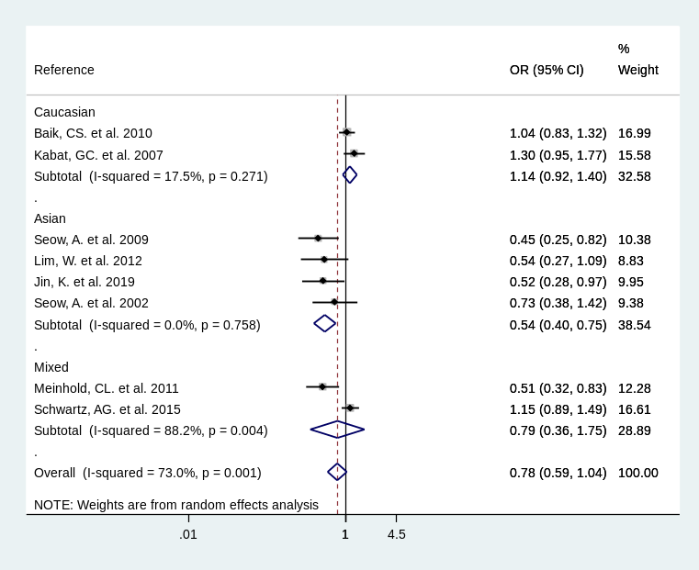  d)
Supplementary Figure S6. Forest plots for the association between parity and lung cancer risks in never-smoked vs. ever smoked women stratified by study designs and ethnicity (≥3 children vs. 0-2 children). a) never smokers stratified by study design; b) never smokers stratified by ethnicity; c) ever smokers stratified by study design; d) ever smokers stratified by ethnicity;
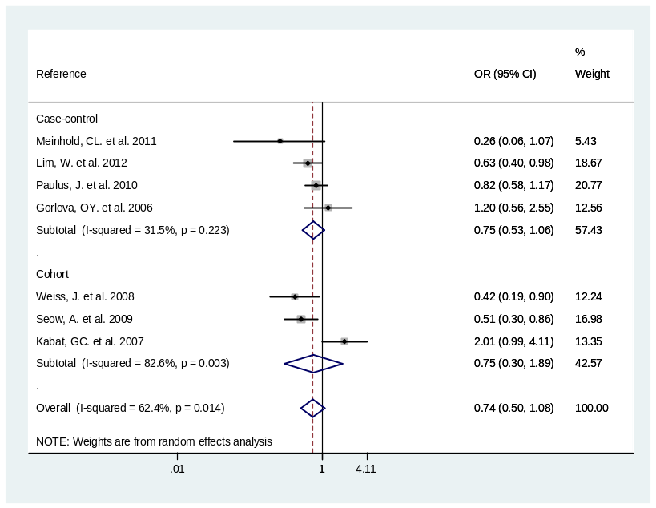  a) | 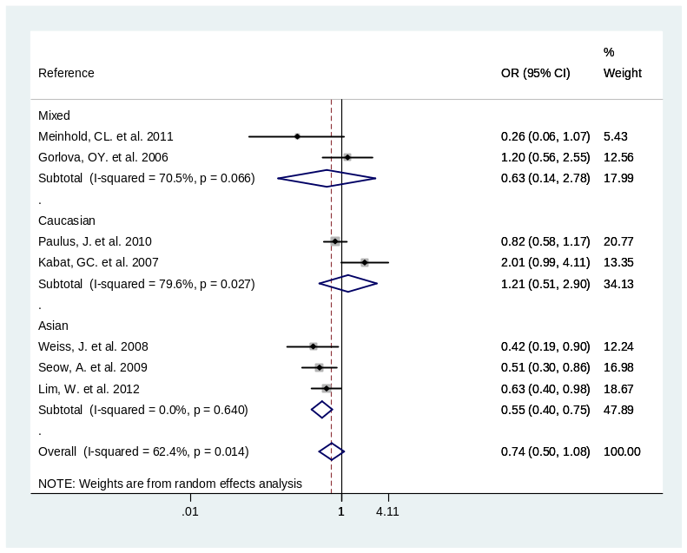  b)
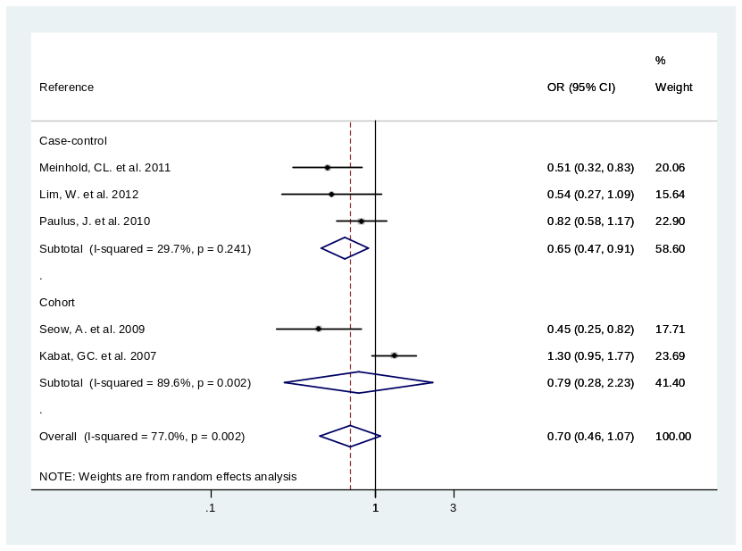  c) | 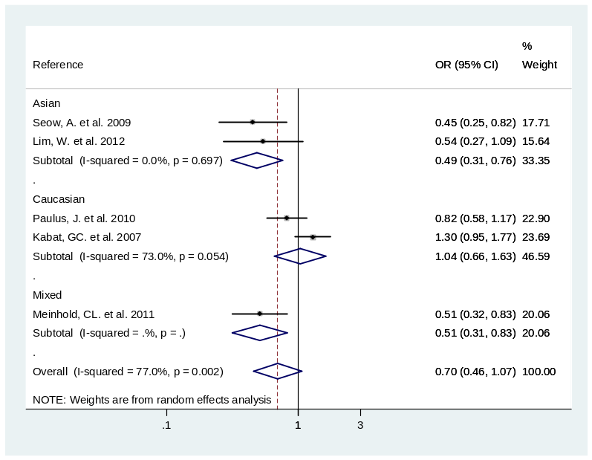  d)
Supplementary Figure S7. Forest plots for the association between parity and lung cancer risks in never-smoked vs. ever smoked women stratified by study designs and ethnicity (≥1 child vs. Nulliparous). a) Never smokers stratified by study design; b) never smokers stratified by ethnicity; c) ever smokers stratified by study design; d) ever smokers stratified by ethnicity.
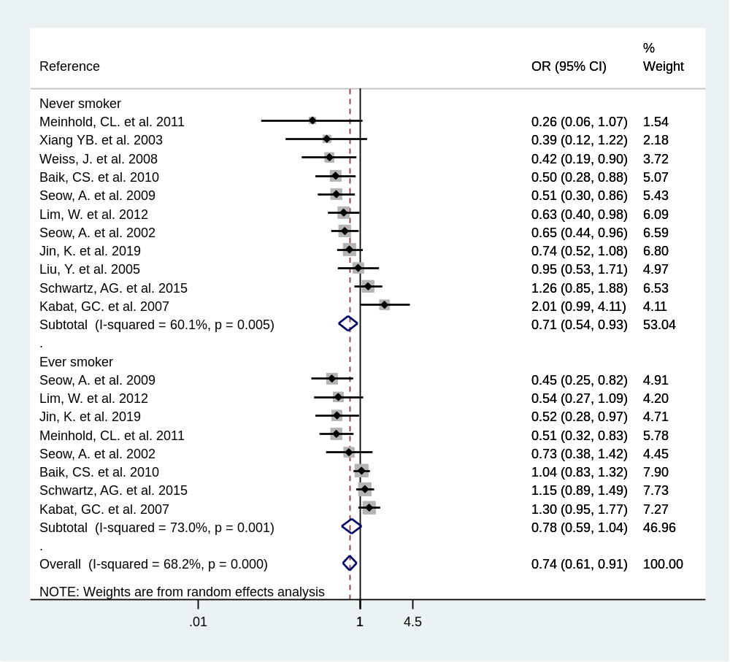

Supplementary Figure S8. Forest plots for lung cancer risks in never-smoked vs. ever smoked women with reproductive variables of parity (≥3 children vs. 0-2 children).

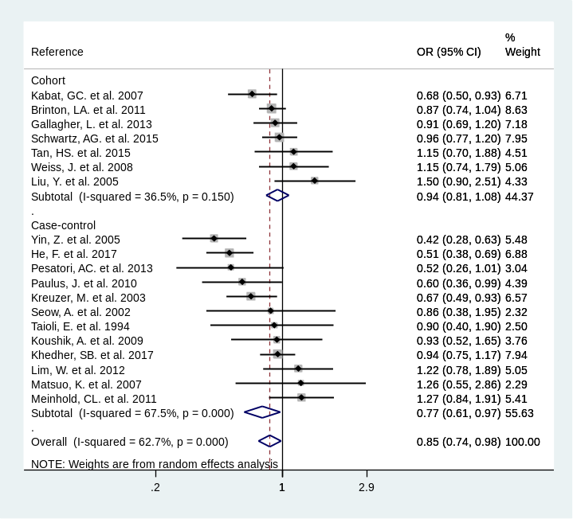  a) | 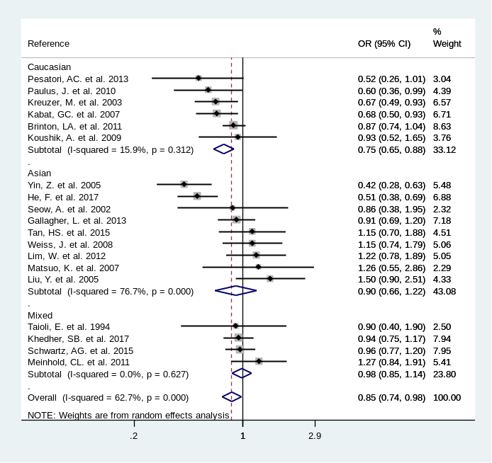  b)
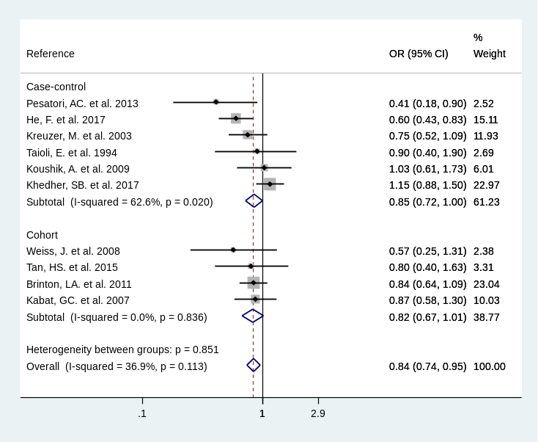  c) | 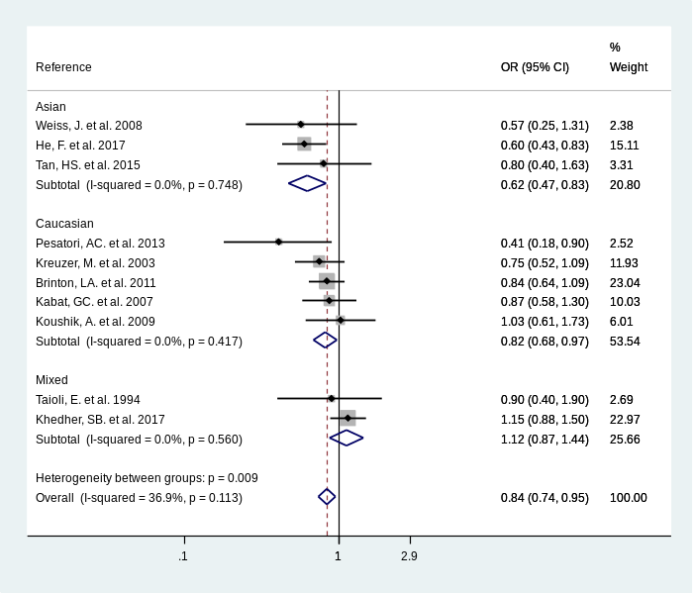  d)

Supplementary Figure S9. Forest plots for the association between age at first birth and lung cancer risks in women (≥25 vs. Nulliparous / <25). a) Overall lung cancer risks stratified by study designs; b) overall lung cancer risks stratified by ethnicity; c) adenocarcinoma risks stratified by study designs; d) adenocarcinoma risks stratified by ethnicity.
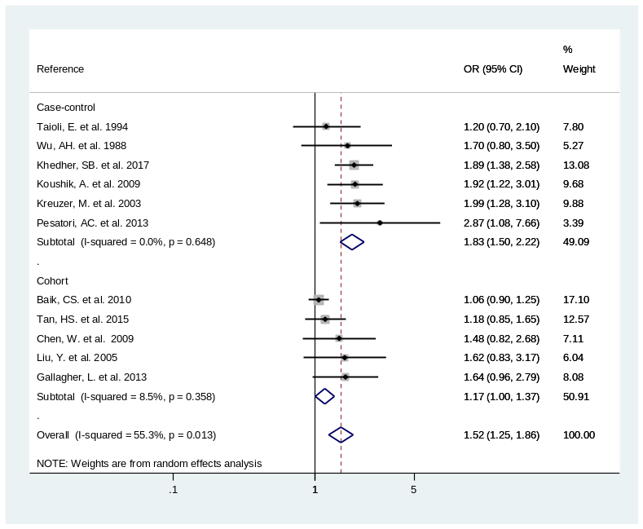  a) | 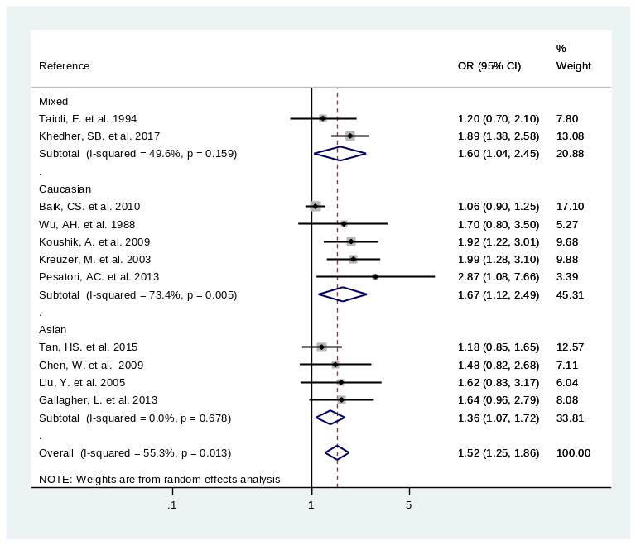  b)
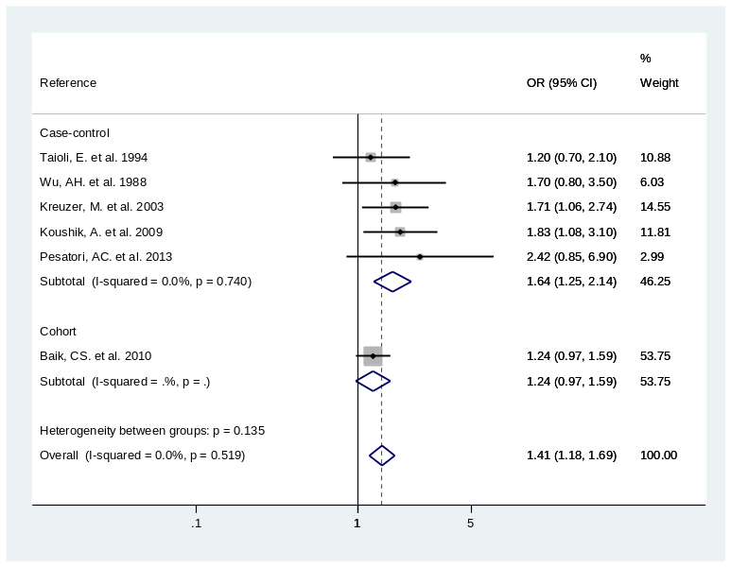  c) | 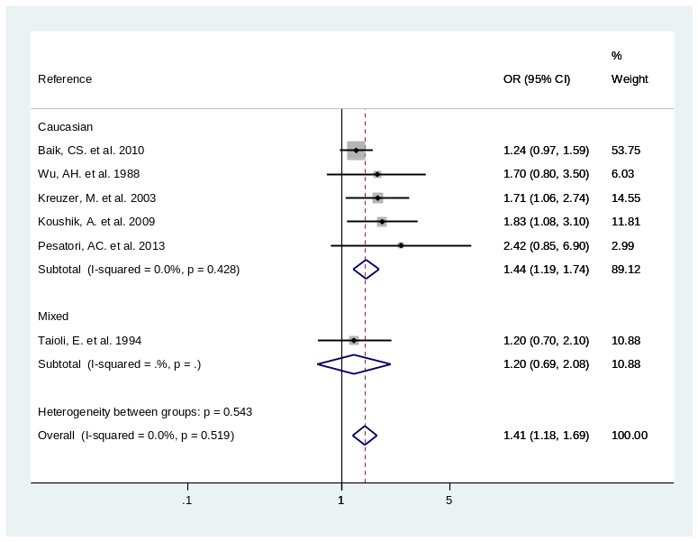  d)
Supplementary Figure S10. Forest plots for the association between menopause reason and lung cancer risks in women (non-natural menopause versus natural menopause). a) Overall lung cancer risks stratified by study designs; b) overall lung cancer risks stratified by ethnicity; c) adenocarcinoma risks stratified by study designs; d) adenocarcinoma risks stratified by ethnicity.
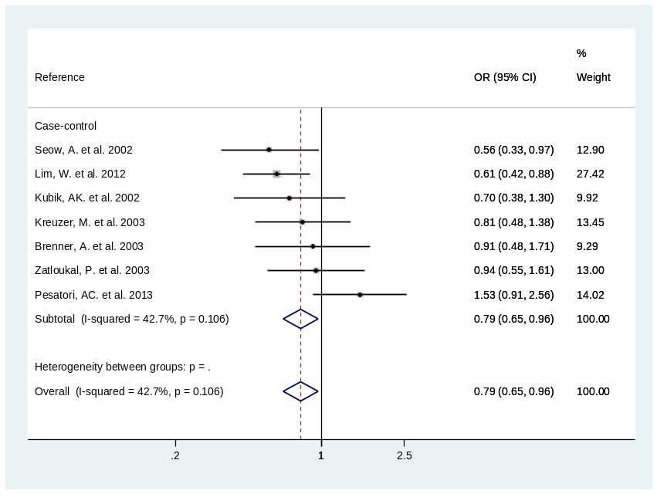  a) | 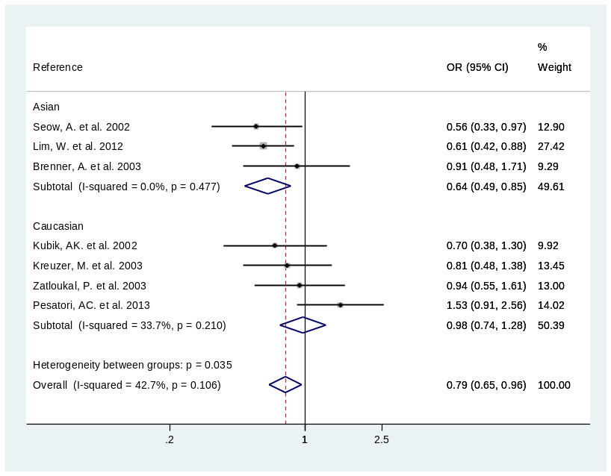  b)
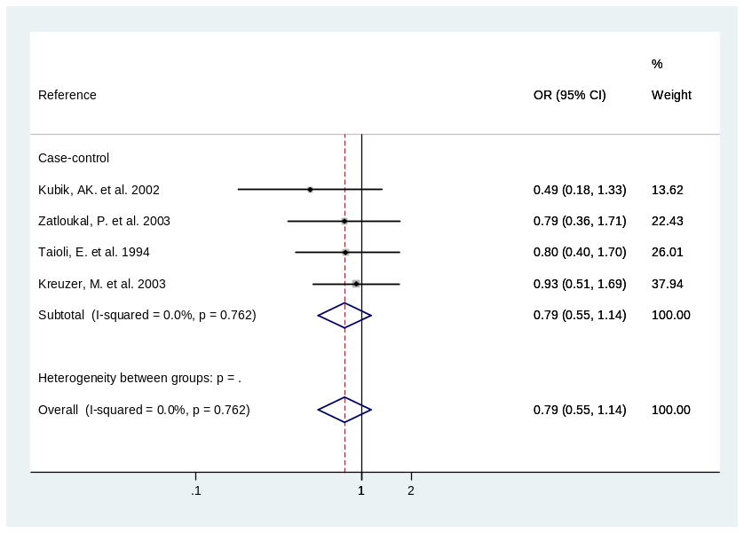  cc) | 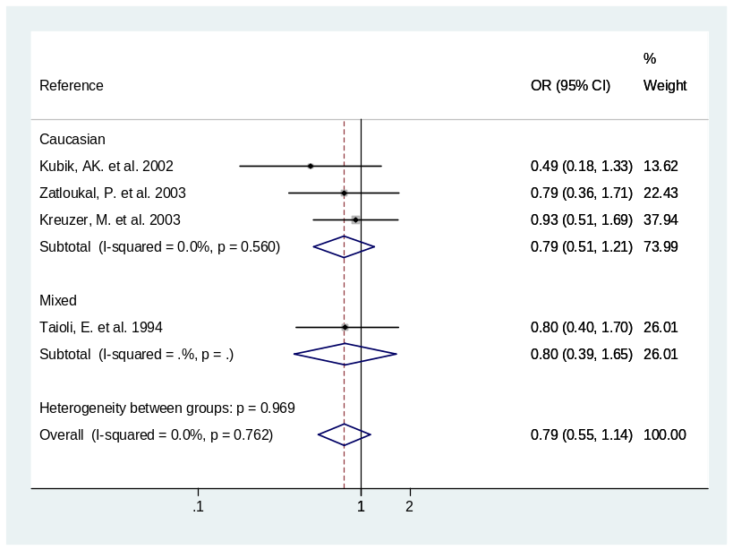  d)
Supplementary Figure S11. Forest plots for the association between menstrual cycle length and lung cancer risks in women (>30 days vs. <27 to ≤ 30 days). a) Overall lung cancer risks stratified by study designs; b) overall lung cancer risks stratified by ethnicity; c) adenocarcinoma risks stratified by study designs; d) adenocarcinoma risks stratified by ethnicity.
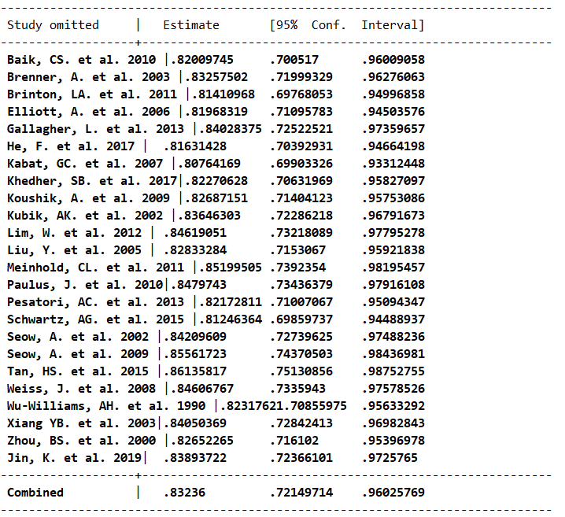
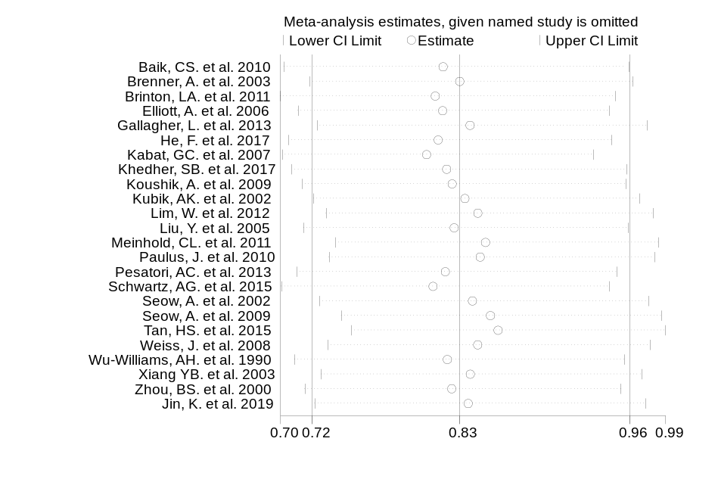
a)

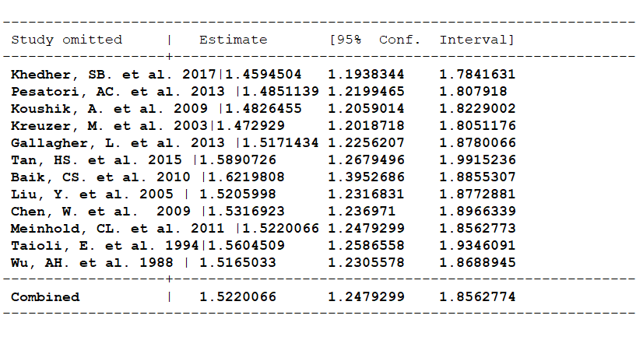
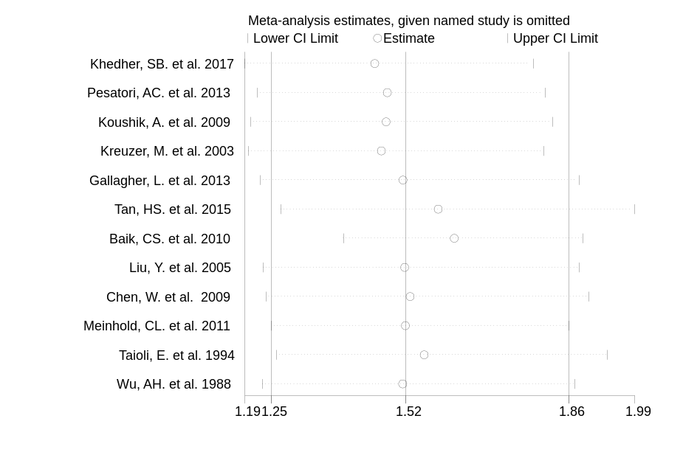
b)
Supplementary Figure S12. Sensitivity analysis for: a) parity; b) menopause type;
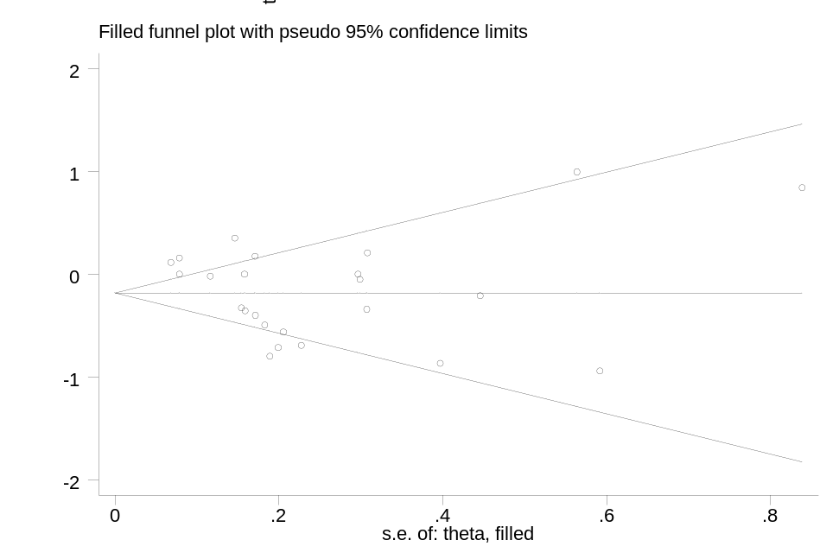
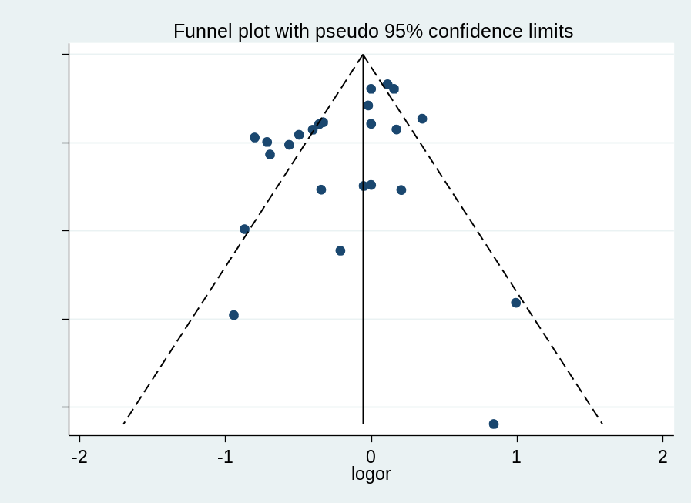
a)

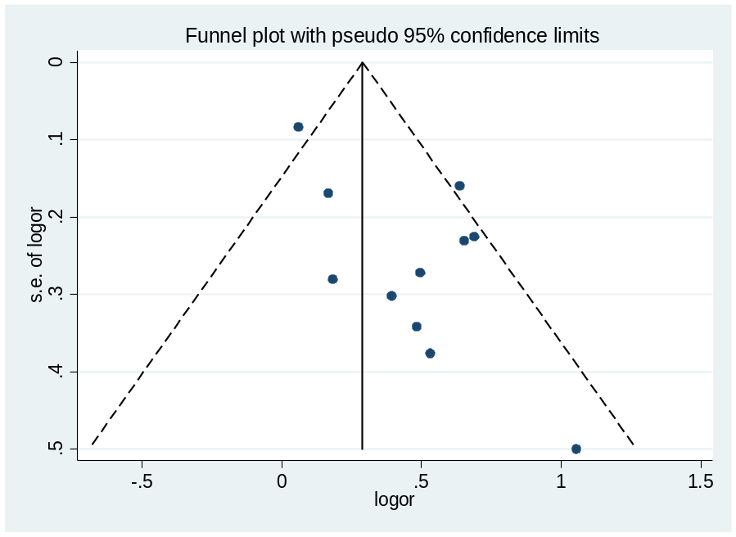
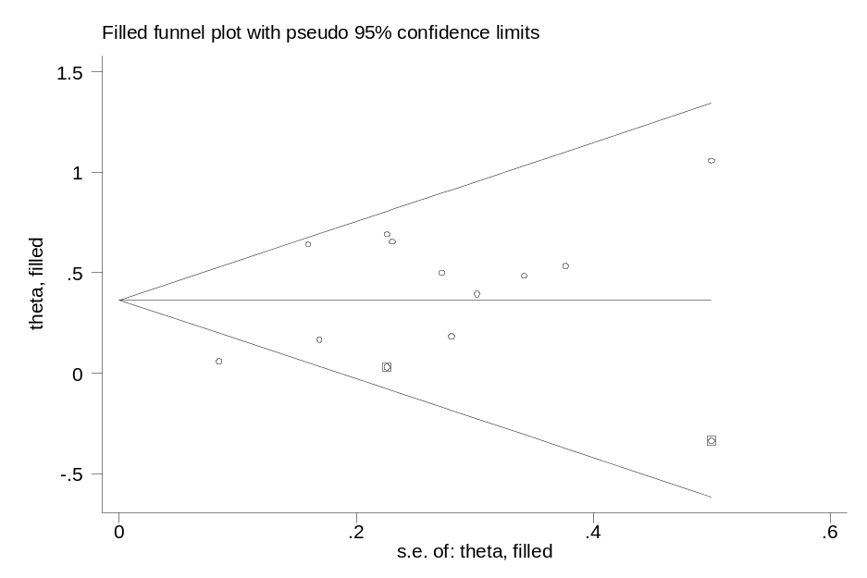
b)
Supplementary Figure S13. Funnel plots and funnel plots with trim and fill for: a) parity; b) menopause type.

