List of Figure Titles, Legends and Figures

Figure Titles

Figure 1. Flow chart of sampling stages for urban-rural cross-sectional analysis, taken from Riskesdas 2018 data. Census block was used as primary sampling unit. *Source of information from raw primary data and the Official National Report of Riskesdas 2018.⁵

Figure 2. Weighted proportion of prediabetes in urban and rural subjects (excluding those with diabetes).

Figure 3. Urban-rural difference for physical activity level in women. Significance obtained using Mann-Whitney U test.

Legends

No legends for Figure 1

Legends for Figure 2
Left Pie (N=9702)
Rose pie = weighted proportion of urban population with prediabetes at 34.9% (95% CI : 33.6-36.2)
Blue pie = weighted proportion of urban population with normal glucose tolerance (NGT) at 65.1% (95% CI : 63.8-66.4)

Right Pie (N=10162)
Light yellow pie = weighted proportion of rural population with prediabetes at 44.8% (95% CI : 43.4-46.2)
Light purple pie = weighted proportion of rural population with NGT at 55.2% (95% CI : 53.8-56.6)

Legends for Figure 3
Green bar = proportion of those with good physical activity
Orange bar = proportion of those with low physical activity
p value for physical activity difference between urban and rural women was <0.0001

Figure 1

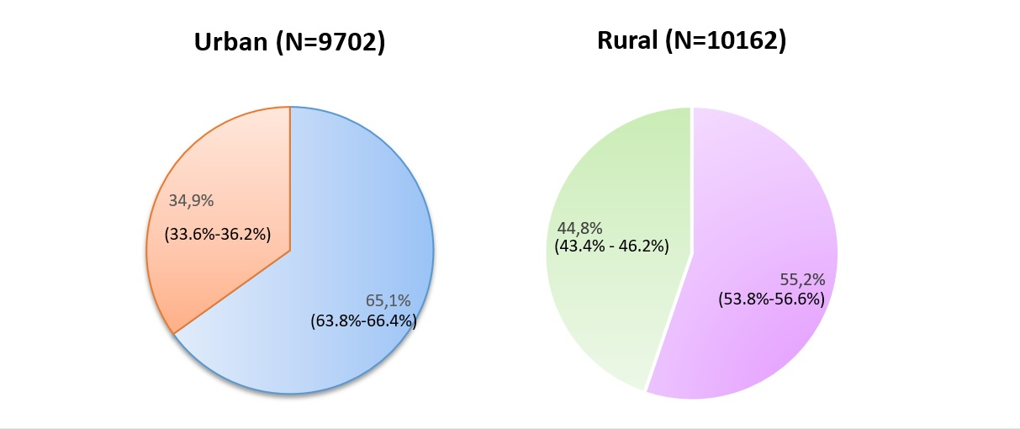

Figure 2

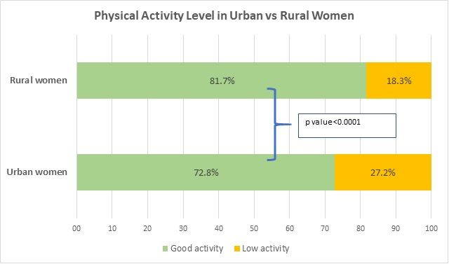
Figure 3

