Additional file 2: Screenshots and functions of the Family Move app
Screenshots | Description
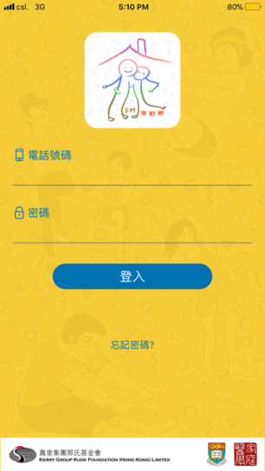 | A unique, anonymous participant number was assigned to each user family account. This allows the administrator to monitor and analyze user data such as frequency and duration of app use.
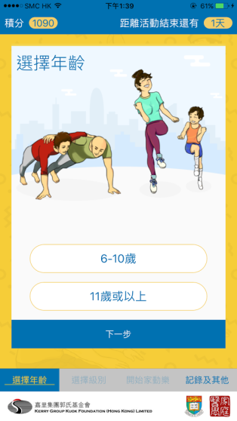  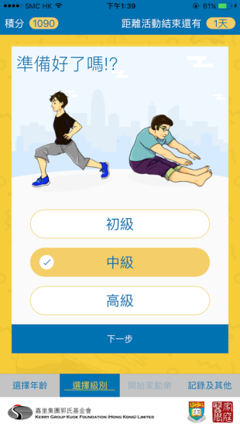 | An automated 8-week parent-child exercise program with age-appropriate exercises organized by levels of exercise difficulty. Exercise moves are stratified into two groups for children aged 6 to 10 years and adolescents aged 11 years or above, respectively. The exercise moves within each age group are further subdivided into three levels of difficulty. Each level has a different release period (i.e. release of clips in Level 1 in Week 1, those in Level 2 in Week 3, those in Level 3 in Week 5, and revision of all clips in Week 7).
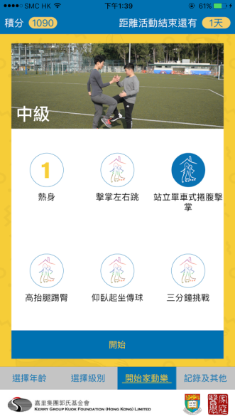 | A set of exercise demo videos presented by age group and levels. Each level consists of one warm-up clip (1 minute), 4 short demo clips (30 seconds per clip) including Cantonese audio instructions and subtitles to remind users of the benefits and correct posture of the exercise move, and 1 long challenge clip (3 minutes) integrating the four moves with background music.
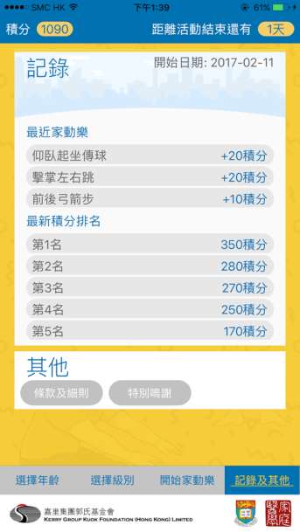 | Point system. Users receive points for each exercise clip viewed. More points are awarded to more difficult moves. Points can be accumulated and used to rank the level of app usage.  - Scoreboard. A scoreboard is used to display personal score and the scores of the top five users. This can facilitate self-regulatory processes by comparing usage levels among users.
Push notifications. Notifications are pushed twice per week as prompts to remind users of the health benefits of practicing the exercise moves.

