Additional file 2:
Table S1. Constructs and items measured in the PLS SEM.
Table S2. Psychometric Table of Measurements.
Figure S1. Results of SEM.
Table S3. Path coefficients tested in the SEM
Table S1. Constructs and items measured in the PLS SEM
Construct | Items | Description
Protective Behavior | B1 | I try not to go to crowded public places, such as restaurants, department stores and public transportation to reduce the chance of infection
Protective Behavior | B2 | I wear a mask to reduce the risk of getting infected
Protective Behavior | B3 | I open windows in my house and office
Protective Behavior | B4 | I maintain physical health consciously through various means
Protective Behavior | B5 | I follow the official behavioral guidelines
Protective Behavior | B6 | I remind my family members and friends to take precaution measures
Protective Behavior | B7 | I try my best to stay away from relatives, friends, and colleagues if infected
Protective Behavior | B8 | I try to wash my hands frequently and stop touching my eyes, mouth and nose
Protective Behavior | B9 | I try my best to avoid any contacts with wild animals
Risk perception | R1 | I am very likely to be infected
Risk perception | R2 | I will be infected if a patient is in the same room as me
Risk perception | R3 | I think the epidemic is serious in my community
Risk perception | R4 | I think the spread of this disease is very wide
Risk perception | R5 | I think this outbreak is very serious
Risk perception | R6 | COVID-19 has a high mortality rate
Risk perception | R7 | The infection has very serious impacts on health
Risk perception | R8 | I think COVID-19 is difficult to treat
Risk perception | R9 | I think the outbreak is difficult to control
Negative Emotion | E1 | I worry that I or my family members will be infected
Negative Emotion | E2 | I am very nervous about the outbreak
Negative Emotion | E3 | I am very concerned when I know someone coming back from or going to Wuhan
Knowledge | K1 | What is COVID-19?
Knowledge | K2 | What the symptoms of COVID-19?
Knowledge | K3 | What are the transmission routes?
Knowledge | K4 | What preventive measures work?
Official Communication | O1 | Attention to official governmental media
Official Communication | O2 | Trust in official governmental media
Knowledge, risk perception and official communication were treated as a formative measurement, while negative emotion and protective behavior were treated as a reflective measurement. The Cronbach's Alpha (CA), Composite Reliability (CR) and Average Variance Extracted (AVE) coefficients indicate that the reflective measurements are appropriate for the modelling (Table S2).

Table S2. Psychometric Table of Measurements
Reflective Construct | Item | Loading | Standard Error | t | p
Protective Behavior  CA=0.896  CR=0.914  AVE=0.543 | B1 | 0.704 | 0.016 | 44.218 | 0.000
Protective Behavior  CA=0.896  CR=0.914  AVE=0.543 | B2 | 0.722 | 0.014 | 51.508 | 0.000
Protective Behavior  CA=0.896  CR=0.914  AVE=0.543 | B3 | 0.740 | 0.013 | 57.223 | 0.000
Protective Behavior  CA=0.896  CR=0.914  AVE=0.543 | B4 | 0.599 | 0.020 | 30.111 | 0.000
Protective Behavior  CA=0.896  CR=0.914  AVE=0.543 | B5 | 0.783 | 0.014 | 56.551 | 0.000
Protective Behavior  CA=0.896  CR=0.914  AVE=0.543 | B6 | 0.818 | 0.009 | 88.687 | 0.000
Protective Behavior  CA=0.896  CR=0.914  AVE=0.543 | B7 | 0.762 | 0.013 | 58.648 | 0.000
Protective Behavior  CA=0.896  CR=0.914  AVE=0.543 | B8 | 0.725 | 0.015 | 47.669 | 0.000
Protective Behavior  CA=0.896  CR=0.914  AVE=0.543 | B9 | 0.758 | 0.015 | 51.601 | 0.000
Negative Emotion

CA=0.618  CR=0.794  AVE=0.563 | E1 | 0.784 | 0.013 | 60.048 | 0.000
CA=0.618  CR=0.794  AVE=0.563 | E2 | 0.716 | 0.020 | 36.605 | 0.000
CA=0.618  CR=0.794  AVE=0.563 | E3 | 0.750 | 0.015 | 48.916 | 0.000
Formative Construct | Item | Weight | Variance Inflation Factor  (VIF)
Risk Perception | R1 | 0.039 | 1.202
Risk Perception | R2 | 0.186 | 1.169
Risk Perception | R3 | 0.005 | 1.196
Risk Perception | R4 | 0.138 | 1.250
Risk Perception | R5 | 0.141 | 1.365
Risk Perception | R6 | 0.465 | 1.497
Risk Perception | R7 | 0.436 | 1.552
Risk Perception | R8 | 0.033 | 1.332
Risk Perception | R9 | 0.021 | 1.329
Knowledge | K1 | 0.243 | 1.143
Knowledge | K2 | 0.092 | 1.115
Knowledge | K3 | 0.327 | 1.061
Knowledge | K4 | 0.736 | 1.213
Official Communication | O1 | 0.836 | 1.055
Official Communication | O2 | 0.390 | 1.055

The SEM results (Figure S1) support all of the theoretical hypotheses that guided the selection of the above measurments in the study. All of the path coefficients tested in the model are statistically significant (p<0.001, Table S3).

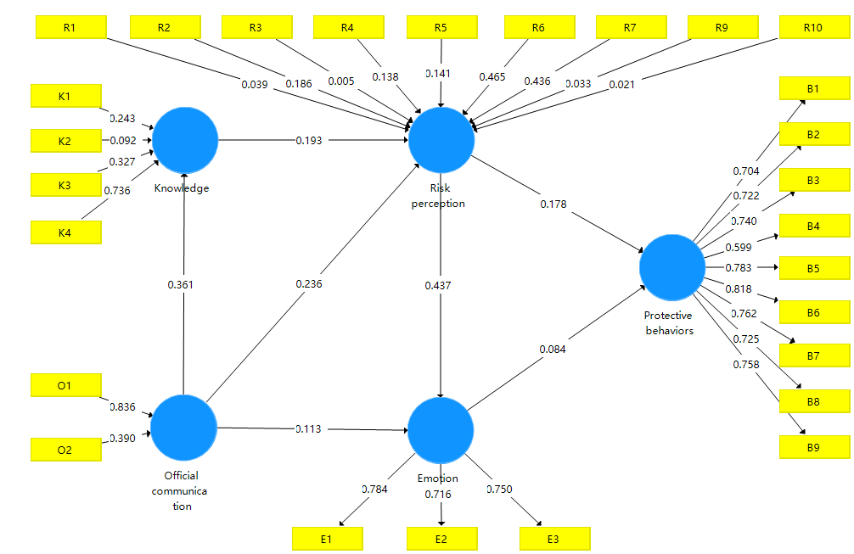
Figure S1. Results of SEM

Table S3. Path coefficients tested in the SEM
Path | Original Sample  (O) | Mean | Standard  Deviation | T | P
Emotion -> Protective behaviors | 0.084 | 0.084 | 0.022 | 3.898 | 0.000
Knowledge -> Risk perception | 0.193 | 0.193 | 0.031 | 6.183 | 0.000
Official communication -> Emotion | 0.113 | 0.112 | 0.020 | 5.756 | 0.000
Official communication -> Knowledge | 0.361 | 0.361 | 0.026 | 14.012 | 0.000
Official communication -> Risk perception | 0.236 | 0.238 | 0.024 | 9.762 | 0.000
Risk perception -> Emotion | 0.437 | 0.437 | 0.023 | 19.392 | 0.000
Risk perception -> Protective behaviors | 0.178 | 0.180 | 0.026 | 6.979 | 0.000

