Supplementary figures
Figure S1
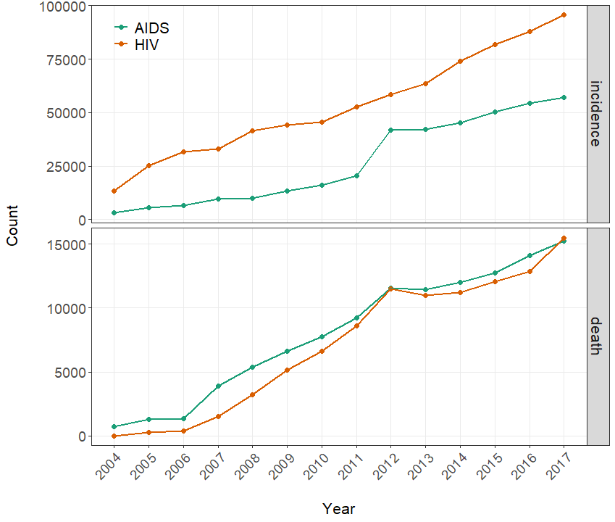

Figure S2
A. B.
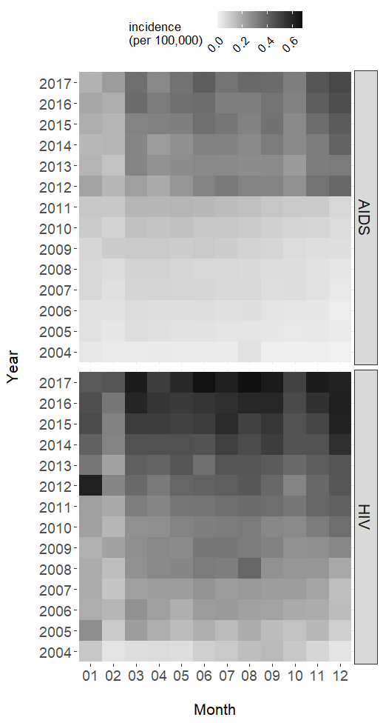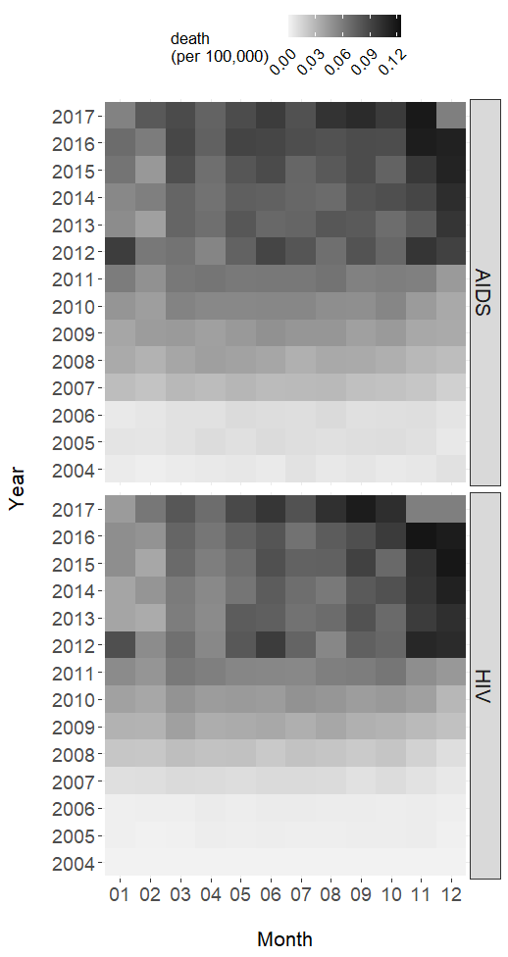

Figure S3
A. B.
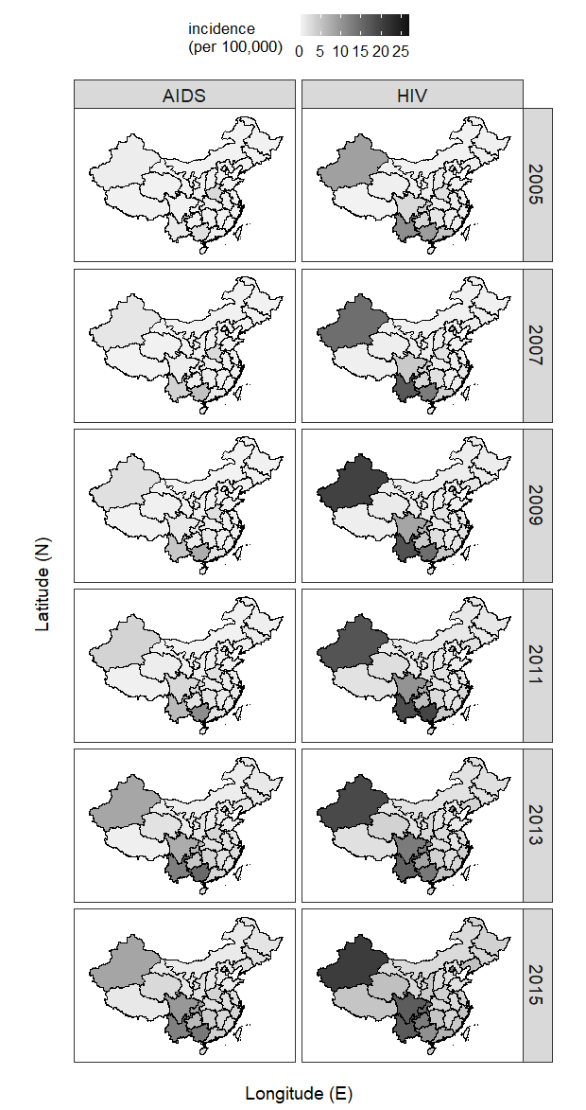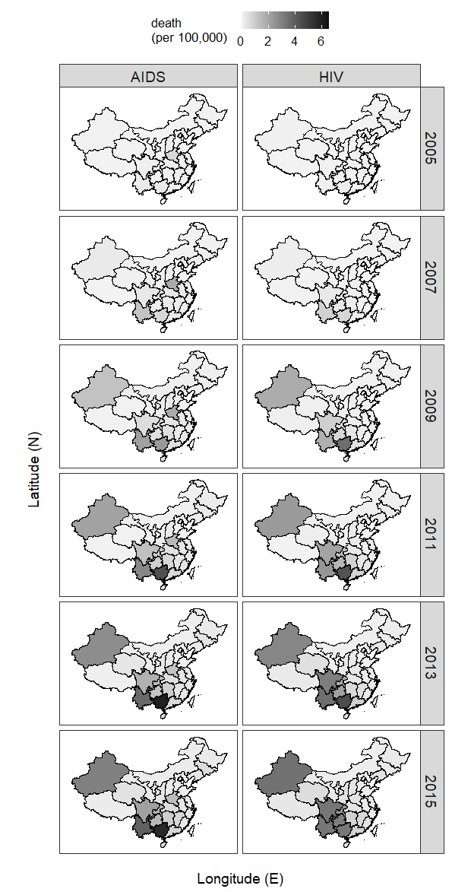

Figure S4
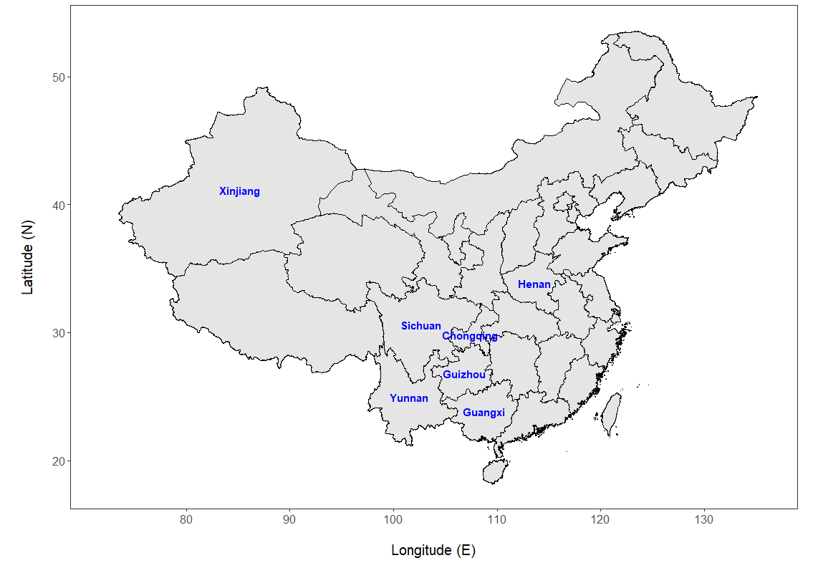

Supplementary figure legends
Figure S1. Annual total incidence and death counts of AIDS/HIV in China from 2004 to 2017.
Figure S2. Monthly incidence (A) and death (B) counts (per 100,000) of AIDS/HIV in China from 2004 to 2017.
Figure S3. Incidence (A) and death (B) (per 100,000) of AIDS/HIV in 31 provincial regions in odd years from 2005 to 2015 as gradient-scaled maps of China. Note: these maps were placed here to save space for Figure 3, and thus the two figures should be interpreted together. Shaded provincial regions were comparable in Fig. 3 and Fig. S3 as the same color scale was applied in these two figures.
Figure S4. Map of China annotated for provincial regions with high incidence or death of AIDS/HIV.

