Appendices

Technical Appendix:

Literature review methods

We searched PubMed, Google Scholar, WHO, UNICEF, UNFPA, and the NCD Alliance for articles published between Jan 1st, 1980 to Sept 30th, 2017. Reference lists of retrieved articles were further reviewed for additional relevant articles. Key search terms included, “adolescen*”, “youth”, “young people”, “health” AND “risk factors” or “protective factor” or “determinant” or “issue” or “policies” or “interventions” or “structural” or “community-based” or “school-based” or “peer-based” or “family-based” or “cross-cutting” or “conceptual frameworks” or “conceptual models” AND “non-communicable diseases” or “NCD” AND “low-income” or “middle-income” or “LMIC” or “developing countr*.

WHO Maternal, Newborn, Child and Adolescent Health (MNCAH) policy indicator database

The WHO Maternal, Newborn, Child and Adolescent Health (MNCAH) policy indicator database contains data on eleven adolescent NCD-related risk and health outcome policies, laws and regulations from 104 low and middle income countries (LMICs) globally. We obtained this data and explored country-level readiness for NCD initiatives by using the suggested scoring system. Available responses in the dashboard were “Yes, No, Unknown/not reported, Not enquired” which were coded as “1, 0, missing, missing” to represent the existence and or non-existence of a policy, respectively. It should be noted that the WHO MNCAH dashboard collects data only on existence of policies, not their implementation. This scoring was used to calculate an individual indicator score, a composite score and percentage for eleven policy indicators. The composite percentage score was used to construct a radar plot of the availability of select policies for each of the regions.

Appendix 1: Hierarchical levels, domains, and indicators related to NCDs among adolescents and later adulthood used for multivariable statistical modeling
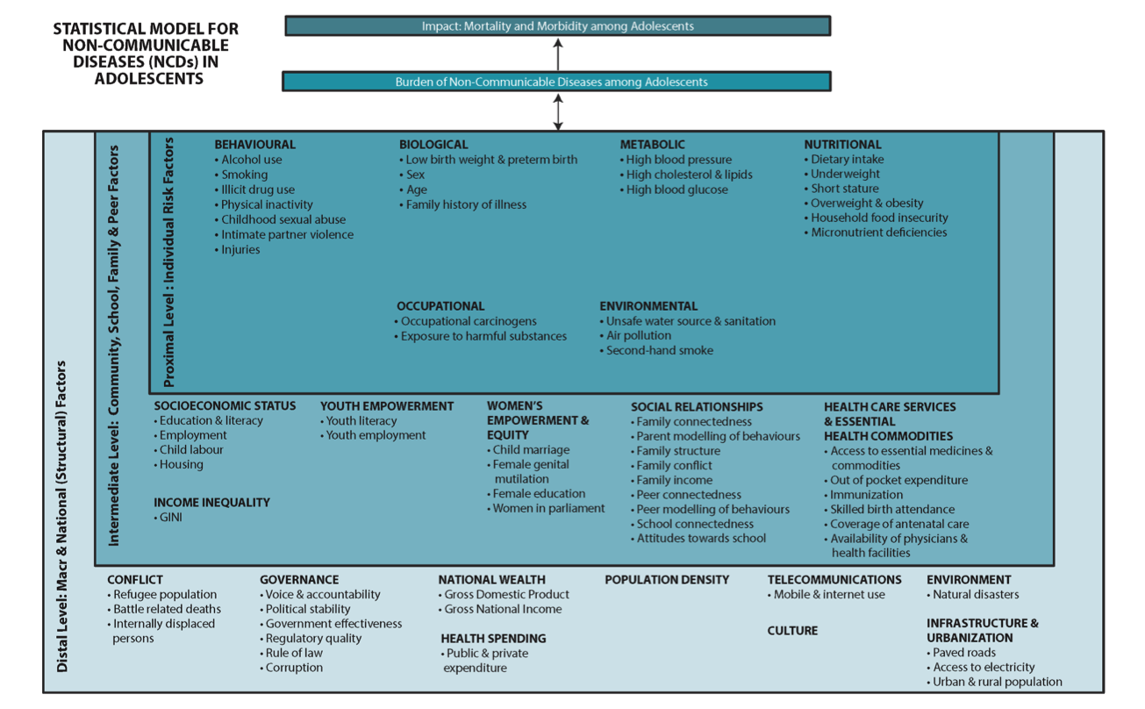
Note: multivariable analysis focused on intermediate and distal level domains only.

Table: Indicators, data source and final year collected for quantitative analysis

Indicator | Data Source | Year of Data Collection
Battle related deaths (total; log) | World Bank | 2013
Internally displaced persons (total; log) | World Bank | 2013
Refugee populations by country of asylum (total; log) | World Bank | 2014
Political stability/absence of terrorism | World Bank | 2013
Government effectiveness | World Bank | 2013
Corruption | World Bank | 2013
Frequency of natural disasters (total; log) | Emergency Events Database (EM-DAT), Centre for Research on the Epidemiology of Disasters (CRED) | 2015
Cost damage of natural disasters (USD; log) | Emergency Events Database (EM-DAT), Centre for Research on the Epidemiology of Disasters (CRED) | 2015
Urbanization (% of population; log) | UNICEF | 2015
Access to electricity (% population; cubed) | World Bank | 2015
Population density (people per m² land; log) | World Bank | 2015
Mobile cellular subscriptions (per 100 people; log) | World Bank | 2014
Internet users (per 100 people; log) | World Bank | 2014
GDP per capita, 5-year lag (USD; log) | World Bank | 2014
Government expenditure on health, 2-year lag (% of total health expenditure; log) | WHO | 2013
Total health expenditure per capita, 2-year lag (PPP, NCU per USD; log) | WHO | 2013
Adult literacy rate (% of adults ages 15+ years; cubed) | World Bank | 2015
Primary school enrolment ratio (gross %; log) | World Bank | 2003-2014
Secondary school enrolment ratio (gross %; log) | World Bank | 2013
Employment to population ratio (% of adults 15+ years; log) | World Bank | 2015
Youth literacy rate (% total 15-24 year olds; squared) | World Bank | 2014
Female youth literacy rate (% 15-24 year olds; squared) | World Bank | 2014
Youth unemployment rate  (% total 15-24 year olds; log) | World Bank | 2013
Adolescent fertility rate  (births per 1,000 females aged 15-19 years; log) | World Bank | 2009-2014
Total fertility rate (births per woman; log) | World Bank | 2013
Adult female literacy rate  (% females 15+ years who can read and write; cubed) | World Bank | 2015
Women in parliament (% of parliamentary  seats held by women; log) | World Bank | 2014
Secondary school gender parity index  (ratio of girls to boys in secondary education; log) | World Bank | 2013
Tertiary school gender parity index  (ratio of girls to boys in tertiary education; log) | World Bank | 2013
GINI index (log) | World Bank | 2012
Out of pocket expenditure as % of total health expenditure (log) | WHO | 2013
Physician density per 1,000 population (log) | WHO | 2003-2013

Appendix 2: Top NCD DALYs in adolescents across WHO regions

Adolescents: 10-14  years old | Males |  |  | Females
Adolescents: 10-14  years old | Health Outcome | DALYs (1000s) | % of Total | Health Outcome | DALYs (1000s) | % of Total
Africa Region | Conduct disorder | 315 | 8.37 | Asthma | 294 | 8.42
Africa Region | Asthma | 281 | 7.47 | Anxiety disorders | 239 | 6.84
Africa Region | Major depressive disorder | 178 | 4.72 | Migraine | 231 | 6.62
Africa Region | Sickle cell disorders | 162 | 4.31 | Major depressive disorder | 208 | 5.95
Africa Region | Age-related and other hearing loss | 161 | 4.28 | Conduct disorder | 202 | 5.78
Africa Region | Anxiety disorders | 160 | 4.25 | Acne vulgaris | 160 | 4.58
Africa Region | Acne vulgaris | 147 | 3.92 | Dermatitis | 149 | 4.27
Africa Region | Low back pain | 137 | 3.63 | Sickle cell disorders | 145 | 4.15
Africa Region | Migraine | 136 | 3.61 | Age-related and other hearing loss | 133 | 3.81
Africa Region | Dermatitis | 126 | 3.36 | Low back pain | 103 | 2.96
Africa Region | Total DALYs | 11,073 |  | Total DALYs | 9,732
Africa Region | NCD DALYs | 3,759 |  | NCD DALYs | 3,491
Africa Region | Percent of total NCD burden in region age group |  | 47.93 | Percent of total NCD burden in region age group |  | 53.37
Eastern Mediterranean Region | Conduct disorder | 190 | 9.46 | Migraine | 161 | 8.09
Eastern Mediterranean Region | Asthma | 145 | 7.20 | Anxiety disorders | 149 | 7.48
Eastern Mediterranean Region | Anxiety disorders | 102 | 5.05 | Asthma | 137 | 6.86
Eastern Mediterranean Region | Migraine | 84 | 4.18 | Conduct disorder | 126 | 6.33
Eastern Mediterranean Region | Epilepsy | 83 | 4.12 | Major depressive disorder | 93 | 4.68
Eastern Mediterranean Region | Low back pain | 71 | 3.53 | Epilepsy | 80 | 4.01
Eastern Mediterranean Region | Major depressive disorder | 69 | 3.45 | Congenital heart anomalies | 76 | 3.80
Eastern Mediterranean Region | Acne vulgaris | 68 | 3.37 | Acne vulgaris | 69 | 3.48
Eastern Mediterranean Region | Thalassemias trait | 57 | 2.86 | Low back pain | 65 | 3.26
Eastern Mediterranean Region | Congenital heart anomalies | 57 | 2.84 | Dermatitis | 59 | 2.96
Eastern Mediterranean Region | Total DALYs | 4,318 |  | Total DALYs | 3,606
Eastern Mediterranean Region | NCD DALYs | 2,010 |  | NCD DALYs | 1,991
Eastern Mediterranean Region | Percent of total NCD burden in region age group |  | 46.07 | Percent of total NCD burden in region age group |  | 50.93
European Region | Conduct disorder | 140 | 10.95 | Anxiety disorders | 128 | 10.32
European Region | Asthma | 87 | 6.79 | Migraine | 120 | 9.65
European Region | Migraine | 84 | 6.59 | Conduct disorder | 89 | 7.22
European Region | Anxiety disorders | 79 | 6.16 | Asthma | 89 | 7.19
European Region | Low back pain | 63 | 4.96 | Major depressive disorder | 75 | 6.09
European Region | Acne vulgaris | 58 | 4.58 | Low back pain | 67 | 5.43
European Region | Major depressive disorder | 57 | 4.48 | Acne vulgaris | 61 | 4.92
European Region | Age-related and other hearing loss | 35 | 2.78 | Viral skin diseases | 41 | 3.30
European Region | Autism | 35 | 2.78 | Dermatitis | 34 | 2.77
European Region | Epilepsy | 35 | 2.71 | Epilepsy | 30 | 2.41
European Region | Total DALYs | 2,021 |  | Total DALYs | 1,756
European Region | NCD DALYs | 1,274 |  | NCD DALYs | 1,239
European Region | Percent of total NCD burden in region age group |  | 52.79 | Percent of total NCD burden in region age group |  | 59.29
Region of the Americas | Conduct disorder | 222 | 10.20 | Anxiety disorders | 204 | 9.46
Region of the Americas | Asthma | 221 | 10.17 | Migraine | 192 | 8.91
Region of the Americas | Anxiety disorders | 122 | 5.60 | Asthma | 191 | 8.84
Region of the Americas | Migraine | 112 | 5.14 | Major depressive disorder | 148 | 6.86
Region of the Americas | Major depressive disorder | 88 | 4.04 | Conduct disorder | 140 | 6.47
Region of the Americas | Low back pain | 76 | 3.51 | Low back pain | 94 | 4.37
Region of the Americas | Dermatitis | 72 | 3.33 | Dermatitis | 82 | 3.79
Region of the Americas | Acne vulgaris | 72 | 3.33 | Acne vulgaris | 81 | 3.76
Region of the Americas | Other congenital birth defects | 62 | 2.84 | Viral skin diseases | 69 | 3.18
Region of the Americas | Age-related and other hearing loss | 59 | 2.72 | Other congenital birth defects | 53 | 2.44
Region of the Americas | Total DALYs | 3,645 |  | Total DALYs | 3,108
Region of the Americas | NCD DALYs | 2,173 |  | NCD DALYs | 2,156
Region of the Americas | Percent of total NCD burden in region age group |  | 50.88 | Percent of total NCD burden in region age group |  | 58.07
South-East Asia Region | Conduct disorder | 498 | 9.64 | Migraine | 446 | 9.61
South-East Asia Region | Asthma | 312 | 6.05 | Anxiety disorders | 309 | 6.65
South-East Asia Region | Migraine | 259 | 5.02 | Conduct disorder | 261 | 5.61
South-East Asia Region | Acne vulgaris | 218 | 4.23 | Asthma | 261 | 5.61
South-East Asia Region | Epilepsy | 215 | 4.17 | Acne vulgaris | 219 | 4.72
South-East Asia Region | Age-related and other hearing loss | 214 | 4.14 | Major depressive disorder | 199 | 4.28
South-East Asia Region | Anxiety disorders | 213 | 4.13 | Epilepsy | 184 | 3.96
South-East Asia Region | Low back pain | 197 | 3.81 | Age-related and other hearing loss | 178 | 3.83
South-East Asia Region | Major depressive disorder | 175 | 3.39 | Low back pain | 178 | 3.82
South-East Asia Region | Autism | 144 | 2.79 | Congenital heart anomalies | 150 | 3.22
South-East Asia Region | Total DALYs | 11,525 |  | Total DALYs | 9,629
South-East Asia Region | NCD DALYs | 5,162 |  | NCD DALYs | 4,647
South-East Asia Region | Percent of total NCD burden in region age group |  | 47.37 | Percent of total NCD burden in region age group |  | 51.31
Western Pacific Region | Conduct disorder | 269 | 9.06 | Anxiety disorders | 228 | 8.86
Western Pacific Region | Anxiety disorders | 160 | 5.40 | Acne vulgaris | 159 | 6.18
Western Pacific Region | Asthma | 155 | 5.23 | Thalassemias trait | 144 | 5.60
Western Pacific Region | Acne vulgaris | 155 | 5.21 | Asthma | 142 | 5.53
Western Pacific Region | Thalassemias trait | 124 | 4.19 | Conduct disorder | 137 | 5.31
Western Pacific Region | Age-related and other hearing loss | 111 | 3.72 | Migraine | 120 | 4.67
Western Pacific Region | Low back pain | 103 | 3.46 | Low back pain | 111 | 4.32
Western Pacific Region | Congenital heart anomalies | 100 | 3.36 | Major depressive disorder | 100 | 3.87
Western Pacific Region | Acute lymphoid leukemia | 99 | 3.35 | Congenital heart anomalies | 89 | 3.45
Western Pacific Region | Migraine | 97 | 3.25 | Scabies | 85 | 3.30
Western Pacific Region | Total DALYs | 5,465 |  | Total DALYs | 3,965
Western Pacific Region | NCD DALYs | 2,968 |  | NCD DALYs | 2,573
Western Pacific Region | Percent of total NCD burden in region age group |  | 46.22 | Percent of total NCD burden in region age group |  | 51.10

Adolescents: 15-19  years old | Males |  |  | Females
Adolescents: 15-19  years old | Health Outcome | DALYs (1000s) | % of Total | Health Outcome | DALYs (1000s) | % of Total
Africa Region | Major depressive disorder | 394 | 8.91 | Major depressive disorder | 454 | 11.93
Africa Region | Asthma | 209 | 4.72 | Migraine | 260 | 6.85
Africa Region | Conduct disorder | 208 | 4.69 | Anxiety disorders | 251 | 6.60
Africa Region | Low back pain | 204 | 4.62 | Acne vulgaris | 213 | 5.60
Africa Region | Acne vulgaris | 194 | 4.39 | Asthma | 204 | 5.36
Africa Region | Epilepsy | 189 | 4.27 | Low back pain | 158 | 4.16
Africa Region | Anxiety disorders | 166 | 3.76 | Age-related and other hearing loss | 123 | 3.24
Africa Region | Age-related and other hearing loss | 160 | 3.61 | Conduct disorder | 118 | 3.11
Africa Region | Migraine | 151 | 3.41 | Epilepsy | 106 | 2.79
Africa Region | Sickle cell disorders | 125 | 2.83 | Dermatitis | 100 | 2.62
Africa Region | Total DALYs | 10,587 |  | Total DALYs | 9,193
Africa Region | NCD DALYs | 4,424 |  | NCD DALYs | 3,801
Africa Region | Percent of total NCD burden in region age group |  | 45.21 | Percent of total NCD burden in region age group |  | 52.27
Eastern Mediterranean Region | Major depressive disorder | 163 | 6.46 | Migraine | 208 | 7.86
Eastern Mediterranean Region | Low back pain | 149 | 5.92 | Major depressive disorder | 208 | 7.86
Eastern Mediterranean Region | Conduct disorder | 141 | 5.58 | Anxiety disorders | 179 | 6.79
Eastern Mediterranean Region | Migraine | 122 | 4.86 | Low back pain | 125 | 4.73
Eastern Mediterranean Region | Anxiety disorders | 115 | 4.54 | Other musculoskeletal disorders | 103 | 3.90
Eastern Mediterranean Region | Asthma | 101 | 3.99 | Asthma | 99 | 3.75
Eastern Mediterranean Region | Acne vulgaris | 98 | 3.90 | Acne vulgaris | 99 | 3.73
Eastern Mediterranean Region | Other musculoskeletal disorders | 96 | 3.82 | Conduct disorder | 82 | 3.12
Eastern Mediterranean Region | Epilepsy | 80 | 3.19 | Epilepsy | 74 | 2.82
Eastern Mediterranean Region | Hemorrhagic stroke | 71 | 2.81 | Ischemic heart disease | 59 | 2.23
Eastern Mediterranean Region | Total DALYs | 6,084 |  | Total DALYs | 4,551
Eastern Mediterranean Region | NCD DALYs | 2,520 |  | NCD DALYs | 2,640
Eastern Mediterranean Region | Percent of total NCD burden in region age group |  | 45.07 | Percent of total NCD burden in region age group |  | 46.80
European Region | Low back pain | 150 | 8.36 | Major depressive disorder | 183 | 9.84
European Region | Major depressive disorder | 128 | 7.16 | Migraine | 169 | 9.10
European Region | Conduct disorder | 115 | 6.41 | Anxiety disorders | 160 | 8.57
European Region | Migraine | 106 | 5.92 | Low back pain | 152 | 8.17
European Region | Acne vulgaris | 102 | 5.70 | Acne vulgaris | 103 | 5.56
European Region | Anxiety disorders | 95 | 5.31 | Asthma | 84 | 4.52
European Region | Asthma | 75 | 4.19 | Conduct disorder | 66 | 3.54
European Region | Epilepsy | 45 | 2.49 | Other musculoskeletal disorders | 50 | 2.67
European Region | Other musculoskeletal disorders | 42 | 2.36 | Bipolar disorder | 44 | 2.37
European Region | Opioid use disorders | 39 | 2.19 | Neck pain | 40 | 2.17
European Region | Total DALYs | 2,791 |  | Total DALYs | 2,383
European Region | NCD DALYs | 1,790 |  | NCD DALYs | 1,861
European Region | Percent of total NCD burden in region age group |  | 50.10 | Percent of total NCD burden in region age group |  | 56.50
Region of the Americas | Major depressive disorder | 240 | 8.27 | Major depressive disorder | 409 | 12.80
Region of the Americas | Conduct disorder | 182 | 6.26 | Anxiety disorders | 293 | 9.18
Region of the Americas | Low back pain | 164 | 5.64 | Migraine | 266 | 8.32
Region of the Americas | Anxiety disorders | 163 | 5.61 | Low back pain | 195 | 6.10
Region of the Americas | Other musculoskeletal disorders | 160 | 5.50 | Other musculoskeletal disorders | 174 | 5.45
Region of the Americas | Asthma | 145 | 5.00 | Asthma | 157 | 4.89
Region of the Americas | Migraine | 132 | 4.53 | Acne vulgaris | 130 | 4.07
Region of the Americas | Acne vulgaris | 123 | 4.22 | Conduct disorder | 102 | 3.19
Region of the Americas | Bipolar disorder | 62 | 2.12 | Bipolar disorder | 73 | 2.29
Region of the Americas | Age-related and other hearing loss | 61 | 2.10 | Dermatitis | 67 | 2.11
Region of the Americas | Total DALYs | 5,711 |  | Total DALYs | 4,240
Region of the Americas | NCD DALYs | 2,907 |  | NCD DALYs | 3,198
Region of the Americas | Percent of total NCD burden in region age group |  | 49.26 | Percent of total NCD burden in region age group |  | 58.40
South-East Asia Region | Major depressive disorder | 455 | 6.32 | Migraine | 574 | 8.37
South-East Asia Region | Low back pain | 446 | 6.19 | Major depressive disorder | 529 | 7.70
South-East Asia Region | Migraine | 383 | 5.32 | Other musculoskeletal disorders | 415 | 6.04
South-East Asia Region | Conduct disorder | 364 | 5.05 | Anxiety disorders | 364 | 5.31
South-East Asia Region | Other musculoskeletal disorders | 319 | 4.43 | Acne vulgaris | 315 | 4.59
South-East Asia Region | Acne vulgaris | 315 | 4.38 | Low back pain | 305 | 4.45
South-East Asia Region | Anxiety disorders | 261 | 3.62 | Asthma | 203 | 2.96
South-East Asia Region | Asthma | 233 | 3.23 | Age-related and other hearing loss | 177 | 2.57
South-East Asia Region | Epilepsy | 229 | 3.18 | Conduct disorder | 173 | 2.53
South-East Asia Region | Age-related and other hearing loss | 219 | 3.05 | Rheumatic heart disease | 158 | 2.30
South-East Asia Region | Total DALYs | 14,633 |  | Total DALYs | 13,659
South-East Asia Region | NCD DALYs | 7,206 |  | NCD DALYs | 6,863
South-East Asia Region | Percent of total NCD burden in region age group |  | 44.76 | Percent of total NCD burden in region age group |  | 46.82
Western Pacific Region | Acne vulgaris | 227 | 5.90 | Major depressive disorder | 269 | 7.70
Western Pacific Region | Conduct disorder | 218 | 5.66 | Anxiety disorders | 263 | 7.51
Western Pacific Region | Low back pain | 205 | 5.34 | Other musculoskeletal disorders | 225 | 6.44
Western Pacific Region | Major depressive disorder | 204 | 5.29 | Acne vulgaris | 221 | 6.32
Western Pacific Region | Anxiety disorders | 188 | 4.90 | Low back pain | 214 | 6.13
Western Pacific Region | Other musculoskeletal disorders | 171 | 4.45 | Migraine | 191 | 5.46
Western Pacific Region | Migraine | 139 | 3.62 | Asthma | 115 | 3.30
Western Pacific Region | Asthma | 123 | 3.20 | Conduct disorder | 99 | 2.83
Western Pacific Region | Age-related and other hearing loss | 113 | 2.93 | Scabies | 95 | 2.71
Western Pacific Region | Scabies | 103 | 2.67 | Premenstrual syndrome | 84 | 2.40
Western Pacific Region | Total DALYs | 6,403 |  | Total DALYs | 4,688
Western Pacific Region | NCD DALYs | 3,848 |  | NCD DALYs | 3,497
Western Pacific Region | Percent of total NCD burden in region age group |  | 43.95 | Percent of total NCD burden in region age group |  | 50.80

Appendix 3: Youth and adulthood DALYS related to NCD risk factors that begin in adolescence

 |  |  | Both |  |  |  |  |  | Male |  |  |  |  |  | Female
 |  |  | Risk Factor |  | DALYs (1000s) |  | % of Total |  | Risk Factor |  |  | DALYs (1000s) | % of Total |  | Risk Factor |  |  | DALYs (1000s) | % of Total
15-49 Years Old | 1 |  | High Body Mass Index |  | 37,304 |  | 13.19 |  | High systolic blood pressure |  |  | 25,057 | 14.16 |  | High body-mass index |  |  | 15,460 | 14.60
15-49 Years Old | 2 |  | High Systolic Blood Pressure |  | 36,247 |  | 12.82 |  | Smoking |  |  | 24,355 | 13.77 |  | High systolic blood pressure |  |  | 11,190 | 10.57
15-49 Years Old | 3 |  | Smoking |  | 29,251 |  | 10.34 |  | High body-mass index |  |  | 21,844 | 12.35 |  | High fasting plasma glucose |  |  | 11,061 | 10.45
15-49 Years Old | 4 |  | High Fasting Plasma Glucose |  | 28,112 |  | 9.94 |  | Alcohol use |  |  | 20,231 | 11.43 |  | High total cholesterol |  |  | 6,640 | 6.27
15-49 Years Old | 5 |  | Alcohol Use |  | 25,620 |  | 9.06 |  | High total cholesterol |  |  | 17,112 | 9.67 |  | Drug use |  |  | 6,044 | 5.71
15-49 Years Old | 6 |  | High Total Cholesterol |  | 23,752 |  | 8.40 |  | High fasting plasma glucose |  |  | 17,052 | 9.64 |  | Diet low in whole grains |  |  | 6,043 | 5.71
15-49 Years Old | 7 |  | Drug Use |  | 19,181 |  | 6.78 |  | Drug use |  |  | 13,137 | 7.42 |  | Diet low in fruits |  |  | 5,818 | 5.50
15-49 Years Old | 8 |  | Diet low in fruits |  | 17,412 |  | 6.16 |  | Ambient particulate matter pollution |  |  | 11,596 | 6.55 |  | Impaired kidney function |  |  | 5,638 | 5.33
15-49 Years Old | 9 |  | Diet low in whole grains |  | 17,409 |  | 6.16 |  | Diet low in fruits |  |  | 11,594 | 6.55 |  | Alcohol use |  |  | 5,388 | 5.09
15-49 Years Old | 10 |  | Ambient particulate matter pollution |  | 16,975 |  | 6.00 |  | Diet low in whole grains |  |  | 11,366 | 6.42 |  | Ambient particulate matter pollution |  |  | 5,379 | 5.08
15-49 Years Old |  |  | Top 10 Total DALYs (1000s) |  | 251,261 |  |  |  | Top 10 Total DALYs (1000s) |  |  | 173,343 |  |  | Top 10 Total DALYs (1000s) |  |  | 78,660
15-49 Years Old |  |  | Total DALYs (Level 0) (1000s) |  | 282,806 |  |  |  | Total DALYs (Level 0) (1000s) |  |  | 176,928 |  |  | Total DALYs (Level 0) (1000s) |  |  | 105,878
 |  |  | Risk Factor |  | DALYs (1000s) |  | % of Total |  | Risk Factor |  |  | DALYs (1000s) | % of Total |  | Risk Factor |  |  | DALYs (1000s) | % of Total
50-69 Years Old | 1 |  | High systolic blood pressure |  | 99,826 |  | 30.66 |  | Smoking |  |  | 62,298 | 31.03 |  | High systolic blood pressure |  |  | 38,801 | 31.10
50-69 Years Old | 2 |  | Smoking |  | 76,743 |  | 23.57 |  | High systolic blood pressure |  |  | 61,025 | 30.39 |  | High body-mass index |  |  | 32,022 | 25.66
50-69 Years Old | 3 |  | High body-mass index |  | 67,911 |  | 20.86 |  | High fasting plasma glucose |  |  | 38,329 | 19.09 |  | High fasting plasma glucose |  |  | 28,328 | 22.70
50-69 Years Old | 4 |  | High fasting plasma glucose |  | 66,656 |  | 20.47 |  | High body-mass index |  |  | 35,889 | 17.87 |  | High total cholesterol |  |  | 16,443 | 13.18
50-69 Years Old | 5 |  | High total cholesterol |  | 44,873 |  | 13.78 |  | High total cholesterol |  |  | 28,430 | 14.16 |  | Smoking |  |  | 14,445 | 11.58
50-69 Years Old | 6 |  | Ambient particulate matter pollution |  | 37,787 |  | 11.61 |  | Alcohol use |  |  | 24,618 | 12.26 |  | Ambient particulate matter pollution |  |  | 13,498 | 10.82
50-69 Years Old | 7 |  | Alcohol use |  | 30,571 |  | 9.39 |  | Ambient particulate matter pollution |  |  | 24,289 | 12.10 |  | Diet low in whole grains |  |  | 11,619 | 9.31
50-69 Years Old | 8 |  | Diet low in fruits |  | 29,982 |  | 9.21 |  | Diet low in fruits |  |  | 19,260 | 9.59 |  | Diet low in fruits |  |  | 10,722 | 8.59
50-69 Years Old | 9 |  | Diet low in whole grains |  | 29,622 |  | 9.10 |  | Diet low in whole grains |  |  | 18,003 | 8.97 |  | Impaired kidney function |  |  | 10,524 | 8.43
50-69 Years Old | 10 |  | Impaired kidney function |  | 25,479 |  | 7.83 |  | Diet high in sodium |  |  | 15,482 | 7.71 |  | Household air pollution from solid fuels |  |  | 10,013 | 8.03
50-69 Years Old |  |  | Top 10 Total DALYs (1000s) |  | 509,451 |  | 156.49 |  | Top 10 Total DALYs (1000s) |  |  | 327,623 |  |  | Top 10 Total DALYs (1000s) |  |  | 186,415
50-69 Years Old |  |  | Total DALYs (Level 0) (1000s) |  | 325,558 |  |  |  | Total DALYs (Level 0) (1000s) |  |  | 200,782 |  |  | Total DALYs (Level 0) (1000s) |  |  | 124,776

Appendix 4: Top NCD DALYS for health outcomes in adults aged 15-49 and 50-69 years

Appendix 5: Policies, laws and regulations for adolescent NCD prevention in the Eastern Mediterranean, the Americas, Europe, and the Western Pacific.
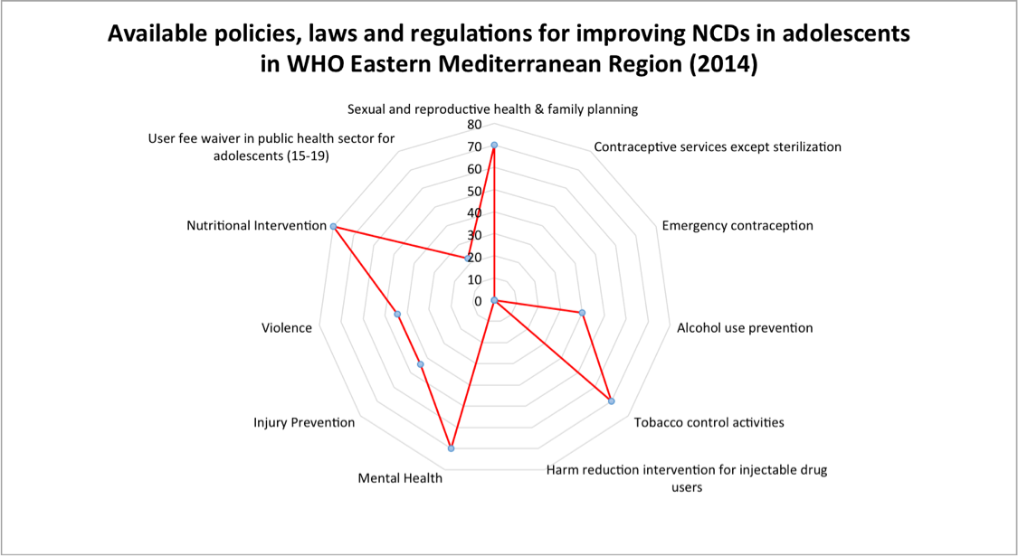

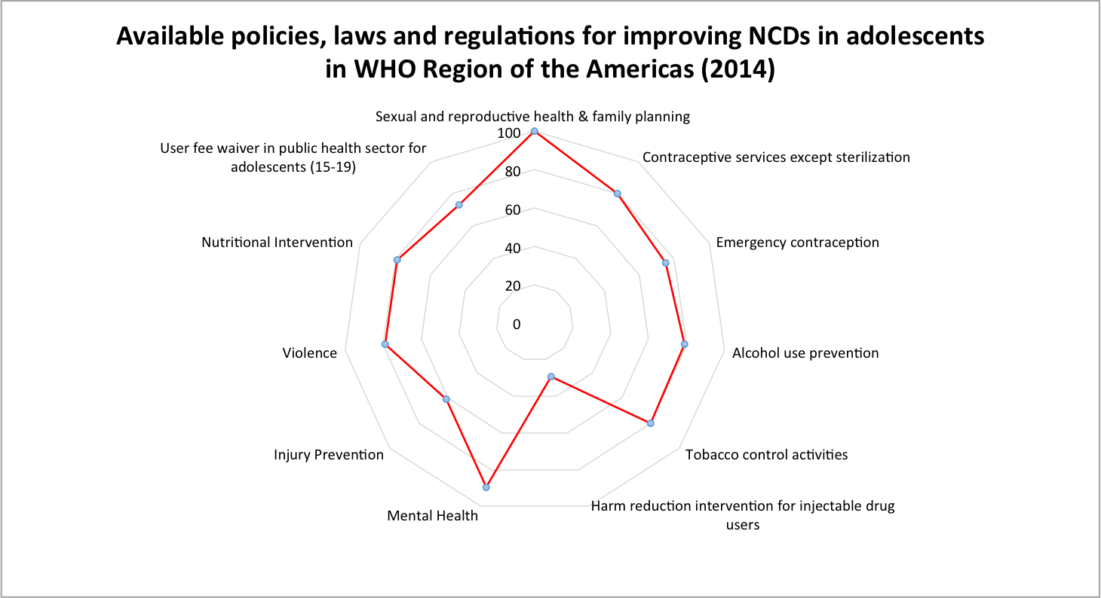

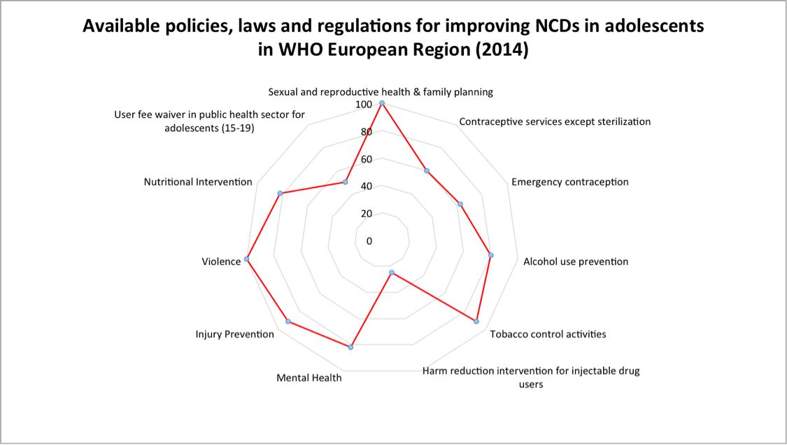

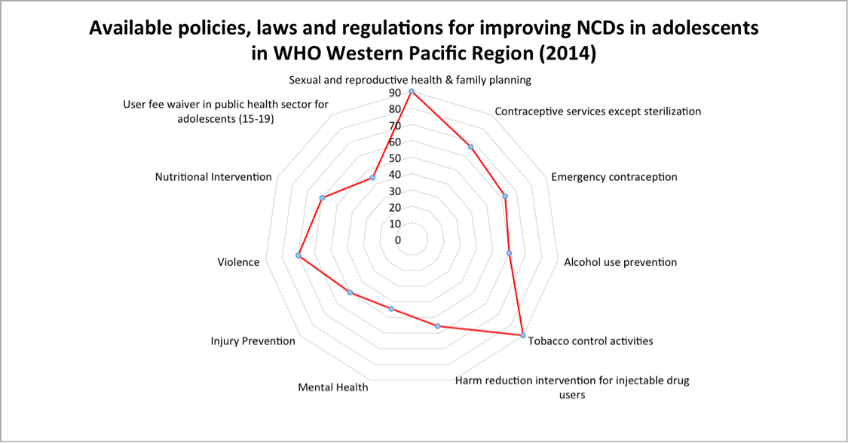

Appendix 6: Policies, laws and regulations indicator breakdown for all regions by country

WHO African Region
Countries | National policies, strategies and plans for Adolescents
Countries | Sexual and reproductive health & family planning | Nutritional Intervention | Alcohol use prevention | Tobacco control activities | Mental health | Injury prevention | Violence
1. Angola | Yes | Yes | No | No | Unknown/not reported | No | Yes
2. Benin | Yes | Yes | Yes | Yes | Yes | Unknown/not reported | Yes
3. Botswana | Yes | No | Yes | Yes | No | Yes | Yes
4. Burkina Faso | Yes | Yes | Yes | Yes | Yes | Yes | Yes
5. Burundi | Yes | Yes | Yes | Yes | Yes | Yes | Yes
6. Cameroon | No | No | No | No | No | No | No
7. Central African Republic | Yes | Yes | Yes | Yes | Yes | Yes | Yes
8. Chad | Unknown/not reported | Yes | Yes | Yes | Yes | Yes | Yes
9. Comoros | Yes | Yes | Yes | Yes | Yes | Yes | Yes
10. Congo | Yes | Yes | Yes | Yes | Yes | Yes | Yes
11. Cote d'Ivoire | Yes | Yes | Yes | Yes | Yes | Yes | Yes
12. Democratic Republic of the Congo | Yes | Yes | Yes | Yes | Unknown/not reported | Yes | Yes
13. Equatorial Guinea | Yes | Unknown/not reported | Unknown/not reported | Unknown/not reported | Unknown/not reported | Unknown/not reported | Unknown/not reported
14. Eritrea | Yes | No | No | No | No | No | No
15. Ethiopia | Yes | Yes | No | No | Yes | Unknown/not reported | Yes
16. Gabon | Yes | Yes | Yes | Yes | Yes | No | Yes
17. Gambia | Yes | Yes | Yes | Yes | Yes | Yes | Yes
18. Ghana | Yes | Yes | No | No | Yes | No | No
19. Guinea | Yes | No | Yes | Yes | Yes | Yes | Yes
20. Guinea-Bissau | Yes | Yes | Yes | Yes | Yes | No | Yes
21. Kenya | Yes | Unknown/not reported | Yes | Yes | Unknown/not reported | Unknown/not reported | Unknown/not reported
22. Lesotho | Yes | Yes | Yes | Yes | Yes | Yes | Yes
23. Liberia | Yes | Yes | Yes | Yes | Yes | Yes | Yes
24. Madagascar | Yes | No | No | No | No | No | Yes
25. Malawi | Yes | Yes | Yes | Yes | Yes | Yes | Yes
26. Mali | Yes | Yes | Yes | Yes | Yes | Yes | Yes
27. Mauritania | Unknown/not reported | Unknown/not reported | Unknown/not reported | Unknown/not reported | Unknown/not reported | Unknown/not reported | Unknown/not reported
28. Mozambique | Yes | Yes | Yes | Yes | Yes | Yes | Yes
29. Namibia | Yes | No | No | No | No | No | No
30. Niger | Yes | Yes | Yes | Yes | Yes | Yes | Yes
31. Nigeria | Yes | Yes | Yes | Yes | Yes | Yes | Yes
32. Rwanda | Yes | Yes | Yes | Yes | Yes | Yes | Yes
33. Sao Tome and Principe | Yes | Yes | Yes | Yes | Yes | Yes | Yes
34. Senegal | Yes | Yes | Yes | Yes | Yes | Yes | Yes
35. Seychelles | Yes | Yes | Yes | Yes | Yes | Yes | Yes
36. Sierra Leone | Yes | Yes | Yes | Yes | Yes | Yes | Yes
37. South Africa | Yes | Yes | Yes | Yes | Yes | Yes | Yes
38. South Sudan | No | No | No | No | No | No | No
39. Swaziland | Yes | Yes | No | No | Yes | Unknown/not reported | Yes
40. Togo | Yes | No | Yes | Yes | No | No | Yes
41. Uganda | Yes | Yes | Yes | Yes | Yes | Yes | Yes
42. United Republic of Tanzania | Yes | Yes | Yes | Yes | Yes | No | Yes
43. Zambia | Yes | Yes | Yes | Yes | Yes | Yes | No
44. Zimbabwe | Yes | Yes | Yes | Yes | Yes | Yes | Yes
Total Yes | 40 | 33 | 33 | 33 | 32 | 27 | 35
Total countries per policy indicator | 42 | 41 | 42 | 42 | 39 | 38 | 41
Total %age | 0.952 | 0.805 | 0.786 | 0.786 | 0.821 | 0.711 | 0.854

WHO African Region
Countries | Laws and regulations allow minor adolescents to seek |  |  | User fee waiver in public health sector for adolescents (15-19 years)
Countries | Contraceptives services except sterilization | Emergency contraception | Harm reduction intervention for injectable drug users
1. Angola | No | No | No | Yes
2. Benin | Yes | Yes | Yes | No
3. Botswana | Yes | Yes | No | Yes
4. Burkina Faso | Yes | Yes | Yes | No
5. Burundi | No | No | No | No
6. Cameroon | Unknown/not reported | Unknown/not reported | Unknown/not reported | No
7. Central African Republic | Unknown/not reported | Unknown/not reported | Unknown/not reported | No
8. Chad | Unknown/not reported | Unknown/not reported | No | No
9. Comoros | No | No | No | No
10. Congo | No | No | No | No
11. Cote d'Ivoire | Yes | Yes | Yes | No
12. Democratic Republic of the Congo | No | No | No | No
13. Equatorial Guinea | Yes | Unknown/not reported | Unknown/not reported | No
14. Eritrea | Yes | Yes | Unknown/not reported | No
15. Ethiopia | Yes | Unknown/not reported | No | No
16. Gabon | No | No | No | No
17. Gambia | Yes | Yes | Unknown/not reported | No
18. Ghana | Yes | Unknown/not reported | No | No
19. Guinea | Yes | Yes | Unknown/not reported | No
20. Guinea-Bissau | Unknown/not reported | Unknown/not reported | Unknown/not reported | No
21. Kenya | Yes | Yes | Yes | Yes
22. Lesotho | No | Unknown/not reported | Yes | No
23. Liberia | No | No | No | Yes
24. Madagascar | Unknown/not reported | No | No | No
25. Malawi | Yes | Yes | Unknown/not reported | Yes
26. Mali | Yes | Unknown/not reported | Unknown/not reported | No
27. Mauritania | Unknown/not reported | Unknown/not reported | Unknown/not reported | No
28. Mozambique | No | Unknown/not reported | No | No
29. Namibia | No | No | No | No
30. Niger | Yes | Yes | Yes | No
31. Nigeria | Yes | Unknown/not reported | Unknown/not reported | No
32. Rwanda | No | No | No | No
33. Sao Tome and Principe | No | No | Unknown/not reported | No
34. Senegal | Yes | Unknown/not reported | Unknown/not reported | No
35. Seychelles | No | Not enquired | No | Not enquired
36. Sierra Leone | No | No | No | Yes
37. South Africa | Yes | Yes | Yes | Yes
38. South Sudan | No | No | No | No
39. Swaziland | No | No | No | No
40. Togo | No | Unknown/not reported | No | No
41. Uganda | Yes | Yes | No | Yes
42. United Republic of Tanzania | Yes | Unknown/not reported | Yes | No
43. Zambia | No | No | No | Yes
44. Zimbabwe | No | No | No | Unknown/not reported
Total Yes | 19 | 12 | 8 | 9
Total countries per policy indicator | 38 | 28 | 31 | 42
Total %age | 0.500 | 0.429 | 0.258 | 0.214
Number of Countries included: 44
Number of Countries not included: 3 (Algeria, Cobo Verde, Mauritius)
Total number of Countries in the region: 47

WHO Region of the Americas
Countries | National policies, strategies and plans for Adolescents
Countries | Sexual and reproductive health & family planning | Nutritional Intervention | Alcohol use prevention | Tobacco control activities | Mental health | Injury prevention | Violence
1. Argentina | Yes | Yes | Yes | Yes | Yes | No | Yes
2. Belize | Yes | No | No | No | Yes | No | No
3. Bolivia (Plurinational State of) | Yes | Yes | Yes | Yes | Yes | Yes | Yes
4. Brazil | Yes | Yes | Yes | Yes | Yes | Yes | Yes
5. Colombia | Yes | No | No | No | Yes | No | No
6. Costa Rica | Yes | Yes | Yes | Yes | Yes | Yes | Yes
7. Cuba | Yes | Yes | Yes | Yes | Yes | Yes | Yes
8. Ecuador | Yes | Yes | Yes | Yes | Yes | No | Yes
9. El Salvador | Yes | Yes | Yes | Yes | Yes | Yes | Yes
10. Guatemala | Yes | Yes | Yes | Yes | Yes | Unknown/not reported | Yes
11. Guyana | Yes | Yes | Yes | Yes | Yes | Yes | Yes
12. Haiti | Yes | No | No | No | No | No | No
13. Honduras | Yes | Yes | Yes | Yes | Yes | Yes | Yes
14. Jamaica | Yes | Unknown/not reported | Unknown/not reported | Yes | Unknown/not reported | Unknown/not reported | Unknown/not reported
15. Mexico | Yes | Yes | Yes | Yes | Yes | Yes | Yes
16. Nicaragua | Yes | Yes | No | No | Yes | Yes | Yes
17. Panama | Yes | Yes | Yes | Yes | Yes | Yes | Yes
18. Paraguay | Yes | Yes | Yes | Yes | Yes | Yes | Yes
19. Peru | Yes | Yes | Yes | Yes | Yes | No | Yes
20. Suriname | Yes | No | Yes | Yes | No | No | No
Total Yes | 20 | 15 | 15 | 16 | 17 | 11 | 15
Total Countries per policy indicator | 20 | 19 | 19 | 20 | 19 | 18 | 19
Total %age | 0.100 | 0.789 | 0.789 | 0.800 | 0.894 | 0.611 | 0.789

WHO Region of the Americas
Countries | Laws and regulations allow minor adolescents to seek |  |  | User fee waiver in public health sector for adolescents (15-19 years)
Countries | Contraceptives services except sterilization | Emergency contraception | Harm reduction intervention for injectable drug users
1. Argentina | Yes | Yes | No | Yes
2. Belize | No | Not enquired | Unknown/not reported | Not enquired
3. Bolivia (Plurinational State of) | Unknown/not reported | No | No | Yes
4. Brazil | Yes | Yes | Yes | Yes
5. Colombia | Yes | Yes | No | No
6. Costa Rica | Yes | No | No | Yes
7. Cuba | Yes | Yes | Unknown/not reported | Yes
8. Ecuador | Yes | Yes | Yes | Yes
9. El Salvador | Yes | Yes | Yes | Yes
10. Guatemala | Yes | Yes | No | Yes
11. Guyana | Yes | Not enquired | No | Not enquired
12. Haiti | No | No | No | No
13. Honduras | Yes | No | Unknown/not reported | No
14. Jamaica | Yes | Yes | No | Yes
15. Mexico | Yes | Yes | No | Yes
16. Nicaragua | No | Not enquired | No | Not enquired
17. Panama | Yes | Yes | Yes | No
18. Paraguay | Yes | Yes | Yes | Yes
19. Peru | No | Not enquired | No | Not enquired
20. Suriname | Yes | Not enquired | No | Not enquired
Total Yes | 15 | 11 | 5 | 11
Total Countries per policy indicator | 19 | 15 | 17 | 15
Total %age | 0.789 | 0.733 | 0.294 | 0.733
Number of Countries included: 20
Number of Countries not included: 15 (Antigua and Barbuda, Bahamas, Barbados, Canada, Chile, Dominica, Dominican Republic, Grenada, St. Kitts and Nevis, St. Lucia, St. Vincent and the Grenadines, Trinidad and Tobago, USA, Uruguay, Venenzuela (Bolivarian Republic of)
Total number of Countries in the region: 35

WHO Eastern Mediterranean Region
Countries | National policies, strategies and plans for Adolescents
Countries | Sexual and reproductive health & family planning | Nutritional Intervention | Alcohol use prevention | Tobacco control activities | Mental health | Injury prevention | Violence
1. Afghanistan | Yes | No | No | Yes | No | No | No
2. Djibouti | No | No | No | No | No | No | No
3. Egypt | No | Yes | No | Yes | Yes | Yes | Yes
4. Iraq | Yes | Yes | Yes | Yes | Yes | Yes | Yes
5. Morocco | Yes | Yes | Yes | Yes | Yes | Unknown/not reported | No
6. Oman | Yes | Yes | Yes | Yes | Yes | Yes | Yes
7. Pakistan | No | Yes | Yes | Yes | Yes | Yes | Yes
8. Somalia | Yes | Yes | No | No | Yes | No | Unknown/not reported
9. Sudan | Yes | Yes | No | Yes | Yes | No | No
10. Yemen | Yes | Yes | No | No | No | No | No
Total Yes | 7 | 8 | 4 | 7 | 7 | 4 | 4
Total Countries per policy indicator | 10 | 10 | 10 | 10 | 10 | 9 | 9
Total %age | 0.700 | 0.800 | 0.400 | 0.700 | 0.700 | 0.444 | 0.444

WHO Eastern Mediterranean Region
Countries | Laws and regulations allow minor adolescents to seek |  |  | User fee waiver in public health sector for adolescents (15-19 years)
Countries | Contraceptives services except sterilization | Emergency contraception | Harm reduction intervention for injectable drug users
1. Afghanistan | Unknown/not reported | Unknown/not reported | Unknown/not reported | Yes
2. Djibouti | No | No | No | No
3. Egypt | No | No | No | Yes
4. Iraq | No | No | No | No
5. Morocco | No | No | Unknown/not reported | No
6. Oman | No | No | Unknown/not reported | No
7. Pakistan | No | Unknown/not reported | Unknown/not reported | No
8. Somalia | No | No | No | Unknown/not reported
9. Sudan | No | No | No | No
10. Yemen | No | No | No | No
Total Yes | 0 | 0 | 0 | 2
Total Countries per policy indicator | 9 | 8 | 6 | 9
Total %age | 0 | 0 | 0 | 0.222
Number of Countries included: 10
Number of Countries not included: 12 (Bahrain, Iran (Islamic Republic of), Jordan, Kuwait, Lebanon, Libya, Palestine, Qatar, Saudi Arabia, Syrian Arab Republic, Tunisia, United Arab Emirates)
Total number of Countries in the region: 22
WHO European Region
Countries | National policies, strategies and plans for Adolescents
Countries | Sexual and reproductive health & family planning | Nutritional Intervention | Alcohol use prevention | Tobacco control activities | Mental health | Injury prevention | Violence
1. Albania | Yes | Yes | Yes | Yes | Yes | Yes | Yes
2. Armenia | Yes | No | Yes | Yes | Yes | Yes | Yes
3. Azerbaijan | Yes | Yes | Yes | Yes | Yes | Yes | Yes
4. Bulgaria | Yes | Yes | No | Yes | Yes | Yes | Yes
5. Kazakhstan | Yes | Yes | Yes | Yes | Yes | Yes | Yes
6. Kyrgyzstan | Yes | Yes | Unknown/not reported | Yes | No | Yes | Yes
7. Republic of Moldova | Yes | Yes | Yes | Yes | Yes | Yes | Yes
8. Tajikistan | Yes | Yes | Yes | Yes | Yes | Yes | Yes
9. Turkey | Yes | Yes | Yes | Yes | Yes | Yes | Yes
10. Turkmenistan | Yes | No | No | No | No | No | Unknown/not reported
11. Uzbekistan | Yes | Yes | Yes | Yes | Yes | Yes | Yes
Total Yes | 11 | 9 | 8 | 10 | 9 | 10 | 10
Total Countries per policy indicator | 11 | 11 | 10 | 11 | 11 | 11 | 10
Total %age | 0.100 | 0.818 | 0.800 | 0.909 | 0.818 | 0.909 | 0.100

WHO European Region
Countries | Laws and regulations allow minor adolescents to seek |  |  | User fee waiver in public health sector for adolescents (15-19 years)
Countries | Contraceptives services except sterilization | Emergency contraception | Harm reduction intervention for injectable drug users
1. Albania | Unknown/not reported | Not enquired | Unknown/not reported | Not enquired
2. Armenia | No | No | No | Yes
3. Azerbaijan | No | No | No | Yes
4. Bulgaria | Yes | Yes | No | No
5. Kazakhstan | No | No | No | Yes
6. Kyrgyzstan | Yes | Yes | Yes | No
7. Republic of Moldova | Yes | Yes | Yes | No
8. Tajikistan | Yes | Yes | No | No
9. Turkey | Yes | Not enquired | Unknown/not reported | Not enquired
10. Turkmenistan | No | Not enquired | No | Not enquired
11. Uzbekistan | Yes | Yes | Unknown/not reported | Yes
Total Yes | 6 | 5 | 2 | 4
Total Countries | 10 | 8 | 8 | 8
Total %age | 0.600 | 0.625 | 0.250 | 0.500
Number of countries included: 11
Number of countries not included: 41 (Andorra, Austria, Belarus, Belgium, Bosnia and Herzegovina, Croatia, Cyprus, Czech Republic, Denmark, Estonia, Finland, France, Georgia, Germany, Greece, Hungary, Iceland, Ireland, Israel, Italy, Latvia, Lithuania, Luxembourg, Malta, Monaco, Montenegro, Netherlands, Norway, Poland, Portugal, Romania, Russian Federation, San Marino, Serbia, Slovakia, Slovenia, Spain, Sweden, Switzerland, The former Yugoslav Republic of Macedonia, Ukraine, United Kingdom)
Total number of countries in the region: 52

WHO South-East Asia Region
Countries | National policies, strategies and plans for Adolescents
Countries | Sexual and reproductive health & family planning | Nutritional Intervention | Alcohol use prevention | Tobacco control activities | Mental health | Injury prevention | Violence
1. Bangladesh | Yes | Yes | Yes | Yes | Yes | Yes | Unknown/not reported
2. India | Yes | Yes | Yes | Yes | Yes | Yes | Yes
3. Indonesia | No | Yes | Yes | Yes | Yes | No | Yes
4. Maldives | Yes | Yes | No | Yes | Yes | Yes | Yes
5. Myanmar | Yes | Yes | Unknown/not reported | Unknown/not reported | Unknown/not reported | Unknown/not reported | Unknown/not reported
6. Nepal | Yes | Yes | Yes | Yes | Yes | Yes | Yes
7. Sri Lanka | Yes | Yes | Yes | Yes | Yes | No | No
8. Timor Leste | Yes | Yes | Yes | Yes | Yes | Yes | Yes
Total Yes | 7 | 8 | 6 | 7 | 7 | 5 | 5
Total Countries per policy indicator | 8 | 8 | 7 | 7 | 7 | 7 | 6
Total %age | 0.875 | 0.100 | 0.857 | 0.100 | 0.100 | 0.714 | 0.833

WHO South-East Asia Region
Countries | Laws and regulations allow minor adolescents to seek |  |  | User fee waiver in public health sector for adolescents (15-19 years)
Countries | Contraceptives services except sterilization | Emergency contraception | Harm reduction intervention for injectable drug users
1. Bangladesh | Unknown/not reported | Unknown/not reported | Unknown/not reported | No
2. India | No | No | No | Yes
3. Indonesia | No | No | Yes | No
4. Maldives | No | Not enquired | Unknown/not reported | Not enquired
5. Myanmar | Yes | Yes | Unknown/not reported | Yes
6. Nepal | No | No | No | Yes
7. Sri Lanka | Yes | Yes | No | Yes
8. Timor Leste | No | No | No | Yes
Total Yes | 2 | 2 | 1 | 5
Total Countries per policy indicator | 7 | 6 | 5 | 7
Total %age | 0.286 | 0.333 | 0.200 | 0.714
Number of countries included: 8
Number of countries not included: 3 (Bhutan, Democratic Peoples Republic of Korea, Thailand)
Total number of countries in the region: 11

WHO Western Pacific Region
Countries | National policies, strategies and plans for Adolescents
Countries | Sexual and reproductive health & family planning | Nutritional Intervention | Alcohol use prevention | Tobacco control activities | Mental health | Injury prevention | Violence
1. Cambodia | Yes | Yes | Yes | Yes | No | Yes | Yes
2. China | Yes | Yes | Yes | Yes | Yes | Yes | Yes
3. Kiribati | Yes | Yes | Yes | Yes | Yes | No | Yes
4. Lao PDR | No | No | No | Yes | No | No | No
5. Malaysia | Yes | Yes | Yes | Yes | Yes | Yes | Yes
6. Papua New Guinea | Yes | No | Yes | Yes | No | No | Yes
7. Philippines | Yes | Yes | No | No | No | Yes | Yes
8. Solomon Islands | Yes | No | No | Yes | Unknown/not reported | No | No
9. Vanuatu | Yes | No | Yes | Yes | Yes | No | No
10. Viet Nam | Yes | Yes | No | Yes | No | Yes | Yes
Total Yes | 9 | 6 | 6 | 9 | 4 | 5 | 7
Total Countries per policy indicator | 10 | 10 | 10 | 10 | 9 | 10 | 10
Total %age | 0.900 | 0.600 | 0.600 | 0.900 | 0.444 | 0.500 | 0.700

WHO Western Pacific Region
Countries | Laws and regulations allow minor adolescents to seek |  |  | User fee waiver in public health sector for adolescents (15-19 years)
Countries | Contraceptives services except sterilization | Emergency contraception | Harm reduction intervention for injectable drug users
1. Cambodia | Yes | Yes | Yes | No
2. China | Unknown/not reported | Not enquired | Unknown/not reported | Not enquired
3. Kiribati | Yes | Yes | Yes | Yes
4. Lao PDR | No | No | No | Yes
5. Malaysia | Yes | Yes | Yes | No
6. Papua New Guinea | Yes | Yes | Yes | Yes
7. Philippines | No | No | No | No
8. Solomon Islands | No | No | No | Yes
9. Vanuatu | Yes | Yes | No | No
10. Viet Nam | Yes | Unknown/not reported | Yes | No
Total Yes | 6 | 5 | 5 | 4
Total Countries per policy indicator | 9 | 8 | 9 | 9
Total %age | 0.667 | 0.625 | 0.556 | 0.444
Number of countries included: 10
Number of countries not included: 17 (Australia, Brunei Darussalam, Cook Islands, Fiji, Japan, Marshall Islands, Micronesia (Federated States of), Mongolia, Nauru, New Zealand, Niue, Palau, Republic of Korea, Samoa, Singapore, Tonga, Tuvalu)
Total number of countries in the region: 27

Appendix 7: Evidence-based NCD health interventions for adolescents and lifestyle factors among adolescents to prevent adulthood NCDs

Community-based interventions: Community-based interventions view the health of people as embedded within the behaviours, norms and values of the community around them (1). In turn, they seek to instill community-level behavioural change by focusing on the diffusion of protective behaviours, social norms and influences.²⁷ Examples of community-based interventions include educational programs, media campaigns, community mobilization, and positive youth development programs. These interventions have contributed to enhanced life skills, positive attitudes, social and emotional skills, and problem solving skills among adolescents (1). They have also had a positive impact on issues such as alcohol use, sexual behaviour, early pregnancy and early marriage (2–8). Community based interventions aimed at promoting gender-equitable norms have been the most commonly evaluated in LMICs. However, evidence on their effectiveness is mixed (9).

Other forms of community-based interventions seek to address conspicuous, emerging, and chronic health issues by providing preventative and curative health interventions through community platforms such as youth centres and adolescent-friendly clinics. Services delivered through youth centres include sexual and reproductive health counselling, access to modern methods of contraception, nutritional interventions for pregnant adolescents, and treatments for depression and anxiety (8). However, there is insufficient evidence on the impact of youth centres on adolescent health outcomes due to the limited access of adolescents to these services (8). Adolescent-friendly clinics seek to provide accessible, acceptable, equitable, appropriate and effective health services tailored to adolescents. Some evidence suggests their effectiveness in positively impacting condom use and the use of modern contraceptive methods among adolescents (4).

School-based interventions: School-based interventions use schools as a setting for targeting health risk factors among adolescents. Effective school-based interventions can be grouped into curriculum-based interventions and school-based health service interventions. Curriculum-based interventions have led to enhanced knowledge and attitudes around sexual and reproductive health and improved safe sex behaviour among adolescents in HICs and LMICs (5,10–15). They have also resulted in increased graduation and employment rates, and reduced heavy drinking, violence, and crime rates (16–20). Despite some evidence on the positive impact of curriculum-based interventions on suicide prevention, only a few studies have sought to determine their effectiveness (21–24). Overall, evidence on the impact of school-based interventions on adolescent mental health is lacking (5), and their implementation has been concentrated mainly in HICs (25).

School-based health service interventions entail delivering primary care interventions to students, such as contraceptives, vaccines, and micronutrient supplementation. The provision of contraceptives has generally shown mixed results in terms of its impact on safe sex behaviours among adolescents (12,26,27). By contrast, delivering vaccines such as human papillomavirus (HPV) vaccines in school settings has resulted in high coverage and acceptability among adolescents in LMICs (26,28,29). The distribution of iron and folic acid supplementation in schools has also had a positive impact in reducing anaemia prevalence among adolescent girls in LMICs (30).

Peer-based interventions: Peer-based interventions target risk factors stemming from peer relationships, and often take place in schools and community settings where such relationships are forged (1,31). These interventions generally consist of improving decision making, goal setting, anger management, and communication skills, as well as enhancing coping mechanisms in response to media and peer pressure. They further seek to improve interpersonal skills and encourage the forming of healthy relationships. Peer-based interventions have had a positive impact on substance use, delinquency, course failure, and school suspension among adolescents in HICs.⁶²⁻⁶⁷ As well, they have resulted in increased knowledge of sexual health and risky sexual behaviour among adolescents in LMICs (32–34).

Family-based interventions: Family-based interventions seek to enhance protective factors within family settings. They consist of improving the health and behaviours of first-time mothers during pregnancy, as well as strengthening parenting skills, reducing parental conflict, and promoting healthy relationships between parents and their children (31). In this sense, family-based interventions have the potential to address risk factors across developmental stages, from pre-birth to secondary school, as well as during parenthood (31). Outcomes include reduced child abuse and neglect, increased high school graduation rates, and decreased depression, alcohol use, drug use, risky sexual behaviour, adolescent pregnancies, and crime rates (2,35–48). Outcomes during parenthood include fewer births, reduced alcohol use, fewer sexual partners, lower welfare dependence and increased involvement in the workforce (44). Nonetheless, trials for family-based interventions have been conducted primarily in the United States (31), illustrating the need for further research on their impact in other countries, particularly in LMICs.

Towards a multi-level, multi-component and intersectoral approach to improve NCD-related risk factors among adolescents: The impact of the aforementioned interventions can be enhanced when implemented as part of a multi-level, multi-component and intersectoral approach (1). It is important to highlight the complexity in conceptualizing, implementing, and assessing such an approach, given the need for transdisciplinary research efforts, intersectoral collaborations, and significant time investments (49). Nonetheless, by capturing the complex pathways through which health risks and protective factors trickle down from the distal to the individual level and by fostering coordination across sectors, such multifaceted interventions are more likely to maximize impact and yield long-term improvements in NCD outcomes (49). Specific interventions as used in various settings and platforms and detailed in the table below.

Delivery platform | Intervention | Target population | Country implemented | Outcomes
Community-based | Seattle Social Development Project | Students attending schools in high crime neighbourhoods | United States | Age 18:  · Less violence  · Less heavy drinking  · Less likely to engage in intercourse  · Less likely to be pregnant or cause pregnancy  Age 21:  · Delayed onset of first intercourse  · Increase condom use  · Fewer sex partners  · Less likely to sell drugs  · More likely to graduate  Age 27:  · Better educational and economic attainment  · Less likely to be diagnosed with mental disorder  · Less likely to be diagnosed with an STI
Community-based | Sistering, Informing, Healing, Loving and Empowering (SiHLE) | Sexually experienced girls aged 14-18 | United States | · Increased use of condoms,  · Decreased number of sexual partners,  · Fewer STIs (i.e., Chlamydia infections)  · Decrease in pregnancy
Community-based | Project P.A.T.H.S. (Positive Adolescent Training through Holistic Social Programs) | Students in secondary school (Grades 7-9) | Hong Kong | · Better psychosocial competencies  · Reduced use of substances  · Reduced delinquency
Community-based | Program H (Horizons) | Men and Women | Brazil  India, Tanzania, Croatia, Vietnam and several countries in Central America. | · Prevented intimate partner and sexual violence against women
Community-based | Stepping Stones | Age 15-26 | South Africa | · Lower rates of intimate partner violence  · Reduced proportion of reported perpetration of intimate partner violence
Community-based | Life skills Training | Youth from urban and suburban areas | United States | After 3 years:  · Reduction in drug use  After 6 years:  · Reduced one pack a-day smoking  · Reduced binge drinking  · Reduced illicit drug use (inhalants, narcotics, and hallucinogens
School-based | Children’s Aid Society Carrera | Boys and Girls aged 10-12 | United States | · Reduced teenage pregnancy
School-based | Unplugged | Students in grades 7-9 (aged 12-14) | 7 European Countries | · Reduction in drunkenness  · Reduction in the frequency of marijuana use
School-based | Signs of Suicide (SOS) | Adolescents aged 13 to 17 | United States, Canada and Ireland | · Decrease in suicide attempts
School-based | Good Behavior Game (GBG) | Late Childhood – ages 5 to 11 | United States  And Canadian provinces | · Decrease in suicide attempts
School-based | Olweus Bullying Prevention Program | Late Childhood – ages 5 to 11  Early Adolescence – ages 12 to 14  Late Adolescence - ages 15 to 18 | Norway  Australia, Lithuania,  Netherlands, United Kingdom and United States | · Decrease in being bullied (victims) and being perpetrators
School-based | Gatehouse project | Students in grade 8 | Australia | · Reduction in sexual activity, smoking, alcohol use and antisocial behaviour
School-based | Healthy Relationships | Adolescent males and females | Canada | · Decrease in perpetration and victimization of dating violence
School-based | Safe Dates | Adolescent males and females | Canada and United States | · Decrease in dating sexual violence
School-based | Shifting Boundaries | Adolescent males and females | United States | · Decrease in dating sexual violence
Peer-based | Peer provider reproductive health service | Youths <20 | United States | · Increased use of contraceptives  · Increased use of health care services  · Reduced incidence of pregnancy
Peer-based | Project ALERT | Middle and junior high school students from urban, suburban and rural areas | United States | · Reduced incidence of smoking  · Decreased use of alcohol and substance use
Family-based | Strengthening Families Program | Parents and Youth 10-14 | United States | After a five-year follow-up:  · Reduction in substance use and delinquency
Family-based | New Beginnings Mother and Child Program | Youth 9-12 from divorces families | United States | After a 6-year follow up:  · Fewer sexual partners  · Fewer mental health symptoms  · Fewer externalizing problems  · Fewer substance-misuse disorders
Family-based | The Nurse-Family Partnership | Low-income first time mothers | United States | Mothers:  · Fewer pregnancies  · Fewer self-reported arrests  · Less smoking during pregnancy  At age 15:  · Fewer arrests and convictions  · Fewer drinking days  · Fewer lifetime sexual partners  Children:  · Improved cognitive development  · Fewer serious behaviour problems
Family-based | Functional Family Therapy | Youth and families | United States | · Reductions in substance use and delinquency
Family-based | Positive Parenting Program (Triple P) | Infants ages 0 to 2  Early Childhood – ages 3 to 4  Late Childhood ages 5 to 11) | United States and Australia | · Reduce child maltreatment
Multi-level, Multi-component and intersectoraal approach | Zomba Cash Transfer Program | Females aged 13-23 | Malawi | At a 1-year follow up:  · Recent dropouts more likely to return to school and stay in school  Overall:  · Decrease in early marriage
Multi-level, Multi-component and intersectoraal approach | Conditional Cash Transfer | Students in grade 6 (age 14) | Kenya | At a 3-year follow up:  · Less likely to have ever had sexual intercourse (girls)  · Less likely to have dropped out of school (girls)  · Less likely be married (boys)
Multi-level, Multi-component and intersectoraal approach | Saving bonds program | Girls younger than 18 years of age | India | · Increased educational attainment
Multi-level, Multi-component and intersectoraal approach | Computer-Based Intervention | Youth aged 10-12 | United States | · Reduction in smoking, drinking and marijuana use, improving family involvement  · Reducing negative peer influences
Multi-level, Multi-component and intersectoraal approach | KiVa | Students in grades 1 to 9 (Ages 7 to 15) | Finland | · Reduced physical victimization and cybervictimization

Appendix 8: References
1. Patton GC, Sawyer SM, Santelli JS, Ross DA, Afi R, Allen NB, et al. Our future : a Lancet commission on adolescent health and wellbeing. 2016;6736(16).
2. Carson, K.V., Brinn, M.P., Labiszewski, N.A., Esterman, A.J., Chang, A.B., & Smith BJ. Community interventions for preventing smoking in young people. Cochrane Database Syst Rev. 2000;(7):2–4.
3. Foxcroft, D. R., & Tsertsvadze A. Universal family‐based prevention programs for alcohol misuse in young people. Cochrane Libr. 2011;
4. Gottschalk LB, Ortayli N. Interventions to improve adolescents’ contraceptive behaviors in low- and middle-income countries: A review of the evidence base. Contraception. The Authors; 2014;90(3):211–25.
5. Lassi ZS, Salam RA, Das JK, Wazny K, Bhutta ZA. An unfinished agenda on adolescent health: Opportunities for interventions. Semin Perinatol. 2015;39(5):353–60.
6. Martineau F, Tyner E, Lorenc T, Petticrew M, Lock K. Population-level interventions to reduce alcohol-related harm: An overview of systematic reviews. Prev Med (Baltim). Elsevier Inc.; 2013;57(4):278–96.
7. Thomas RE, Lorenzetti DL, Spragins W. Systematic review of mentoring to prevent or reduce tobacco use by adolescents. Acad Pediatr. Elsevier Ltd; 2013;13(4):300–7.
8. Zuurmond MA; Geary RS; Ross DA. The effectiveness of youth centers in increasing use of sexual and reproductive health services: a systematic review. Stud Fam Plann. 2012;43(4):239–54.
9. Lundgren R, Amin A. Addressing intimate partner violence and sexual violence among adolescents: Emerging evidence of effectiveness. J Adolesc Heal. Elsevier Inc.; 2015;56(1):S42–50.
10. Allen-Meares P, Montgomery KL, Kim JS. School-based social work interventions: A cross-national systematic review. Soc Work (United States). 2013;58(3):253–62.
11. Amaugo LG, Papadopoulos C, Ochieng BMN, Ali N. The effectiveness of HIV/AIDS school-based sexual health education programmes in Nigeria: A systematic review. Health Educ Res. 2014;29(4):633–48.
12. Blank L, Baxter SK, Payne N, Guillaume LR, Squires H. Systematic review and narrative synthesis of the effectiveness of contraceptive service interventions for young people, delivered in health care settings. Health Educ Res. 2012;27(6):1102–19.
13. Fonner VA, Armstrong KS, Kennedy CE, O’Reilly KR, Sweat MD. School based sex education and HIV prevention in lowand middle-income countries: A systematic review and meta-analysis. PLoS One. 2014;9(3).
14. Harrison A, Newell M-L, Imrie J, Hoddinott G. HIV prevention for South African youth: which interventions work? A systematic review of current evidence. BMC Public Health. 2010;10(1):102.
15. A MKSRG. The efficacy of interventions to reduce adolescent childbearing in low- and middle-income countries: a systematic review. TT -. Stud Fam Plann. 2013;44(4):369–88.
16. Hawkins JD, Catalano RF, Kosterman R, Abbott R, Hill KG. Preventing adolescent health-risk behaviors by strengthening protection during childhood. Arch Pediatr Adolesc Med. 1999;153(3):226–34.
17. Hawkins JD, Guo J, Hill KG, Battin-Pearson S, Abbott RD. Long-term effects of the Seattle social development intervention on school bonding trajectories. Appl Dev Sci. 2001;5(4):214–24.
18. Hawkins JD, Kosterman R, Catalano RF, Hill KG, Abbott RD. Promoting Positive Adult Functioning Through Social Development Intervention in Childhood. Arch Pediatr Adolesc Med. 2005;159(1):25–31.
19. Hawkins, J. D., Kosterman, R., Catalano, R. F., Hill, K. G., & Abbott RD. Effects of social development intervention in childhood 15 years later. Arch Pediatr Adolesc Med. 2008;162(12):1133–41.
20. Lonczak HS, Abbott RD, Hawkins JD, Kosterman R, Catalano RF. Effects of the Seattle Social Development Project on Sexual Behavior, Pregnancy, Birth, and Sexually Transmitted Disease Outcomes by Age 21 Years. Arch Pediatr Adolesc Med. 2002;156(5):438.
21. Cusimano MD, Sameem M. The effectiveness of middle and high school-based suicide prevention programmes for adolescents: A systematic review. Inj Prev. 2011;17(1):43–9.
22. Katz C, Bolton SL, Katz LY, Isaak C, Tilston-Jones T, Sareen J. A systematic review of school-based suicide prevention programs. Depress Anxiety. 2013;30(10):1030–45.
23. Klimes-Dougan B, Klingbeil DA, Meller SJ. The impact of universal suicide-prevention programs on the help-seeking attitudes and behaviors of youths. Crisis. 2013;34(2):82–97.
24. Robinson J, Cox G, Malone A, Williamson M, Baldwin G, Fletcher K, et al. A systematic review of school-based interventions aimed at preventing, treating, and responding to suicide- related behavior in young people. Crisis. 2013;34(3):164–82.
25. World Health Organization. Adolescent mental health: mapping actions of nongovernmental organizations and other international development organizations. Geneva; 2012.
26. Binagwaho, A., Wagner, C.M., Gatera, M., Karema, C., Nutt, C.T., Ngabo F. Achieving high coverage in Rwanda’s national human papillomavirus vaccination programme. Bull World Health Organ. 2012;623–8.
27. Owen J, Carroll C, Cooke J, Formby E, Hayter M, Hirst J, et al. School-linked sexual health services for young people (SSHYP): A survey and systematic review concerning current models, effectiveness, cost-effectiveness and research opportunities. Health Technol Assess (Rockv). 2010;14(30).
28. LaMontagne, D.S., Barge, S., Thi Le, N., Mugisha, E., Penny, M.E., Gandhi, S., Janmohamed, A., Kumakech, E., Mosquiera, N.R., Nguyen, N.Q., Paul, P., Tang, Y., Minh, T.H., Uttekar, B.P., & Jumaan AO. Human papillomavirus vaccine delivery strategies that achieved high coverage in low- and middle-income countries. Bull World Health Organ. 2011;89(11):821–30.
29. Joel Ladner, Marie Helene Besson, Marian Rodrigues, Etienne Audureau, Joseph Saba. Performance of 21 HPV vaccination programs implemented in low and middle-income countries , 2009 – 2013. BMC Public Health. 2014;14:1–11.
30. HAIDER R. Adolescent nutrition: a review of the situation in selected South‐East Asian countries. New Delhi; 2006.
31. Catalano RF, Fagan AA, Gavin LE, Greenberg MT, Irwin CE, Ross DA, et al. Worldwide application of prevention science in adolescent health. Lancet. Elsevier Ltd; 2012;379(9826):1653–64.
32. Speizer IS, Magnani RJ, Colvin CE. The effectiveness of adolescent reproductive health interventions in developing countries: A review of the evidence. J Adolesc Heal. 2003;33(5):324–48.
33. Fenton KA, Johnson AM, Mcmanus S, Erens B. Series editors Measuring sexual behaviour : methodological challenges in survey research. Sex transm Inf. 2001;84–92.
34. Kirby, D., Obasi, A., & Laris BA. The effectiveness of sex education and HIV education interventions in schools in developing countries. World Heaolth Organ Tech Rep Ser. 2006;938(103):317–41.
35. Campbell FA, Ramey CT, Miller-johnson S. Early Childhood Education : Young Adult Outcomes From the Abecedarian Project Elizabeth Pungello and Joseph Sparling. Appl Dev Sci. 2002;6(1):42–57.
36. Schinke, S.P., Schwinn, T.M., Noia, J., & Cole KC. Reducing the risks of alcohol use among urban youth: three-year effects of a computer-based intervention with and without parent involvement. J Stud Alcohol. 2004;65(4):443–9.
37. Schweinhart, L. J., Barnes, H. V., & Weikhart DP. Significant benefits: The High/Scope Perry preschool study through age 27. In: Child Welfare: Major Themes in Health and Social Welfare. London; New York: Routledge; 2005. p. 9–29.
38. Schwinn, T. M., & Schinke SP. Preventing Alcohol Use Among Late Adolescent Urban Youth: 6-Year Results From a Computer-Based Intervention. J Stud Alcohol Drugs. 2010;71(4):535–8.
39. Thomas RE, Baker PRA, Thomas BC, Lorenzetti DL. Family-based programmes for preventing smoking by children and adolescents. Cochrane Database Syst Rev. 2015;2017(12).
40. Spoth R, Trudeau L, Guyll M, Shin C, Redmond C. Universal Intervention Effects on Substance Use Among Young Adults Mediated by Delayed Adolescent Substance Initiation. J Consult Clin Psychol. 2009;77(4):620–32.
41. Fagan AA, Catalano RF. What Works in Youth Violence Prevention: A Review of the Literature. Res Soc Work Pract. 2013;23(2):141–56.
42. Gates S, Mccambridge J, Smith LA, Foxcroft D. Interventions for prevention of drug use by young people delivered in non-school settings. Cochrane Database Syst Rev. 2009;(1).
43. Kumpfer KL, Alvarado R, Whiteside HO. Family-based interventions for substance use and misuse prevention. Subst Use Misuse. 2003;38(11–13):1759–1787+1916.
44. Controlled R, Olds D, Henderson CR, Cole R, Eckenrode J, Kitzman H, et al. Long-term Effects of Nurse Home Visitation on Children ’ s Criminal and Antisocial Behavior. 2014;280(14).
45. Olds, D.L., Kitzman, H., Cole, R., Robinson, J., Sidora, K., Luckey, D.W., Henderson, C.R., Hanks, C., Bondy, J. & Holmberg J. Effects of nurse home-visiting on maternal life course and child development: Age 6 follow-up results of a randomized trial. Pediatrics. 2004;114(6):1550–9.
46. Olds, D.L., Robinson, J., O’Brien, R., Luckey, D.W., Pettitt, L.M., Henderson, C.R., Ng, R.K., Sheff, K.L., Korfmacher, J., Hiatt, S. & Talmi A. Home visiting by paraprofessionals and by nurses: a randomized, controlled trial. Pediatrics. 2002;110(3):486–96.
47. Reynolds AJ, Temple JA, Ou S-R, Robertson DL, Mersky JP, Topitzes JW, et al. Effects of a School-Based, Early Childhood Intervention on Adult Health and Well-being. Arch Pediatr Adolesc Med. 2007;161(8):730.
48. Reynolds AJ, Temple J a, Robertson DL, Mann E a. Long-term Effects of an Early Childhood Intervention on Educational Achievement. 2001;285(18):2339–47.
49. Trickett EJ, Beehler S. The Ecology of Multilevel Interventions to Reduce Social Inequalities in Health. Am Behav Sci. 2013;57(8):1227–46.

