Impact of increasing the availability of healthier vs. less healthy food on food selection: A laboratory experiment

Supplementary Materials

Analyses by Income
Primary analysis
Analysis using income as an indicator of socioeconomic status rather than education showed very similar results to the education analysis, although the odds of selecting a healthier option were increased to 2.8 times higher (95%CIs: 1.7, 4.8) in the increased healthier options condition compared to the equal healthier and less-healthy options condition (see Table S1).

Table S1. Logistic regression predicting healthier option selection (socioeconomic status variable: annual household income)
 |  | Odds Ratio  (95% CIs) | p-value
Availability condition  (ref: Equal Healthier and Less Healthy) | Increased Less Healthy | 0.34  (0.19, 0.61) | <0.001
 | Increased Healthier | 2.82  (1.67, 4.78) | <0.001
Annual household income  (ref: Up to £17,499) | £17,500-£29,999 | 1.17  (0.58, 2.35) | 0.667
Annual household income  (ref: Up to £17,499) | £30,000-£49,999 | 0.93  (0.48, 1.79) | 0.827
Annual household income  (ref: Up to £17,499) | £50,000+ | 1.18  (0.61, 2.30) | 0.624
Age |  | 1.00  (0.99, 1.02) | 0.574
Gender  (ref: Female) | Male | 0.61  (0.39, 0.97) | 0.038
Hunger |  | 0.81  (0.65, 1.00) | 0.048
Intercept |  | 0.83  (0.34, 2.06) | 0.692
Pseudo R-squared=0.1361; Log-likelihood chi-square (degrees of freedom: 8)= 69.74 (p<0.0001); Number of observations= 374

Primary Hypothesis: As before, comparing the size of these odds ratios suggested no difference between the size of the effect of increasing healthier options compared to increasing less-healthy options (coefficient= -0.044; 95% CIs: -0.99, 0.91; p=0.928): both appeared similarly effective at increasing the odds of selecting a healthier option.

Interactions with Income
The patterning of results for income was similar to that for education – with reverse patterning seen in the equal healthier and less-healthy options condition (higher proportions selecting healthier options as income decreased) to that in the increased less-healthy options condition (higher proportions selecting healthier options as income increased). No patterning by income group was seen for the increased healthier options condition.

Figure 2 also shows that the confidence intervals for this analysis were very wide. Reflecting this, no significant interactions were found in the model (Table S2), although the direction again suggested that higher income participants were disproportionately more likely than lower income participants to select healthier options in both the increased healthier and increased less-healthy option conditions compared to the equal healthier and less-healthy options condition. Similar changes to the odds ratios for the increased healthier and increased less-healthy conditions between the model with interactions and the model without interactions (reported in Table S1) were observed as those seen in the education analysis (reflecting where most change occurred by socioeconomic group).

Figure 2. Adjusted proportions of participants selecting healthier options, by availability condition and household income (error bars represent 95% CIs)
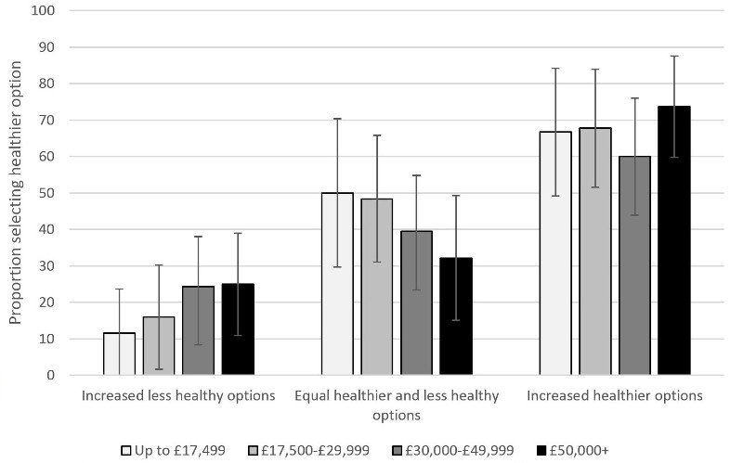

Table S2. Logistic regression predicting healthier option selection, including interactions between availability condition and annual household income
 |  | Odds Ratio  (95% CIs) | p-value
Availability condition  (ref: Equal Healthier and Less Healthy) | Increased Less Healthy | 0.13  (0.03, 0.56) | 0.006
 | Increased Healthier | 2.11  (0.65, 6.91) | 0.216
Annual household income  (ref: Up to £17,499) | £17,500-£29,999 | 1.00  (0.33, 3.07) | 0.998
Annual household income  (ref: Up to £17,499) | £30,000-£49,999 | 0.65  (0.22, 1.92) | 0.437
Annual household income  (ref: Up to £17,499) | £50,000+ | 0.51  (0.16, 1.67) | 0.268
Availability condition by Income interactions | Increased Less Healthy & £17,500-£29,999 | 1.63  (0.23, 11.70) | 0.629
Availability condition by Income interactions | Increased Less Healthy & £30,000-£49,999 | 3.66  (0.61, 22.04) | 0.156
Availability condition by Income interactions | Increased Less Healthy & £50,000+ | 5.30  (0.83, 33.73) | 0.078
Availability condition by Income interactions | Increased Healthier & £17,500-£29,999 | 1.03  (0.21, 5.00) | 0.973
Availability condition by Income interactions | Increased Healthier & £30,000-£49,999 | 1.08  (0.23, 4.97) | 0.923
Availability condition by Income interactions | Increased Healthier & £50,000+ | 2.76  (0.55, 13.78) | 0.215
Age |  | 1.00  (0.99, 1.02) | 0.535
Gender  (ref: Female) | Male | 0.60  (0.38, 0.96) | 0.033
Hunger |  | 0.82  (0.66, 1.02) | 0.077
Intercept |  | 1.14  (0.37, 3.55) | 0.818
Pseudo R-squared=0.1471; Log-likelihood chi-square (degrees of freedom: 14)= 75.38 (p<0.0001); Number of observations= 374
N.B. This model showed a small increase in terms of the Akaike Information Criterion (AIC), but a substantially higher Bayesian Information Criterion (BIC) to the model without interactions

Table S3. Logistic regression predicting healthier option selection, including interactions between availability condition and highest educational qualification
 |  | Odds Ratio  (95% CIs) | p-value
Availability condition  (ref: Equal Healthier and Less Healthy) | Increased Less Healthy | 0.17  (0.07, 0.38) | <0.001
 | Increased Healthier | 1.59  (0.79, 3.19) | 0.192
Education  (ref: Lower: Up to GCSE) | Higher: Degree or above | 0.54  (0.26, 1.12) | 0.098
Availability condition by Education interactions | Increased Less Healthy & Higher Education | 4.04  (1.31, 12.40) | 0.015
Availability condition by Education interactions | Increased Healthier & Higher Education | 2.50  (0.91, 6.83) | 0.075
Age |  | 1.01  (0.99, 1.02) | 0.324
Gender  (ref: Female) | Male | 0.60  (0.39, 0.94) | 0.025
Hunger |  | 0.80  (0.65, 0.99) | 0.039
Intercept |  | 1.11  (0.45, 2.72) | 0.819
Pseudo R-squared=0.1385; Log-likelihood chi-square (degrees of freedom: 8)= 77.80 (p<0.0001); Number of observations= 410
N.B. This model showed little difference in terms of the Akaike Information Criterion (AIC), but a higher Bayesian Information Criterion (BIC) to the model without interactions

Table S4. Logistic regression predicting healthier option selection, including response inhibition variables
 |  | Odds Ratio  (95% CIs) | p-value
Availability condition  (ref: Equal Healthier and Less Healthy) | Increased Less Healthy | 0.32  (0.18, 0.56) | <0.001
 | Increased Healthier | 2.39  (1.45, 3.97) | 0.001
Education  (ref: Lower: Up to GCSE) | Higher: Degree or above | 1.15  (0.73, 1.80) | 0.543
Age |  | 1.01  (0.99, 1.02) | 0.482
Gender  (ref: Female) | Male | 0.58  (0.37, 0.90) | 0.016
Hunger |  | 0.79  (0.64, 0.98) | 0.029
Stop-signal reaction time |  | 0.9997  (0.9984, 1.0010) | 0.653
Stroop score |  | 0.9997  (0.9987, 1.0006) | 0.512
Intercept |  | 0.87  (0.36, 2.10) | 0.753
Pseudo R-squared=0.1298; Log-likelihood chi-square (degrees of freedom: 8)= 71.95 (p<0.0001); Number of observations= 405 [Three participants had missing values for SSRT and six for Stroop scores]

N.B. This model had higher Akaike Information Criterion (AIC) and Bayesian Information Criterion (BIC) to the model without response inhibition variables

Table S5. Logistic regression predicting healthier option selection, including food appeal variables
 |  |  | Odds Ratio  (95% CIs) | p-value
Availability condition  (ref: Equal Healthier and Less Healthy) |  | Increased Less Healthy | 0.20  (0.10, 0.40) | <0.001
 |  | Increased Healthier | 2.12  (1.16, 3.86) | 0.014
Education  (ref: Lower: Up to GCSE) |  | Higher: Degree or above | 0.86  (0.50, 1.48) | 0.585
Age |  |  | 0.99  (0.97, 1.01) | 0.398
Gender  (ref: Female) |  | Male | 0.61  (0.36, 1.02) | 0.062
Hunger |  |  | 0.87  (0.69, 1.12) | 0.283
Explicit: enjoyment ratings | Healthier food |  | 2.79  (1.97, 3.95) | <0.001
Explicit: enjoyment ratings | Less healthy food |  | 0.32  (0.23, 0.44) | <0.001
Implicit: IAT scores | Healthier food |  | 0.66  (0.40, 1.11) | 0.121
Implicit: IAT scores | Less healthy food |  | 0.78  (0.47, 1.29) | 0.341
Intercept |  |  | 4.05  (1.32, 12.38) | 0.014
Pseudo R-squared=0.2884; Log-likelihood chi-square (degrees of freedom: 10)= 146.53 (p<0.0001); Number of observations= 370 [Two participants had missing values for both explicit food appeal variables, 17 for healthier IAT score and 39 for less healthy IAT score]

N.B. This model had lower Akaike Information Criterion (AIC) and Bayesian Information Criterion (BIC) to the model without food appeal variables

