Unique Participant ID:

- Please circle the picture below that best describes your relationship with the natural environment (self = you; nature = the environment):

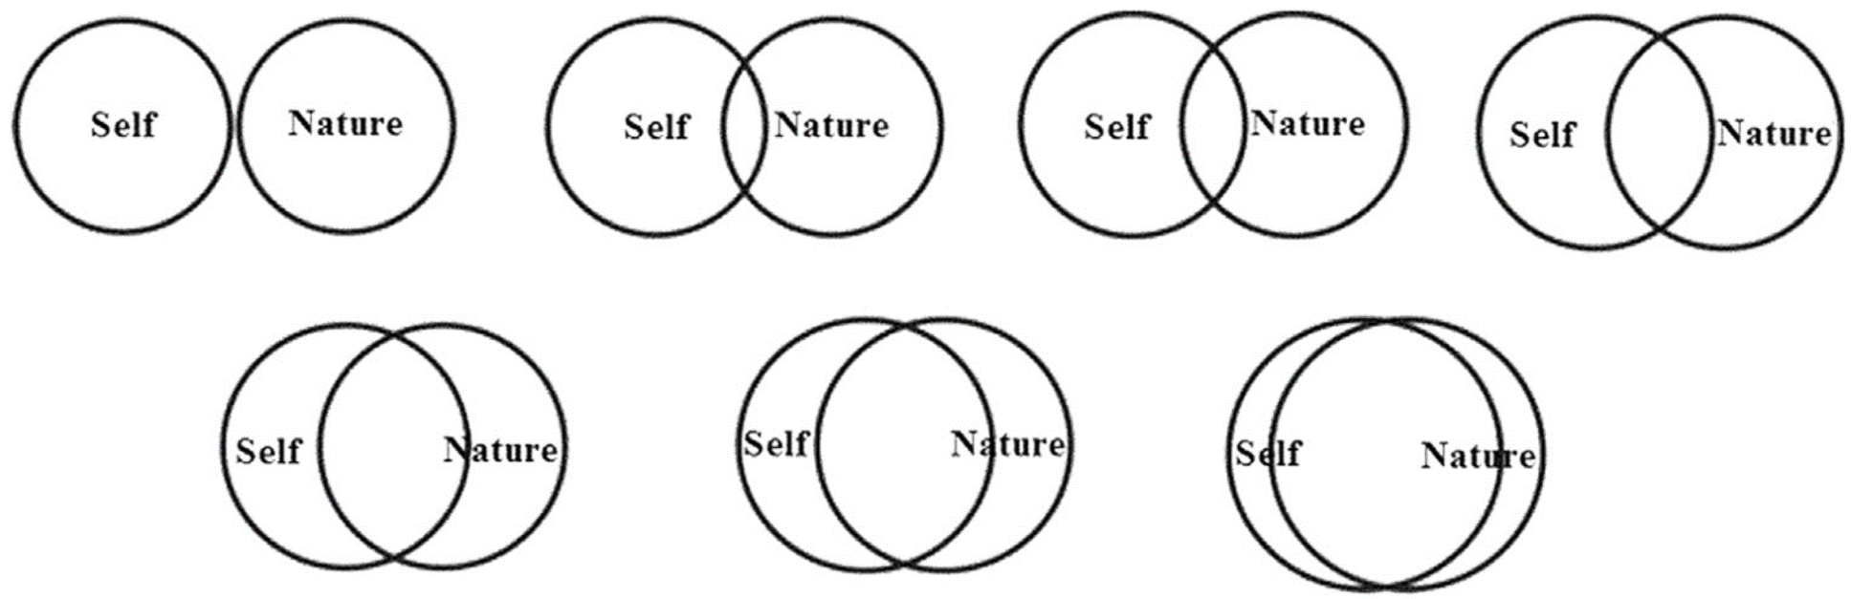

- Please circle the face below that best describes how much you agree or disagree with each of the following statements:
(Circle only one face per statement. If you need to change your answer, erase completely).

I like to hear different sounds in nature

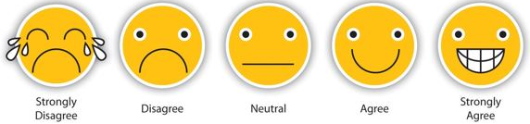

I like to see wildflowers in nature

When I feel sad, I like to go outside and enjoy nature

Being in the natural environment makes me feel peaceful

I like to garden

Collecting rocks and shells is fun

I feel sad when wild animals are hurt

I like to see wild animals living in a clean environment

I enjoy touching animals and plants

Taking care of animals is important to me

Humans are part of the natural world

People cannot live without plants and animals

Being outdoors makes me happy

My actions will make the natural world different

Picking up trash on the ground can help the environment

People do not have the right to change the natural environment

Thank you for your participation!

