Additional file 7.

Sample content from English, Arabic and Simplified Chinese Healthy Beginnings booklets

The Healthy Beginnings booklets align with baby age and the program’s key messages – focussing on infant feeding and active play. Available from www.healthybeginnings.net.au

This sample content is from Healthy Beginnings information booklet targeting infant age 4-6 months, pages 4 and 5. Content is focussed on introducing solids foods. English mainstream booklet (a), and culturally adapted Simplified Chinese (b) and Arabic (c) versions are displayed below.

Key changes in this sample include:
- Images include individuals with appearance of target populations
- Reduced and simplified text, reading level lowered <grade 6 (prior to translation)
- Increased visuals
- Adapted wording and translated into Arabic and Simplified Chinese languages
- Content is focussed on culturally relevant information
  - Emphasis on hunger and fullness cues (relates to belief of earlier introduction of complementary foods as a positive sign of baby development, and also relates to perceptions of less-responsive feeding)
  - Emphasis of baby making a mess and self-feeding (relates to perceptions of needing to maintain a clean space while baby is eating, and not self-feeding)
  - Image of sippy cup to illustrate what this is and promote cup use
  - Images of culturally relevant foods and consistencies for baby between 6-12m.

- Mainstream English language information booklet targeting infant age 4-6 months.
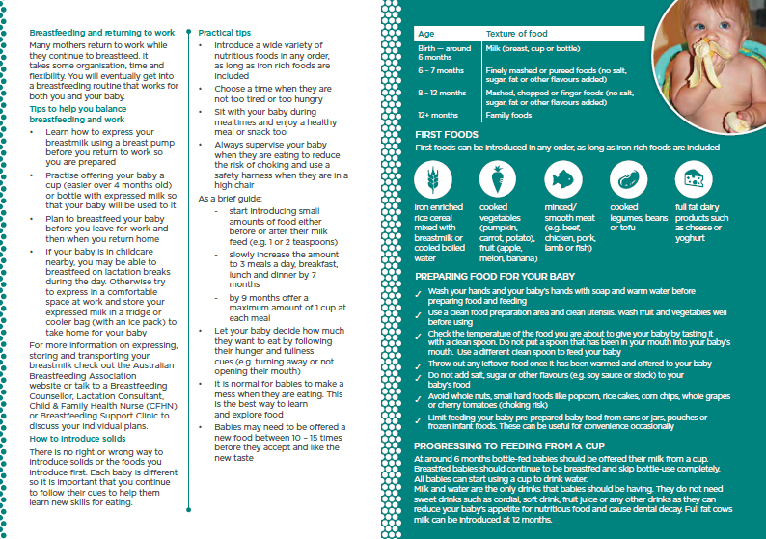

- Culturally adapted Simplified Chinese language information booklet
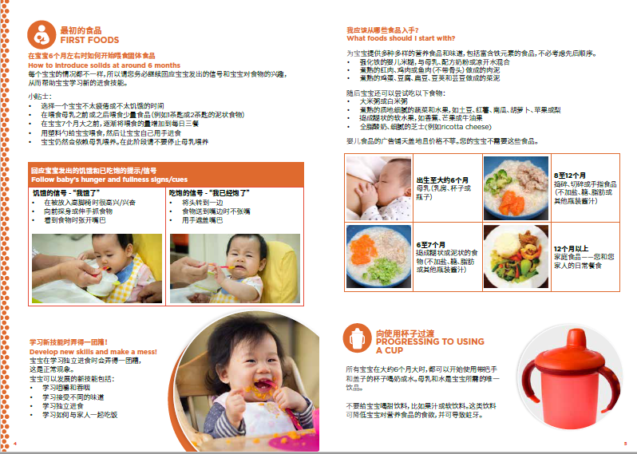

- Culturally adapted Arabic language information booklet
