Figure 1. Proportions of Students with BMI>85th %ile Attaining Individual Target Behaviors After One Year (N=55)

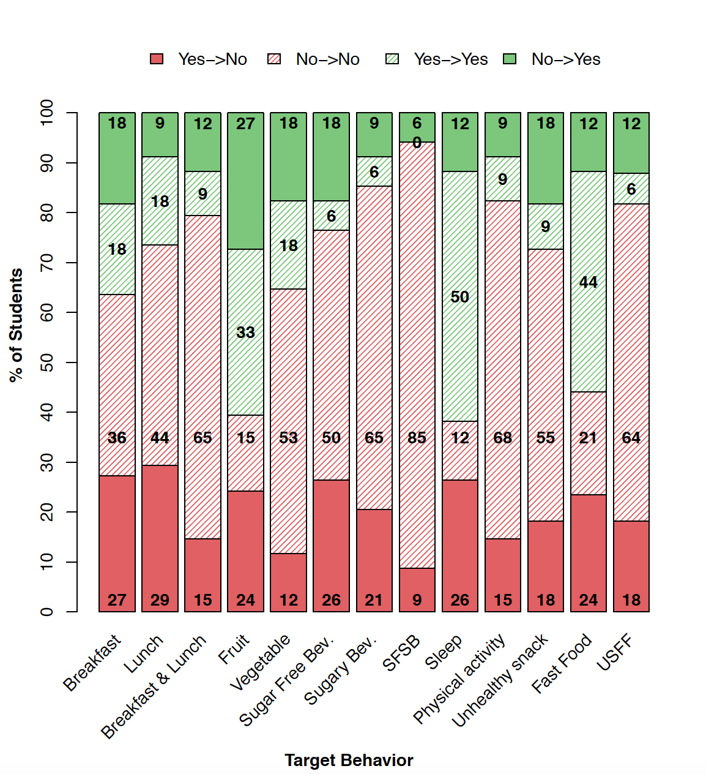

Table 1. Target Behavior Changes Following Program Participation Including Multiple Imputation (MI) Results (N=76)

 | Beta per one academic year  (MI) | 95% CI  (MI) | P-value  (MI)
Composite Score* | 0.09  (-0.13) | (-0.28, 0.46)  (-0.54-0.28) | 0.632  (0.520)
BMI Z-score | 0.01  (-0.04) | (-0.04, 0.05)  (-0.45-0.37) | 0.799  (0.838)
 | OR per one academic year | 95% CI | P-value
Breakfast | 1.06  (0.49) | (0.38-2.99)  (0.2-1.22) | 0.914  (0.127)
Lunch | 0.18  (0.14) | (0.06-0.52)  (0.05-0.37) | 0.001  (6.5E-05)
Breakfast & Lunch | 0.7  (0.46) | (0.25-1.97)  (0.18-1.17) | 0.5  (0.102)
Fruit | 1.16  (0.65) | (0.56-2.42)  (0.32-1.28) | 0.688  (0.211)
Vegetable | 1.95  (2.25) | (0.72-5.27)  (0.85-5.93) | 0.186  (0.101)
Sugar Free Beverage | 1.25  (1.16) | (0.48-3.21)  (0.48-2.79) | 0.647  (0.741)
Sugary Beverage | 0.86  (1.37) | (0.32-2.3)  (0.56-3.39) | 0.756  (0.487)
Sugar-Free and Sugary Beverage | 1.49  (1.45) | (0.41-5.44)  (0.38-5.47) | 0.544  (0.584)
Sleep | 0.74  (0.70) | (0.27-2.02)  (0.26-1.84) | 0.558  (0.465)
Physical activity | 1.2  (0.79) | (0.27-2.02)  (0.28-2.22) | 0.756  (0.647)
Unhealthy snack | 1.32  (1.59) | (0.55-3.18)  (0.68-3.73) | 0.54  (0.284)
Fast Food | 0.5  (0.49) | (0.21-1.22)  (0.21-1.15) | 0.13  (0.101)
Unhealthy Snack and Fast Food | 0.77  (0.91) | (0.29-2.01)  (0.32-2.63) | 0.593  (0.867)
*Composite score is the score of 7 target variables

A generalized linear (for the outcomes such as composite score and BMI Z-score) or logistic (individual target behavior) mixed-effects model was fitted including the school year, elapsed time as fixed effects and random intercepts by subject. Then, the effect of elapsed time (per one academic year as 9 months) is shown in the table.

Table 2. Target behavior change for Low (<75%) and High (>75%) Afterschool Attendance with BMI>85th%ile (N=55)

 | Low afterschool attendance |  |  | High afterschool attendance |  |  | Interaction
 | Beta per one academic year | 95% CI | P | Beta per one academic year | 95% CI | P | P
Composite Score | -0.18 | (-0.7-0.33) | 0.478 | 0.03 | (-0.84-0.91) | 0.938 | 0.67
BMI.Z-score | -0.01 | (-0.07-0.04) | 0.676 | -0.01 | (-0.11-0.08) | 0.822 | 0.989
 | OR per one academic year | 95% CI | P | OR per one academic year | 95% CI | P | P
Breakfast | 0.67 | (0.16-2.72) | 0.571 | 0.32 | (0.03-3.31) | 0.342 | 0.602
Lunch | 0.36 | (0.08-1.67) | 0.190 | 0.00 | (0-0.05) | 0.002 | 0.007
Breakfast & Lunch | 0.86 | (0.21-3.5) | 0.833 | 0.15 | (0.01-2.43) | 0.181 | 0.27
Fruit | 0.92 | (0.35-2.41) | 0.859 | 5.93 | (0.85-41.46) | 0.073 | 0.092
Vegetable | 1.51 | (0.38-6.02) | 0.558 | 1.62 | (0.11-23.02) | 0.724 | 0.965
Sugar Free Beverage | 1.09 | (0.31-3.81) | 0.889 | 0.63 | (0.07-5.47) | 0.677 | 0.666
Sugary Beverage | 0.29 | (0.07-1.14) | 0.076 | 2.14 | (0.23-19.58) | 0.502 | 0.131
Sugar-Free and Sugary Beverage | 0.59 | (0.1-3.67) | 0.573 | 1.22 | (0.06-26.94) | 0.900 | 0.693
Sleep | 0.73 | (0.2-2.61) | 0.628 | 0.23 | (0.03-1.75) | 0.156 | 0.344
Physical activity | 0.90 | (0.21-3.84) | 0.892 | 1.70 | (0.16-18.42) | 0.664 | 0.661
Unhealthy snack | 0.63 | (0.19-2.05) | 0.443 | 1.81 | (0.24-13.61) | 0.563 | 0.374
Fast Food | 0.71 | (0.21-2.42) | 0.579 | 0.49 | (0.08-3.13) | 0.450 | 0.747
Unhealthy Snack and Fast Food | 0.49 | (0.15-1.65) | 0.252 | 0.85 | (0.07-9.94) | 0.896 | 0.698

A generalized linear (for the outcomes such as composite score and BMI Z-score) or logistic (individual target behavior) mixed-effects model was fitted including the school year, elapsed time, after-school attendance (low and high) and an interaction of elapsed time and attendance as fixed effects and random intercepts by subject. Then, the linear trend by elapsed time (per one academic year as 9 months) according to after-school attendance (low, high) was calculated based on the model fit.

Table 3. Association Between Target Behavior Attainment as Exposure and BMI Z-score with BMI>85th%ile (N=55)

 | Beta | 95% CI | P
Composite Score | -0.009 | (-0.027, 0.009) | 0.338
Breakfast | -0.057 | (-0.105, -0.008) | 0.024
Lunch | -0.025 | (-0.074, 0.025) | 0.327
Breakfast & Lunch | -0.05 | (-0.101, 0.001) | 0.056
Fruit | 0.006 | (-0.031, 0.044) | 0.743
Vegetable | -0.022 | (-0.073, 0.028) | 0.398
Sugar Free Beverage | -0.006 | (-0.052, 0.041) | 0.81
Sugary Beverage | -0.011 | (-0.062, 0.039) | 0.661
Sugar-Free and Sugary Beverage | 0.004 | (-0.066, 0.075) | 0.909
Sleep | -0.049 | (-0.094, -0.003) | 0.036
Physical activity | -0.016 | (-0.069, 0.036) | 0.552
Unhealthy snack | 0.038 | (-0.006, 0.083) | 0.097
Fast Food | 0.029 | (-0.016, 0.074) | 0.215
Unhealthy Snack and Fast Food | 0.061 | (0.014, 0.107) | 0.012

A linear mixed-effects model was fitted on the data with BMI Z-score as outcome, and school year, elapsed time, and target behavior (exposure. each exposure separately in a model) as fixed effects and subject-to-subject variation by random intercepts.

