The risk model and nomogram for high-frequency hearing loss in noise-exposed workers
Ruican Sun¹, Weiwei Shang², Yingqiong Cao³, Yajia Lan^{1*}

- Department of Occupational and Environmental Health, West China School of Public Health and West China Fourth Hospital, Sichuan University, Chengdu, Sichuan, China
- Department of Occupational Health and Radial Control, Sichuan Center for Disease Control and Prevention, Chengdu, Sichuan, China
- Department of Occupational Disease Prevention and Control, Pidu District Center for Disease Control and Prevention, Chengdu, Sichuan, China
* Correspondence and request of materials should be addressed to Yajia Lan (e-mail: yajialan501@126.com).

Supplementary Material-Table 1. The selected values of the statistical distribution of hearing threshold levels
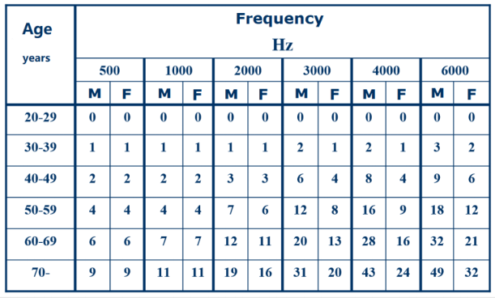
Footnote. M=male; F=female; Calculation formula of BHFTA = [the left ear (HL3 kHz + HL4kHz + HL6kHz) +the right ear (HL3kHz + HL4kHz + HL6kHz)]/ 6. The table was derived from the Regulation of Acoustic Statistical Distribution of the Hearing Thresholds as A Function of Age (GB/T 7582-2004)

