Supplement C: Additional results
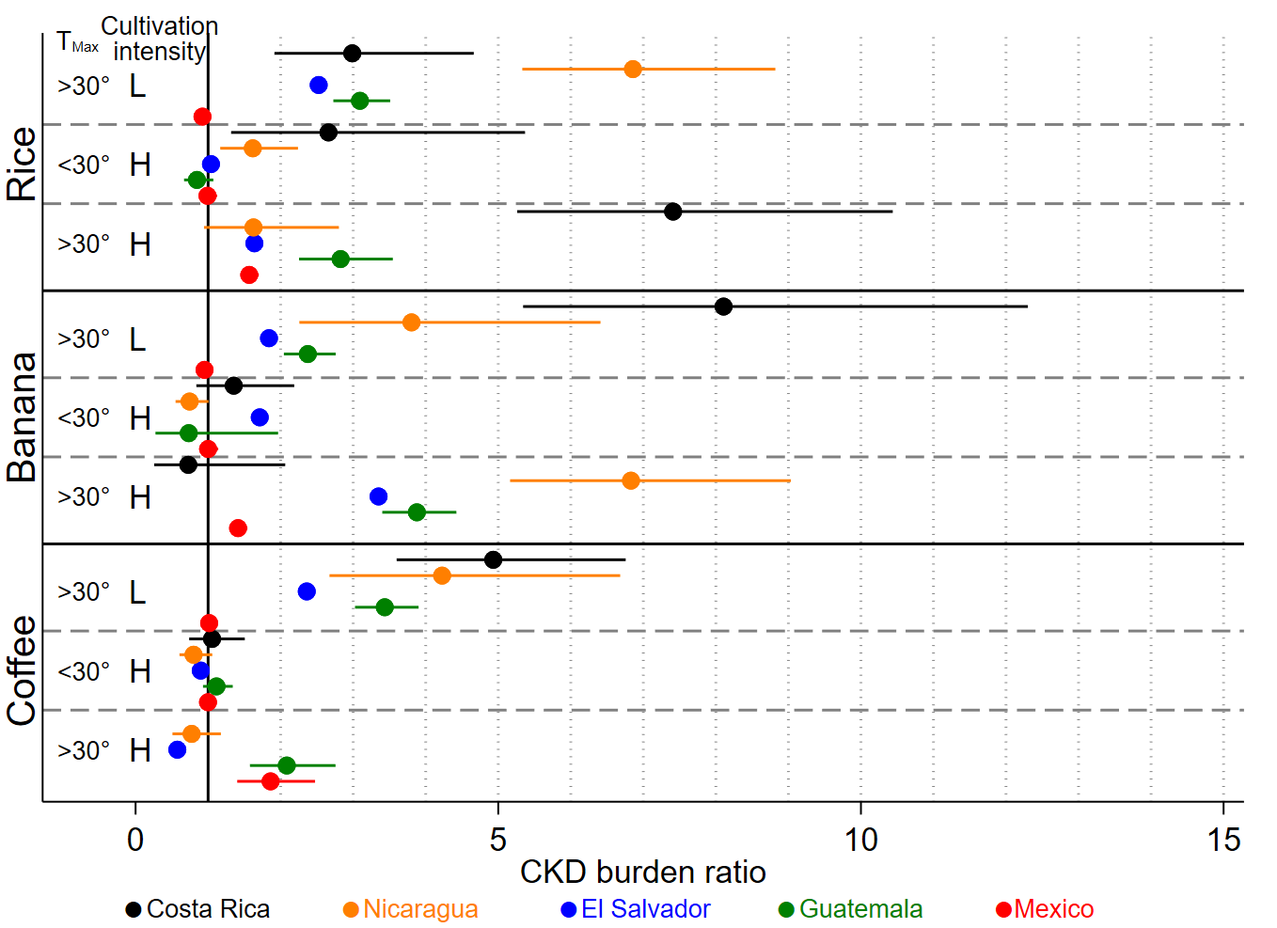
Figure C1 Association between CKD, crop (coffee, rice and banana) and heat by country in non-spatial regression analysis adjusted for population density.
CKD burden ratio= CKD mortality rate ratio in working age men for Mexico, Guatemala and Costa Rica. Proportion odds ratio for CKD deaths out of total non-communicable disease deaths in all age and sex groups in Nicaragua. Admission rate ratio for unspecified CKD in all age and sex groups in El Salvador. CKD=Chronic Kidney Disease. T_{max}=Mean maximum temperature according to Worldclim.org (1,2). L=Low cultivation intensity. H=High cultivation intensity

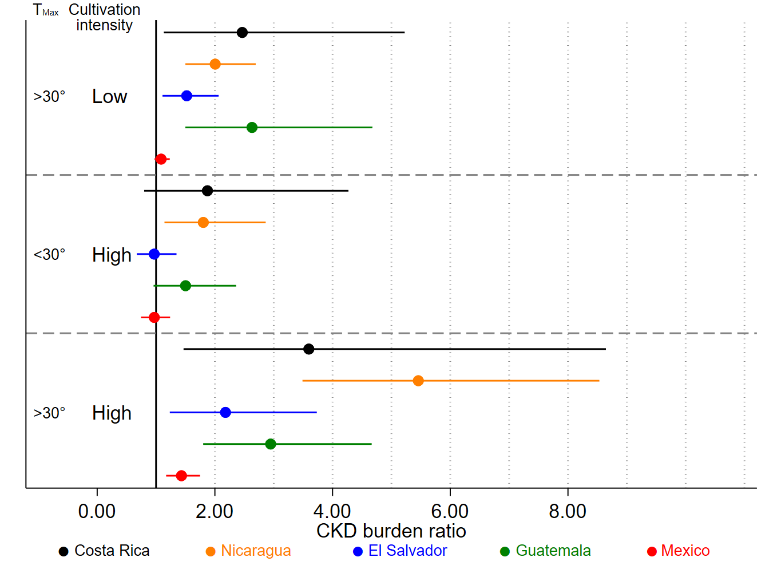
Figure C2 Association between CKD, sugarcane cultivation and heat by country in spatial regression analysis adjusted for population density.
CKD burden ratio= CKD mortality rate ratio in working age men for Mexico, Guatemala and Costa Rica. Proportion odds ratio for CKD deaths out of total non-communicable disease deaths in all age and sex groups in Nicaragua. Admission rate ratio for unspecified CKD in all age and sex groups in El Salvador. CKD=Chronic Kidney Disease. T_{max}=Mean maximum temperature according to Worldclim.org (1,2).

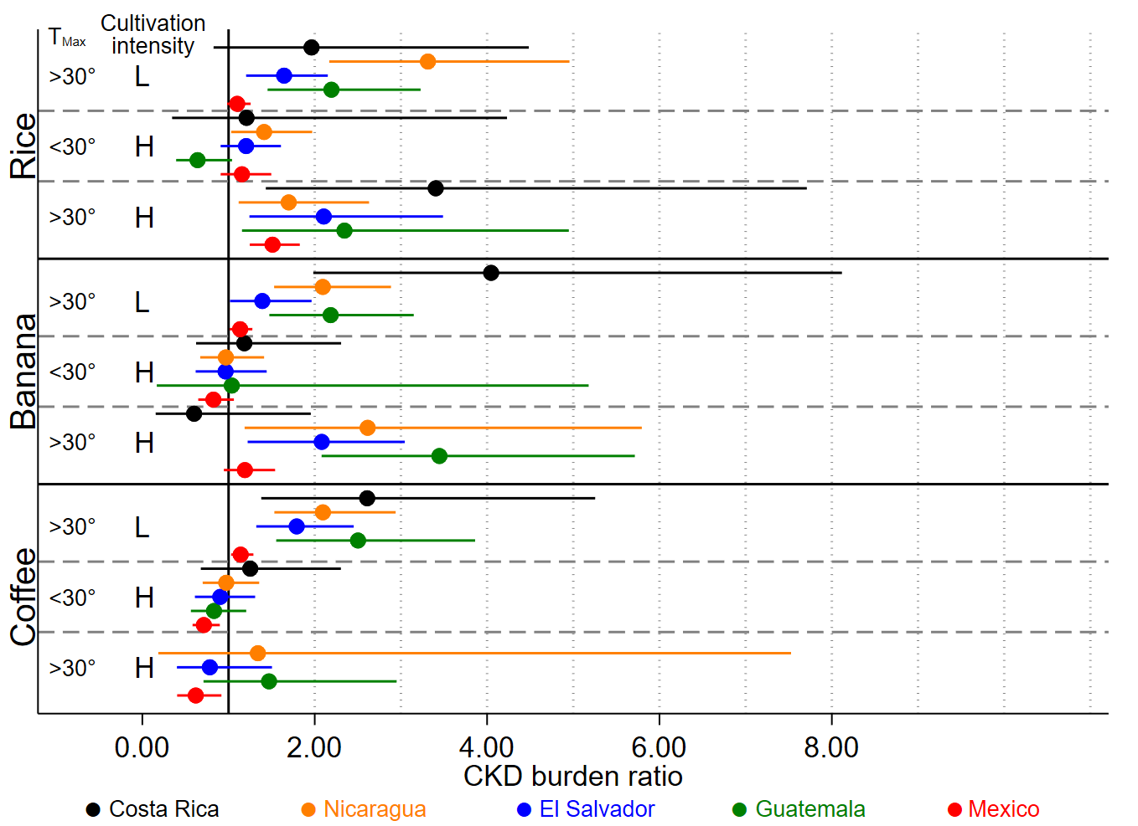
Figure C3 Association between CKD, crop and heat by country in spatial regression analysis adjusted for population density.
CKD burden ratio= CKD mortality rate ratio in working age men for Mexico, Guatemala and Costa Rica. Proportion odds ratio for CKD deaths out of total non-communicable disease deaths in all age and sex groups in Nicaragua. Admission rate ratio for unspecified CKD in all age and sex groups in El Salvador. CKD=Chronic Kidney Disease. T_{max}=Mean maximum temperature according to Worldclim.org (1,2). L=Low cultivation intensity. H=High cultivation intensity

References
1. Fick SE, Hijmans RJ. WorldClim 2: new 1-km spatial resolution climate surfaces for global land areas. International Journal of Climatology. 2017;37(12):4302-15.
2. WorldClim - Global Climate Data, http://worldclim.org/version2. Accessed 2018-04-06

