Title Page
Supplementary Figure 1
Lifestyle habits of adults during the COVID-19 pandemic lockdown in Cyprus: evidence from a cross-sectional study

Authors Information:

Dr Ourania Kolokotroni, Department of Primary Care and Population Health, Medical School, University of Nicosia *
Dr Maria C Mosquera, Department of Primary Care and Population Health, Medical School, University of Nicosia *
Dr Annalisa Quattrocchi, Department of Primary Care and Population Health, Medical School, University of Nicosia
Dr Alexandros Heraclides, Department of Primary Care and Population Health, Medical School, University of Nicosia
Dr Christiana Demetriou, Department of Primary Care and Population Health, Medical School, University of Nicosia
Dr Elena Philippou, Department of Life and Health Sciences, School of Sciences and Engineering, University of Nicosia. Department of Nutritional Sciences, King’s College London.

*Equal contribution

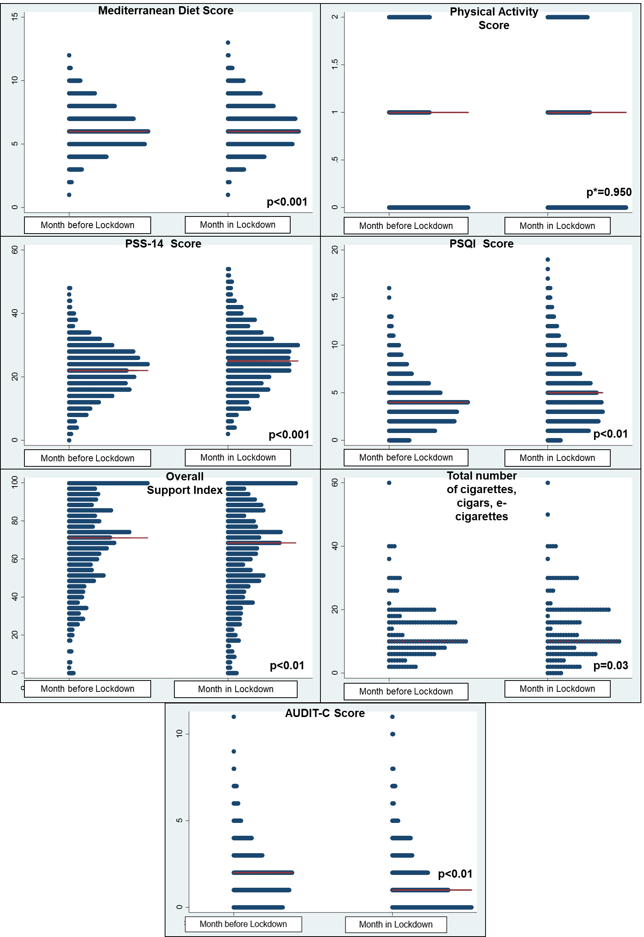
Supplementary Figure 1 – Dot plots showing Month before Lockdown and Month in Lockdown values for Mediterranean Diet Score, Physical Activity Score, PSS-14 score, PSQI score, Overall Support Index, Total number of cigarettes, cigars and e-cigarettes smoked, and AUDIT-C score.
P-values for all variables are from the Signrank test, with the exception of Physical Activity Score for which the Bower symmetry test was used.

