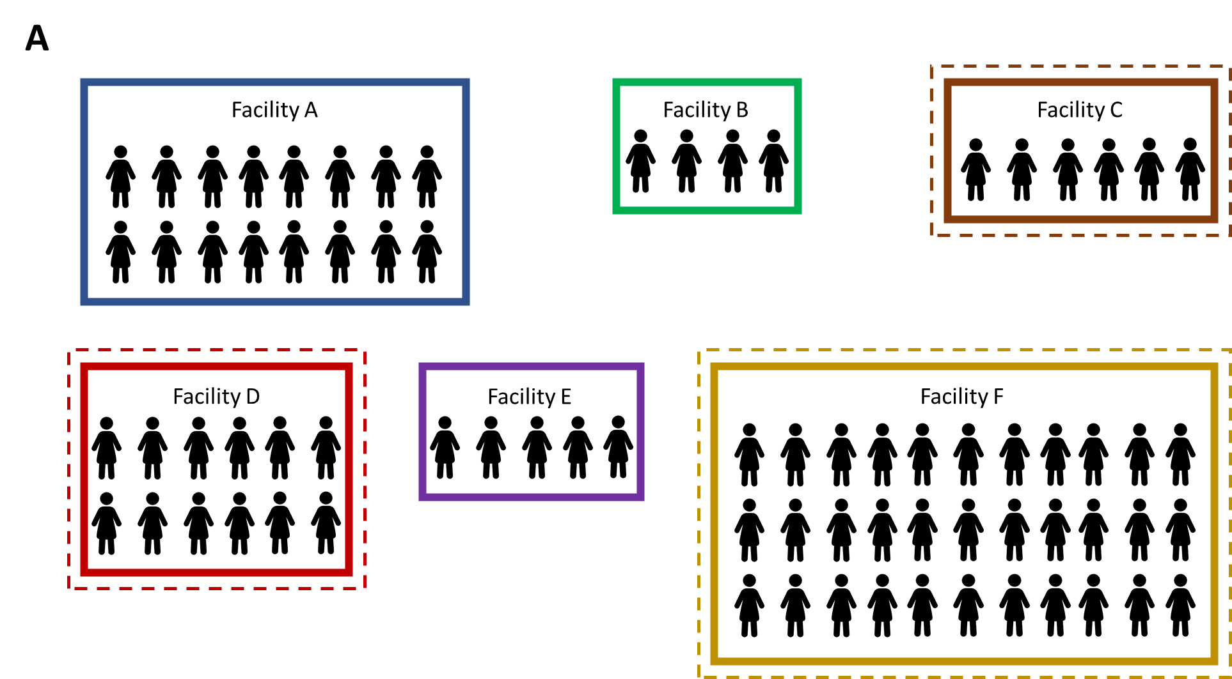
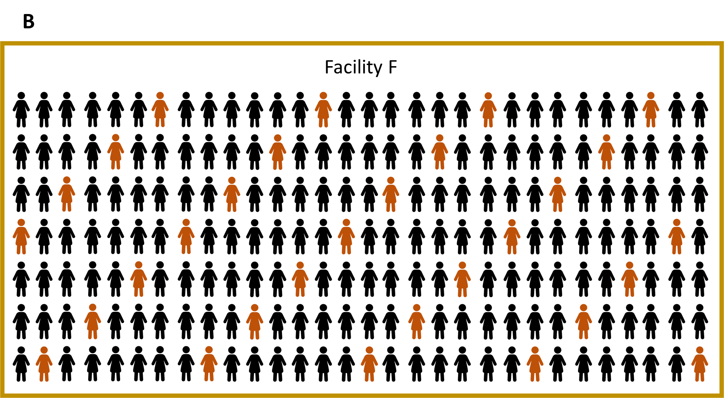
Supplemental Figure. Sampling diagram demonstrating stratified two-stage cluster sampling. To achieve a representative sample of people living with HIV, we first sampled facilities providing antiretroviral therapy with probability-proportional-to-size; in this example, Facilities C, D, and F are sampled from a sampling frame of six facilities (A). At each sampled facility, we systematically sampled 30 adults and 30 children from a registry; in this example with N=210 adult patients in Facility F, a sampling interval of N/30=7 is used to sample 30 adult patients for inclusion in the survey (B).

