Health indicators on adolescents reveal disparity and inequality on regional and national levels

Mengqiao Wang*
Department of Epidemiology and Biostatistics, West China School of Public Health and West China Fourth Hospital, Sichuan University, P.R. China
Address: Renmin South Road 16, Chengdu, Sichuan Province, 610041, P.R. China.
Phone: 86-13880649045
* Corresponding author (mengqiaowang@gmail.com)

Supplemental materials
- 11 supplementary figures

Supplementary Figures
Figure S1
A.
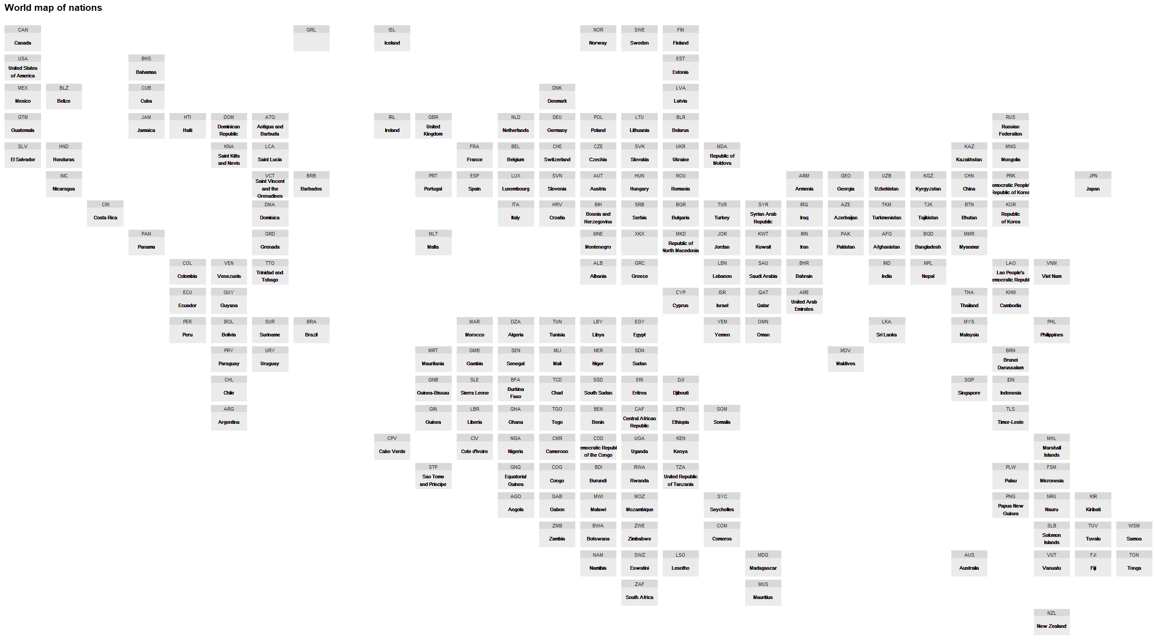

B.
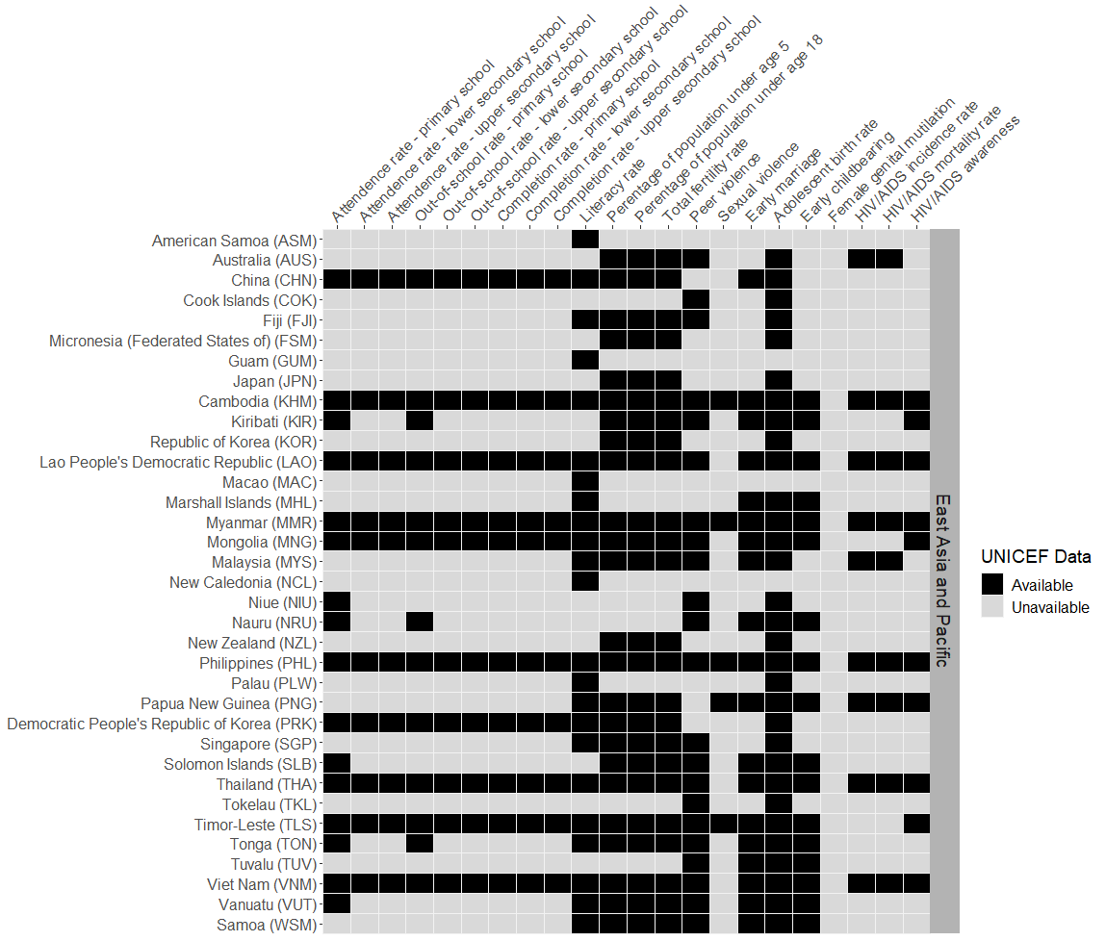

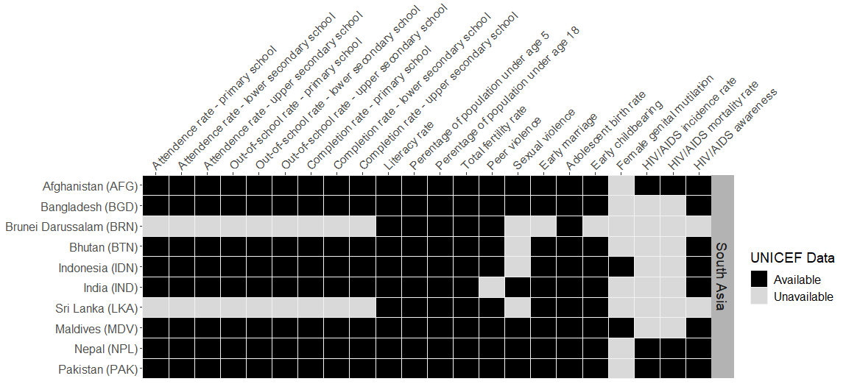

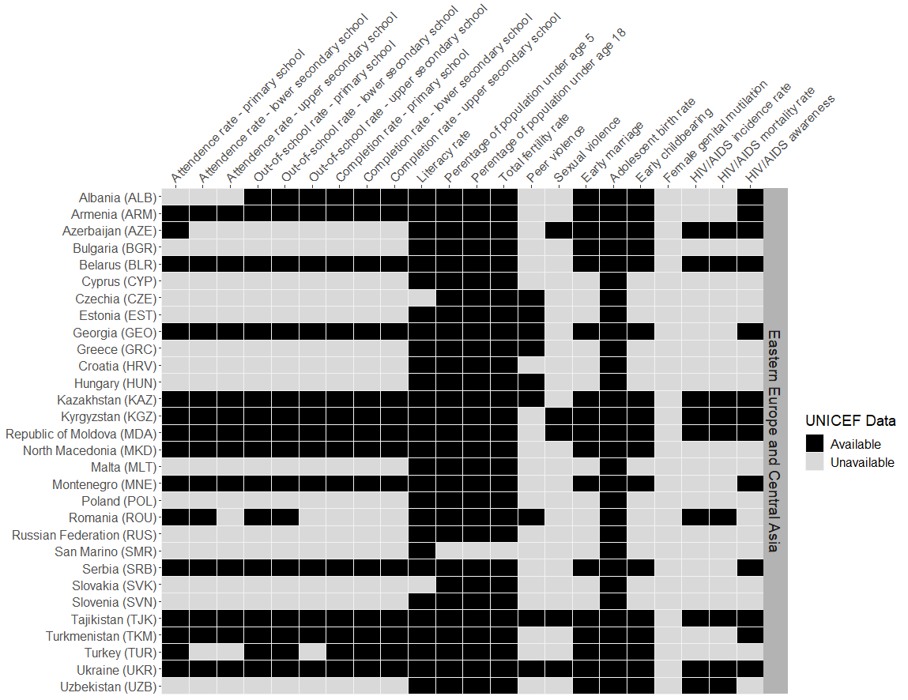

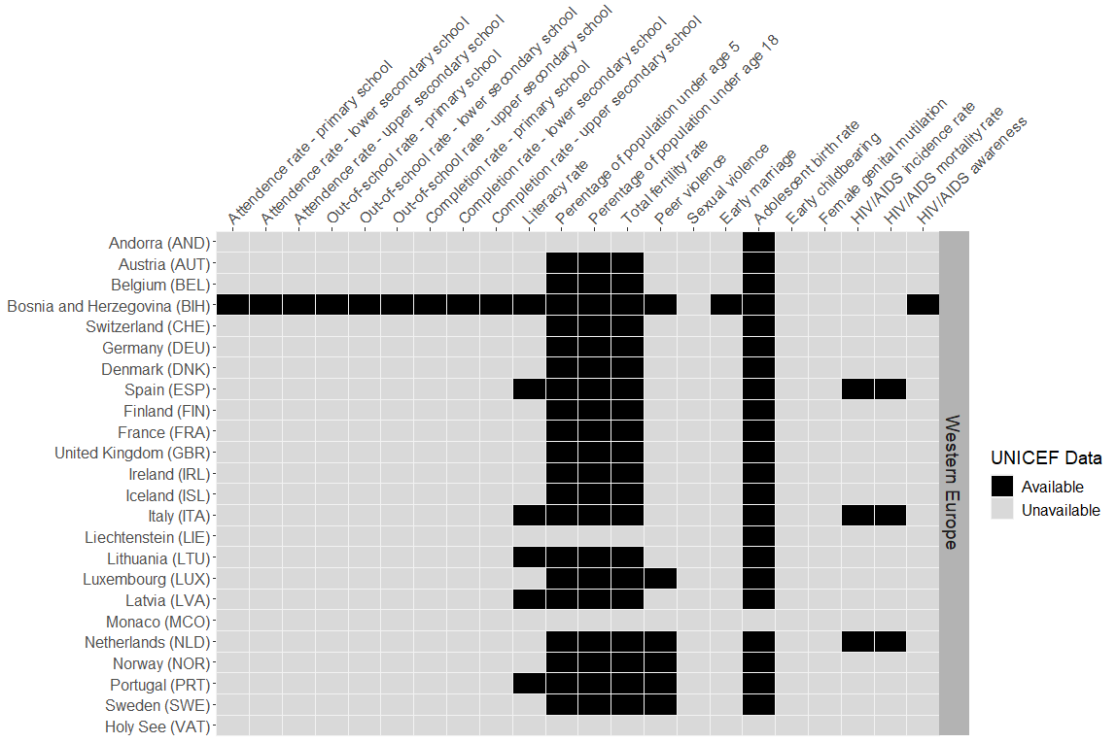

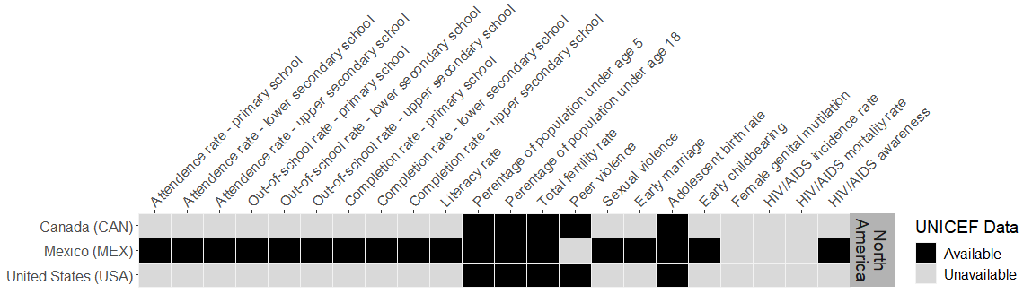

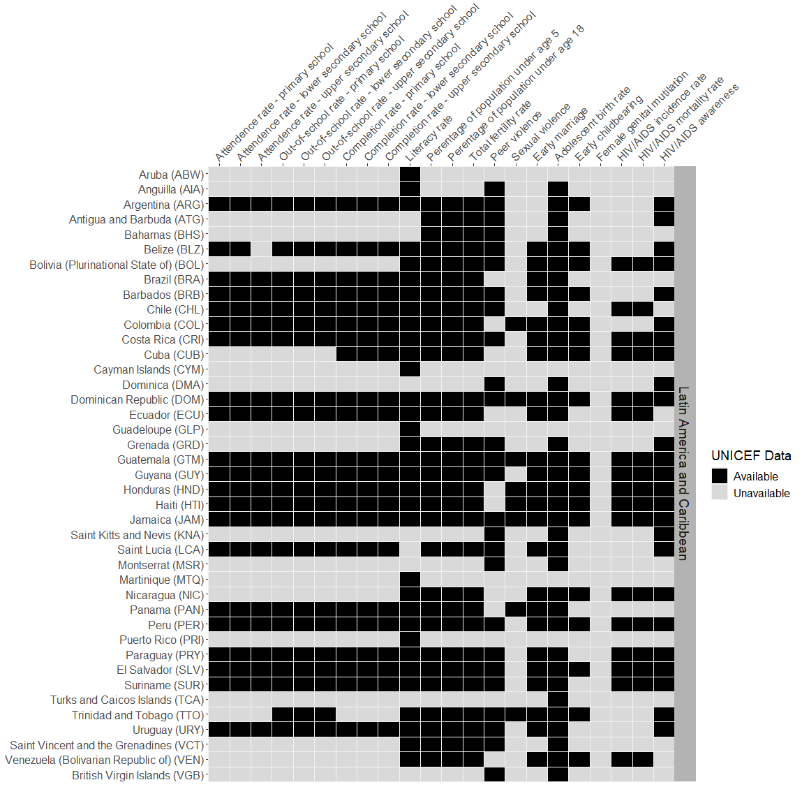

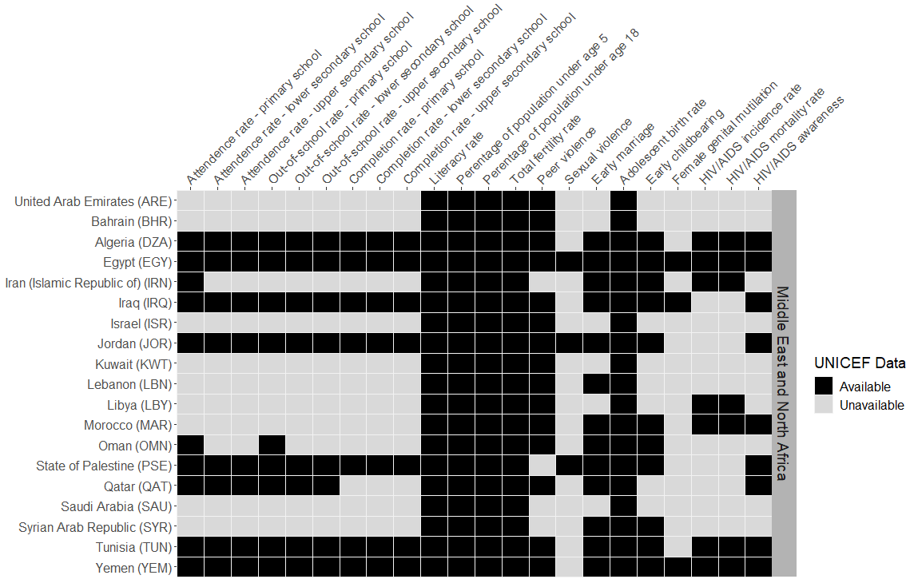

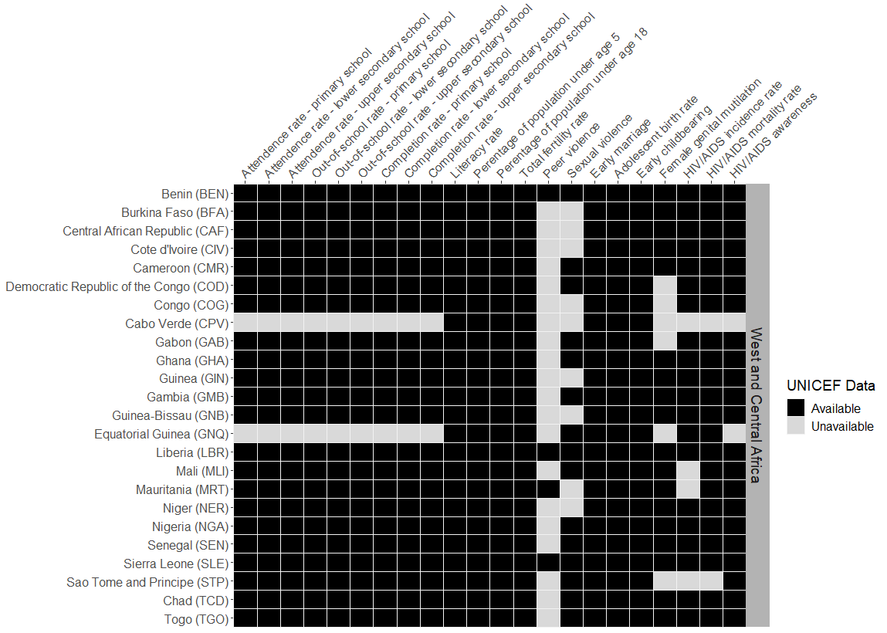

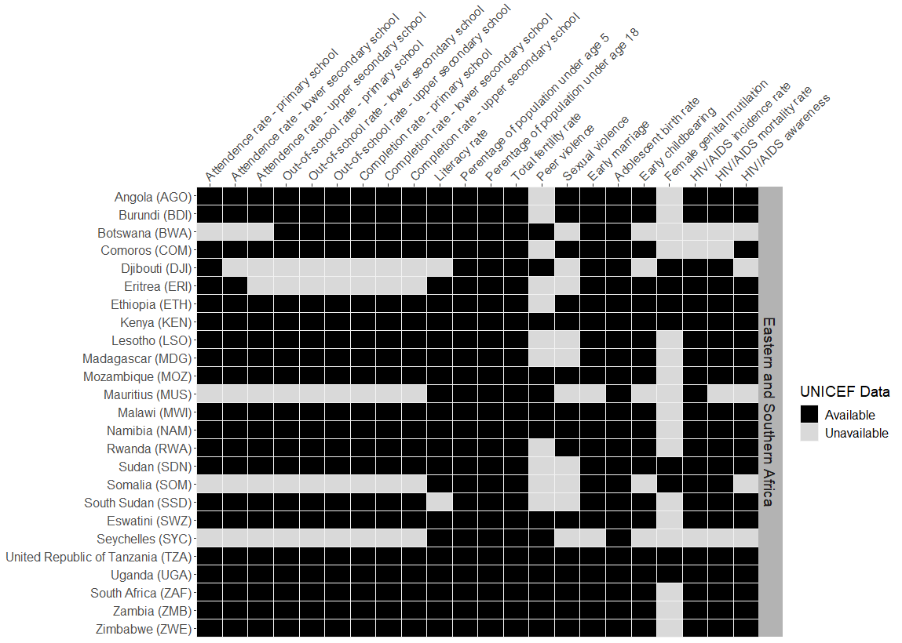

Figure S2
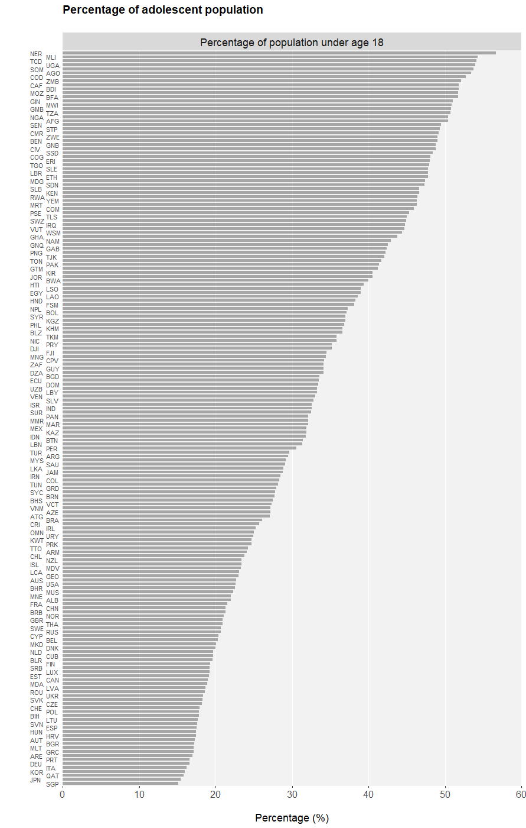

Figure S3
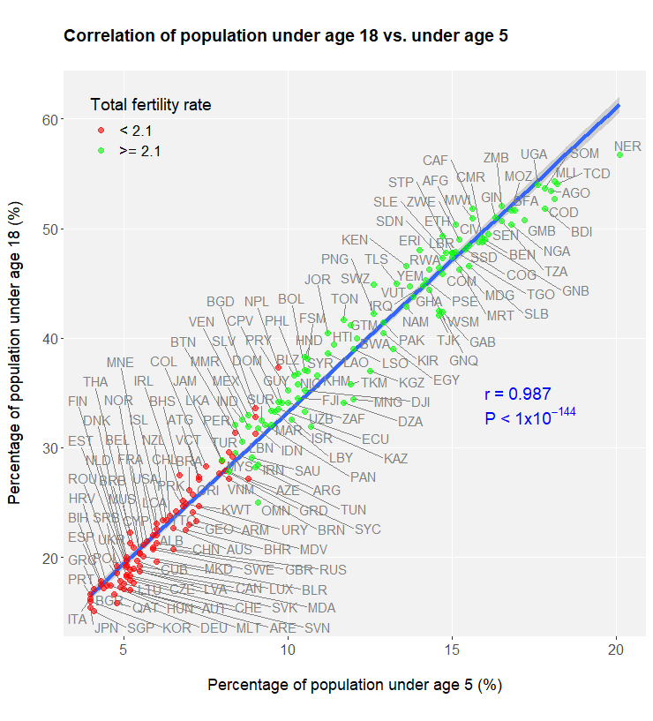

Figure S4
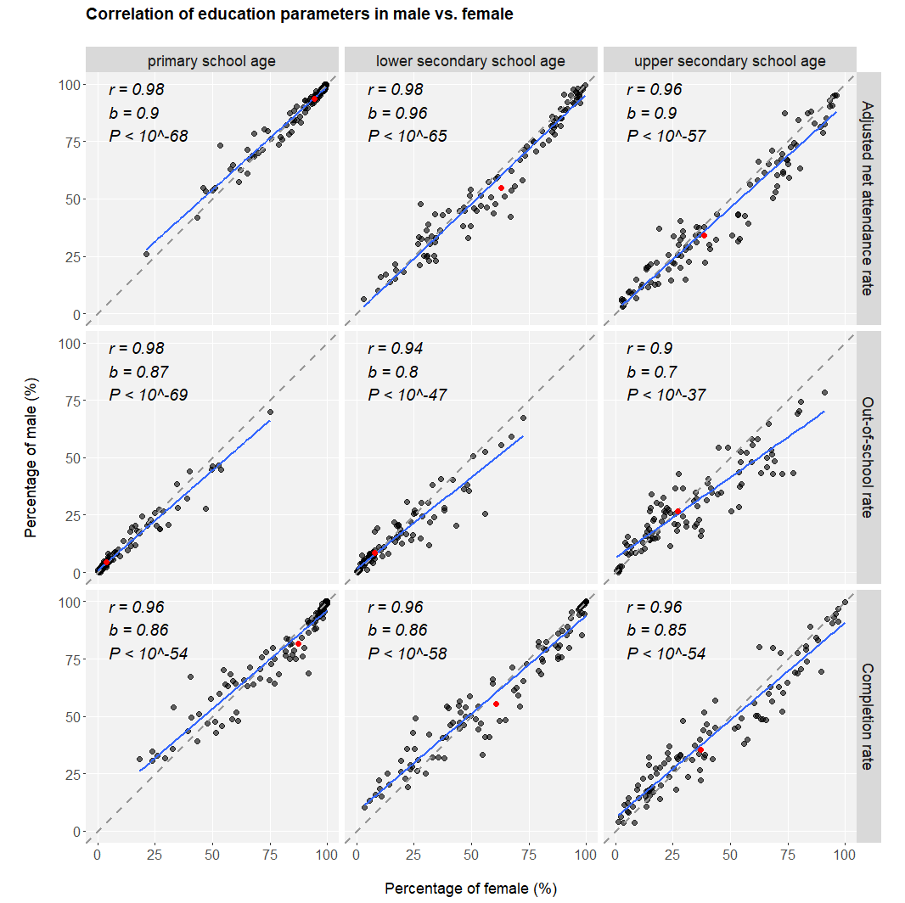

Figure S5
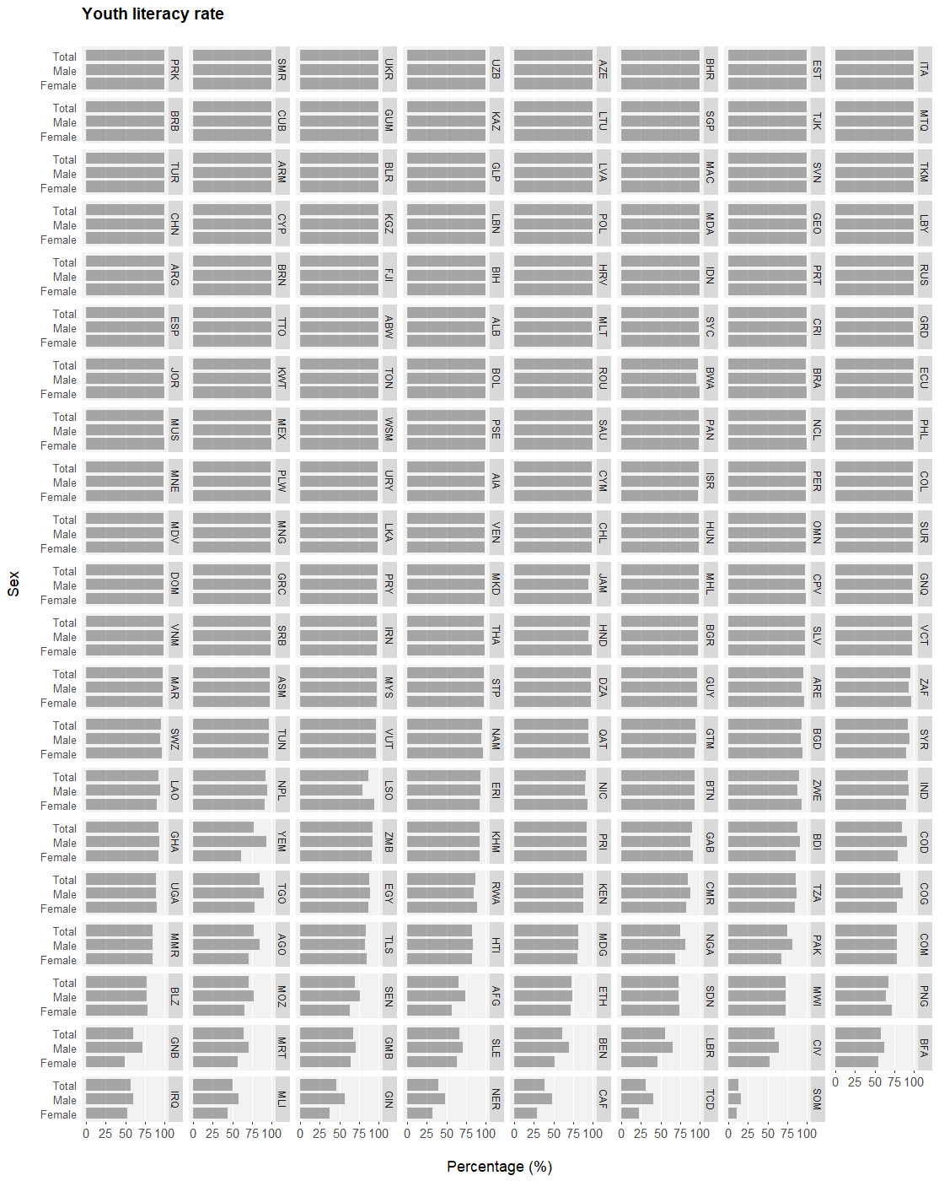

Figure S6
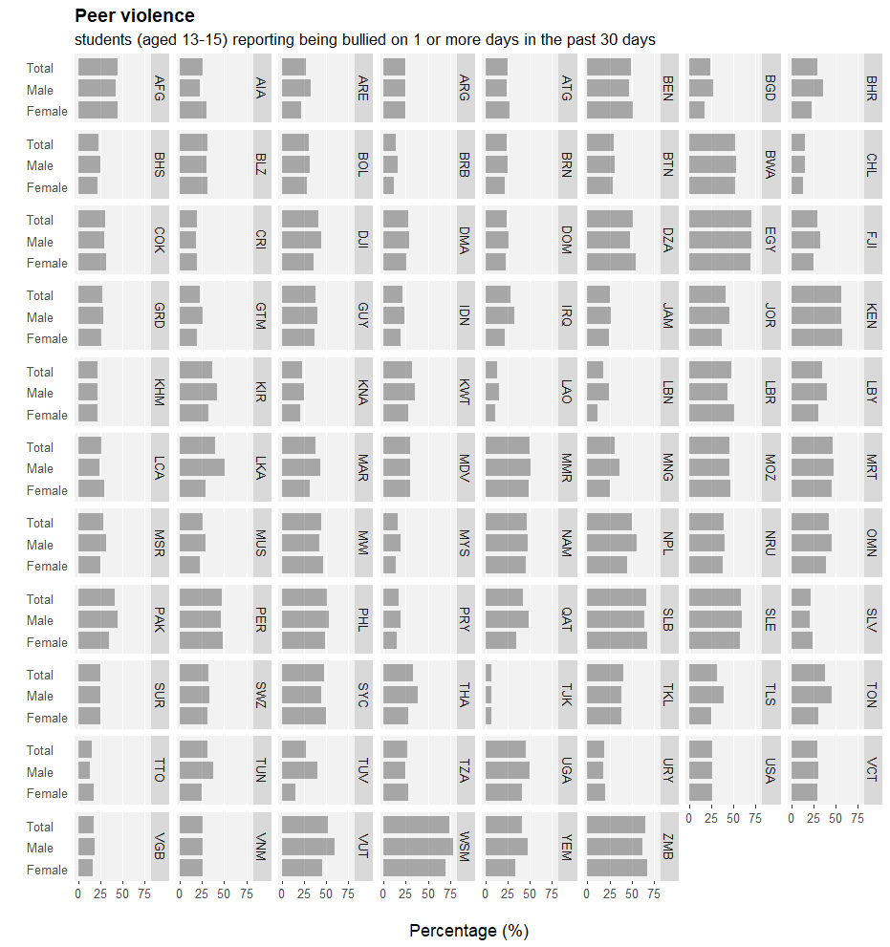

Figure S7
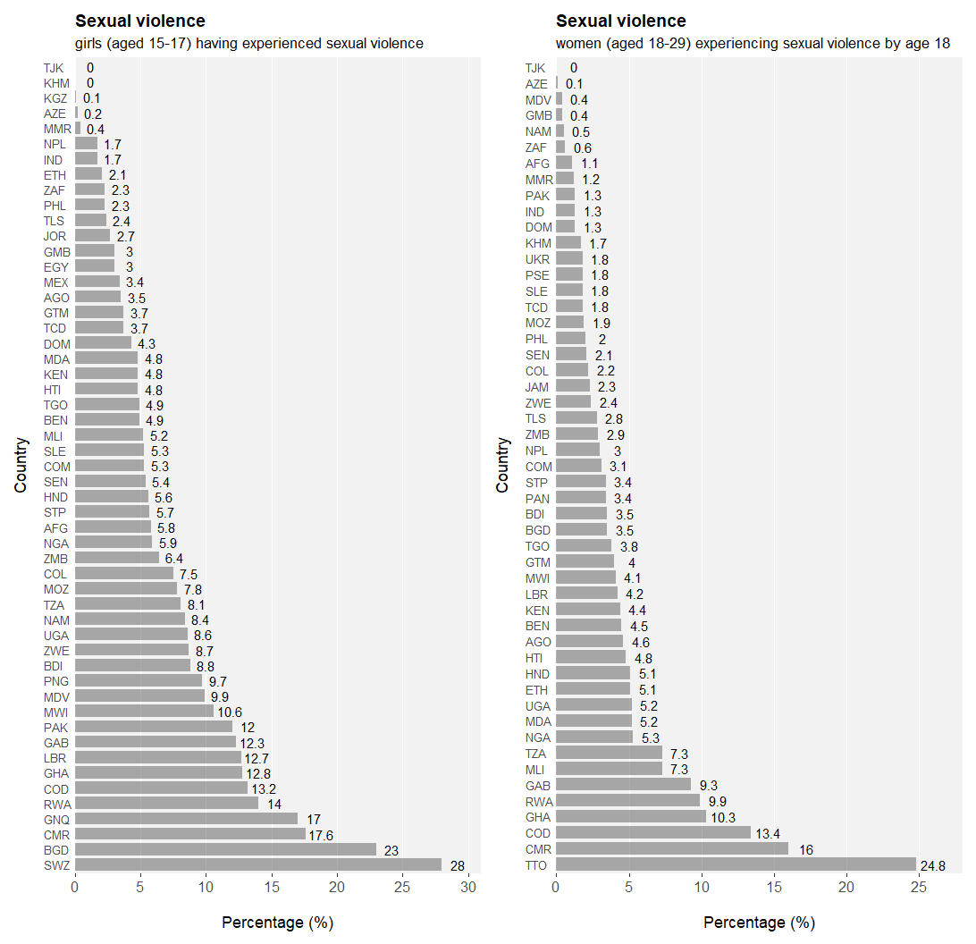

Figure S8
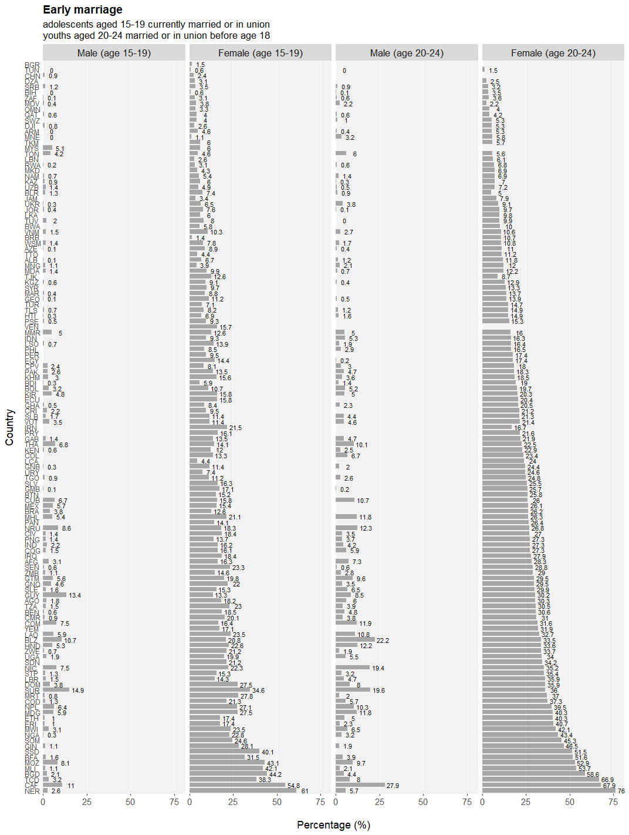

Figure S9
A.
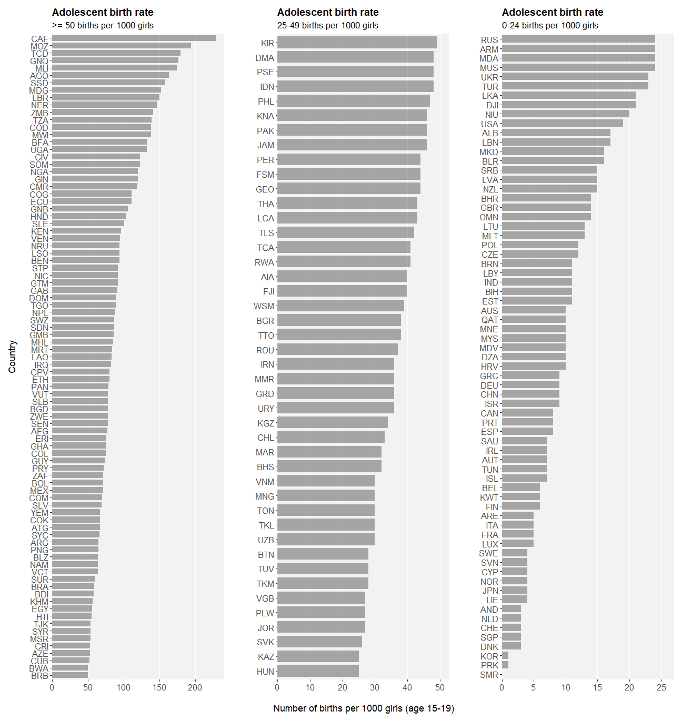

B.
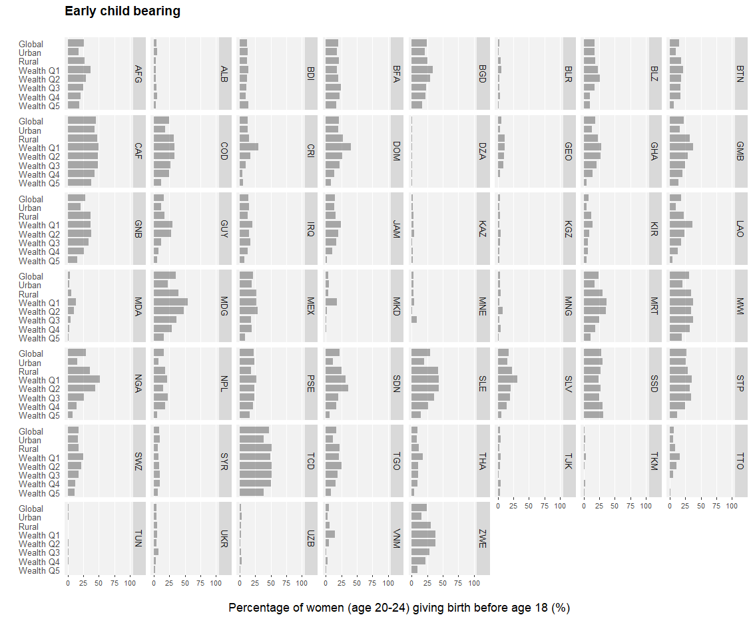

Figure S10
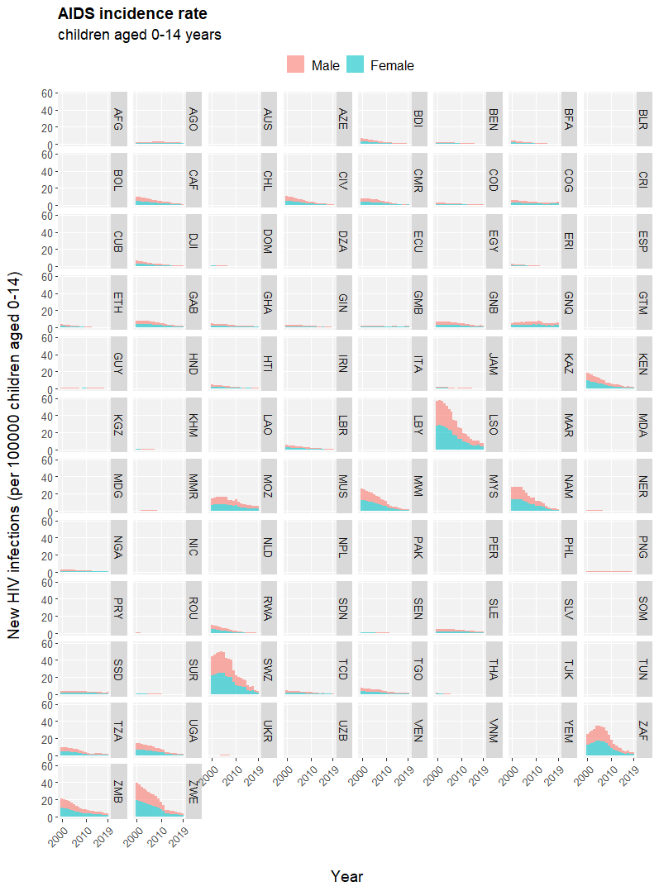

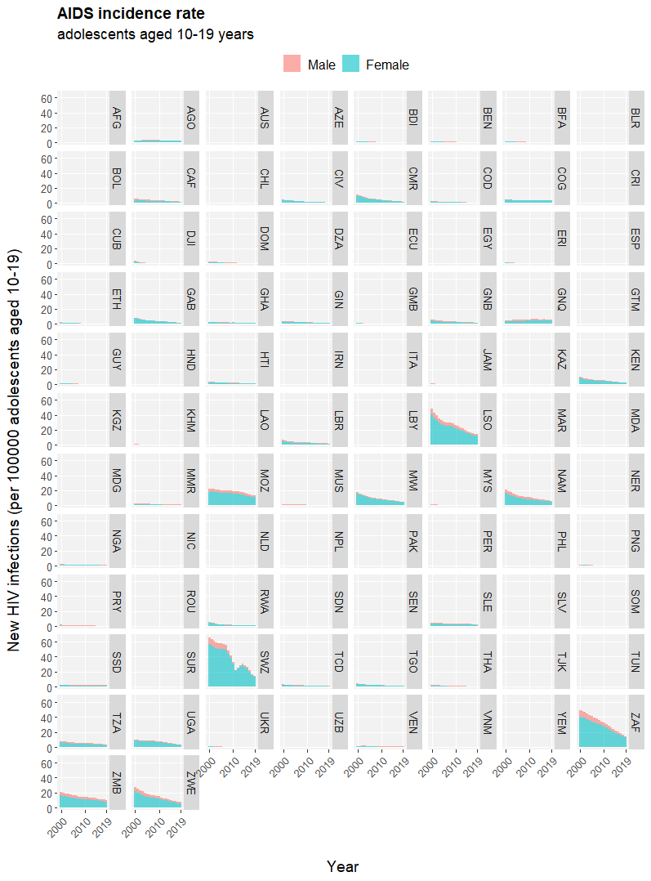

Figure S11
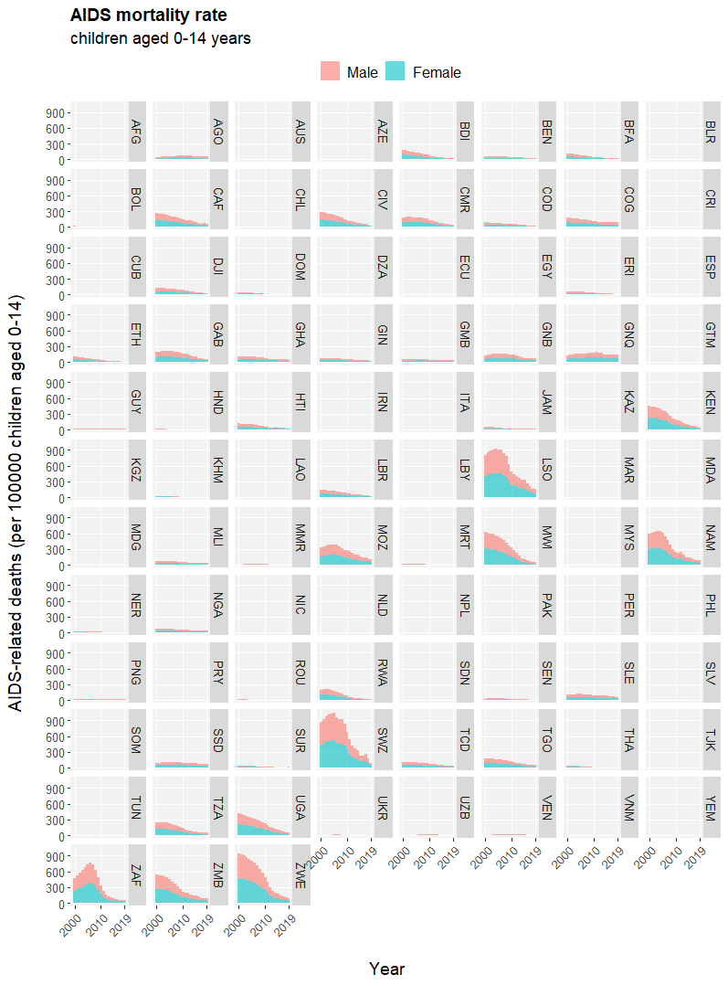

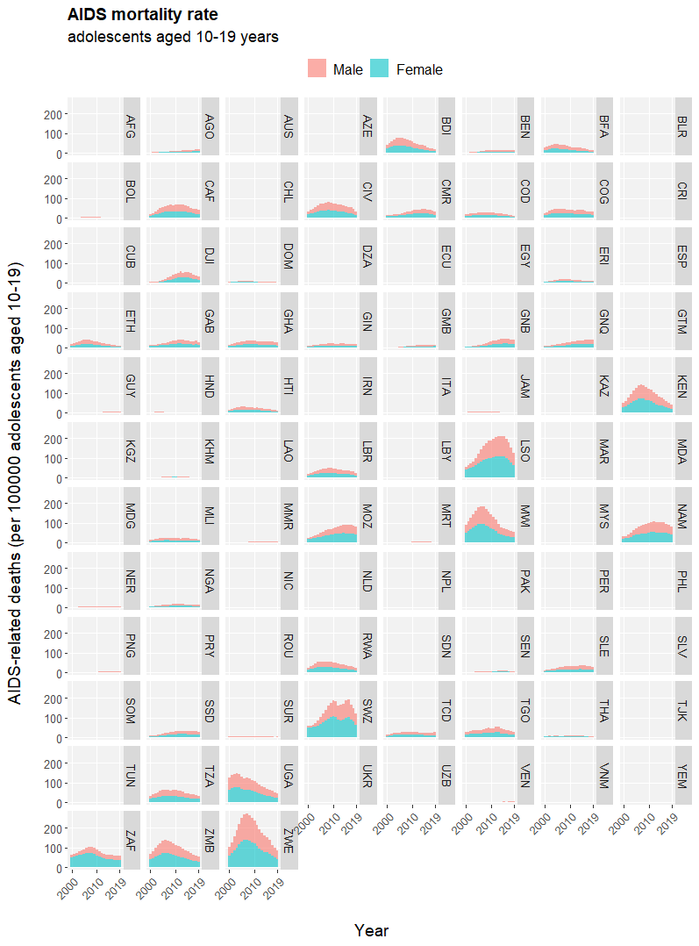

Supplementary Figure Legends
Figure S1. A. World map of countries/territories with names and ISO3 codes displaying their relative geographic locations. B. Description of data availability of UNCIEF health indicators included in this study for all countries/territories by the respective regions.
Figure S2. Proportion of under-18 (adolescents) population out of total population among countries in 2018. Data source: United Nations Population Division (UNPD), 2019.
Figure S3. Scatter plot of under-5 (children) and under-18 (adolescents) population proportions among countries in 2018. The trend line fitted by linear regression is displayed as a blue solid line with the associated Pearson’s correlation coefficient (r) and null-hypothesis test P value (P) reported. Points are shaded with regard to the status of total fertility rate (TFR). 2.1 is the commonly accepted threshold for the inter-generational replacement TFR. Data source: United Nations Population Division (UNPD), 2019.
Figure S4. Correlation of education status (adjusted net attendance rate, out-of-school rate, and completion rate) for school age (primary, lower secondary and upper secondary) in male vs. female among countries. Data source: UNICEF global databases, 2019.
Figure S5. Youth literacy rate (percentage of literate persons aged 15-24) conditioned on sex (male and female) among countries. Data source: UNESCO Institute for Statistics global databases, 2019, based on survey data for the most recent year available during the period 2012-2018.
Figure S6. Percentage of adolescents (aged 13-15) having underwent peer violence (bullying) conditioned on sex (male and female) among nations. Data source: HBSC, GSHS, and other relevant surveys, the most recent version.
Figure S7. Percentage of girls (aged 15-17) having experienced sexual violence and young women (aged 18-29) having experienced sexual violence by the age of 18 among nations. Data source: DHS and other relevant surveys, the most recent version.
Figure S8. Percentage of early marriage in adolescents (aged 15-19 and 20-24) by sex (male and female) among nations. Data source: UNICEF MICS, DHS, and other relevant surveys, the most recent version.
Figure S9. Status of early child bearing. A. Adolescent birth rates in female adolescents (aged 15-19) among nations. Data source: UN Population Division 2018. B. Percentage of women (aged 20-24) giving birth before the age of 18 conditioned on living environment (urban and rural) and economic condition (wealth status in 5 quintiles of 20%) among nations. Data source: UNICEF MICS, DHS, and other relevant surveys, the most recent version.
Figure S10. AIDS incidence rates in children (aged 0-14) and adolescents (aged 10-19) by sex (male and female) among nations in the past two decades (2000-2019). Data source: UNAIDS 2020 estimates.
Figure S11. AIDS mortality rates in children (aged 0-14) and adolescents (aged 10-19) by sex (male and female) among nations in the past two decades (2000-2019). Data source: UNAIDS 2020 estimates.

