SUPPLEMENTAL IMAGES:
Supplemental Figure 1: Frequency of (A, B) violent crime, (C, D) drug-related crime, and (E, F) burglary exposure within the Census block group of participant residence during gestation based on self-reported race and ethnicity. Plots on the left (A, C, and E) display crimes per km², and plots on the right (B, D, and F) display crimes per 1000 people per km². Violin plots display the smoothed kernel density of crime, while boxplots display the 25th quartile, median, 75th quartile, and Tukey whiskers (outliers are not displayed for simplicity).

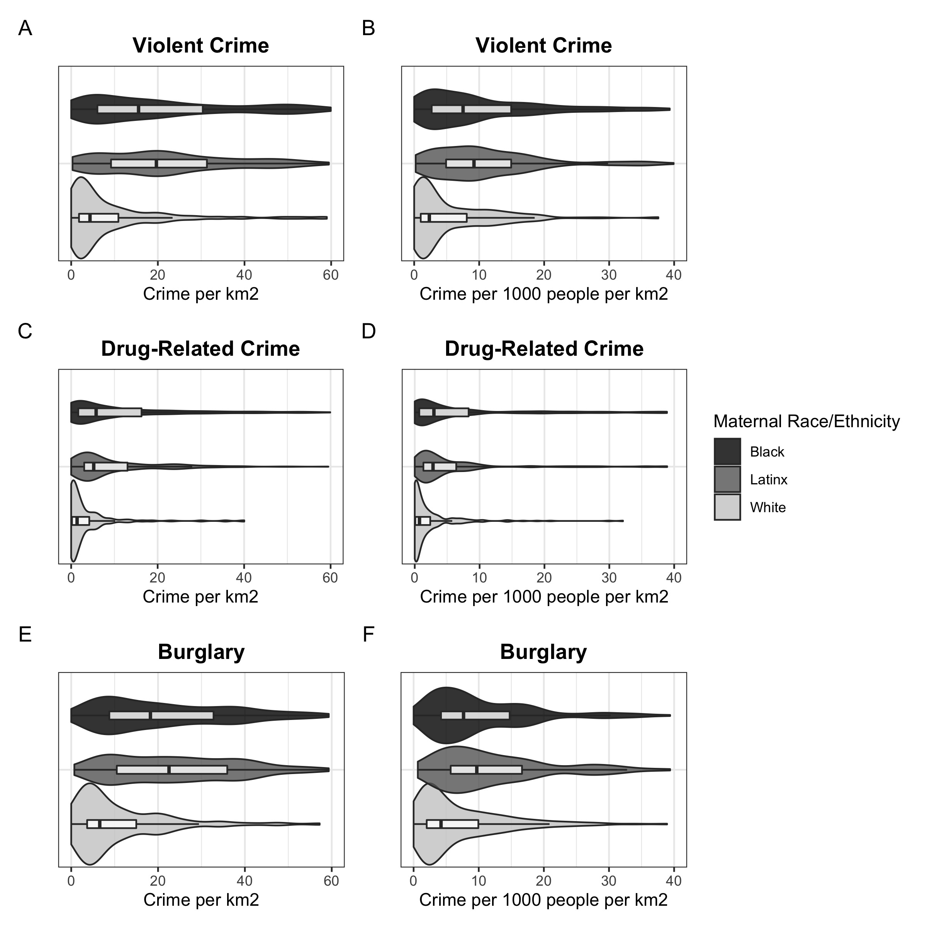

Supplemental Figure 2. Frequency of (A, B) violent crime, (C, D) drug-related crime, and (E, F) burglary exposure within 400m of participant residence during gestation based on self-reported race and ethnicity. Plots on the left (A, C, and E) display crimes per km², and plots on the right (B, D, and F) display crimes per 1000 people per km². Violin plots display the smoothed kernel density of crime, while boxplots display the 25th quartile, median, 75th quartile, and Tukey whiskers (outliers are not displayed for simplicity).

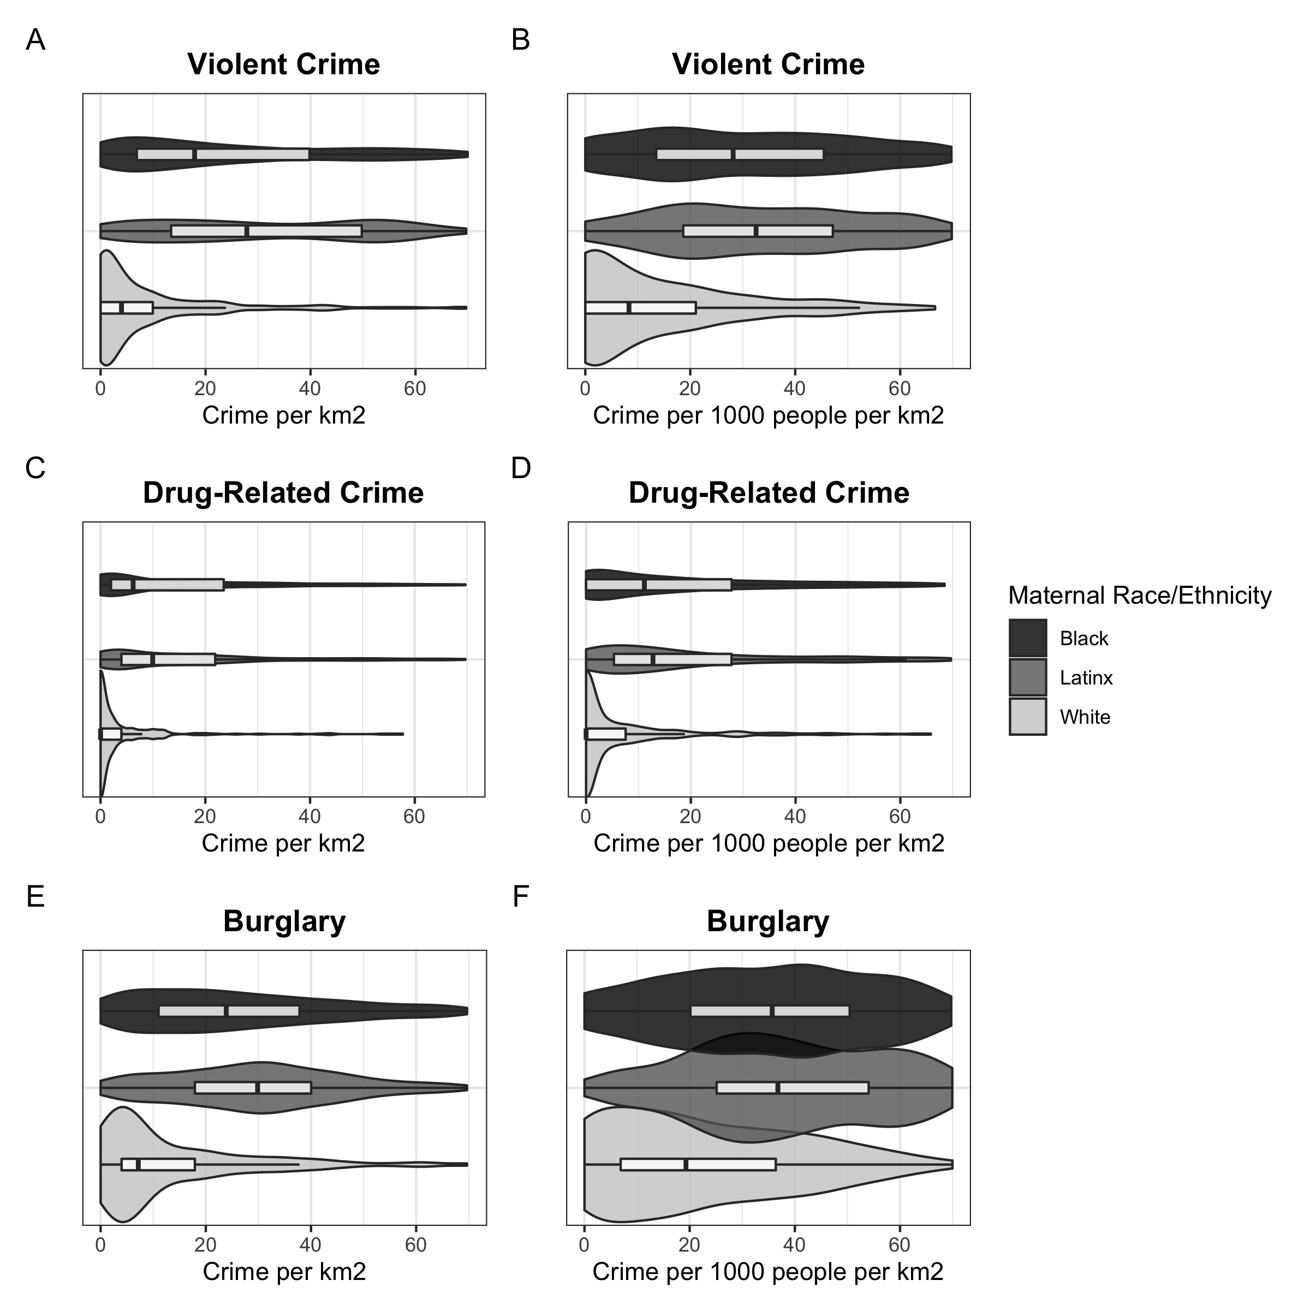

Supplemental Figure 3. Frequency of (A, B) violent crime, (C, D) drug-related crime, and (E, F) burglary exposure within 1600m of participant residence during gestation based on self-reported race and ethnicity. Plots on the left (A, C, and E) display crimes per km², and plots on the right (B, D, and F) display crimes per 1000 people per km². Violin plots display the smoothed kernel density of crime, while boxplots display the 25th quartile, median, 75th quartile, and Tukey whiskers (outliers are not displayed for simplicity).

