Medicine storage:

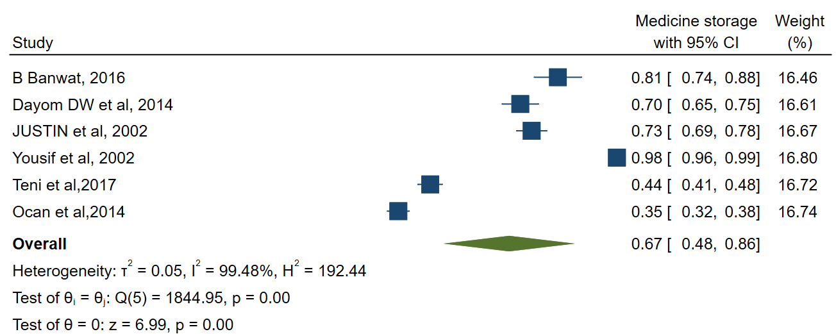

1. Forest plot assessing the prevalence of medicine storage among households, Sub-Saharan Africa

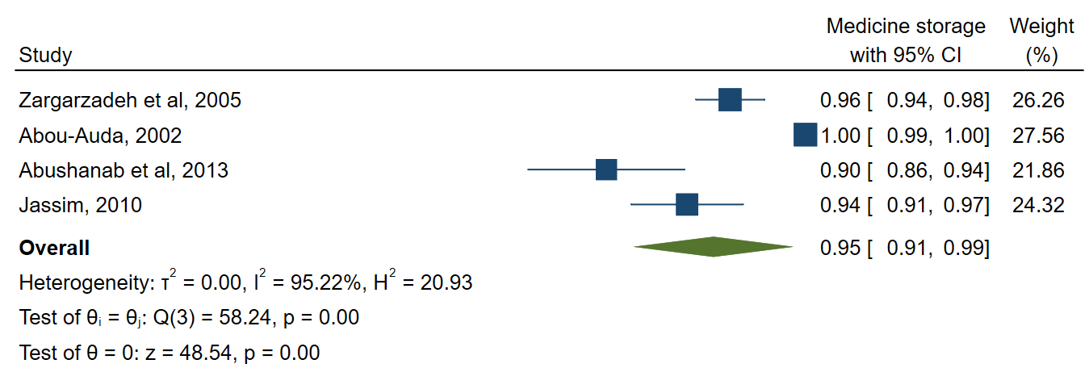

2.Forest plot assessing the prevalence of medicine storage among households, Southwest Asia

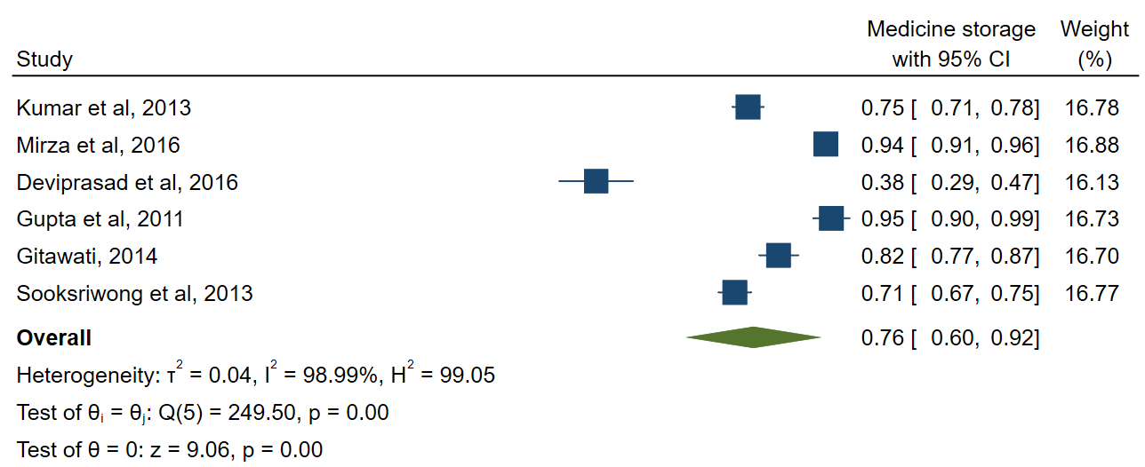

3.Forest plot assessing the prevalence of medicine storage among households, South and Southeast Asia

Real wastage:

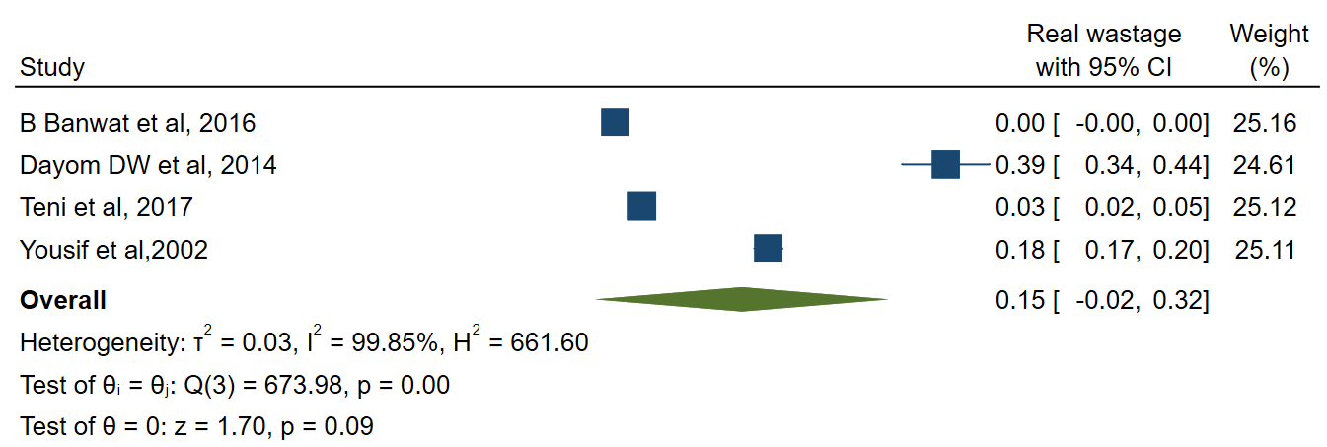

1. Forest plot assessing the prevalence of real wastage among households, Sub-Saharan Africa

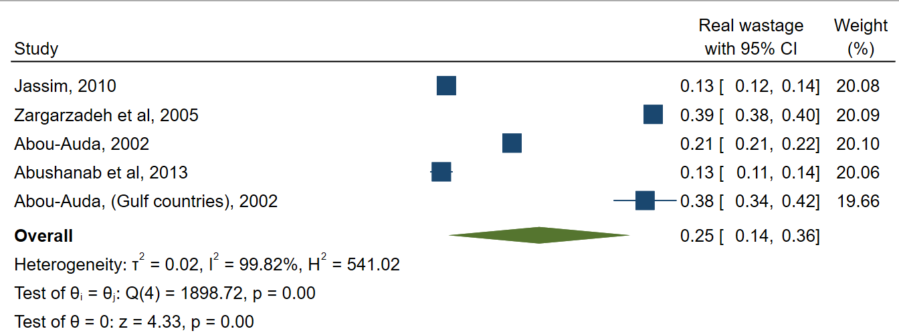

2. Forest plot assessing the prevalence of real wastage among households, Southwest Asia
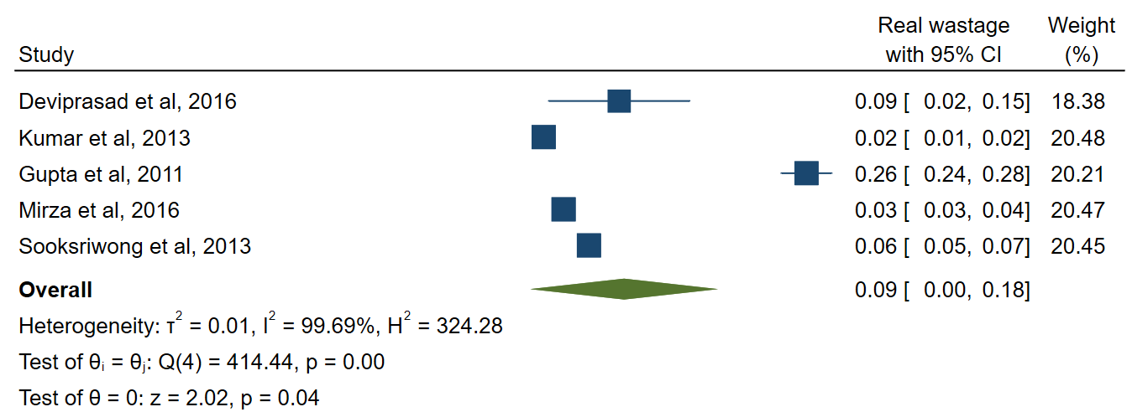

3. Forest plot assessing the prevalence of real wastage among households, South and Southeast Asia

