Appendix A: Health state vignettes
Health state: Screened; cytology normal (S1)
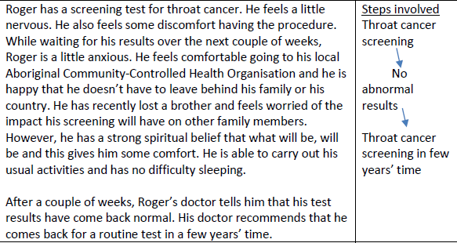

Health state: HPV vaccination (S2)
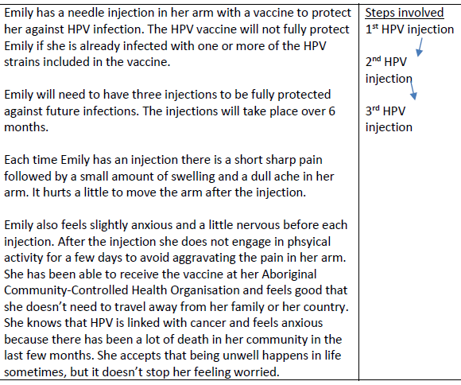

Health state: HPV positive, endoscopy normal (S3)
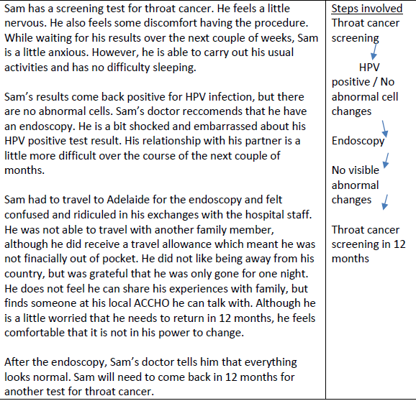

Health state: Oral warts (S4)
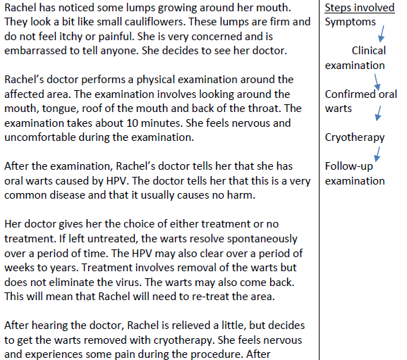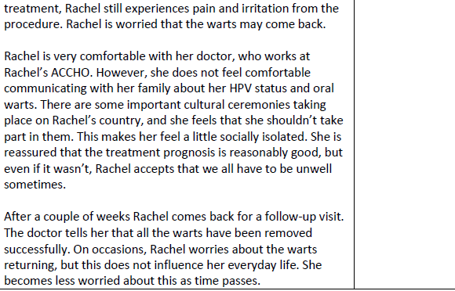

Health state: High grade cytology with histologically-confirmed Grade II/III oral intraepithelial neoplasia (S5)
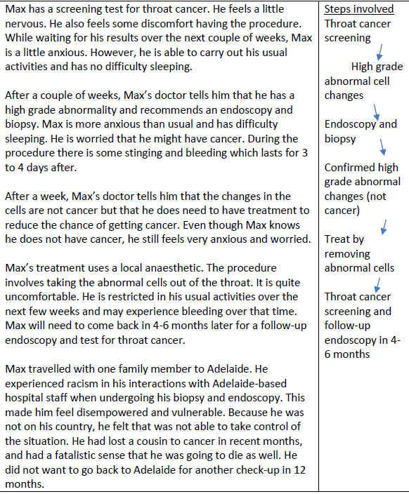

Health state: Early stage invasive throat cancer (S6)
