Appendix : Updated Covid-19 data (July 2021)

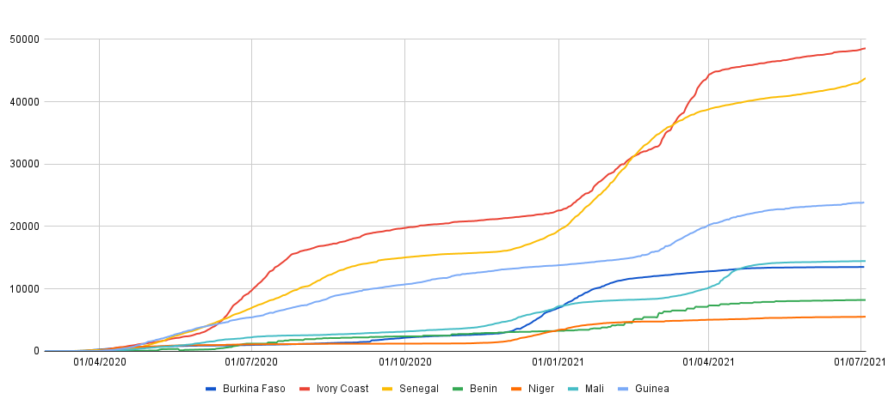

(a)

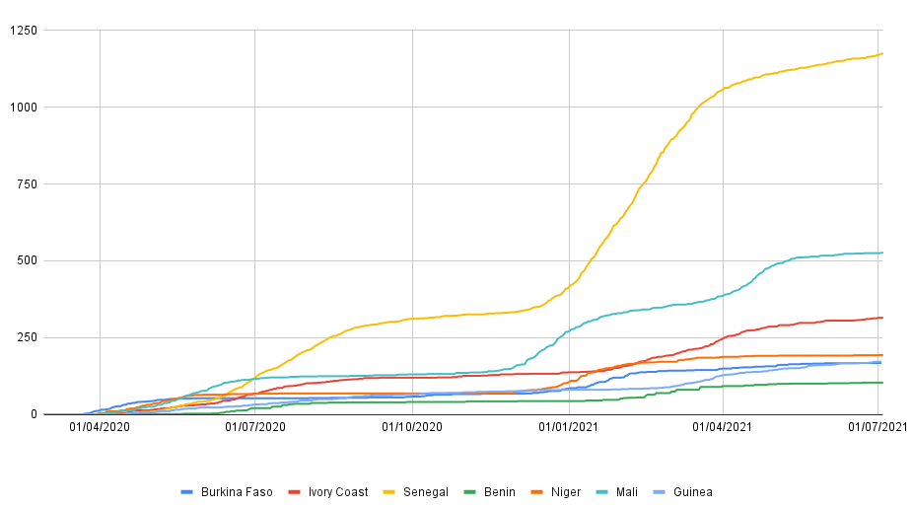

(b)
Figure 1: Cumulative COVID-19 cases (a) and deaths (b) by country between 28 February and 3 July 2021

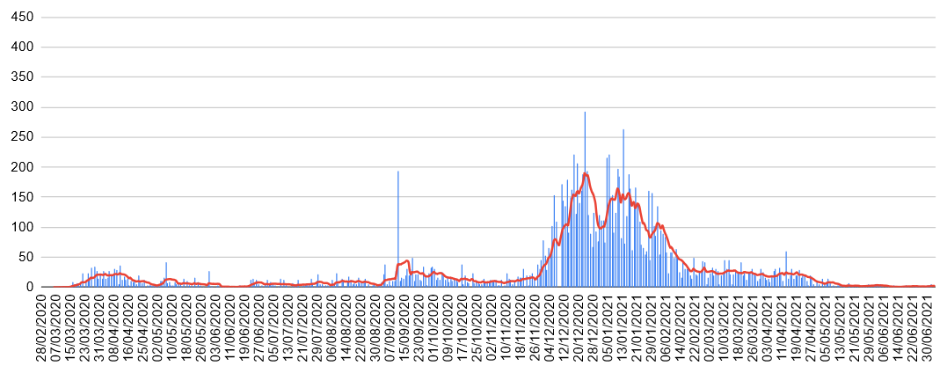

Burkina Faso

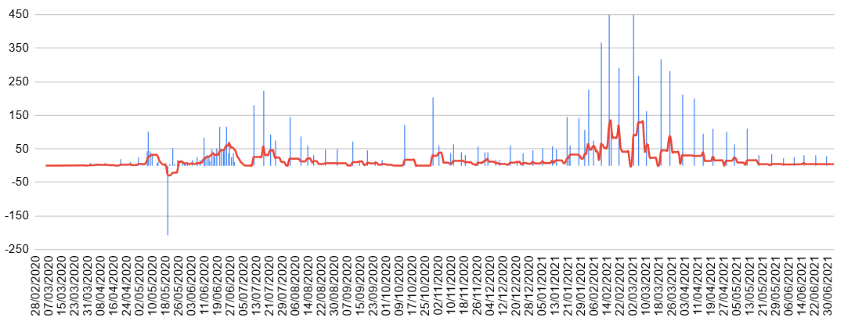

Benin

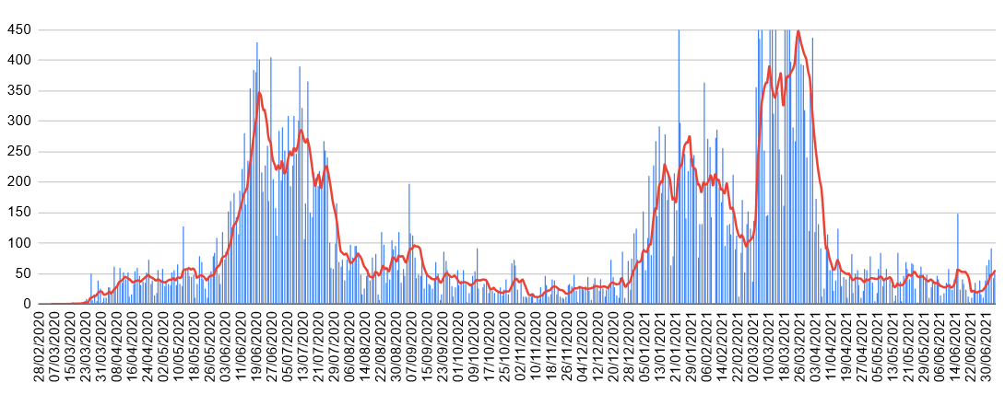

Ivory Coast

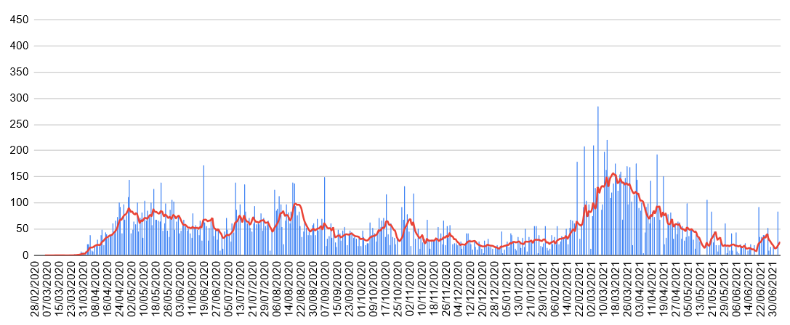

Guinea

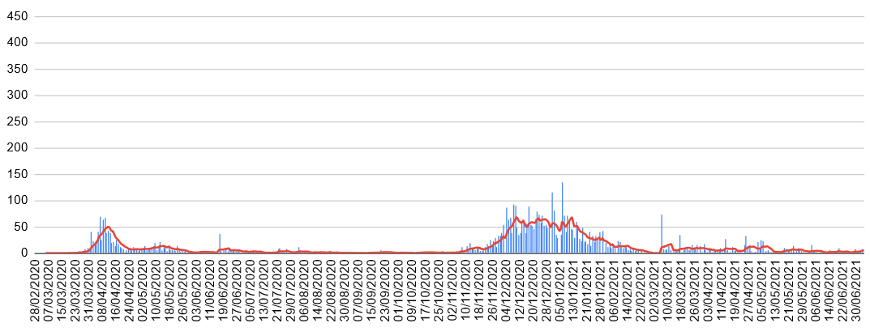

Niger

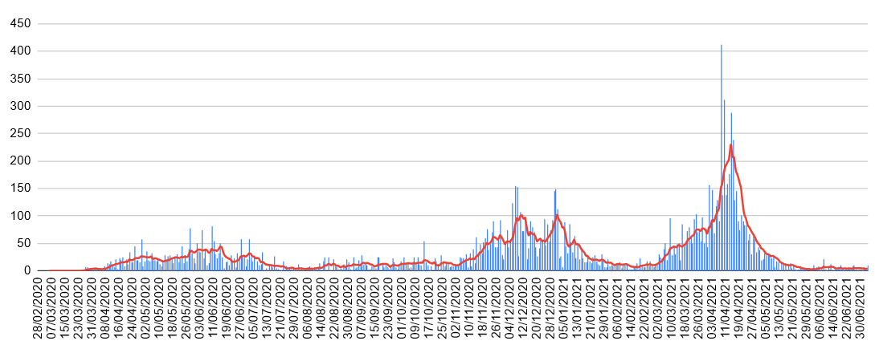

Mali

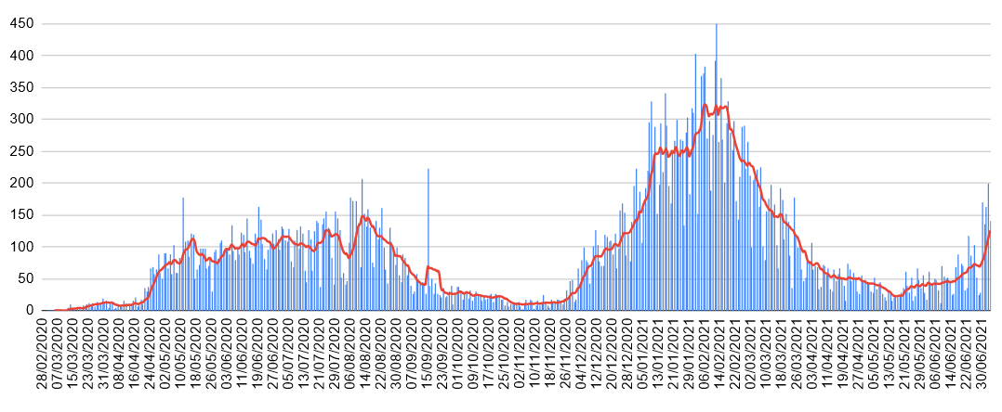

Senegal
Figure 2: Number of daily cases and moving average (7 days) per country (red line) between 28 February 2020 and 3 July 2021

Table 1: Attack rate and Case Fatality rate of COVID-19 (end of February to 3 July 2021)
 | Benin | Burkina Faso | Côte d’Ivoire | Guinea | Mali | Niger | Senegal
Attack rate per  100,000 population | 71,32 | 62,73 | 183,12 | 179,80 | 68,97 | 22,80 | 269,15
Case fatality rate | 1,27 | 1,24 | 0,65 | 0,77 | 3,64 | 3,53 | 2,69

Table 2: Number of PCR tests per 100,000 inhabitants as of 3 July, 2021
Benin | Burkina Faso | Côte d’Ivoire | Guinea | Mali | Niger | Senegal
Not available since June 2021 | 991 | 2703 | 2991 | 1529 | 428 | 360

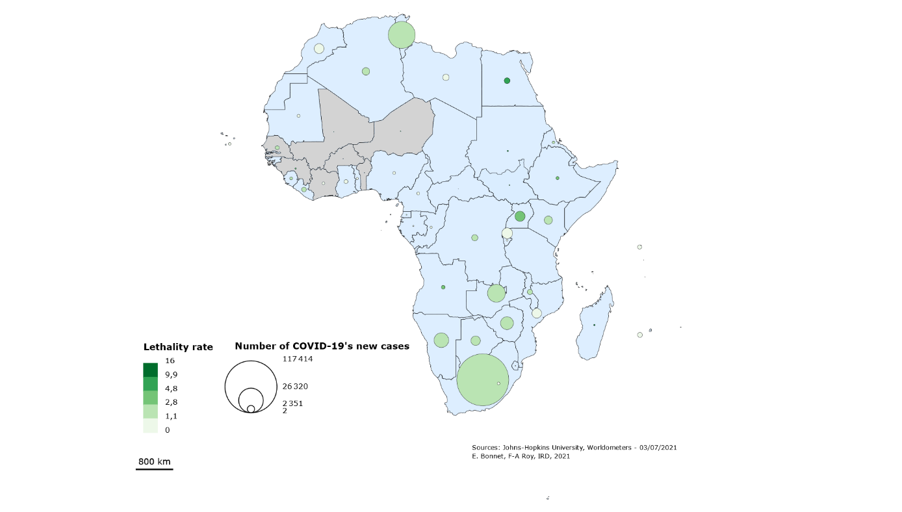

Figure 3: Case and Case-Fatality Mapping in Africa (in brown, country of our study)

(2020/03 – 2021/06)

CLUSTERS DETECTED in Burkina Faso 2020/03/01 to 2021/06/30

1.Location IDs included.: DIEBOUGOU, DANO, GAOUA, KARANGASSO VIGUE, HOUNDE, LENA, BOROMO,
BAGASSI, SIDERADOUGOU, BOBO DIOULASSO
Coordinates / radius..: (10.928009 N, 3.261135 W) / 114.18 km
Time frame............: 2020/9/11 to 2020/12/12
Number of cases.......: 70461
Expected cases........: 47722.74
Observed / expected...: 1.48
Test statistic........: 4815.279714
P-value...............: < 0.00000000000000001

2.Location IDs included.: GOROM GOROM, FALAGOUNTOU
Coordinates / radius..: (14.398626 N, 0.256172 W) / 46.57 km
Time frame............: 2020/4/10 to 2020/11/29
Number of cases.......: 5791
Expected cases........: 1663.79
Observed / expected...: 3.48
Test statistic........: 3098.538189
P-value...............: < 0.00000000000000001

3.Location IDs included.: BOGANDE, PIELA, MANNI, TOUGOURI, BOULSA, YALGO, GAYERI, SEBBA,
POUYTENGA, KOUPELA, ZORGHO, BOUROUM, DORI, KORSIMORO, KAYA, SEYTENGA,
BARSALOGHO, FADA, ZINIARE, TENKODOGO
Coordinates / radius..: (12.948564 N, 0.048381 W) / 137.14 km
Time frame............: 2020/12/21 to 2021/4/6
Number of cases.......: 73543
Expected cases........: 61206.52
Observed / expected...: 1.20
Test statistic........: 1196.281583
P-value...............: < 0.00000000000000001

4.Location IDs included.: KOMBISSIRI
Coordinates / radius..: (11.984075 N, 1.336525 W) / 0 km
Time frame............: 2020/7/7 to 2020/12/10
Number of cases.......: 2291
Expected cases........: 1000.04
Observed / expected...: 2.29
Test statistic........: 608.466723
P-value...............: < 0.00000000000000001

5.Location IDs included.: KOUDOUGOU, REO, SABOU, TENADO, NANORO, SIGLE
Coordinates / radius..: (12.295035 N, 2.324108 W) / 54.81 km
Time frame............: 2021/1/5 to 2021/6/29
Number of cases.......: 26643
Expected cases........: 22141.84
Observed / expected...: 1.20
Test statistic........: 433.131465
P-value...............: < 0.00000000000000001

6.Location IDs included.: TOMA
Coordinates / radius..: (12.686276 N, 2.885188 W) / 0 km
Time frame............: 2020/8/18 to 2020/12/16
Number of cases.......: 624
Expected cases........: 200.27
Observed / expected...: 3.12
Test statistic........: 285.467128
P-value...............: < 0.00000000000000001

Figure 4 : Spatio-temporal cluster of COVID-19 – Burkina Faso (2020/03 – 2021/06)

CLUSTERS DETECTED in Senegal 2020/03/01 to 2021/06/30

1.Location IDs included.: Podor, Dagana, Richard-Toll, Pete, Keur Momar Sarr, Linguere, Dahra,
Thilogne, Sakal, Coki, Saint-Louis, Louga, Ranerou, Matam, Kebemer,
Darou Mousty
Coordinates / radius..: (16.660065 N, 14.959326 W) / 213.99 km
Time frame............: 2021/1/7 to 2021/3/14
Number of cases.......: 132626
Expected cases........: 84043.04
Observed / expected...: 1.58
Test statistic........: 12169.413198
P-value...............: < 0.00000000000000001

2.Location IDs included.: Passy, Sokone, Makacoulibantang, Foundiougne, Kaolack, Ndoffane,
Fatick, Guinguineo, Dioffor, Diakhao, Niakhar, Birkilane, Nioro du
Rip, Gossas, Joal, Thiadaye, Diourbel, Kaffrine, Bambey, Mbour
Coordinates / radius..: (13.986558 N, 16.261040 W) / 83.86 km
Time frame............: 2021/1/22 to 2021/3/14
Number of cases.......: 167426
Expected cases........: 118278.36
Observed / expected...: 1.42
Test statistic........: 9288.495707
P-value...............: < 0.00000000000000001

3.Location IDs included.: Mbake, Touba
Coordinates / radius..: (14.792911 N, 15.907353 W) / 11.50 km
Time frame............: 2020/3/11 to 2020/7/21
Number of cases.......: 37771
Expected cases........: 19518.36
Observed / expected...: 1.94
Test statistic........: 6717.690930
P-value...............: < 0.00000000000000001

4.Location IDs included.: Velingara, Medina Yoro Foula, Tambacounda, Kolda, Koumpentoum,
Khoungheul, Salemata, Dianke Makha, Sedhiou, Malem Hoddar,
Bounkiling, Goudiry
Coordinates / radius..: (13.083355 N, 14.048129 W) / 179.66 km
Time frame............: 2020/4/10 to 2020/6/18
Number of cases.......: 12791
Expected cases........: 4987.54
Observed / expected...: 2.56
Test statistic........: 4249.370690
P-value...............: < 0.00000000000000001

5.Location IDs included.: Popenguine
Coordinates / radius..: (14.628358 N, 17.075243 W) / 0 km
Time frame............: 2020/10/16 to 2021/1/2
Number of cases.......: 28375
Expected cases........: 22407.54
Observed / expected...: 1.27
Test statistic........: 735.870287
P-value...............: < 0.00000000000000001

6.Location IDs included.: Pout
Coordinates / radius..: (14.773743 N, 17.059550 W) / 0 km
Time frame............: 2020/4/27 to 2020/6/8
Number of cases.......: 2022
Expected cases........: 812.36
Observed / expected...: 2.49
Test statistic........: 634.364719
P-value...............: < 0.00000000000000001

Figure 4 : Spatio-temporal cluster of COVID-19 – Senegal (2020/03 – 2021/06)

